AAUW Austin Public Policy
Advocacy Alert  July 2026
Meet the 2026-27 Branch Public Policy Leadership Team
Mary Ellen Scribner, Chair. Focus and Subcommittee Chair: Public Education – PreK-12 & Higher Education
Jackie Hardee, Focus and Subcommittee Chair: Elections and Voting (Also monitor state and federal voting rights legislation)
Suki Steinhauser, Focus and Subcommittee Chair: Women’s Health and Economic Issues (Organize presence at marches & rallies)
Ann Berasley, Legislative Advisor
GET THOSE BALLOTS IN THE BOX!

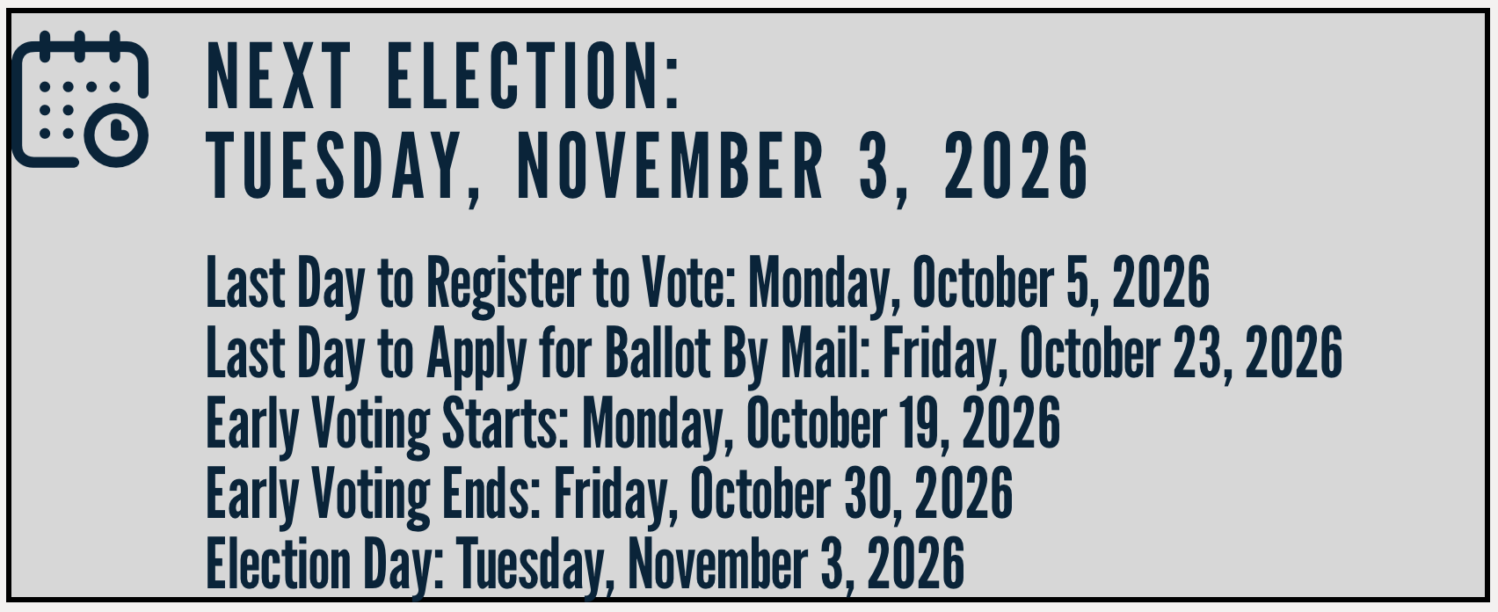
Thank you to everyone who wrote and spoke out against the corruption of the social studies TEKS, the mandated reading list better suited to a fundamentalist Sunday school class, all the violations of separation of church and state, etc. As we lamented the failure to provide a legitimate social studies curriculum to Texas students, I was asked, “Can it be changed?” Of course it can, but we have to win elections in order to do it. How do we do that? We get people to vote! ¡Ándale!

WEBINAR: Your AAUW, Your Community, Your Action
Join AAUW: It’s My Vote! on July 8 at 6:00pm CT for a practical look at AAUW’s It’s My Vote! campaign — a nonpartisan effort to give women the tools, information, and confidence to make their voices heard. You’ll hear directly from AAUW members about what’s working in their communities and leave with ideas your branch can put into action right away. Register now The paragraph below describes what the AAUW ACTION FUND promises to provide in this webinar. What the committee leadership team will be looking for is ways to get voters to vote! Central Texas (especially Travis County) has a high rate of voter registration, but then they don’t “bother” to vote! We want to learn ways to persuade them that their vote matters, and if they need transportation or other help, we can provide it. “What can one branch do to shape the 2026 midterms? More than you might think. With more than 110,000 seats on the ballot, AAUW branches have an important role to play in helping voters show up informed and ready. Join us for a practical look at AAUW’s It’s My Vote! campaign — a nonpartisan effort to give women the tools, information, and confidence to make their voices heard. You’ll hear directly from AAUW members about what’s working in their communities, get a preview of upcoming resources from AAUW, and leave with ideas your branch can put into action right away. We’re not telling anyone who to vote for. We’re making sure every woman has what she needs to participate.”
New York Times
🗳️ Read Mourning the Silence of Civic Education, by Chan-Yul Kim, 16, of McNeil High School right here in Austin, one of the winners of The Learning Network’s Student Open Letter Contest.

If you want to be an active member of the public policy committee this year, please email maryescribner@gmail.com.
Save the Date: An organizational meeting for the 2026-27 committee will take place on Thursday, August 27, 2026, at 10 a.m. via Zoom.

