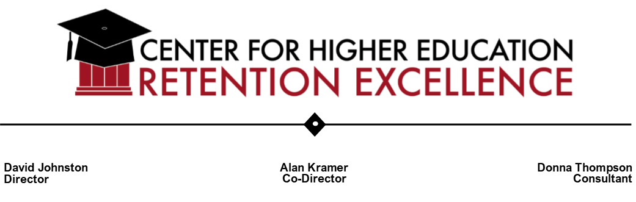
Agenda for 4/11/25” “Men in (and Out) of College” – at Goodwin University
- Welcomes and Introductions

- Background: Why a need for this conference (see Reeves book re. stats) – David Johnston, Director, CHERE

- Changing role of men in our society

- Impact on boys

- Impact on girls

- Declining number of male students pursuing higher education and of those who attend, graduating

- Overview of issues facing boys and men and Strategies –Expert Panel:

- T.J. Barber, Dean, Connecticut Community College-Manchester

- Jeffrey Burda, Director, Counseling and Psychological Services (CAPS), Univ. of Hartford

- John Paul Chaisson-Cardona, Vice President of Diversity, Equity & Inclusion, Connecticut Community College system

- William Fothergill, Counselor, Brotherhood Initiative, Conn. State University.

- Jordan Green, Director of Reaching Back Services and Community Engagement, Hartford Promise

- Nicole Miller, Associate Dean of Diversity, Equity, Inclusion and Belonging, Goodwin University

- Jay Williams, President, Hartford Foundation for Public Giving

- Juan Melian, Assistant Principal, Conard High School, West Hartford (invited)

- Matt Cerosimo, football coach at Conard High School (invited)

- Student Panel – students from several campuses in Hartford area

- Lunch

- After lunch: Wiley Dawson, Assistant Director, UConn Hartford: “How can support for Black men enhance support for all men on campus?”

