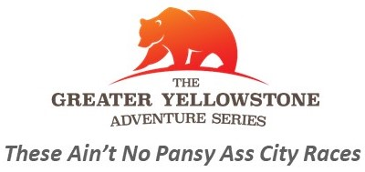

**The 10th Annual Big Sky Marathon**

**July 14, 2024**

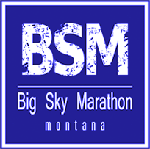

***RUNNERS INFORMATION PACKET***

***The Second Longest Downhill Road Marathon on Planet Earth***

**Race Time and Date**

* Sunday, July 14, 2024
* Full Marathon Runners Starting Time: Approximately 7:30 AM
* Half Marathon Runners Starting Time: Approximately 8:15 AM

**Race Check In**

* **Check-in and race day registration – Two Options**

**Friday, July 12, 2024**

4:00 to 6:00 PM at Lion’s Club Park in Ennis at the end of Main Street and right next to the Madison River.

Runners check in, sign waivers, receive bib numbers, and collect SWAG. Please check in on Friday if you can even though the race is on Sunday.

**Sunday, July 14, 2024** – Race Day Check In and late signup (if available)

Volunteers will check runners in on race day morning in Ennis. This will be from 5:00 to 5:45 AM at Varney Bridge on the Madison River. This is about 12 miles south of Ennis. Look for the big yellow school buses at/near the Varney Bridge Fishing Access site. If space is available, runners can sign up and pay on race day morning.

**Double Marathoners can pick up both packets at the Madison Marathon check in on Friday.**

*Half and full marathon runners will be shuttled to their respective starting lines. They will start their races at different times but within 30 to 45 minutes of each other.*

**Race Day Logistics & Schedule**

* **Runners drive to and Park at Varney Bridge**: The staging area and finish line will be at Varney Bridge which is 12 miles south of Ennis on Varney Bridge Road. Park in the areas designed by the volunteers. This will be deep within the fishing access site depending on the number of vehicles and permitting requirements. You will leave your vehicle at this location until the end of the race. Any SWAG bags or other gear should be left in your car or in a truck near the finish line. Volunteers will take bags from the starting lines back to the finish line as needed and put them into the finish line truck.
* **Morning Shuttle Bus**: The shuttle buses will leave from Varney Bridge for the starting line by 6:00 AM. Any runners taking the shuttle should be at the shuttle stop by 5:30 or earlier to allow time for check in. This bus is for runners who do not want to drive their cars up to the race course. All runners are strongly encouraged to take the shuttle bus rather than drive on your own. Please note that the route is from the top of the Gravelly Range back down to the Madison River. So, if you are driving up to the starting line, you’ll need a second driver to bring your car back down the mountain.
* **Shuttle bus arrival at the Starting Line:** The shuttle buses will drive directly to the starting lines (full and half) and then return to its home base so everything needs to be taken off the bus. The route is an out and back for the full and a straight shot for the half marathon. For the full marathon, it is approximately 22 miles from the start to Highway 287 on the valley floor (crossing the Madison River at Varney Bridge) and then back four miles to the finish line at Varney Bridge (see map below). All runners will board the shuttles to the full marathon starting line. The shuttles should arrive to that start by 7:00 AM. All runners will disembark to loosen up and use bathrooms as needed. For the half marathon runners, the starting line is at approximately Mile 4 of the full marathon and in a large meadow with millions of wildflowers. The half marathoners can stay on the bus or disembark and wait for the race director to get the full marathon started before driving down to start the half marathon. It’s a nice place to relax and prepare for the half marathon. The waiting time will be approximately 30 to 45 minutes.
* **Race Start**: The Big Sky Marathon will start at approximately 7:30 AM. The Big Sky Half Marathon will start at approximately 8:15 AM. The buses will leave the route completely so nothing should be left on the buses. There will be a truck for any drop bags and this truck will be parked near the finish line at Varney Bridge.
* **Awards Ceremony** – The awards ceremony for the Big Sky Half Marathon will be at approximately 10:00 AM at Varney Bridge. The awards ceremony for the Big Sky Marathon will be at approximately 12:00 Noon at Varney Bridge.
* **Last Call for Runners**: Since the race finishes at Varney Bridge and all runners’ vehicles should be there, the race director will allow runners up to nine hours to finish the race. The race director will make all the final calls for the race including pulling someone out of the race due to injury, potential injury, or time.

**IMPORTANT:** There is VERY limited cell phone coverage in the Gravelly Range. The cell phone coverage will be spotty on the way down the mountain, but will get progressively better the closer the runners get to the Madison River.

***This race is operated under special use permit with the Beaverhead-Deerlodge National Forest.***

**Staging Area & Finish Line**

The staging area and finish line is at Varney Bridge on the Madison River. All runners should drive to this location and park your vehicles as directed by the race volunteers on race day. The shuttle buses will leave from this location (not from Ennis).

The physical location of Varney Bridge is 45.236670 N, -111.751661 W It is about 12 miles from Ennis and can be reached via Varney Bridge Road or Highway 287.

The physical location of the Big Sky Marathon starting line is at approximately the following coordinates: 45.077556 N, -111.866895 W. This is at approximately Mile 17 of the Madison Marathon route on the Gravelly Range Road. There will be porta-johns at this starting line.

If you have any questions or problems on race day, a number will be provided for the RD by race day. BE AWARE that the RD may not be in cell coverage range.

A portion of the Big Sky Marathon is being run on National Forest Service land under a special use permit. A key criteria for receiving the permit each year is that the race will not create any negative impacts on the land and the environment. If you are camping on the Gravelly Range, please read the camping information below.

**Level of Runner Support**

The **Big Sky Marathon will be a limited support race**. This means there will be some form of water and/or hydration approximately every three miles on the route, but not many aid stations. We will have medical support along the route and there will be mile marker signs along the route. The route is also cup-less meaning no cups will be at the water stations. Runners should carry their own water bottles and fill them up at the stations.

Please do not expect a high level of runner support like other marathons can offer. The logistics and distance from the town of Ennis makes this kind of support very difficult. In addition, we have to be careful about impacting the environment since it is at a high altitude, remote, and on National Forest Service land.

Lastly, only the first several miles of the race are on National Forest land. Once runners cross a cattle guard gate, they are running on a Madison County road that crosses private land. Eventually, runners will arrive back on public land next to the Madison River.

We encourage runners to carry their own timing devices, water bottles and food/gels as needed. **BE AWARE AND BE PREPARED:** **This is a high-altitude race and an extreme downhill**. It has a net drop of over 3,600 feet.

**Cautions:**

* IMPORTANT: All runners will be required to sign a waiver before running the race. If these waivers are not signed, the runner will not be allowed to run the race and will forfeit the entry fee.
* There will be an EMT or medical crew on the route, but he/she may be some distance from a runner in trouble. If a runner experiences any problems due to exhaustion, the altitude, dehydration, etc… it is their responsibility to inform race volunteers and others for help.
* As part of our permit for the races, the Forest Service required us to distribute the following information on sheep and sheep dogs found on the Gravelly Range. Please review the information below carefully. The Big Sky Marathon route does not pass through the areas where the sheep are *generally grazed* though they could be there as well.
* The race director has seen these sheep dogs and they are extremely huge! The advice provided by the Forest Service is very good and should not be dismissed as being overzealous or overly dramatic. The race director will contact the shepherds in the area prior to race day to request them to move their sheep away from the road on race day if they are in or near the Big Sky Marathon route.

**Sheep Guard Dogs**

[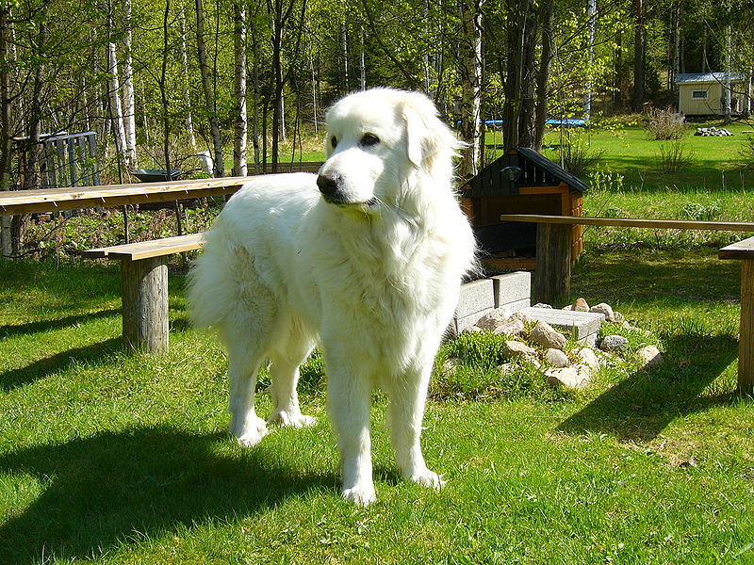](http://upload.wikimedia.org/wikipedia/commons/0/09/Pyreneittenkoira.jpg)

**From the US Forest Service**

This is a Great Pyrenees Guard Dog. These types of dogs are in use as Sheep Guard Dogs on top of the Gravelly Mountains. They are trained to guard the sheep. **They will chase you if you run.** If you have a dog with you, the guard dog may see it as a threat to the sheep. They are not pets. The sheep herders have little control over them. They may be seen anywhere.

If you come upon one or it comes up to you. **STOP**, stand still, let the dog sniff you and check you out. Tell it to **“GO TO THE SHEEP.”** It will then most likely wander away. **WAIT** for the dog to move off and leave a far distance. Then resume your travel.  **DO NOT RUN** when the dog can see you. **DON’T FEED IT, DON’T TRY TO PET IT!**

**Camping Options**

For those of you who have not been on the Gravelly Range, it is incredibly beautiful. Aside from acclimatizing yourself to the elevation in order to get ready for the race, it is an enjoyable place to camp for a night or two. There are several camping options right along the course route as well as very near the route. You will have to haul your own water to the sites. You will also have to observe ‘leave no trace’ camping ethics such as building fires in existing fire rings only, burying all human waste, packing everything out, and storing all food and refuse properly. The most ideal camping location for the Big Sky Marathon is likely Clover Meadows. There will be a lot of activity there on Saturday for the Madison Marathon, but it will quiet down greatly by the evening so you’ll get plenty of quiet rest for the following day’s race (Sunday).

Food and Refuse Storage Requirements

In the Daytime – All food and refuse must be acceptably stored or attended. Attended means that someone is within 100 feet and in sight of accessible food and refuse.

At Night – Unless being transported, eaten or prepared to be eaten, all food must be properly stored. Refuse must also be properly stored.

To be properly stored food, refuse and other attractants must be secured in an enclosed hard sided vehicle (including pick-up camper shell or horse trailer); a certified bear resistant container; or suspended at least ten feet clear of the ground at all points and four feet horizontally from any supporting tree or pole.

Items requiring proper storage – anything (excluding unflavored water and bailed hay) that can be eaten to provide nourishment, including soft drinks, canned food, alcoholic beverages, pet food, processed livestock feeds and grains, personal hygiene products, and refuse, including empty food and beverage containers.

There are some forest service cabins available for rent. The Forest Service rents these out through its website at [www.recreation.gov](http://www.recreation.gov). You will need to key in the state and the time frame and review the options. According to the Forest Service office in Ennis, there are cabins at Black Butte, West Fork, Wall Creek, and Vigilante which are relatively near the race route, in particular Black Butte and West Fork. You need to reserve these and pay for them with a credit card.

There are two campgrounds in the area. Clover Meadows, as noted above, is the staging area and finish line for the Madison Marathon. It is also a campground. There is one outhouse toilet and a few fire rings for building fires. This is a free campground and no reservations are required. Cottonwood Campground is on the Ruby Road leading up to the Gravelly Range. It is also free with no reservations required.

Finally, dispersed camping is allowed in the Gravelly Range only at sites identified by a wooden or fiberglass post with a tent symbol as shown in the photo below. This means you can camp at the obvious site behind the sign. These signs are generally a few yards off the side of the road and easy to spot. You can only use an existing fire ring to build your fire and you must observe all leave no trace camping ethics. Be aware that fires may not be allowed if it is an unusually dry year. The US Forest Service will make this call and this information will be forwarded to all runners.

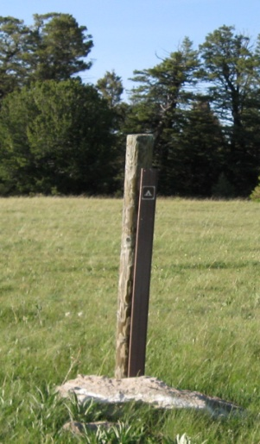

We have identified tent sites (there could be more that we did not find) at the following locations along or near the race route coming from the Call Road and heading towards Clover Meadows and the starting line of the Madison Marathon. If you camp at any of these sites, it will not take long to get to the starting line of the Big Sky Marathon (i.e. less than 30 minutes in most cases):

1. The first site is about one mile from the entrance to the Beaverhead Deerlodge National Forest as you climb up the Call Road from Ennis. It will be on your right. This site is about 12 miles from Clover Meadows.
2. The next site is at the junction of Road 292 and Road 290. Road 292 is the Call Road that you will take up to the course from Ennis. Road 290 is the road that the race will be held on. From here, you are 10 miles from Clover Meadows. This is quite near the starting line of the Big Sky Marathon.
3. The next two sites are just a few miles further along Road 290 heading towards Clover Meadows Campground. They will be on your right side as you drive towards Clover Meadows.
4. The next place to camp along this road will be Clover Meadows campground itself.
5. A few miles past Clover Meadows, heading south, there is another campsite on your left side.

**The Races**

There are only the full and half marathon race categories.

**The Course Route**

**Full Marathon Start: 45.04 32 N, -111.5200 W**

**Half Marathon Start: 45.07 11 N, -111.5204 W**

**Finish: 45.236670 N, -111.751661 W (Varney Bridge on the Madison River)**

**Net Drop: Approximately 3,651 feet** (for the full)

Route: The starting line is within the Beaverhead Deerlodge National Forest and the route runs on the Gravelly Range Road to the US Forest Service Gate and then on the Call Road to Varney Bridge. This will be an entirely gravel road except for about one mile before Varney Bridge.

A good means to describe the full marathon route in terms of its challenges and level of difficulty is to break it down into three sections.

Section One – This is from the starting line to the point on the route where the significant downhill begins. The starting line is at approximately 8,500 to 8,700 feet above sea level. The full marathon start is at about Mile 17 of the Madison Marathon. The runners will not drop in elevation too significantly over the first five to eight miles. There are few or no uphills on this section of the route. It is essentially flat and on top of the Gravelly Range though everything is trending downhill. This entire section is within the Beaverhead Deerlodge National Forest. As runners get close to the border of the National Forest, there will be long, gradual downhills of two to three miles in length crossing enormous bowls and meadows, but they will not necessarily be quad burners.

Section Two – This is the quad burner section. It begins almost immediately after runners leave the National Forest. Runners will cross a cattle guard gate and then the next several miles will be a quite steep downhill. This is a series of switch backs that drop the runner from 8,500 feet to 6,000 feet in a relatively short distance. The “official end” of this section is when the road hits a T-junction after going through most of the Bar 7 ranch. The estimated distance is about seven miles.

Section Three – This section is a flat area that gradually declines in elevation as it gets close to the Madison River. The lower part of the Bar 7 Ranch is approximately 6,000 feet and Ennis and the Madison River is at about 5,000 feet. The first few miles will be on gravel road, but eventually the runners hit pavement near the Ennis Fish Hatchery turn-off. Once pavement is hit, runners are quite close to Varney Bridge and the Madison River (the finish line). When runners reach a T-junction, they turn right to Varney Bridge. The marathon runners cross the bridge and continue running out to Highway 287 which is about four miles away. This section is entirely on gravel road and crosses an enormous open space area with fantastic views of both the Madison and Gravelly Range. At the highway, runners turn around and run back to Varney Bridge and the finish line.

That is how you run one of the longest downhill road marathons on Planet Earth!

**Route Map**

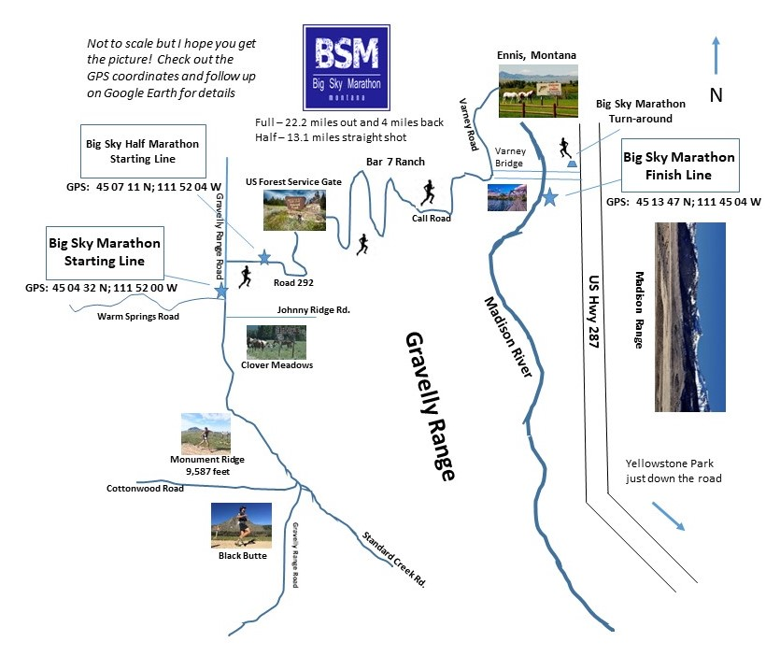

**Madison County Hotels and Restaurants**

The home base for the Greater Yellowstone Adventure Series (GYAS) races is in Ennis, Montana. This is a small town on the Madison River. It is about 50 miles from Bozeman. The drive from Bozeman airport (BZN) to Ennis takes about an hour. Ennis is 70 miles from Yellowstone National Park (the west gate entrance).

**Some of the Madison County hotels that we recommend are:**

Red Bear Inn – [www.redbearinn.com](http://www.redbearinn.com)

El Western – [www.elwestern.com](http://www.elwestern.com)

Sportman’s Lodge – [www.sportsmanslodgemt.com](http://www.sportsmanslodgemt.com)

McAllister Inn – [www.mcallisterlodging.com](http://www.mcallisterlodging.com)

Lure Me Inn – [www.luremeinn.com](http://www.luremeinn.com)

Rainbow Valley Lodge – [www.rainbowvalleylodge.com](http://www.rainbowvalleylodge.com)

Riverside Motel – [www.riversidemotel-outfitters.com](http://www.riversidemotel-outfitters.com)

Moriah Motel – [www.moriahmotel.com](http://www.moriahmotel.com)

King’s Motel – [www.kingsmotelllc-mydirectorystay.com](http://www.kingsmotelllc-mydirectorystay.com)

**Some of the nicer places to eat and drink include:**

G Bar – 305 East Main Street, Ennis Tel: (406) 682-5553

Willies Distillery – 312 Main Street, Ennis Tel: (406) 682-4117

Alley Bistro – 59 MT Hwy 287, Ennis Tel: (406) 682-5695

Bynee’s – 214 Main Street, Ennis Tel: (406) 682-3156

The Continental Divide – 47 Geyser Street, Ennis Tel: (406) 682-7600

Tavern 287 – 129 East Main Street, Ennis Tel: (406) 682-7287

Longbranch Saloon – 125 Main Street, Ennis Tel: (406) 682-7020

Yesterday’s Soda Fountain – 124 Main Street, Ennis Tel: (406) 682-4246

The Pic A Nic Basket – 97 North 1st Street, Ennis Tel: (406) 682-7900

Ennis Sugar High – 170 North Main Street, Ennis Tel: (406) 682-7113

Nacho Mamma’s Burrito – 111West Main Street, Ennis Tel: (406) 682-4006

McAllister Inn Steakhouse – 5566 Highway 287, McAllister Tel: (406) 682-5000

Sportman’s Lodge – 310 North Main Street, Ennis Tel: (406) 682-4242

Wells Fargo Steak & Coffee House – 314 West Wallace Street, Virginia City Tel: (406) 843-5556

Mill Creek Inn – 102 Mill Street, Sheridan Tel: (406) 842-5565

The Shovel and Spoon – 108 North Main, Sheridan Tel: (406) 842-7999

The Old Hotel – 101 East 5th Avenue, Twin Bridges Tel: (406) 684-5959

The Shack – 301 North Main, Twin Bridges Tel: (406) 684-5050