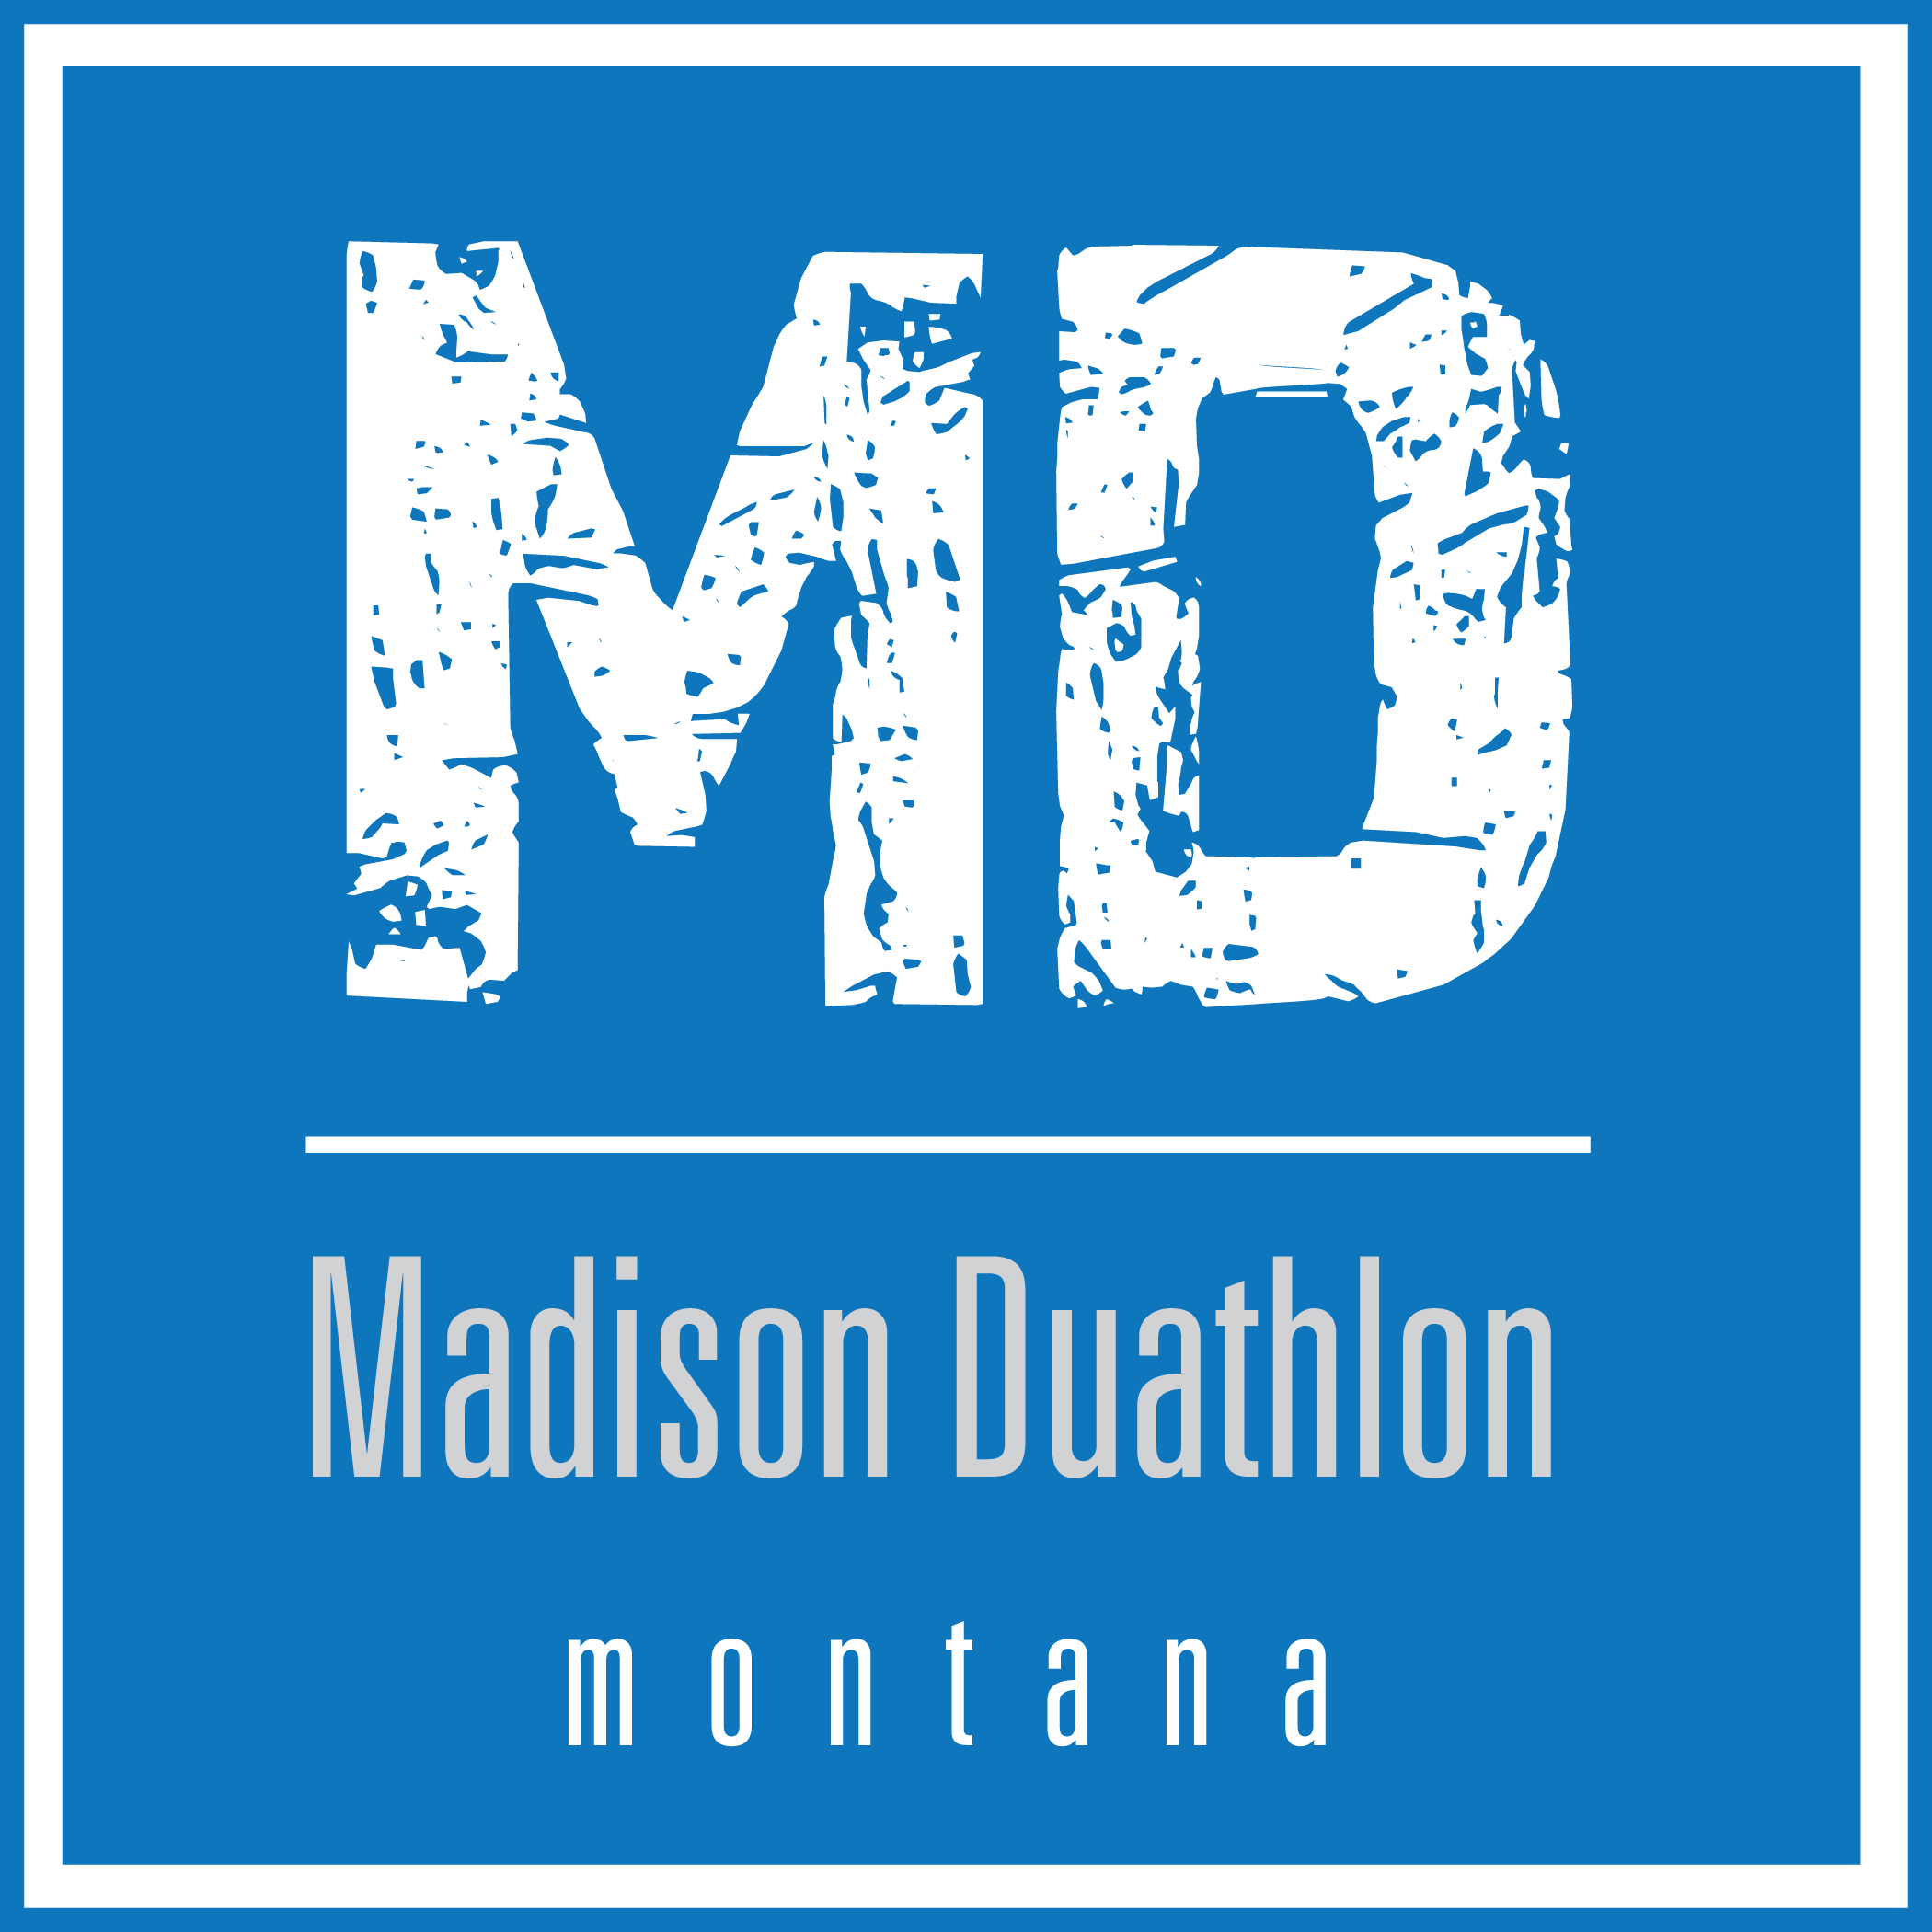

The 6th Annual Madison Duathlon

July 9, 2017

The Gold Miners Trail - Ennis to Virginia City

Official Race Results

Overall Champions

Men’s Division Women’s Division
Neal Andrews Shanna Stack
Bozeman, MT Missoula, MT
1:56:19 2:18:30
Runners-Up
Dylan Malloy Lynda Andros-Clay
Billings, MT Bozeman, MT
2:04:40 2:33:52

Master’s Champions
Men’s Division Women’s Division
Neal Andrews Lynda Andros-Clay
Bozeman, MT Bozeman, MT
1:56:19 2:33:52
Runners-Up
Shane Stack Stacy Newton
Missoula, MT Alta, WY
2:10:27 2:43:07

Overall

- Neal Andrews – Bozeman, MT 1:56:19
- Dylan Malloy – Billings, MT 2:04:40
- Shane Stack – Missoula, MT 2:10:27
- Cory Hardy – Ennis, MT 2:12:05
- Chris Byrnes – Brooklyn, NY 2:15:36
- Shanna Stack – Missoula, MT 2:18:30
- Eric Huff – Sheridan, MT 2:22:03
- Matt Kuper – Cyprus, TX 2:26:15
- Rick Dendinger – Helena, MT 2:30:37
- Eduardo Garcia – Gallatin Gateway, MT 2:32:10
- Jeff Millsap – Virginia City, MT 2:33:36
- Lynda Andros-Clay – Bozeman, MT 2:33:52
- Ed Hays – Laguna Beach, CA 2:42:44
- Stacy Newton – Alta, WY 2:43:07
- Sarah Holexa – Missoula, MT 2:43:48
- Cody Sauer – Bozeman, MT 2:51:39
- Stan Wagner – Bozeman, MT 2:55:05
- Natalie Deschamps – Missoula, MT 3:00:35
- Joshua Holexa – Missoula, MT 3:00:36
- Kim Trotter – Driggs, ID 3:14:38
- Brenda Lindgren – Fergus Falls, MN 3:16:54
- Mariah Vandiver – Burleson, TX 3:23:52
- Lesliann Finch – Billings, MT 3:29:08
- Randall Finch – Billings, MT 3:29:08

Men’s Overall

- Neal Andrews – Bozeman, MT 1:56:19
- Dylan Malloy – Billings, MT 2:04:40
- Shane Stack – Missoula, MT 2:10:27
- Cory Hardy – Ennis, MT 2:12:05
- Chris Byrnes – Brooklyn, NY 2:15:36
- Eric Huff – Sheridan, MT 2:22:03
- Matt Kuper – Cyprus, TX 2:26:15
- Rick Dendinger – Helena, MT 2:30:37
- Eduardo Garcia – Gallatin Gateway, MT 2:32:10
- Jeff Millsap – Virginia City, MT 2:33:36
- Ed Hays – Laguna Beach, CA 2:42:44
- Cody Sauer – Bozeman, MT 2:51:39
- Stan Wagner – Bozeman, MT 2:55:05
- Joshua Holexa – Missoula, MT 3:00:36
- Randall Finch – Billings, MT 3:29:08

Women’s Overall

- Shanna Stack – Missoula, MT 2:18:30
- Lynda Andros-Clay – Bozeman, MT 2:33:52
- Stacy Newton – Alta, WY 2:43:07
- Sarah Holexa – Missoula, MT 2:43:48
- Natalie Deschamps – Missoula, MT 3:00:35
- Kim Trotter – Driggs, ID 3:14:38
- Brenda Lindgren – Fergus Falls, MN 3:16:54
- Mariah Vandiver – Burleson, TX 3:23:52
- Lesliann Finch – Billings, MT 3:29:08

