

**17th Annual Madison Marathon**

**July 13, 2024**

***RUNNER INFORMATION PACKET***

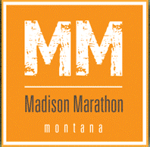

***One of Planet Earth’s Highest Road Marathons***

**Race Time and Date**

* Saturday, July 13, 2024
* All Runners Starting Time: Approximately 8:30 AM near the base of Black Butte Mountain. All runners will be shuttled to the starting line from the Clover Meadows staging area. More detailed logistics are noted below.

**Race Check In**

* **Check-in and late registration (if available*) – Ennis, Montana**
  + Friday, July 12, 2024
  + 4:00 to 6:00 PM at Lion’s Club Park in Ennis at the end of Main Street and right next to the Madison River
  + Runners check in, sign waivers, receive bib numbers, and collect SWAG.

**\*** *If the race has not sold out, runners can still register to run the race until 150 runners (the maximum allowed by the US Forest Service permit) have been signed up.*

* **Race Day Check-in – (for registered runners only)**
  + Saturday, July 13, 2024
  + 6:30 to 7:30 AM at Clover Meadows.

**Race Day Logistics & Schedule**

* **Runners must get to Clover Meadows on their own.** Please send a parking permit request to [sam@yespi.net](mailto:sam@yespi.net) to get a permit for your car. The directions to Clover Meadows are noted below. The parking area is about 100 yards south of Clover Meadows and there will be signs pointing to the area. Please park in an orderly manner and be sure to close up your windows and never leave food or garbage out as it will be a bear attractant.
* **Morning Shuttle Bus**: **There is no shuttle bus from Ennis to Clover Meadows.** The buses will drive directly to Clover Meadows on race day morning without any people. Runners are strongly encouraged to carpool from Ennis to Clover Meadows. If you carpool, you should park your car in the parking lot of Ennis High School and then congregate at the Exxon Town Pump gas station which is about 100 yards away. From the race finish line, there will be volunteer vehicles driving down at various times of the day that can take runners who carpooled a ride up but don’t immediately have a ride down the mountain. The race directors will try to organize car pools as well as possible the day before race day.
* **Race Day Registration**: Registration, signing of race waivers, collection of SWAG, and other details will be made available from 6:30 to 7:30 AM at Clover Meadows. However, please check in on Friday evening if possible.
* **Shuttle bus arrival at Clover Meadows:** The buses should arrive at Clover Meadows by 7:00 AM.
* **Shuttle Bus to the Starting Line**: The shuttle buses will leave Clover Meadows for the starting line at approximately 7:30 AM for the 30-minute drive to the starting line at the base of Black Butte Mountain. ALL runners need to be on the shuttle bus. These buses will then return to town and will not be available for anyone. All your belongings should be taken off the bus. There will be a truck available for drop bags at the starting line. They will be left in a tent at Clover Meadows.
* **Race Start**: All runners will start the race at approximately 8:30 AM.
* **Marathon Awards Ceremony**: The awards ceremony for the half marathon will begin at approximately 11:00 AM and for the full marathon it will begin at approximately 1:00 PM.
* **Staging Area Clean Up**: Volunteers will begin to breakdown and clean up the staging area/finish line beginning at 4:00 PM.
* **Last Call For Runners**: The race director of the Madison Marathon will potentially be the last person standing. He would like to leave Clover Meadows at approximately 6:00 PM. Though there is no official time limit, it is desired that all runners will have completed the race by 6:00 PM which means 9.5 hours to finish the race. The race director will make all the final calls for the race including pulling someone out of the race due to injury, potential injury, or time. The USFS does not allow for overnight competitions.

**IMPORTANT:** There is VERY limited cell phone coverage in the Gravelly Range. There is no coverage available at Clover Meadows, but it can be picked up at various points along the route.

***This race is operated under special use permit with the Beaverhead-Deerlodge National Forest.***

**Staging Area**

Clover Meadows Campground, Beaverhead Deerlodge National Forest (Directions below.)

This large meadow is the staging area and finish line for the Madison Marathon. There is a forest service outhouse toilet along with portable toilets that will be brought up for the race, but there is no running water. The entire race will be held on National Forest Service land in the Beaverhead Deerlodge National Forest.

Parking: There will be a designated parking area next to Clover Meadows. **All runners must park their vehicles in this area and they must have a parking permit.** Parking permits can be obtained from the Greater Yellowstone Adventure Series any time prior to race day. You must request a parking permit by email ([sam@yespi.net](mailto:sam@yespi.net)) and the permit will be emailed to users. This permit must be printed out (black and white is okay) and placed on the front dash of the vehicle parked at the designed lot next to Clover Meadows.

Carpooling from Ennis is highly encouraged. The biggest complaint from runners in the previous years has been the number of cars and dust raised by these cars when they left Clover Meadows. Therefore, we are trying to limit the number of cars as much as possible. Please help us and help your fellow runners by complying with this request.

For campers: Tent campers should park in the designated parking lot and then set up their tent in Clover Meadows. The parking lot and camping spots are less than 50 yards apart. For RVs and trailers, they should park their vehicles in the designated areas in Clover Meadows. There are other camping options along the route (see more details below).

Note: In order to minimize the potential for adverse interactions between bears and people, special food and refuse storage requirements are enforced by the Madison Ranger District. See requirements under **Camping Options** below.

**Directions to Clover Meadows Campground**

The best and quickest way to get to Clover Meadows within the Beaverhead Deerlodge National Forest is via the Call Road.

**Call Road Route**

From Ennis, get on Highway 287 and drive west as if you are going to Virginia City. Turn left off of Highway 287 towards Varney Bridge. This turn is about two miles outside of Ennis. From this turn-off drive towards, but not all the way to, the Ennis Fish Hatchery on Varney Bridge Road. After about 10 miles, you will make one right turn towards the Fish Hatchery. If you go straight and cross Varney Bridge, you’ve made a mistake. If you arrive to the Ennis Fish Hatchery, you’ve made a mistake. Stay on the main road and keep going straight. The road turns to gravel just after the intersection to the Fish Hatchery. Keep going straight onto the gravel road. This is the Call Road which passes through the Bar 7 Ranch and eventually leads you to national forest service land (it is about 10 miles to the national forest service gate from the Bar 7 Ranch). There are signs on this road. Basically, you should always be driving uphill.

You will be on Road 292, but will be following signs that will lead you to Road 290. The race is on Road 290 which is also called the Gravelly Range Road. Shortly after you pass the headquarter gates to the Bar 7 Ranch, you will make a big climb to get on top of the ridge where you will enter the Beaverhead Deerlodge National Forest at a well-marked gate. You can see the road climbing at a quite steep angle from pretty far away. This is the road you will go up. There are a few forest service signs along the way. From the National Forest gate, keep driving and following the signs until you reach Clover Meadows (about 15 miles). The climb up from the Bar 7 Ranch is a bit rough, but passable in a standard car. The road on top of the ridge is in good shape all the way to Clover Meadows. Eventually, you will reach the route of the Madison Marathon and will see mile marker cones. Follow the cones to Clover Meadows.

NOTE: Allow a minimum of one hour and thirty minutes to get to Clover Meadows from Ennis, Montana. If there is heavy rain the day before, please allow for more time as the road may be slick. The road is in generally good condition (i.e. you do not need a four-wheel drive or even a vehicle with high clearance), but it is gravel the entire length and narrow and rough in certain areas. There are a lot of high hills to climb, but the race director could easily get up there in a Toyota Corolla sedan.

**BE AWARE that there is very limited cell phone coverage on the route.**

**Bussing, Carpool Options and/or Requirements**

The Madison Marathon is being run on US National Forest Service land under a special use permit. A key criteria for receiving the permit each year is that the race will not create any negative impacts on the land and the environment. To date, we have successfully made no impacts on the route and the area. Thank you to all runners, volunteers and race supporters! We look forward to repeating the same success this year.

Our biggest concern is the impact of vehicles. The parking area at Clover Meadows has limited capacity. Depending on the number of registered runners, you may receive an email encouraging you to carpool with other runners. We kindly ask that you cooperate with our requests.

**Level of Runner Support**

Just like in years’ past, the **Madison Marathon will be a limited support race**.

This means there will be some form of water and/or hydration support approximately every three miles on the route. There will be some food and water stations, portable toilets, volunteer crews with EMT and First Responder experience, timers, and mile markers. This means there could be long stretches with no one to help you if you get injured or have some kind of issue.

The route is also cup-less meaning no cups will be at the water stations. Runners should carry their own water bottles and fill them up at the stations.

Please do not expect a high level of runner support like other marathons can offer. The logistics and distance from the town of Ennis makes this kind of support very difficult. In addition, we have to be careful about impacting the environment since it is at a high altitude, remote, and on National Forest Service land. The catchphrase of the series is ‘*These Ain’t No Pansy Ass City Races*’ and it’s quite true especially when it comes to aid stations and support.

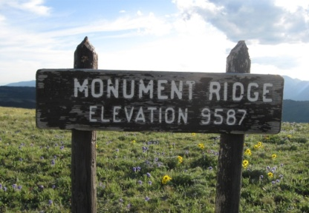

We encourage runners to carry their own timing devices, water bottles and food/gels as needed. **BE AWARE AND BE PREPARED:** **This is a high-altitude race**. All runners will start the race at over 9,200 feet and within a few miles peak at 9,600 feet before leveling off and finishing at 8,550 feet. The average elevation along the course is 9,000 feet above sea level. There are two- to three-mile up hills and down hills on the route.

Some information and tips on running at high altitudes can be found at the following links:

<http://www.mamashealth.com/run/high.asp>

<http://findarticles.com/p/articles/mi_m0NHF/is_9_20/ai_96254887>

<http://www.pponline.co.uk/encyc/0323.htm>

<http://answers.yahoo.com/question/index?qid=20070610181813AAr8KXa>

**Cautions:**

* IMPORTANT: All runners will be required to sign a waiver before running the race. If these waivers are not signed, the runner will not be allowed to run the race and will forfeit their entry fee.
* There will be medical help on the route, but he/she may be some distance from a runner in trouble. If a runner experiences any problems due to exhaustion, the altitude, dehydration, etc… it is their responsibility to inform race volunteers and other runners to ask for help.
* As part of our permit, the Forest Service requires us to distribute the following information on sheep and sheep dogs found on the Gravelly Range.
* The race director has seen these sheep dogs and they are extremely huge! The advice provided by the Forest Service is accurate, important, and should not be dismissed as being overzealous or overly dramatic. The race director will contact the shepherds in the area prior to race day to request them to move their sheep away from the road on race day.

**Sheep Guard Dogs**

[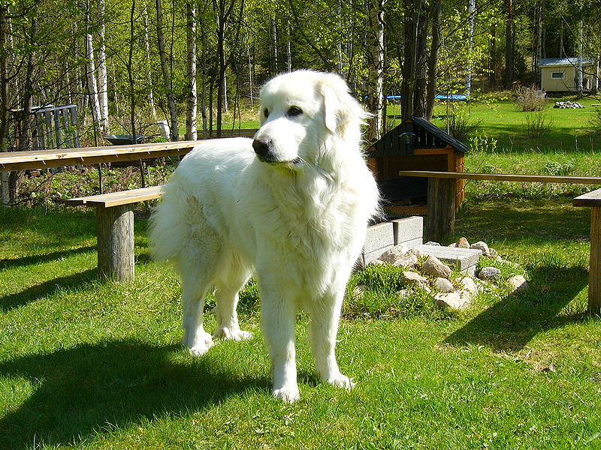](http://upload.wikimedia.org/wikipedia/commons/0/09/Pyreneittenkoira.jpg)

**From the US Forest Service**

This is a Great Pyrenees Guard Dog. These types of dogs are in use as Sheep Guard Dogs

on top of the Gravelly Mountains. They are trained to guard the sheep. **They will chase you**

**if you run.** If you have a dog with you, the guard dog may see it as a threat to the sheep. They

are not pets. The sheep herders have little control over them. They may be seen anywhere.

If you come upon one or it comes up to you. **STOP**, stand still, let the dog sniff you and check you out. Tell it to **“GO TO THE SHEEP.”** It will then most likely wander away. **WAIT** for the dog to move off and leave a far distance. Then resume your travel.  **DO NOT RUN** when the dog can see you. **DON’T FEED IT, DON’T TRY TO PET IT!**

This is kind of scary advice to “Don’t Run!!” when you are running a race. We will make all possible efforts to meet up with and talk to the shepherds on the range and inform them of the route so hopefully no one will come across one of these dogs. No one has in the past and the shepherds, who are usually from Peru, have moved the sheep and dogs far away from the road upon request. One year, a shepherd even helped out at the Mile 6.5 aid station after placing his sheep away from the runners. They know about the race and are very supportive.

In addition, though the dirt/gravel road is in good shape and this race is not a trail run, runners need to be aware of the road conditions and be careful not to twist an ankle, trip over a stone, or somehow fall off the road. Second, there is likely to be wildlife and other animals along the route. While we don’t expect a grizzly bear attack, there are grizzlies in the area. In 2009, a participant following his team saw a lone wolf watching the runners and pacing along the tree line just above the road. Eventually, the wolf came down onto the road, but no runners were nearby. Also in 2009, Eric Huff, the winner of the men’s marathon that year and in 2011, spent the night before the race on the Gravelly Range and saw within the view finder of his spotting scope a grizzly, coyote, mule deer buck, and an elk just below Black Butte peak. In 2010, a black bear ran across the road about 50 yards ahead of a runner. There will no doubt be a lot of wildlife along the route, but there should be little reason to worry about this, but caution is the best approach.

Most importantly, remember that this is a very high-altitude race which is likely to lead to exhaustion sooner than normal for even the more experienced runner. Please keep yourselves well hydrated and be aware of what your body is telling you. Finally, be aware of ATVs and other vehicles that may be on the road because this is a public road and also quite popular among the ATV and motorcycle crowd. We will erect signs warning drivers of a ‘Race In Progress’ at all the appropriate intersections. Hopefully, the drivers will drive slowly, but be aware that there might be dust from these vehicles.

**Camping Options**

For those of you who have not been on the Gravelly Range, it is incredibly beautiful. Aside from acclimatizing yourself to the elevation in order to get ready for the race, it is an enjoyable place to camp for a night or two. There are several camping options right along the course route as well as very near the route. You will have to haul your own water to the sites. You will also have to observe ‘leave no trace’ camping ethics such as building fires in existing fire rings only, burying all human waste, packing everything out, and storing all food and refuse properly.

Food and Refuse Storage Requirements

In the Daytime – All food and refuse must be acceptably stored or attended. Attended means that someone is within 100 feet and in sight of accessible food and refuse.

At Night – Unless being transported, eaten or prepared to be eaten, all food must be properly stored. Refuse and garbage must also be properly stored.

To be properly stored food, refuse and other attractants must be secured in an enclosed hard sided vehicle (including pick-up camper shell or horse trailer); a certified bear resistant container; or suspended at least ten feet clear of the ground at all points and four feet horizontally from any supporting tree or pole.

Items requiring proper storage – anything (excluding unflavored water and bailed hay) that can be eaten to provide nourishment, including soft drinks, canned food, alcoholic beverages, pet food, processed livestock feeds and grains, personal hygiene products, and refuse, including empty food and beverage containers.

There are some forest service cabins available for rent. The Forest Service rents these out through its website at [www.recreation.gov](http://www.recreation.gov). You will need to key in the state and the time frame and review the options. According to the Forest Service office in Ennis, there are cabins at Black Butte, West Fork, Wall Creek, and Vigilante which are relatively near the race route, in particular Black Butte and West Fork. You need to reserve these and pay for them with a credit card.

There are two campgrounds in the area. Clover Meadows is not just the staging area and finish line for the race, but it is also a campground. There is one outhouse toilet and a few fire rings for building fires. This is a free campground and no reservations are required. Cottonwood Campground is on the Ruby Road leading up to the Gravelly Range. It is also free with no reservations required.

Finally, dispersed camping is allowed in the Gravelly Range only at sites identified by a wooden or fiberglass post with a tent symbol as shown in the photo below. This means you can camp at the obvious site behind the sign. These signs are generally a few yards off the side of the road and easy to spot. You can only use an existing fire ring to build your fire and you must observe all leave no trace camping ethics. Be aware that fires may not be allowed if it is an unusually dry year. The US Forest Service will make this call and this information will be forwarded to all runners.

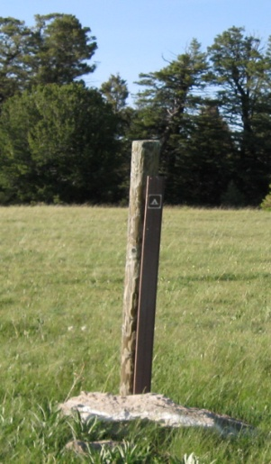

We have identified tent sites (there could be more that we did not find) at the following locations along or near the race route coming from the Call Road and heading towards Clover Meadows and the starting line of the race:

1. The first site is about one mile from the entrance to the Beaverhead Deerlodge National Forest as you climb up the Call Road from Ennis. It will be on your right. This site is about 12 miles from Clover Meadows
2. The next site is at the junction of Road 292 and Road 290. Road 292 is the Call Road that you will take up to the course from Ennis. Road 290 is the road that the race will be held on. From here, you are 10 miles from Clover Meadows.
3. The next two sites are just a few miles further along Road 290 heading towards Clover Meadows Campground. They will be on your right side as you drive towards Clover Meadows.
4. The next place to camp along this road will be Clover Meadows campground itself.
5. A few miles past Clover Meadows, heading south, there is another campsite on your left side.
6. The last site identified is at the starting line for The Madison Marathon. It is past Black Butte Mountain and will be on your left as you come down the hill. Since it is the starting line of the race, we will have set up porta-johns on this site the day before the race.

**The Races**

There are full and half marathon categories.

The full marathon route will be an out and back. The first ‘out’ is 19.65 miles and it will go past Clover Meadows (the staging area and finish line) to the turn-around point and then the ‘back’ is about 6.55 miles to Clover Meadows. There will be a turn-around volunteer to check off bib numbers. If your bib number has not been checked off, we can only assume that you cut the course and did not run the full 26.2 miles. You will receive a DNF. If the volunteer crew is limited, we will rely on the honor system that all runners have run to the turn-around point. The full marathon runners will have a 19.65 mile straight shot followed by a 6.55 mile return on the same route to the finish line. The half marathoners will have a straight shot of 13.1 miles from the starting line to Clover Meadows.

**Route Map**

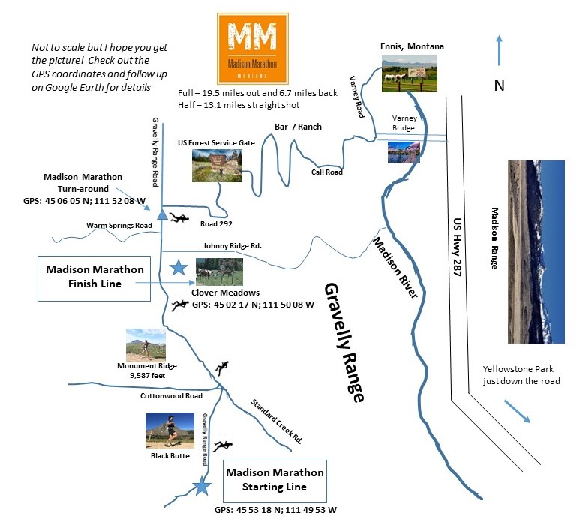

**Route Description**

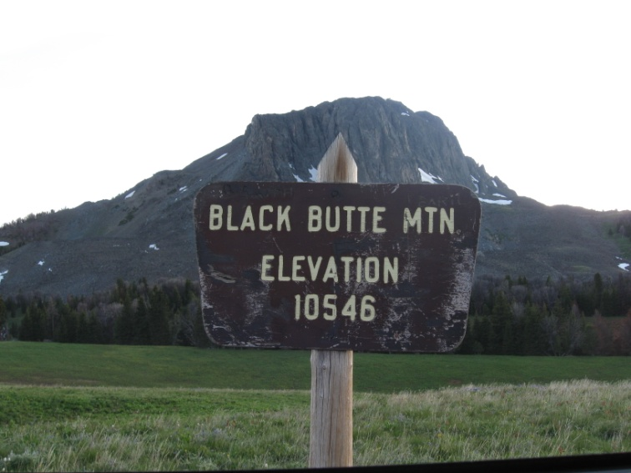

Ready to run one of the Highest Road Marathon on Planet Earth? For many years, it was THE Highest Road Marathon on planet earth until some people in Colorado and Pakistan got their poop in enough of a group to organize a higher elevation road marathon. We had a good eight or nine year run though as the biggest dog on the planet.

No matter. This race is going to change your life. It all starts right near the base of Black Butte Mountain at an elevation of about 9,250 feet. This is not a trail run. The entire race will be run on the Gravelly Range Road or Road 290 as it is listed on most maps. This road is gravel/dirt and in quite good condition. A normal car can easily drive on the road without any problems other than a few areas with potholes. There should not be any large concern about twisting an ankle because of the condition of the road. However, obvious caution should be the rule.

The Forest Service has maps of the Beaverhead Deerlodge National Forest. For this area, view or purchase Broom Trail Ridge and Big Horn Mountain Quadrangle in the Montana-Madison County map series. These maps are available at Shedhorn Sports in Ennis and most likely many other sporting goods stores in Montana. The route can also be easily viewed on Google Earth.

A brief mile by mile description is as follows.

**First Mile**

**Elevation: 9,250**

*Unfortunately or perhaps fortunately, the race starts with a short but steep uphill climb. The good part is you will be running straight towards Black Butte Mountain (elevation 10,546), a huge mountain that dominates the sky line. The road quickly tops out and is flat for about the next mile as you run past this incredible mountain.*

**Mile 2**

**Elevation: 9,370**

*This is a good long downhill. Within the first half mile or so, Black Butte will mostly be behind you. In front of you is a very long looking climb towards Monument Ridge, the highest point on the race course at around 9,600 feet. The prevailing winds tend to come from the South. So, if it is a windy day, you should have a nice tail wind. In 2008, the race director spooked a bear near the road on this section of the race. It was running pell mell (as if in training?) for the woods.*

**Mile 3**

**Elevation: 8,990**

*The downhill run continues to the road junction which then turns into a decent flat section before the start of a very long uphill to Monument Ridge. The country is quite open and has a vast ‘Big Sky Country’ look about it. Since it’s early in the race, you will probably not be too tired. Instead, you will be so thankful that you decided to put this marathon on your calendar. It’s fantastically beautiful.*

**Mile 4**

**Elevation: 9,120**

*The big uphill begins though there is a slightly flat area before the really steep climb. The country opens up and Monument Ridge is a clear goal that is very much in view. The 2008 female marathon winner, Kathy Wilkinson, saw some sheep grazing on the mountain sides at this juncture and it reminded her of scenes from This House of Sky, a novel by Ivan Doig, one of Montana’s most well-known writers. Be aware of sheep again this year and, of course, of the Pyrenees Sheepdogs.*

**Mile 5**

**Elevation: 9,350**

*This section is all uphill as runners do what they can to get to Monument Ridge (the highest point on the course at 9,600 feet). On top of the ridge, runners will get very long range views of the road once traveled and enormously long and steep valleys ahead just in case you needed reminding that you are running a marathon at over 9,000 feet in elevation. There will most likely be photographers near the Monument Ridge sign so you can get your picture taken if you wish.*

**Mile 6**

**Elevation: 9,480**

*This section is either flat or slightly downhill for about half a mile and then flat or slightly uphill for the rest of the mile. Runners will go through large open meadows with Black Butte behind you and very open country ahead. You are basically on top of a ridge with incredible views in all directions. Much of this section is at 9,600 feet in elevation which is the highest point on the route.*

**Mile 7**

**Elevation: 9,340**

*There is a steep climb of about a half mile followed by a long, flat area that skirts the top of the ridge. Runners will parallel the top part of the ridge and have excellent views of the Madison Range. Though the Madison Range is about 30 miles away on the other side of the Madison Valley, they are crystal clear on a sunny, haze-free day. Runners top out at over 9,300 feet and cross a large bowl.*

**Mile 8**

**Elevation: 9,340**

*On this stretch, enjoy the panoramic views that this portion of the run provides. The course still skirts along a large bowl and is mostly flat with a slight climb in the middle portion of the mile. The views to both the East and the West are fantastic.*

**Mile 9**

**Elevation: 9,300**

*This mile is entirely downhill. However, it provides an excellent view of a good uphill to come. The best views here are mostly to the West and the Snow Crest Mountains and Ruby Range.*

**Mile 10**

**Elevation: 8,990**

*The first part of this section is half uphill and half downhill. The course seems to put a long uphill climb further down the road right into your face. There are more great views to the West of ranges across the valleys. On a clear day, you can see for a hundred miles. This mile is a really an up/down, up/down section.*

**Mile 11**

**Elevation: 9,050**

*There is about a half mile uphill at the beginning of this mile. It then flattens out on top and is followed by a good stretch of downhill. This location offers a great view of Sphinx Mountain which is across the valley in the Madison Range. Its elevation is just under 11,000 feet and it has a ‘Matterhorn’ look about it with snow on top pretty much year round. There is also a good view of the final stretch of road to the finish line for the half marathon at Clover Meadows.*

**Mile 12**

**Elevation: 8,790**

*The start of this mile is somewhat flat and then goes down quite steeply over the second half of the mile. This is the final downhill towards Clover Meadows and the finish line for the half marathoners. Runners will descend into some tree stands which should offer some cool air assuming that it is a sunny on race day. The course will flatten out for the final push home for the half marathoners.*

**Mile 13**

**Elevation: 8,550**

*This mile has a slight uphill and then is all flat and goes mostly through the trees. In years past, the race director saw three moose, lots of antelope and a black bear near this section of the course. Congratulations! You have just completed one of the highest road half marathons on Planet Earth. You’re ready to take on the world. For full marathoners, congratulations to you as well – you’re halfway finished with one of the Highest Road Marathons on Planet Earth.*

**Mile 14**

**Elevation: 8,650**

*This part of the course is mostly flat with some slight uphill sections. The views change a bit as runners are moving further north and the land opens up a bit more. However, there are forested areas that you will run through.*

**Mile 15**

**Elevation: 8,700**

*This is quite open country that is mostly flat with some slight but quite long uphill sections. The view to the east and the Madison Range is good in certain sections. The open meadows offer the best perspective on the wild flowers of the area. Hopefully our early/mid July start of the race will mean the flowers will be in bloom big time.*

**Mile 16**

**Elevation: 8,680**

*Again, this is open country that is mostly flat with some long and gradual up and downhill sections. If there is wind, it should be at your backs since the prevailing winds are from the south (you will remember that when you reach the turn-around point). Eric Huff, the winner of the men’s full marathon in 2009 and 2011, felt this section of the course was the most difficult because of the long but gradual uphills.*

**Mile 17**

**Elevation: 8,640**

*Runners are moving due north with views of the Madison Range on the right side and the Ruby Mountains on the left side. The large meadows are often populated with antelope and elk. On one scouting trip for the race, the race director came across several large elk grazing in the meadows.*

**Mile 18**

**Elevation: 8,600**

*More open country here combined with running through thick stands of trees. There are some incredible views of the Madison Range to the east.*

**Mile 19**

**Elevation: 8,650**

*At the 19.55 mile mark, full marathon runners will pass through a small pass called Devil’s Lane and run downhill to a turn around point and then run back to Clover Meadows. The terrain is much like the previous couple of miles with open meadows interspersed with stands of trees. Keep an eye out for elk and antelope and, who knows, you may spook some other animal in the tree stands.*

**Mile 20**

**Elevation at start: 8,650**

*Same as Mile 19 above.*

**Mile 21**

**Elevation: 8,600**

*Same as mile 18 above. As mentioned before, if there is a wind it will most likely be in your face for your run back to Clover Meadows. Again, this is probably the most difficult part of the course for full marathoners as the long and gradual uphills begin to wear runners down.*

**Mile 22**

**Elevation: 8,640**

*Same as mile 17 above. Getting close to finishing one of the ‘Highest Road Marathons on Planet Earth.’ Unfortunately or fortunately, after a day of climbing and descending hills, the route is essentially flat. That’s what happens when you are running so high.*

**Mile 23**

**Elevation: 8,680**

*Same as mile 16 above. Is this where marathoners hit the wall? Many of the runners from the past two years said this was the toughest spot on the run. One experienced runner had cramping problems at this stage*

**Mile 24**

**Elevation: 8,700**

Same as mile 15 above.

**Mile 25**

**Elevation: 8,650**

Same as mile 14 above.

**Last Mile**

**Elevation: 8,600**

*Last Mile to the finish line at Clover Meadows. The Clover Meadows area is visible from quite some distance away, but you need to cross large meadows before you can actually see the finish line. Nevertheless, you have done it. Congratulations on completing one of the Highest Road Marathons on Planet Earth!! You’re truly in a league of distinguished athletes.*

**Madison County Hotels and Restaurants**

The home base for the Greater Yellowstone Adventure Series (GYAS) races is in Ennis, Montana. This is a small town on the Madison River. It is about 50 miles from Bozeman. The drive from Bozeman airport (BZN) to Ennis takes about an hour. Ennis is 70 miles from Yellowstone National Park (the west gate entrance).

**Some of the Madison County hotels that we recommend are:**

Red Bear Inn – [www.redbearinn.com](http://www.redbearinn.com)

El Western – [www.elwestern.com](http://www.elwestern.com)

Sportman’s Lodge – [www.sportsmanslodgemt.com](http://www.sportsmanslodgemt.com)

McAllister Inn – [www.mcallisterlodging.com](http://www.mcallisterlodging.com)

Lure Me Inn – [www.luremeinn.com](http://www.luremeinn.com)

Rainbow Valley Lodge – [www.rainbowvalleylodge.com](http://www.rainbowvalleylodge.com)

Riverside Motel – [www.riversidemotel-outfitters.com](http://www.riversidemotel-outfitters.com)

Moriah Motel – [www.moriahmotel.com](http://www.moriahmotel.com)

King’s Motel – [www.kingsmotelllc-mydirectorystay.com](http://www.kingsmotelllc-mydirectorystay.com)

**Some of the nicer places to eat and drink include:**

G Bar – 305 East Main Street, Ennis Tel: (406) 682-5553

Willies Distillery – 312 Main Street, Ennis Tel: (406) 682-4117

Alley Bistro – 59 MT Hwy 287, Ennis Tel: (406) 682-5695

Bynee’s – 214 Main Street, Ennis Tel: (406) 682-3156

The Continental Divide – 47 Geyser Street, Ennis Tel: (406) 682-7600

Tavern 287 – 129 East Main Street, Ennis Tel: (406) 682-7287

Longbranch Saloon – 125 Main Street, Ennis Tel: (406) 682-7020

Yesterday’s Soda Fountain – 124 Main Street, Ennis Tel: (406) 682-4246

The Pic A Nic Basket – 97 North 1st Street, Ennis Tel: (406) 682-7900

Ennis Sugar High – 170 North Main Street, Ennis Tel: (406) 682-7113

Nacho Mamma’s Burrito – 111West Main Street, Ennis Tel: (406) 682-4006

McAllister Inn Steakhouse – 5566 Highway 287, McAllister Tel: (406) 682-5000

Sportman’s Lodge – 310 North Main Street, Ennis Tel: (406) 682-4242

Wells Fargo Steak & Coffee House – 314 West Wallace Street, Virginia City Tel: (406) 843-5556

Mill Creek Inn – 102 Mill Street, Sheridan Tel: (406) 842-5565

The Shovel and Spoon – 108 North Main, Sheridan Tel: (406) 842-7999

The Old Hotel – 101 East 5th Avenue, Twin Bridges Tel: (406) 684-5959

The Shack – 301 North Main, Twin Bridges Tel: (406) 684-5050