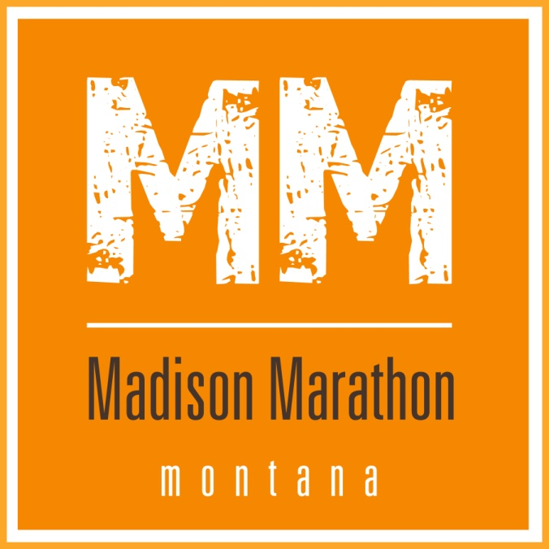

**Parking Permit**

**Print out (black and white is okay) and place this permit on the front dash of your vehicle. Please park in the designated parking area that is just south of the Clover Meadows campground area and next to a large gravel mound. Just follow the signs and park in an orderly fashion next to the other cars just as in a parking lot.**

**Do not leave any food containers or garbage outside of your vehicle. Also, do not leave food containers or garbage in your car and then leave a window, door, or hatch open. This is all about prevention of bears in Clover Meadows. Bears will be and are attracted to food and will enter a camp site if it’s available and easy to get to. If the US Forest Service finds a car with food, garbage, or flavored fluids outside of the car and unattended, you will get ticketed. This is entirely your responsibility.**

**When you leave the race, there are two ways to return to Ennis that will help your fellow runners. First, you can go due south and leave the range via Standard Creek Road through the West Fork. Basically, you’ll re-trace the route to about Mile 3 and then turn left off the route near Black Butte Cabin. You will eventually run into Highway 287 at the West Fork rest area about 40 miles south of Ennis. Second, you can drive north about one mile and then turn right on Johnny Ridge Road. This is a rough road, but passable in standard cars. From the turnoff, it is about 15 miles to Highway 287 and then you’ll be about 15 miles south of Ennis. The former totally avoids runners and the latter should avoid most runners. Thank you!**