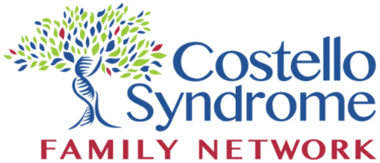


.

Please visit www.costellosyndromeusa.org to learn more.
COSTELLO SYNDROME
AWARENESS DAY
JANUARY 27, 2019
- 15% increased risk of childhood cancer
- Neurological abnormalities including hydrocephalus, chiari malformation, tethered spinal cord
- Feeding difficulties
- Failure to thrive
- Greater than 75% have
orthopedic manifestations
- 85% have cardiac issues
- Endocrine abnormalities
including growth hormone deficiencies and blood
glucose problems

Many more!

Did you know that Costello Syndrome is one of the rarest of rare syndromes and is estimated to occur in 1 out of every 382,000 births?

