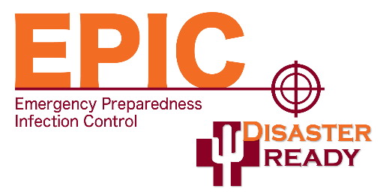
DR EPIC Infection Control Training (FREE)
The Disaster Ready Emergency Preparedness Infection Control (EPIC) program is offering two FREE infection control training courses. These two courses can either be taken by one person or you can separate them out and allow two people from one facility to take each of the trainings. If you are interested in receiving one of these trainings, click on the links below to complete the interest forms. Once we have your contact information from the forms, you will receive an email from us (AHCA) with further instructions on registration. There will be no fees associated with these two trainings because it is a grant funded program. For more information contact Kay Huff at Khuff@azhca.org.
Interest Form Links
AHCA/NCAL Infection Preventionist Specialized Training
AHCA/NCAL Infection Prevention and Control in the Post Covid-19 World
Course Titles and Descriptions
Infection Preventionist Specialized Training Through AHCA/NCAL
About the Training: This training is an online certification program with 22-hours of continuing education. It must be completed in a 12-month period. Through this program, individuals will be specially trained to effectively implement and manage an Infection Prevention and Control Program in a nursing center. The 2021 updated version incorporates information from the COVID-19 pandemic, the most recent regulatory requirements as well as sections on Candida auris, Multi-Drug Resistant Organisms (MDROs), and Enhanced Barrier Precautions (EBP). Additionally, there is an entire section on how to get an effective water management program running in your center. Target
Target Audience: Infection Preventionist
Infection Prevention and Control in the Post-Covid-19 World Provided by AHCA/NCAL
About the Training: This online course is approved for 3.0 continuing education hours and will review how COVID-19 spreads, how to track and report the illness including the regulatory requirements for infection prevention and control. It will review the basics of infection prevention and control practices and will look at the future of infection prevention and control. The course will describe the process for cohorting and utilizing testing to inform cohorting practices. It will look at how to conduct self-assessment processes to continually evaluate and improve the infection prevention and control program in long term care centers. Lastly, the course will review the process and necessity of screening practices and notifications to residents, families, and their representatives including the importance of communication.



Target Audience: Administrators, Infection Preventionists, Directors of Nursing (Clinical & Non-Clinical Leaders)

