________________________________________________ | Account # _(TO BE COMPLETED BY DSO FINANCE DEPT)
Applicant Name, e-mail and phone number
_______________________________________________ | Amount requested: ______________________________
Department/Ministry:
(If you oversee several ministry areas, you may group them together in this application, just explain what expenses are needed for what areas.)

_____TO BE COMPLETED BY DSO FINANCE DEPT)_____ | Amount approved: _______________________________
Assigned budget committee liaison, e-mail and phone number
IMPORTANT: Return deadline is May 1st, 2020

- Provide update on your 2019 and 2020 budgets, did you meet your budget goals and mission goals?
ANSWER HERE

- Explain any variances between your approved budget and actual spending for 2019 and 2020 years:
ANSWER HERE

- Tell us about your ministry?
ANSWER HERE

- Explain how such expense relates to the Diocesan Strategy (refer to Addendum A)
ANSWER HERE

Itemized Expenses | Proposed Budget Funding ($) | Other funding? ($) | Budget Narrative
List the items from your program/committee/other that will incur expenses. This may include:  - Salary support  - Travel and other expenses  - Program funds to support seminars, small group forums, commissions  - Program funds  - Any other expenses | List the amounts proposed for your program | List all other funding for this project, including anticipated income from other sources (i.e. grants) | - Provide a brief written summary of how the funds will be used?  - Provide specific information about your budget expenses. Please include what expenses are needed for various aspects of your ministry  - Explain how such expense relates to the Diocesan Strategy (refer to Addendum A)
PLEASE COMPLETE YOUR INFORMATION HERE

ADDENDUM A
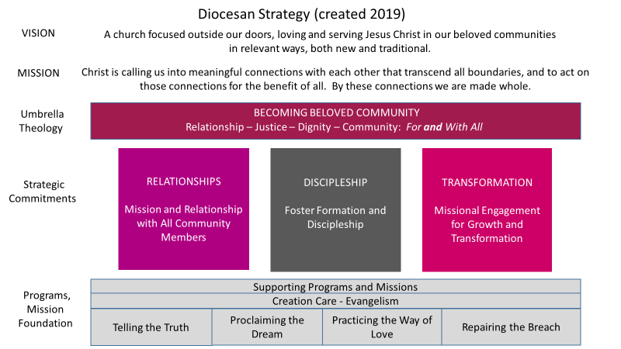

Strategic Choices:
Becoming Beloved Community – Umbrella Theology
- RELATIONSHIPS: Good communication and collaboration
  - Interfaith and ecumenical partnerships
  - Task force for collaborative communication
  - Get the mission of the Procter Center out to diocese and communication
  - Financial Transparency
- DISCIPLESHIP: Formation and Discipleship for all ages
  - Youth programs
  - Develop organic formational programming (Procter)
  - Programs such as Safe Church, Kaleidoscope, Anti Racism, etc.
  - Church Next
  - The Learning Journey
- TRANSFORMATION: Missional engagement for growth (is growth correct? impact? vitality?) and transformation
  - New starts – task force to identify those opportunities
  - Map Dash – understanding our communities and resources in the Diocese
  - Rebuild youth ministries
  - COCL, Church Foundation, ECM

Diocesan Budget Sample
This is just an example to show you how to fill out the budget request. Numbers may not reflect real programming!
Itemized Expenses  Youth Ministry Budget | Proposed Budget Funding ($) | Other funding? ($) | Budget Narrative
- Youth Ministry Salary and Benefits | $50,000 | $0 | A diocesan youth minister will coordinate youth programming with parishes and in various regions of the diocese. This person’s work directly relates to discipleship and formation in the mission strategy. It also supports the relationships strategic area in connecting and communicating with individuals, parishes, and communities.
- Travel  - Diocesan churches and events  - Travel to youth ministry conferences | $3000  $1500 | $0  $0 | - Mileage and professional expenses for travel around the diocese and to various activities.  - Expenses for participation in provincial and regional youth ministry training and collaboration.
- Program Funds  - Regional Youth Gatherings | $4500 | $0 | Costs for regional youth ministry events. Anticipate at least two in each major area of the diocese. Food, supplies, and stipends for leaders.
- Youth Mission Trip/Pilgrimage | $10,000 | $500/person  or $10,000 for 20 people | Assume pilgrimage costs $500-$1500/person. Diocese pays for leaders travel and expenses and scholarships or help underwrite the cost of the pilgrimage for those who need assistance.
- Diocesan Wide Youth Retreats | $10,000 | $50/person for events. | Cost is around $150/person for Procter meals and cabin rental, supplies, and other expenses. Participants are asked to pay $50/person for retreats, so $100/person budgeted with some expectation of limited scholarships available. If 3 retreats a year happen with 30 or more participants = $3000 - $3500 if not everyone can pay the full amount. Budgeting $10,000 for retreats.
- TEC Episcopal Youth Event | $10,000 | $250/per person contribution to event | EYE invites youth from across the Episcopal Church to gather together and raise up and foster young leaders in our churches. Cost to send 12 participants including chaperones to the Episcopal Youth Event. $200/registration fee, $200/housing fee, $400 travel to the event each. $800/per individual. Plus $400 for other expenses/meals incurred during travel.
Total Youth Ministry Budget | $89,000

