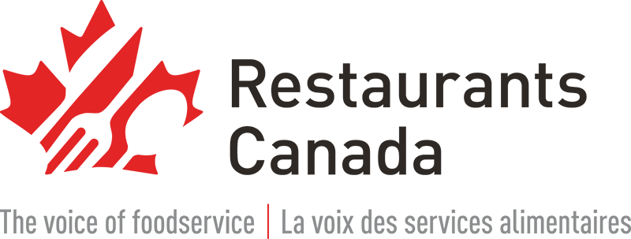
Half of restaurants might not survive the summer without current levels of support

If the rent and wage subsidies are scaled back starting July 4, most restaurants will struggle to pay staff and suppliers. At least half will have to consider closing down for good unless the plan changes.

FOR IMMEDIATE RELEASE

TORONTO, June 17, 2021 — Restaurant customers, industry professionals and suppliers are calling on the federal government to keep current levels of support in place for foodservice businesses still operating under ongoing COVID-19 restrictions.

Working together as part of a Restaurant Survival Coalition, they are demanding an exemption from the scheduled phase-out of the rent and wage subsidies for the highly affected foodservice sector. This continues to be the top measure that Restaurants Canada is advocating for as part of a critically needed Restaurant Survival Support Package.

“Even with most provinces moving forward with reopening plans, restaurants across the country will still be operating at reduced capacity for the next few months,” said Restaurants Canada President and CEO Todd Barclay. “This is not the time to start reeling in the lifeline. Most restaurants have been losing money or barely scraping by nearly every day of the pandemic and will need at least a year to return to some semblance of normal. Half our industry will face risk of closure if government support is scaled back too soon.”

Canadians are calling on elected officials to save their local restaurants

Restaurant operators are innovative and resourceful, but the COVID-19 crisis has stretched their resiliency to the limits. According to survey data from Restaurants Canada:

- Eight out of 10 restaurants have been operating at a loss or barely scraping by throughout the entire pandemic.

- Nearly half (45%) of all foodservice businesses have been consistently losing money for more than a year.

If the rent and wage subsidies are scaled back starting July 4, most restaurants will struggle to keep paying staff and suppliers and might have to consider closing down for good.

Fighting back against this unwanted reality, Canadians are calling on their elected officials to help keep their local restaurants in the picture: Hundreds of postcards are currently on their way to members of Parliament across the country, and Finance Minister Chrystia Freeland in Ottawa, demanding an immediate change of plans.

Anyone who wants to join the Restaurant Survival Coalition and help save local foodservice businesses can visit SupportRestaurants.ca to get started by sending a postcard of their own.

Here are a few excerpts from the many postcard messages sent so far:

We have managed to survive so far, but with the latest setback and still at half capacity with social distancing… we need the wage subsidy and rent subsidy through the summer to help us through. Instead of paying down debt, I’ve added on debt. A big burden for the future to come.
- Saskia Geerts, Owner, Sydney Street Pub, Digby, Nova Scotia

The Lower Deck is a family owned business since 1974. The pandemic has impacted our business dramatically. The decline in the tourism sector combined with the cancellation of cruise ship visitors for two consecutive summer seasons is devastating to our business.
- Mike Condy, Owner/Operator, The Lower Deck, Halifax, Nova Scotia

This restaurant has been around for 11 years. We are a neighbourhood pub with lots of regulars who have helped us survive during this difficult time. But it is not enough. If we close, these customers lose their second home staff lose their jobs and I lose my business that I put so much into.
- Zoey Dassios, Owner, Chicago Pub & Billiards, Kitchener, Ontario

We've been part of the Yonge & Dundas community for 30 years, with generations of staff and customers that have come and gone. The subsidies have allowed us to keep going during COVID, but we need dine-in at 70% to be able to stay afloat. Subsidies need to keep going until then.
- Alan Liu, Managing Director, Salad King, Toronto, Ontario

We employ 1000 people, we purchase 20,000,000 in food supplies many from local farmers in Ontario. We are a pillar in the community supporting charities throughout the province. We have been in business for 50 years. We need help to continue for another 50.
- Peter Higley, President, Pickle Barrel, Toronto, Ontario

About Restaurants Canada

Restaurants Canada is a national, not-for-profit association advancing the potential of Canada’s diverse and dynamic foodservice industry through member programs, research, advocacy, resources and events. Before the start of the COVID-19 pandemic, Canada’s foodservice sector was a $95 billion industry, directly employing 1.2 million people, providing Canada’s number one source of first jobs and serving 22 million customers across the country every day. The industry has since lost hundreds of thousands of jobs and billions in sales due to the impacts of COVID-19.

###

For more information, contact:
Roberto Sarjoo
Director, Marketing and Communications
Restaurants Canada
C: 416-389-7941
RSarjoo@restaurantscanada.org

Marlee Wasser
Manager, Communications and Stakeholder Relations
Restaurants Canada
T: 416-649-4254
Toll-free: 1-800-387-5649 ext. 4254
media@restaurantscanada.org

