How To Redeem The WOCNext 2019 Library Pass

Step 1. Visit wocncec.org/redeem.
Step 2. Log in with your WOCN Society membership infomation or Create a free account.
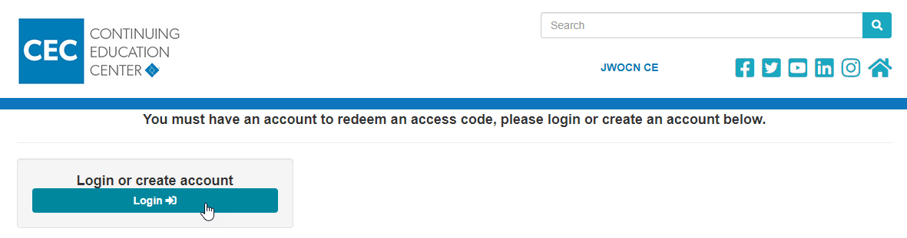
Step 4. Enter the code “WOCNext2019”, then click “Redeem Code”.
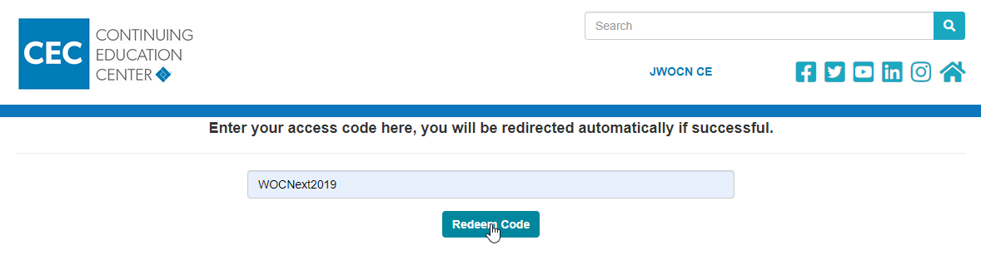Step 5. Enter your information, then press “Submit”.
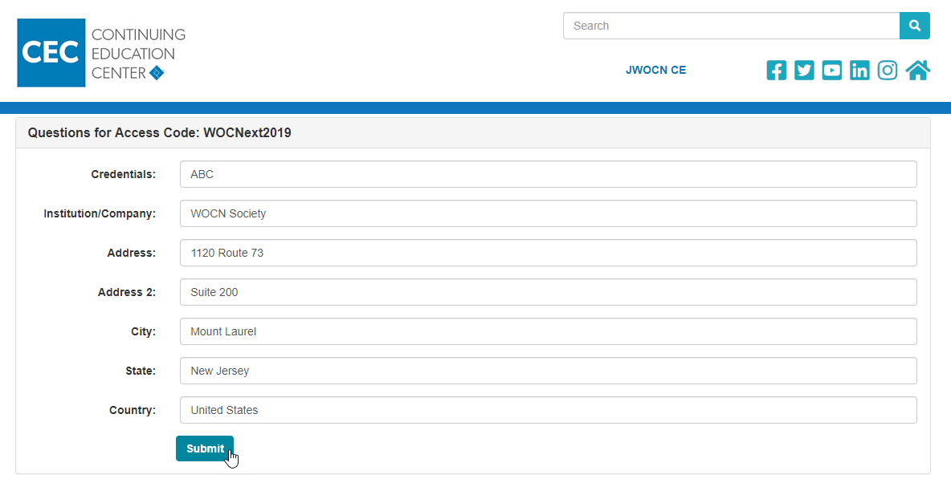

Step 6. You Will Receive An Email Confirmation.
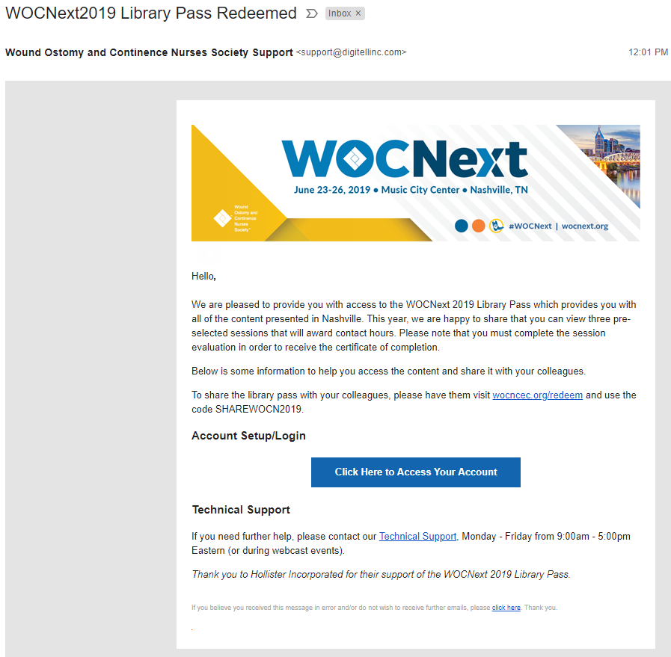

How To Access Sessions From The WOCNext 2019 Library Pass
There are 2 ways that you can assess the sessions from WOCNext 2020 after you have redeemed the Library Pass.

The First Way – Your Confirmation Email:
Step 1: From your confirmation email, click on the button that says, “Click Here to Access Your Account”.
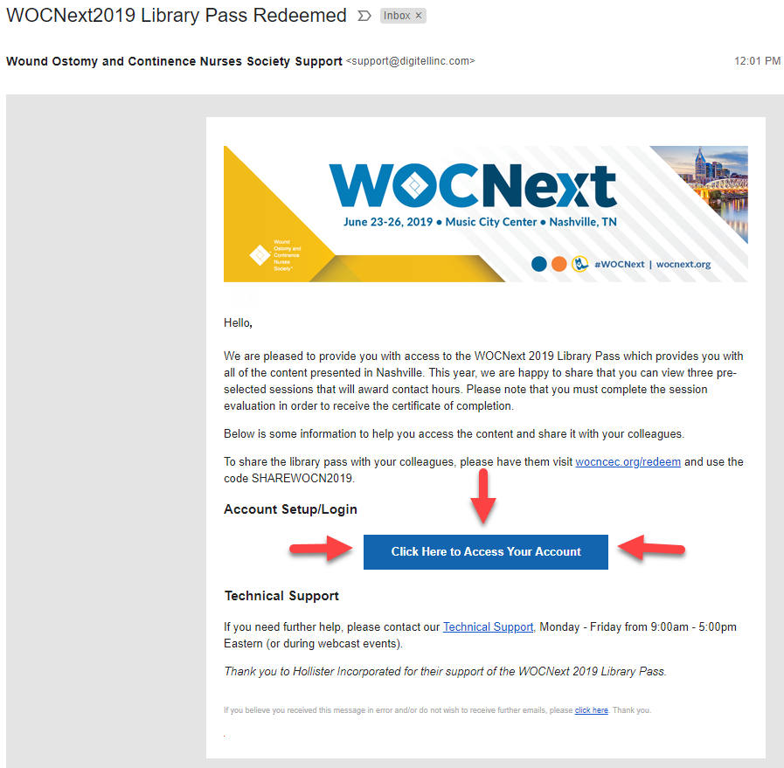

Step 2: Click on “Archives”.
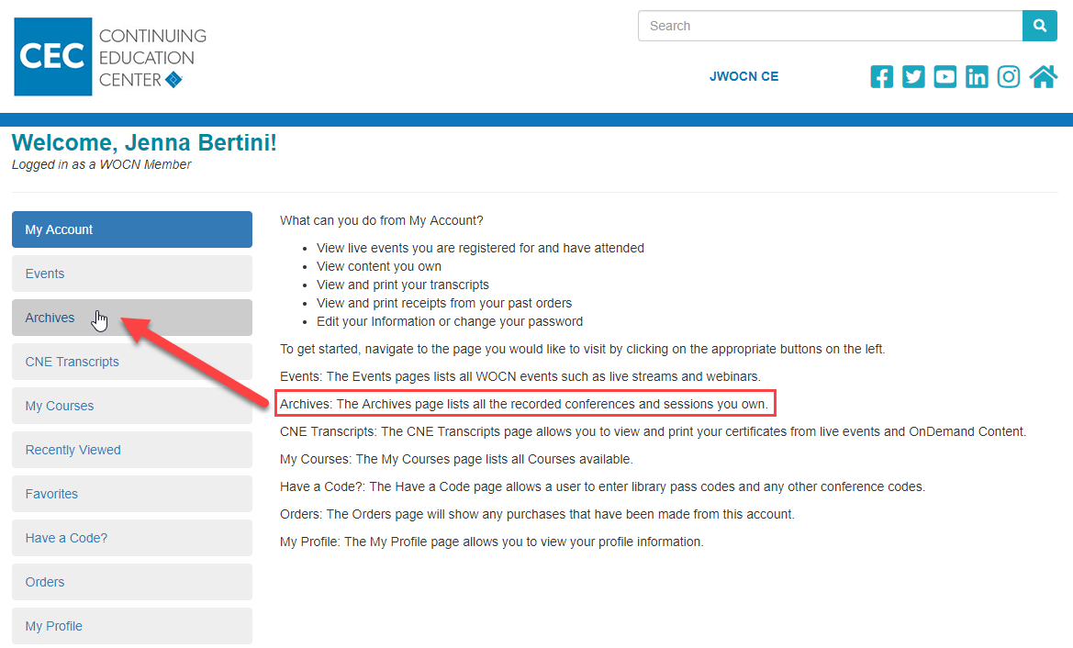
Step 3: Click on “View Product” under WOCNext 2019.
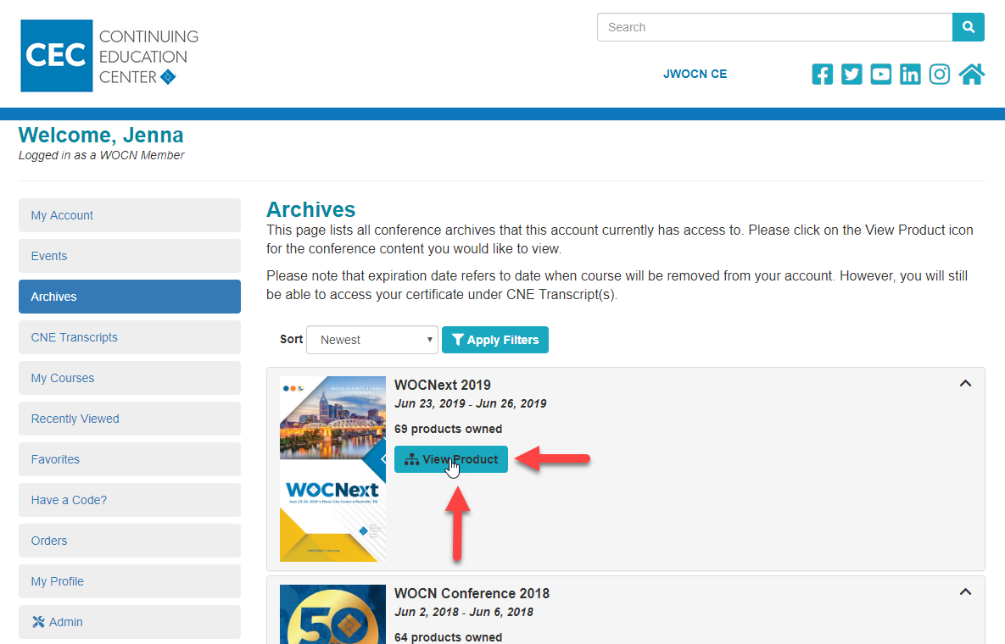
Step 4: From there, you will be able to choose from any session that you would like to view.
The Second Way – Directly Visiting The Continuing Education Center (CEC):
Step 1: Go to wocncec.org.
Step 2: Click on “My Account” on the top right-hand corner. You may need to login first.
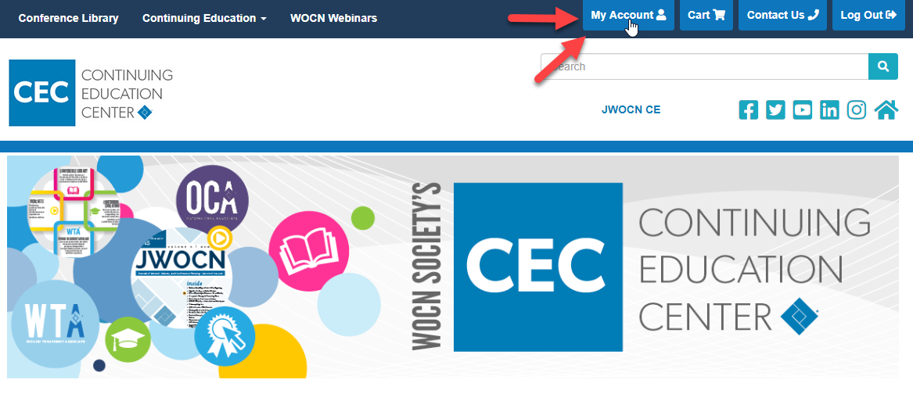
Step 3: Click on “Archives”.

Step 4: Click on “View Product” under WOCNext 2019.
Step 5: From there, you will be able to choose from any session that you would like to view.

New This Year! Sessions That Will Award Contact Hours
This year you can view 3 pre-selected sessions from the Library Pass to earn Contact Hours. To receive the certification of complete, you must view the session and complete the session evaluation. Scroll through the list of sessions to find the sessions that will award Contact Hours.
