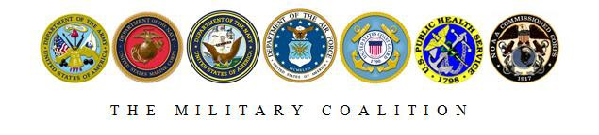

The Honorable Paul Cook
1222 Longworth House Office Building United States House of Representatives Washington, DC 20515

Dear Representative Cook,

The Military Coalition, a consortium of uniformed services and veterans associations representing more than 5.5 million current and former service members and their families and survivors, writes to express our support for H.R. 544, the Private Corrado Piccoli Purple Heart Preservation Act. If enacted, this legislation would make it illegal to buy and sell military-issued Purple Hearts.

The Purple Heart is our nation’s oldest medal, awarded exclusively to members of the armed forces who are wounded by an enemy instrument of war. When servicemembers are killed in action or die of wounds, the Purple Heart is presented posthumously to their next of kin. For those families, the Purple Heart is often the last tangible item they receive in memory of their loved one. In cases where Purple Hearts are subsequently lost or stolen, we believe every effort should be made to return them to their rightful owners.

Unfortunately, the military memorabilia collectors’ market places a high value on military-issued Purple Hearts, with medals engraved with the names of those killed in action commanding the highest prices. The value to collectors is driven up even further if the medal is accompanied by documentation graphically detailing the exact circumstances of the servicemember’s death. We believe that buying and selling the Purple Heart like a common collectible not only cheapens the incredible sacrifice that it represents, but also makes it harder to reunite veterans and families with lost or stolen medals.

The Purple Heart Preservation Act would put an end to this practice by making it illegal to buy and sell military-issued Purple Hearts, eliminating an offensive collector’s market, and making it easier to return them to their rightful owners. We thank you for introducing this important legislation and look forward to working with you to ensure its passage.

Sincerely,

The Military Coalition (Signatures enclosed)

