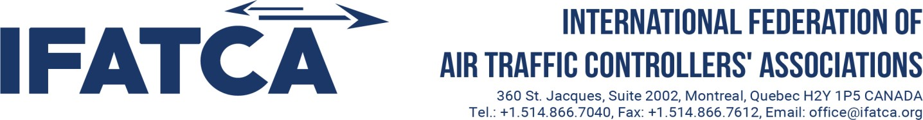

IFATCA Speak English Program - Participant Booking Form

Instructions: (Form to be typed and sent as PDF/DOC. Any other format will be REJECTED)

- You can book one slot per period, a total of 3 slots in the month. Please provide your chosen slots from the available options on the shared calendar in Slot 1 below.
- To assist the Secretariat, please provide an alternate time and date (also from the shared calendar) for each period in Slot 2.
- If the matching is successful, you will receive a confirmation email from the SEP secretariat by the 8th of the month. If the matching is unsuccessful, you will NOT receive an email from the Secretariat.
- If for any reason you need to cancel the confirmed session, please inform sep@ifatca.org no later than 24 hours before the session. In the event of a last minute cancellation, please also inform the session facilitator directly.

Your Name:
Your Email: The one you will be joining the Google Meet session with
Association: You must be a member of an IFATCA or IFALPA Member Association
Period 1  10th - 16th of the month | Slot 1 | Slot 2
Period 2  17th - 23rd of the month | Slot 1 | Slot 2
Period 3  24th - end of the month | Slot 1 | Slot 2

After filling this booking form:
- Save and rename this file with the following format: (IFATCA SEP –” Your Name”).
- Send it back to your MA director or the Point of Contact in your association.
- DO NOT SEND THIS FORM DIRECTLY TO THE SEP SECRETARIAT

IFATCA - Speak English Program - Participant Booking Form – version: 2

