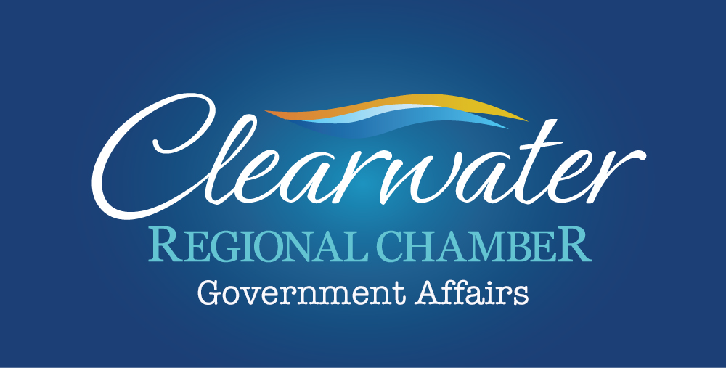

Tourism Partners Meeting, March 26, 2019

Legislative Watch-Points

State Funds (SB 70, Mayfield) - Exempting the State Housing Trust Fund and the Local Government Housing Trust Fund from a provision authorizing the Legislature, in the General Appropriations Act, to transfer unappropriated cash balances from specified trust funds to the Budget Stabilization Fund and the General Revenue Fund, etc.
Florida Tourism Marketing (SB 178, Gruters) - Amending provisions relating to the Florida Tourism Industry Marketing Corporation direct-support organization and the Division of Tourism Marketing of Enterprise Florida, Inc., respectively; abrogating the scheduled repeal of provisions related to the corporation and the division, respectively, etc. (Companion House Bill 6031, Ponder)
Smoking (SB 2018, Gruters) - Smoking; Prohibiting the smoking of tobacco on public beaches; providing civil penalties; authorizing a law enforcement officer to issue a citation as prescribed by a county or municipality to any person who smokes tobacco on a public beach, etc. (Companion House Bill 237, Altman)
Tourism Development Tax (SB 726, Stewart) - Tourist Development Tax; Authorizing counties imposing the tax to use the tax revenues to promote or incentivize film or television productions in this state; requiring such counties to require certain productions to include a specified statement in the production’s credits, etc.
Vacation Rentals (SB 812, Simmons) - Vacation Rentals; Requiring persons engaged in certain public lodging-related transactions to display a valid certificate of registration number in rental listings or advertisements; revising the inspection responsibilities of the Division of Hotels and Restaurants regarding vacation rentals; specifying the conditions under which a notice to depart a premises is effective; revising the classification of “vacation rental”, etc.
Vacation Rentals (SB 1196, Mayfield) - Vacation Rentals; Requiring licenses issued by the Division of Hotels and Restaurants of the Department of Business and Professional Regulation to be displayed conspicuously to the public; requiring the operator of a vacation rental or specified public lodging establishment to display its license number in advertisements; revising the criteria for a public lodging establishment to be classified as a vacation rental, etc.

Governor Ron DeSantis Announces Major Water Policy Reforms
On January 10, 2019, in News Releases, by Staff
Tallahassee, Fla. – Today, Governor Ron DeSantis signed Executive Order 19-12 (Achieving More Now For Florida’s Environment), implementing major reforms to ensure the protection of Florida’s environment and water quality.
“Our water and natural resources are the foundation of our economy and our way of life in Florida,” said Governor Ron DeSantis. “The protection of water resources is one of the most pressing issues facing our state. That’s why today I’m taking immediate action to combat the threats which have devastated our local economies and threatened the health of our communities.”
The order calls for:
– $2.5 Billion over the next four years for Everglades restoration and protection of water resources (a $1 Billion increase in spending over the previous four years and the highest level of funding for restoration in Florida’s history).
– The Establishment of a Blue-Green Algae Task Force, charged with focusing on expediting progress toward reducing the adverse impacts of blue-green algae blooms now and over the next five years.
– Instruction to the South Florida Water Management District to immediately start the next phase of the Everglades Agricultural Area Storage Reservoir Project design and ensure the U.S. Army Corps of Engineers approves the project according to schedule.
– The Creation of the Office of Environmental Accountability and Transparency charged with organizing and directing integrated scientific research and analysis to ensure that all agency actions are aligned with key environmental priorities.
– The Appointment of a Chief Science Officer to coordinate and prioritize scientific data, research, monitoring and analysis needs to ensure alignment with current and emerging environmental concerns most pressing to Floridians.

2019 FLORIDA LEGISLATIVE SESSION DATES

August 1, 2018 Deadline for filing claim bills (Rule 4.81(2))

January 25, 2019 Friday, 5:00 p.m., deadline for submitting requests for drafts of general
bills and joint resolutions, including requests for companion bills

March 1, 2019 Friday, 5:00 p.m., deadline for approving final drafts of general bills and joint
resolutions, including companion bills

March 5, 2019 Regular Session convenes (Article III, section 3(b), Constitution)
12:00 noon, deadline for filing bills for introduction (Rule 3.7(1))

April 20, 2019 All bills are immediately certified (Rule 6.8)
Motion to reconsider made and considered the same day (Rule 6.4(4))

April 23, 2019 50th day—last day for regularly scheduled committee meetings (Rule
2.9(2))

May 3, 2019 60th day—last day of Regular Session (Article III, section 3(d), Constitution)

