2025 CO ACC Heart Failure Summit
December 4-6, 2025 | Colorado Springs, CO

Activity Overview
The Colorado Heart Failure summit uses an innovative format of short lectures, question and answer sessions with experts, and case study presentations highlighting complex and innovative care.

Target Audience
This activity is designed for an audience of physicians, physician associates, nurse practitioners, and nurses.

Learning Objectives
Upon completion of the educational activity, participants should be able to:

CVT SYMPOSIUM
- Evaluate emerging evidence from late-breaking cardiovascular trials to determine their potential impact on clinical decision-making and patient outcomes.
- Integrate updated insights on perioperative cardiac risk assessment, the physiological impact of altitude on heart failure, optimal antiplatelet monotherapy selection, and practical ECG interpretation strategies to improve cardiovascular care and clinical decision-making.

SESSION 1: LATE BREAKING CLINICAL TRIALS: HOW DO NEW THERAPIES MAKE IT FROM THE BENCH TO THE GUIDELINES
- Describe the full pathway by which novel cardiovascular therapies progress from early discovery to clinical guidelines to better understand and engage in the clinical research ecosystem.

SESSION 2: HFPEF: TRIALS, TRIBULATIONS, AND TRIUMPH
- Recognize key mimickers, explore underlying metabolic and inflammatory mechanisms, evaluate its interaction with atrial fibrillation, and integrate guideline-directed medical therapy and exercise-based interventions in HFpEF to optimize patient management.

SESSION 3: HAIL MARY PROCEDURES IN ADVANCED HEART FAILURE? POINT-COUNTERPOINT UPDATES
- Describe advanced interventional strategies for patients with advanced heart failure to inform balanced, evidence-based decision-making in high-risk clinical scenarios.

SESSION 4A: GREAT DEBATES IN CARDIOLOGY
- Compare differing approaches to cardiogenic shock management, initial treatment strategies for newly diagnosed HFrEF, stroke-risk–driven decision-making in atrial fibrillation, and considerations for advanced therapies in young adults to improve evidence-based cardiovascular care.

SESSION 4B: CARDIOVASCULAR TEAM WORKSHOP
- Examine recent clinical insights into HFpEF, the use of remote monitoring, indications for device therapy, and strategies for delivering multidisciplinary heart failure care to enhance informed, patient-centered decision-making in advanced heart failure management.

SESSION 5: MANAGEMENT OF TRICUSPID VALVE DISEASE
- Evaluate tricuspid valve disease by integrating best practices in clinical management, optimal imaging strategies, decision-making for surgical intervention, and patient selection for TEER/TTVR to support evidence-based, multidisciplinary care.

SESSION 6: HOT TOPICS IN CARDIOLOGY
- Integrate emerging insights on genetic screening in cardiology, initiation of GLP-1 therapies, evolving drug-approval and coverage pathways, and updates in immune checkpoint inhibitor myocarditis to inform proactive, personalized strategies for preventing atherosclerotic and cardiometabolic disease.

Criteria for Success
A certificate of completion will be awarded based on the participant's attendance and completion of an online evaluation/claim credit form available at:

https://akhcme.com/2025COACC

Please claim your credit by December 31, 2025.

If you have questions about this CE activity, please contact AKH Inc at JGoldman@akhcme.com.

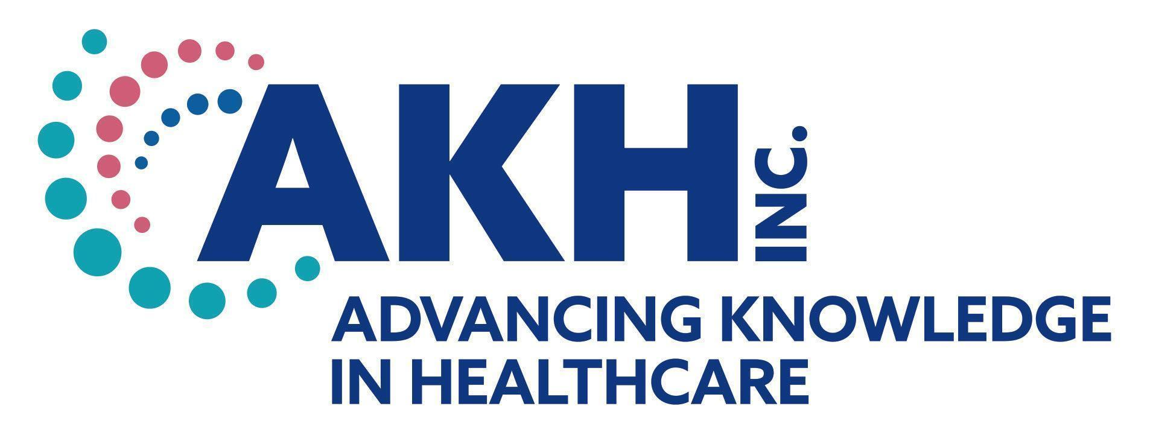
CE credit provided by AKH Inc., Advancing Knowledge in Healthcare.


In support of improving patient care, this activity has been planned and implemented by AKH Inc., Advancing Knowledge in Healthcare and Colorado Chapter, American College of Cardiology. AKH Inc., Advancing Knowledge in Healthcare is jointly accredited by the Accreditation Council for Continuing Medical Education (ACCME), the Accreditation Council for Pharmacy Education (ACPE), and the American Nurses Credentialing Center (ANCC), to provide continuing education for the healthcare team.

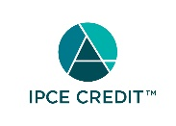
This activity was planned by and for the healthcare team, and learners will receive 13.5 Interprofessional Continuing Education (IPCE) credit for learning and change.

Physicians
AKH Inc., Advancing Knowledge in Healthcare designates this live activity for a maximum of 13.5 AMA PRA Category 1 Credit(s)™. Physicians should claim only the credit commensurate with the extent of their participation in the activity.

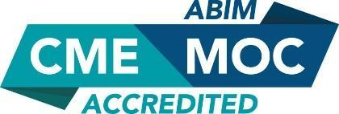
Successful completion of this CME activity, which includes participation in the evaluation component, enables the participant to earn up to 13.5 MOC points in the American Board of Internal Medicine’s (ABIM) Maintenance of Certification (MOC) program. Participants will earn MOC points equivalent to the amount of CME credits claimed for the activity. It is the CME activity provider’s responsibility to submit participant completion information to ACCME for the purpose of granting ABIM MOC credit.

Nurses
Credit being awarded: 13.5 ANCC contact hours

Physician Associates
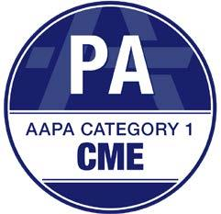
AKH Inc., Advancing Knowledge in Healthcare has been authorized by the American Academy of Physician Associates (AAPA) to award AAPA Category 1 CME credit for activities planned in accordance with AAPA CME Criteria. This activity is designated for 13.5 AAPA Category 1 CME credits. PAs should only claim credit commensurate with the extent of their participation.

Nurse Practitioners

This activity has been planned and implemented in accordance with the Accreditation Standards of the American Association of Nurse Practitioners (AANP) through the joint providership of AKH Inc., Advancing Knowledge in Healthcare and Colorado Chapter, American College of Cardiology. AKH Inc., Advancing Knowledge in Healthcare is accredited by the American Association of Nurse Practitioners as an approved provider of nurse practitioner continuing education. Provider number: 030803. This activity is approved for 13.5 contact hour(s) (which includes 4.25 hour(s) of pharmacology).

Commercial Support
There is no commercial support for this activity.

Disclosures
It is the policy of AKH Inc. to ensure independence, balance, objectivity, scientific rigor, and integrity in all of its continuing education activities. The author must disclose to the participants any significant relationships with ineligible companies whose products or devices may be mentioned in the activity or with the commercial supporter of this continuing education activity. Identified conflicts of interest are mitigated by AKH prior to accreditation of the activity. AKH planners and reviewers have no relevant financial relationships to disclose.

DISCLOSURES
Name | Relationship | Commercial Interest
Ibrahim Ainab (faculty) | N/A | Nothing to disclose
Ammer Al-Dairi (faculty) | N/A | Nothing to disclose
Larry Allen, MD, MHS (faculty) | N/A | Nothing to disclose
Amrut Ambardekar, MD (faculty) | N/A | Nothing to disclose
Ankie Amos, MD (moderator) | N/A | Nothing to disclose
McHale Anderson (faculty) | N/A | Nothing to disclose
Nina Appareddy, MD (faculty) | N/A | Nothing to disclose
Mallette Asmuth, MD (faculty) | N/A | Nothing to disclose
Emily Benton, PhD, NP-C (faculty) | N/A | Nothing to disclose
Larry Berdaduci, MD (faculty) | N/A | Nothing to disclose
Scott Berkowitz (faculty) | N/A | Nothing to disclose
Adam Betkowski, MD (moderator) | N/A | Nothing to disclose
Minakshi Biswas, MD, FACC (faculty) | N/A | Nothing to disclose
Scott Blois, MD (panelist) | N/A | Nothing to disclose
Andreas Brieke, MD (moderator) | N/A | Nothing to disclose
Neel Butala, MD (faculty) | Consultant | Boston Scientific; Catch Bio; HiLabs; Shockwave
 | Ownership Interest | Catch Bio; HiLabs
 | Research Funding | Boston Scientific; Shockwave
Michael Cain, MD (faculty) | N/A | Nothing to disclose
Chirag Chauhan (panelist) | N/A | Nothing to disclose
Shannon Christen, CDE, RDN (faculty) | Advisor; Consultant | ionis
Joseph Cleveland, MD (panelist) | Independent Contractor (Including contracted research); | Abbott Medical; Johnson and Johnson
William Cornwell, MD (faculty) | N/A | Nothing to disclose
Aken Desai, MD, FACC, FSCAI (panelist) | N/A | Nothing to disclose
Tristan Dow, MD (moderator) | N/A | Nothing to disclose
Ethan Ellis (faculty) | Consultant | Biosense Webster; Medtronic
 | Independent Contractor (Including contracted research); Speaker | Medtronic
Kelsey Flint, MD (panelist) | N/A | Nothing to disclose
Kristi Forsmark (faculty) | N/A | Nothing to disclose
Kristy Gama, NP (faculty) | N/A | Nothing to disclose
Lohit Garg, MD, FACC (faculty) | N/A | Nothing to disclose
Daniel Groves, MD (moderator) | N/A | Nothing to disclose
Sonja Hanson Fauchet (faculty) | N/A | Nothing to disclose
Samuel Hayes, MD, MBA, FACC (panelist) | N/A | Nothing to disclose
Christina Healy (faculty) | N/A | Nothing to disclose
Peter Hendricks (faculty) | N/A | Nothing to disclose
Jackie Henry (moderator) | N/A | Nothing to disclose
Jolin Honas, NP-C, AACC | N/A | Nothing to disclose
Judith Hsia (faculty) | Individual Stocks and Stock Options | Astra Zeneca
 | Research Funding | Alexion; Amgen; AstraZeneca; Bayer; Bristol Meyers Squibb; Cleerly; Eli Lilly; Insmed; Novartis; Novo Nordisk; Regeneron
Ruchika Husa (faculty) | N/A | Nothing to disclose
Roni Jacobsen (panelist) | N/A | Nothing to disclose
Arunpreet Kahlon (faculty) | N/A | Nothing to disclose
Manaquibb Khan, MD (faculty) | N/A | Nothing to disclose
Prateeti Khazanie, MD, MPH (panelist) | N/A | Nothing to disclose
Lavanya Kondapalli, MD FACC (moderator) | N/A | Nothing to disclose
Benjamin Kopecky, MD (faculty) | N/A | Nothing to disclose
Christopher Kovach, MD, MSc (faculty) | N/A | Nothing to disclose
Adrián Löffler, MD (faculty) | N/A | Nothing to disclose
Shivanshu Madan (faculty) | N/A | Nothing to disclose
Kim Marincik (panelist) | N/A | Nothing to disclose
Liam Marincik (panelist) | N/A | Nothing to disclose
Maria Marsala, FNP-BC (moderator) | N/A | Nothing to disclose
Mariah Martin, DNP, APRN, ACNP-BC (faculty) | N/A | Nothing to disclose
Ryan Martin, MD, MPH (faculty) | Researcher | Bayer
Jodi Martinez (faculty) | N/A | Nothing to disclose
Elmer Mason (panelist) | N/A | Nothing to disclose
Paula McDermott, MS, CCNS - BC, CHFN, AACC (faculty) | N/A | Nothing to disclose
Luisa Mestroni (faculty) | N/A | Nothing to disclose
Erinleigh Michaud, MD (faculty) | N/A | Nothing to disclose
Brad Mikaelian (faculty) | Advisor | Boston Scientific; Johnson and Johnso
 | Consultant | Medtronic
 | Research Funding | Boston Scientific
 | Speaker | Boston Scientific; Medtronic
Sarah Moritz (faculty) | N/A | Nothing to disclose
Tafadzwa Mtisi (faculty) | N/A | Nothing to disclose
Alexandra Nichols (faculty) | N/A | Nothing to disclose
John Oldemeyer, MD (faculty) | N/A | Nothing to disclose
Jessica Parr, MD, FACC (panelist) | N/A | Nothing to disclose
Payal Patel, MD (faculty) | N/A | Nothing to disclose
Laura Peters, DNP, FNP-C (course director) | N/A | Nothing to disclose
Che Pimentel, NP-C (faculty) | N/A | Nothing to disclose
Kadijah Porter, MD, MS (faculty) | N/A | Nothing to disclose
Heather Raff, MD, FACC (faculty) | N/A | Nothing to disclose
David Raymer, MD, MPHS (faculty) | N/A | Nothing to disclose
Karen Ream, PA-C, MBA (faculty) | N/A | Nothing to disclose
Eric Rudofker, MD (faculty) | N/A | Nothing to disclose
Amneet Sandhu, MD (faculty) | N/A | Nothing to disclose
Cara Saxon, MD (faculty) | N/A | Nothing to disclose
Asher Shafton, MD (panelist) | N/A | Nothing to disclose
Raj Sharma (panelist) | N/A | Nothing to disclose
Jennifer Springer (faculty) | N/A | Nothing to disclose
Pam Strain (panelist) | N/A | Nothing to disclose
Mallory Swirka, AGPCNP-BC (faculty) | N/A | Nothing to disclose
Celene Tan, NP-C (faculty) | N/A | Nothing to disclose
Alexis Tumolo, MD (faculty) | Speaker | Abbott; Biosense Webster; Boston Scientific
Dorothy Caputo, MA, BSN, RN – President, AKH | N/A | Nothing to disclose
Chad Keller, PA-C (reviewer) | N/A | Nothing to disclose
Dan McGeary, NP (reviewer) | N/A | Nothing to disclose
Michele Bielarski, RN (planner/reviewer) | N/A | Nothing to disclose
AKH Inc Staff and Planners | N/A | Nothing to disclose
CO ACC Staff and Planners | N/A | Nothing to disclose
All of the relevant financial relationships listed for these individuals have been mitigated.

Disclosure of Unlabeled Use and Investigational Product
This educational activity may include discussion of uses of agents that are investigational and/or unapproved by the FDA. Please refer to the official prescribing information for each product for discussion of approved indications, contraindications, and warnings.

Disclaimer
This course is designed solely to provide the healthcare professional with information to assist in his/her practice and professional development and is not to be considered a diagnostic tool to replace professional advice or treatment. The course serves as a general guide to the healthcare professional, and therefore, cannot be considered as giving legal, nursing, medical, or other professional advice in specific cases. AKH Inc. specifically disclaim responsibility for any adverse consequences resulting directly or indirectly from information in the course, for undetected error, or through participants misunderstanding of the content.

If you would like to opt out from future communications from AKH please send an email to optout@akhcme.com with your information with "Opt Out" in the subject line.

