WHIPPERWILL ORCHIDS PRE-ORDER FORM
Customer: |  | Order Date:
Phone / Email: |  | Invoice #:
Notes: |  | Due Date:

Picture | Plant Name / Cross | Parents | Pot Size | Qty | Unit Price | Line Total | Comments
ADD PHOTO | C. walkeriana ‘Pendentive’ x walkeriana semi-alba ‘Kenny’ | 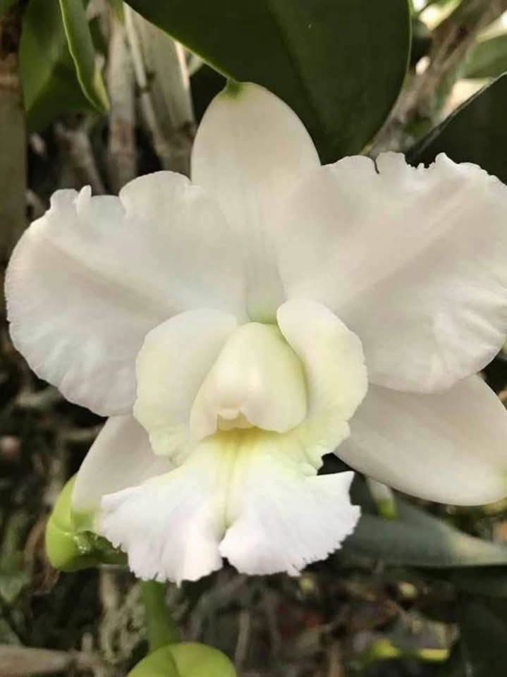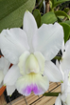 | 2” |  | $18 | $
ADD PHOTO | Rlc. Jessie Lee 'Hawaii' x Rlc. Waikiki Jungle 'Carmela' | 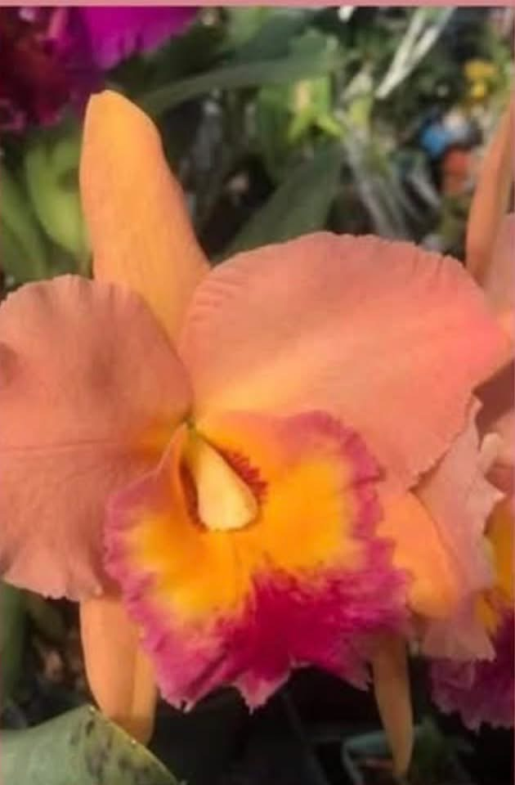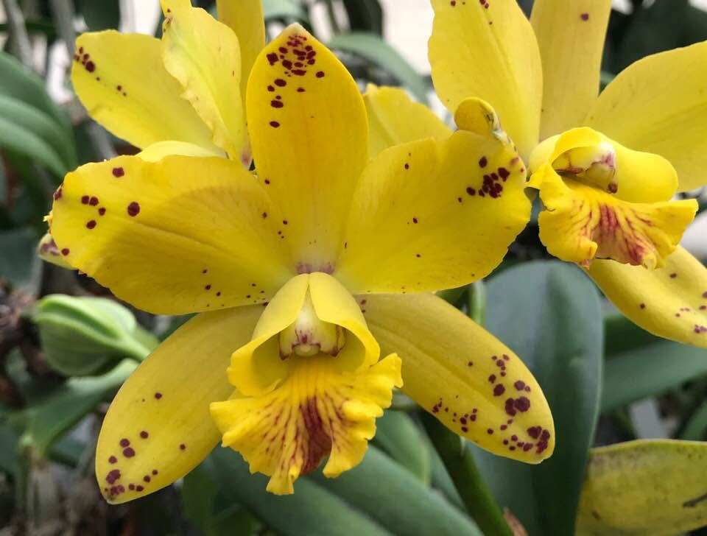 | 2” |  | $15 | $
ADD PHOTO | C. Dale Ott ‘Whipperwill’ | 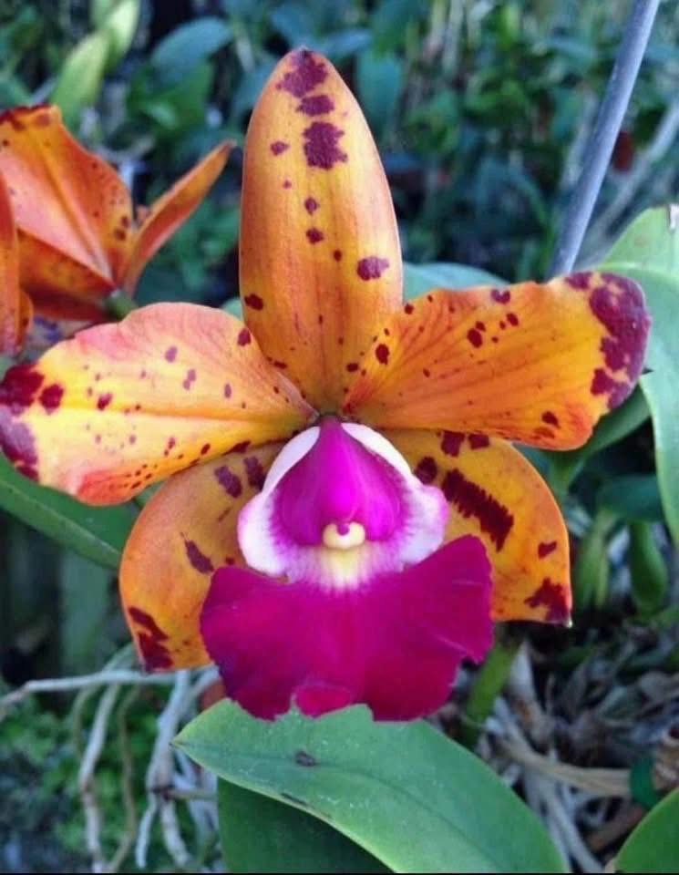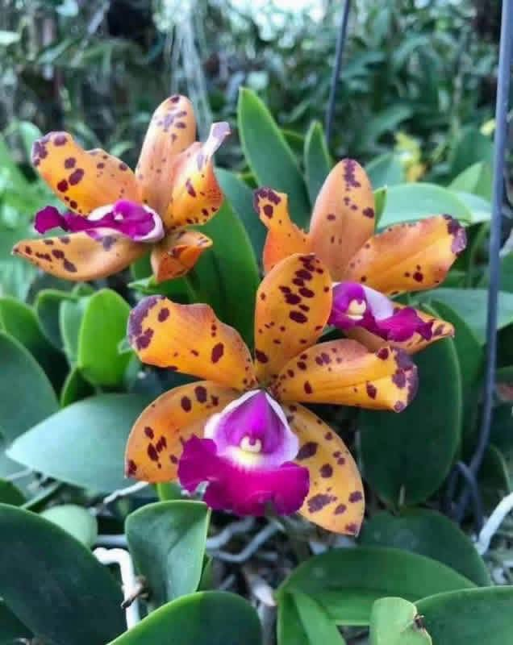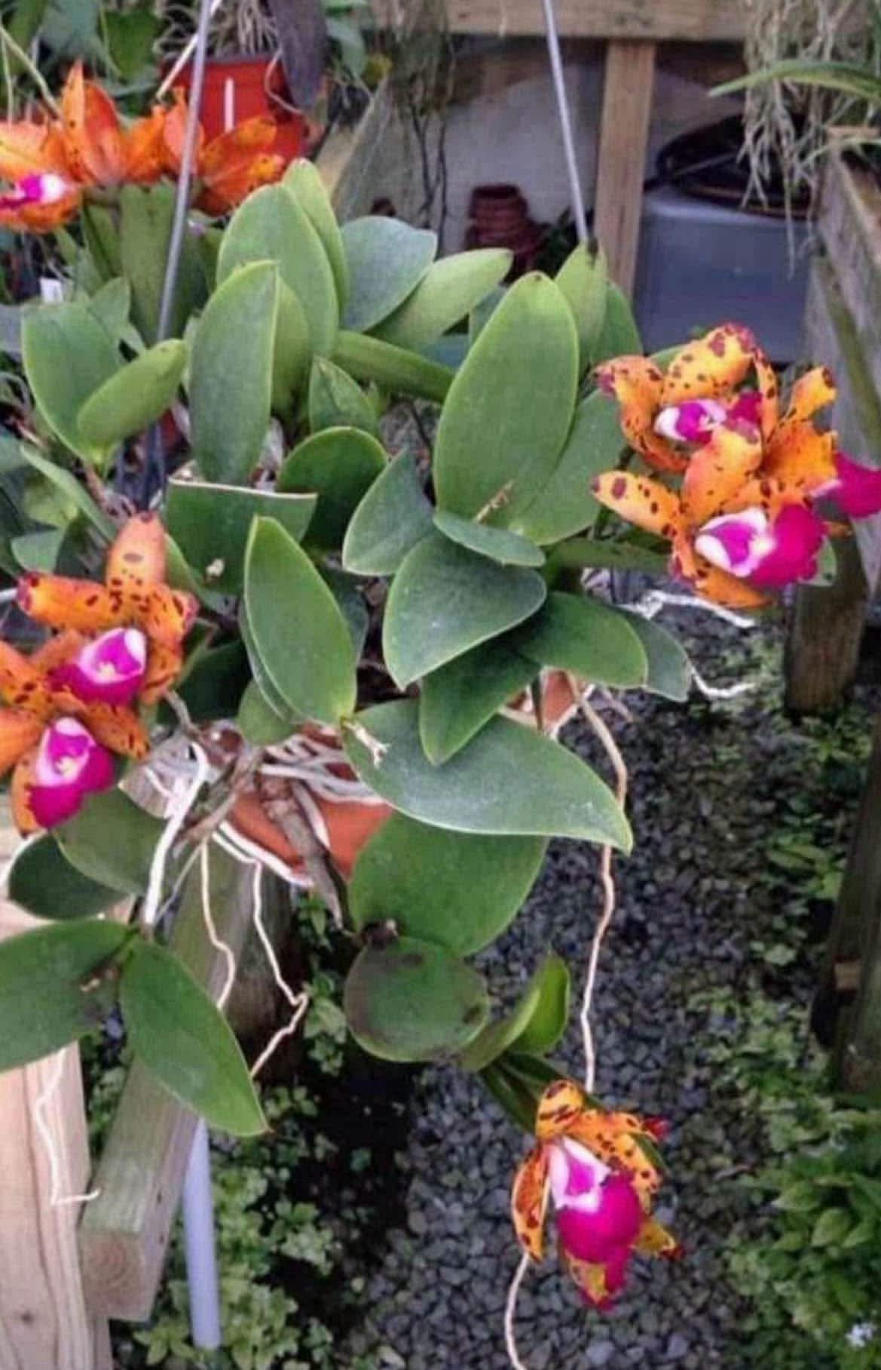 | 3” |  | $28 | $ | NBS to BS, Mericlones
ADD PHOTO | Rlc. Hawaiian Thrill 'Paradise' x (C. Katherine Clarkson x C. Chinese Bronze 'Marco Polo') | 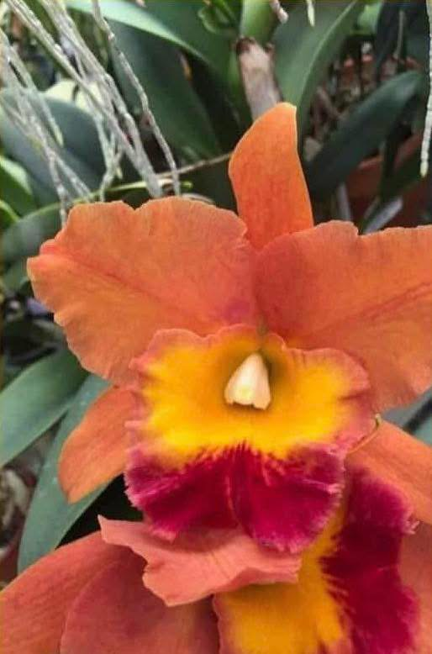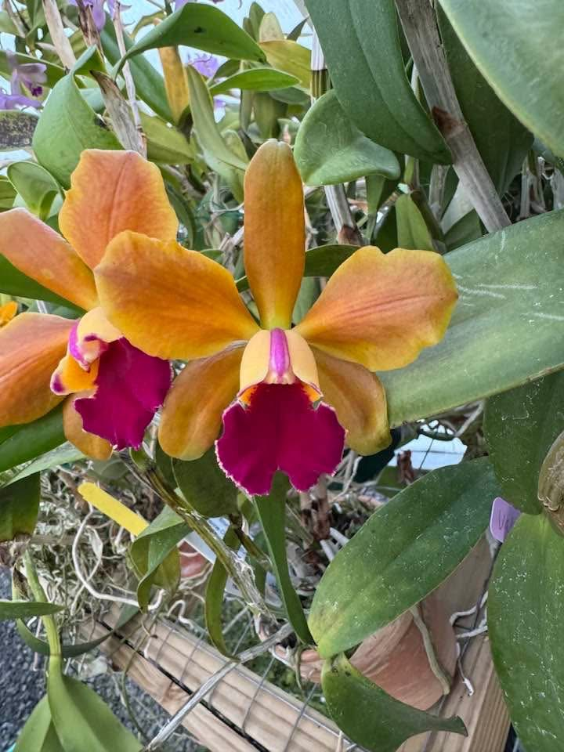 | 2" |  | $15 | $
ADD PHOTO | Rlc. Karen's Sunrise 'Lakeview' x George King 'Serendipity' AM/AOS | 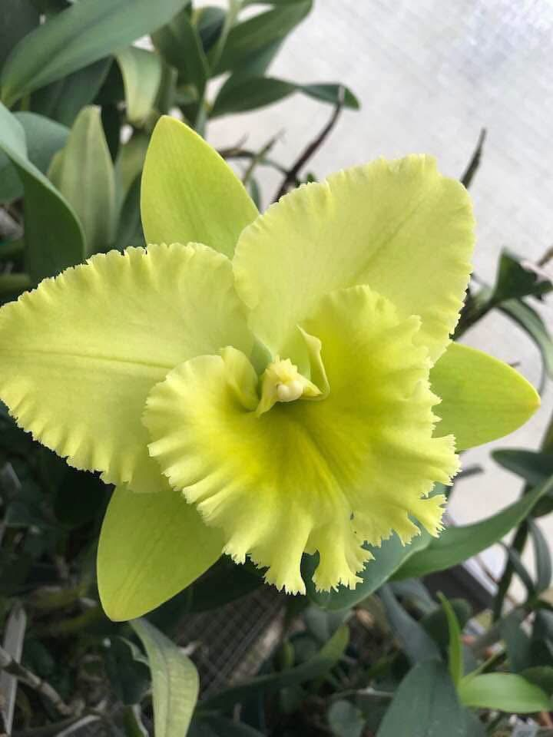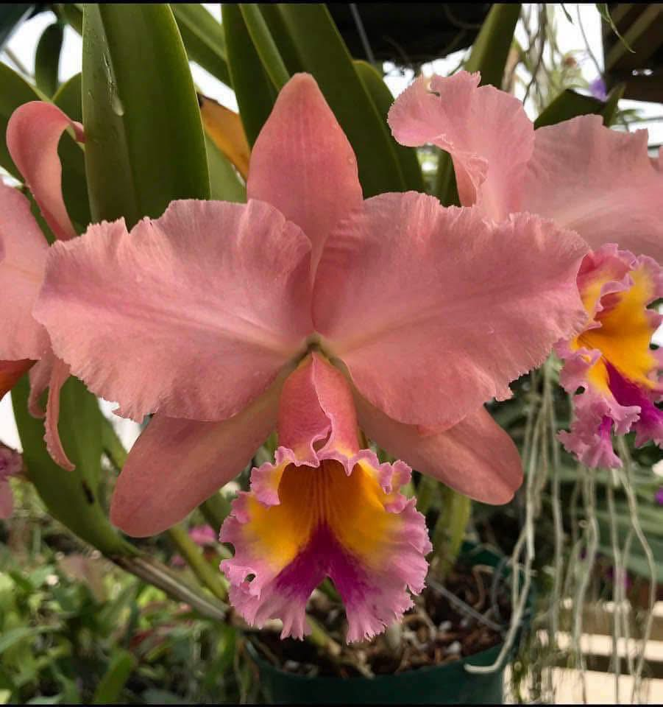 | 3” |  | $22 | $
ADD PHOTO | Rlc. Waikiki Gold 'Lea' HCC/AOS x Waikiki Jungle 'Carmela' | 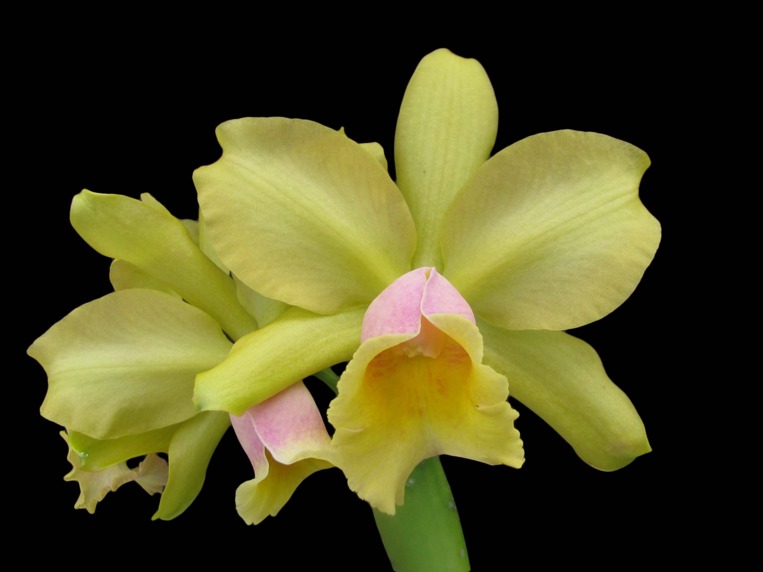 | 4”  Blooming size |  | $38 | $ | 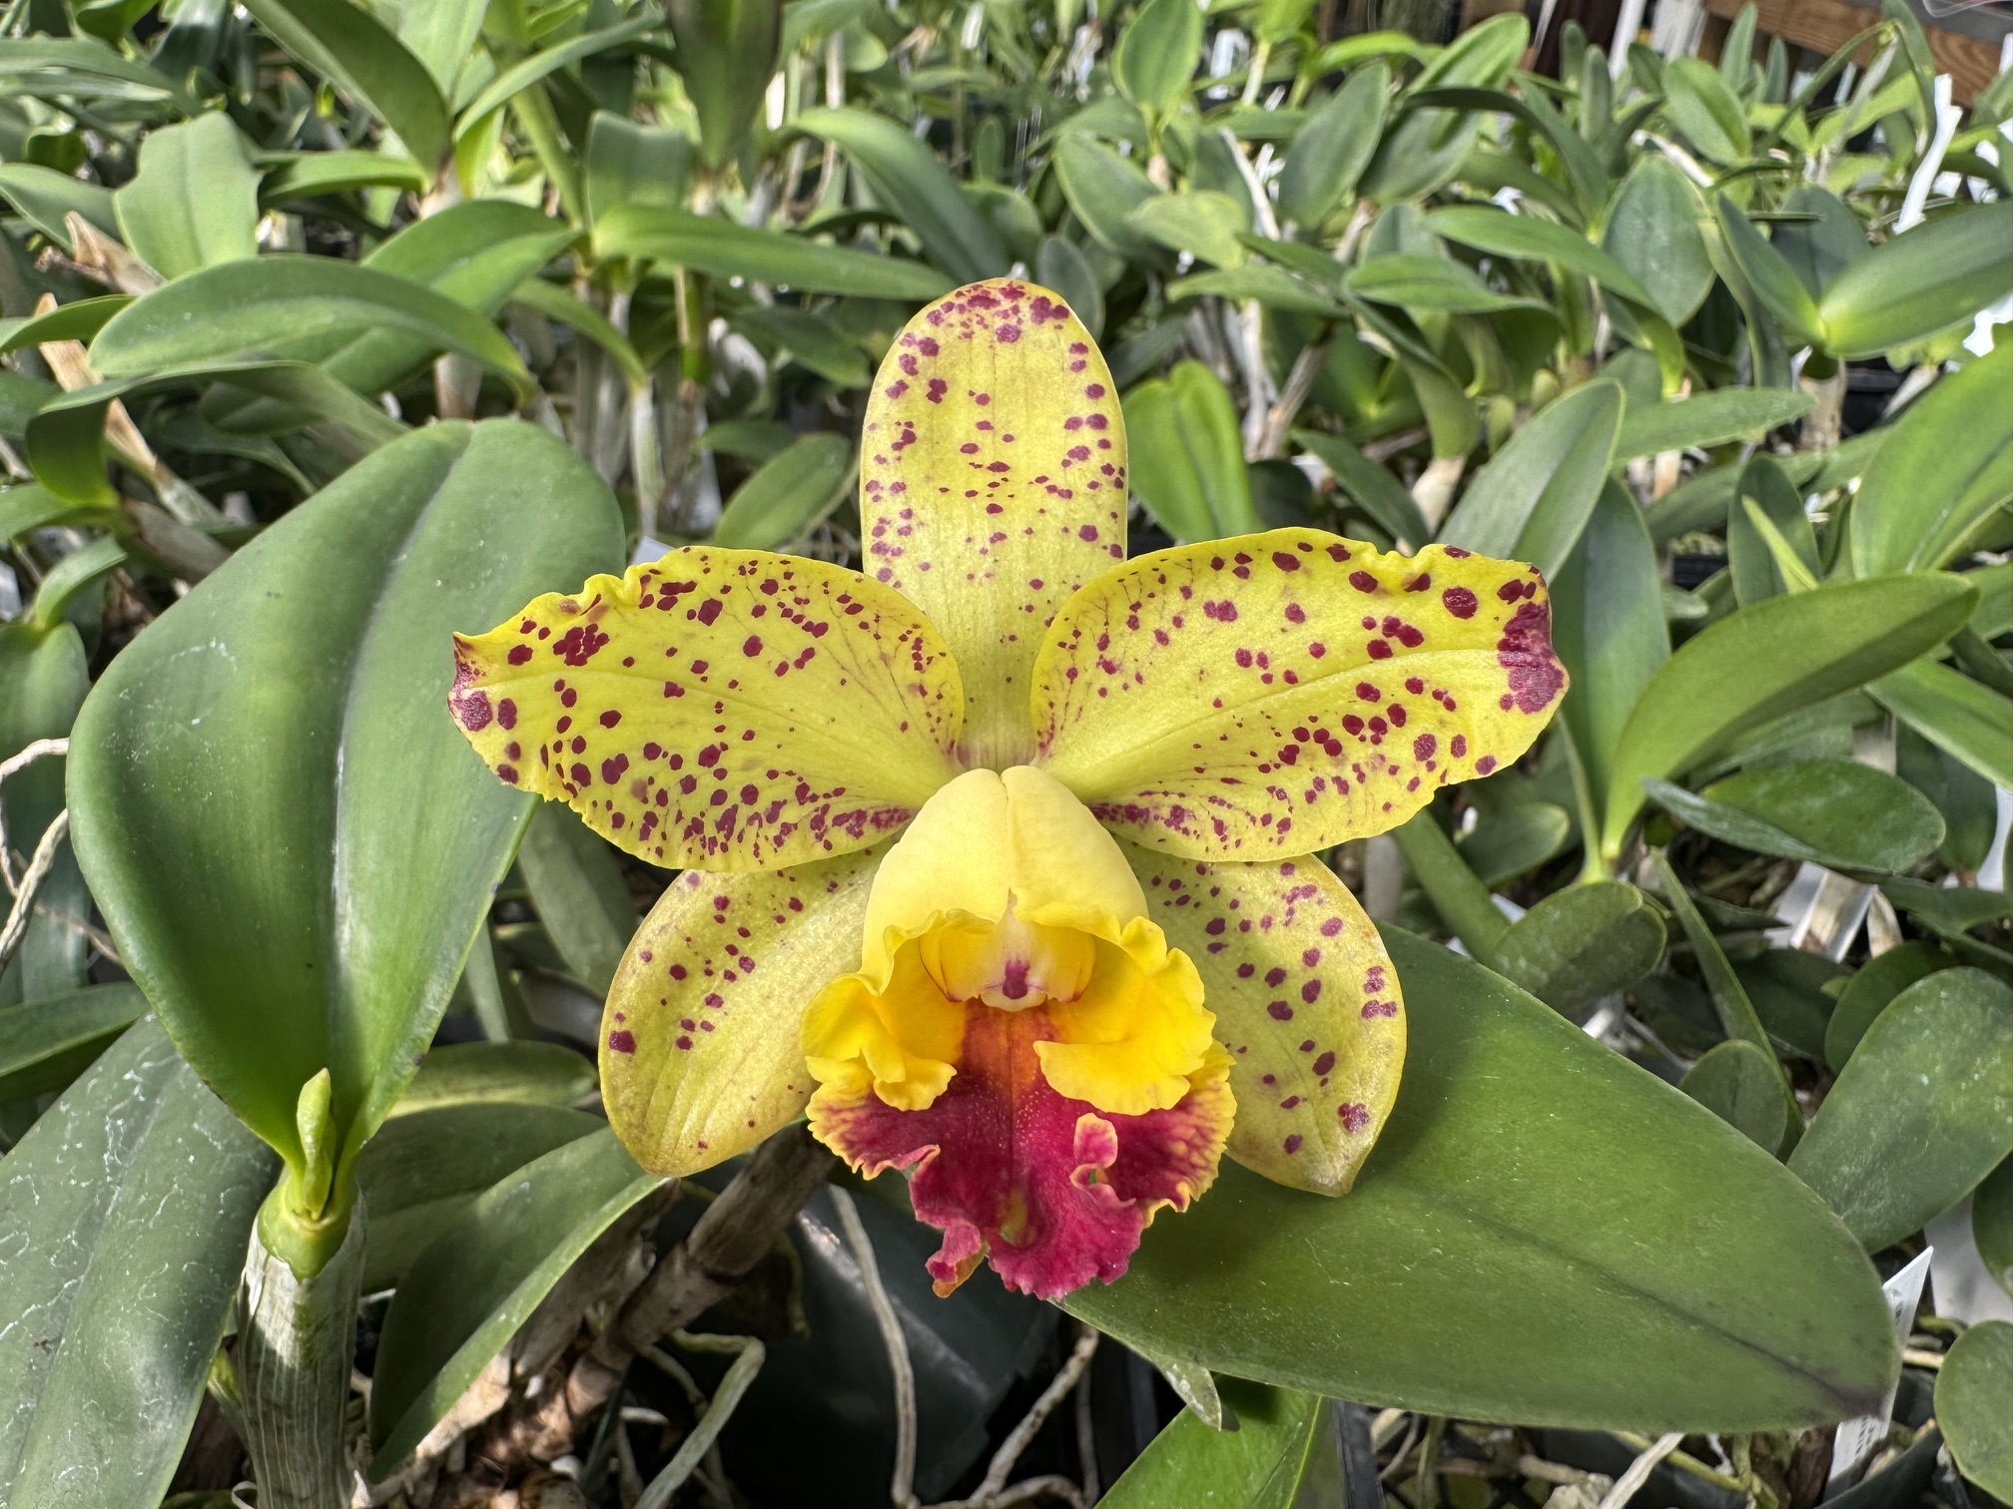 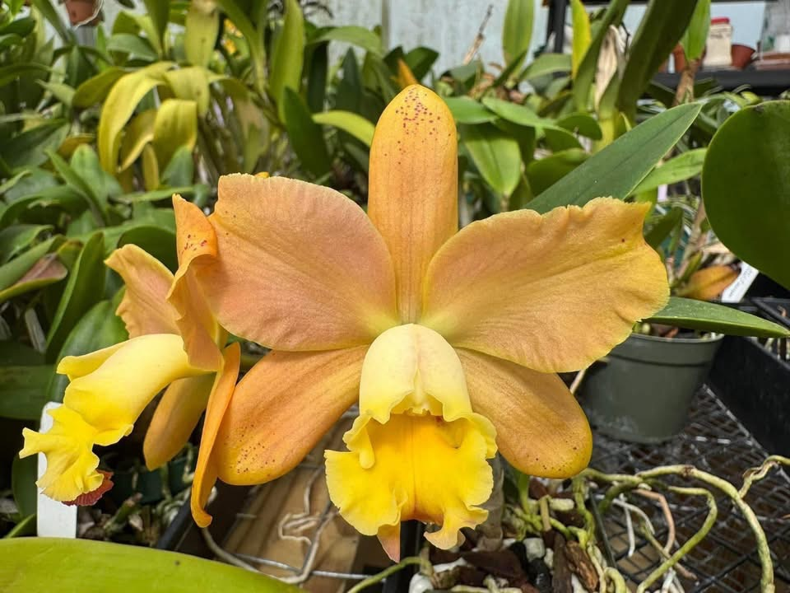 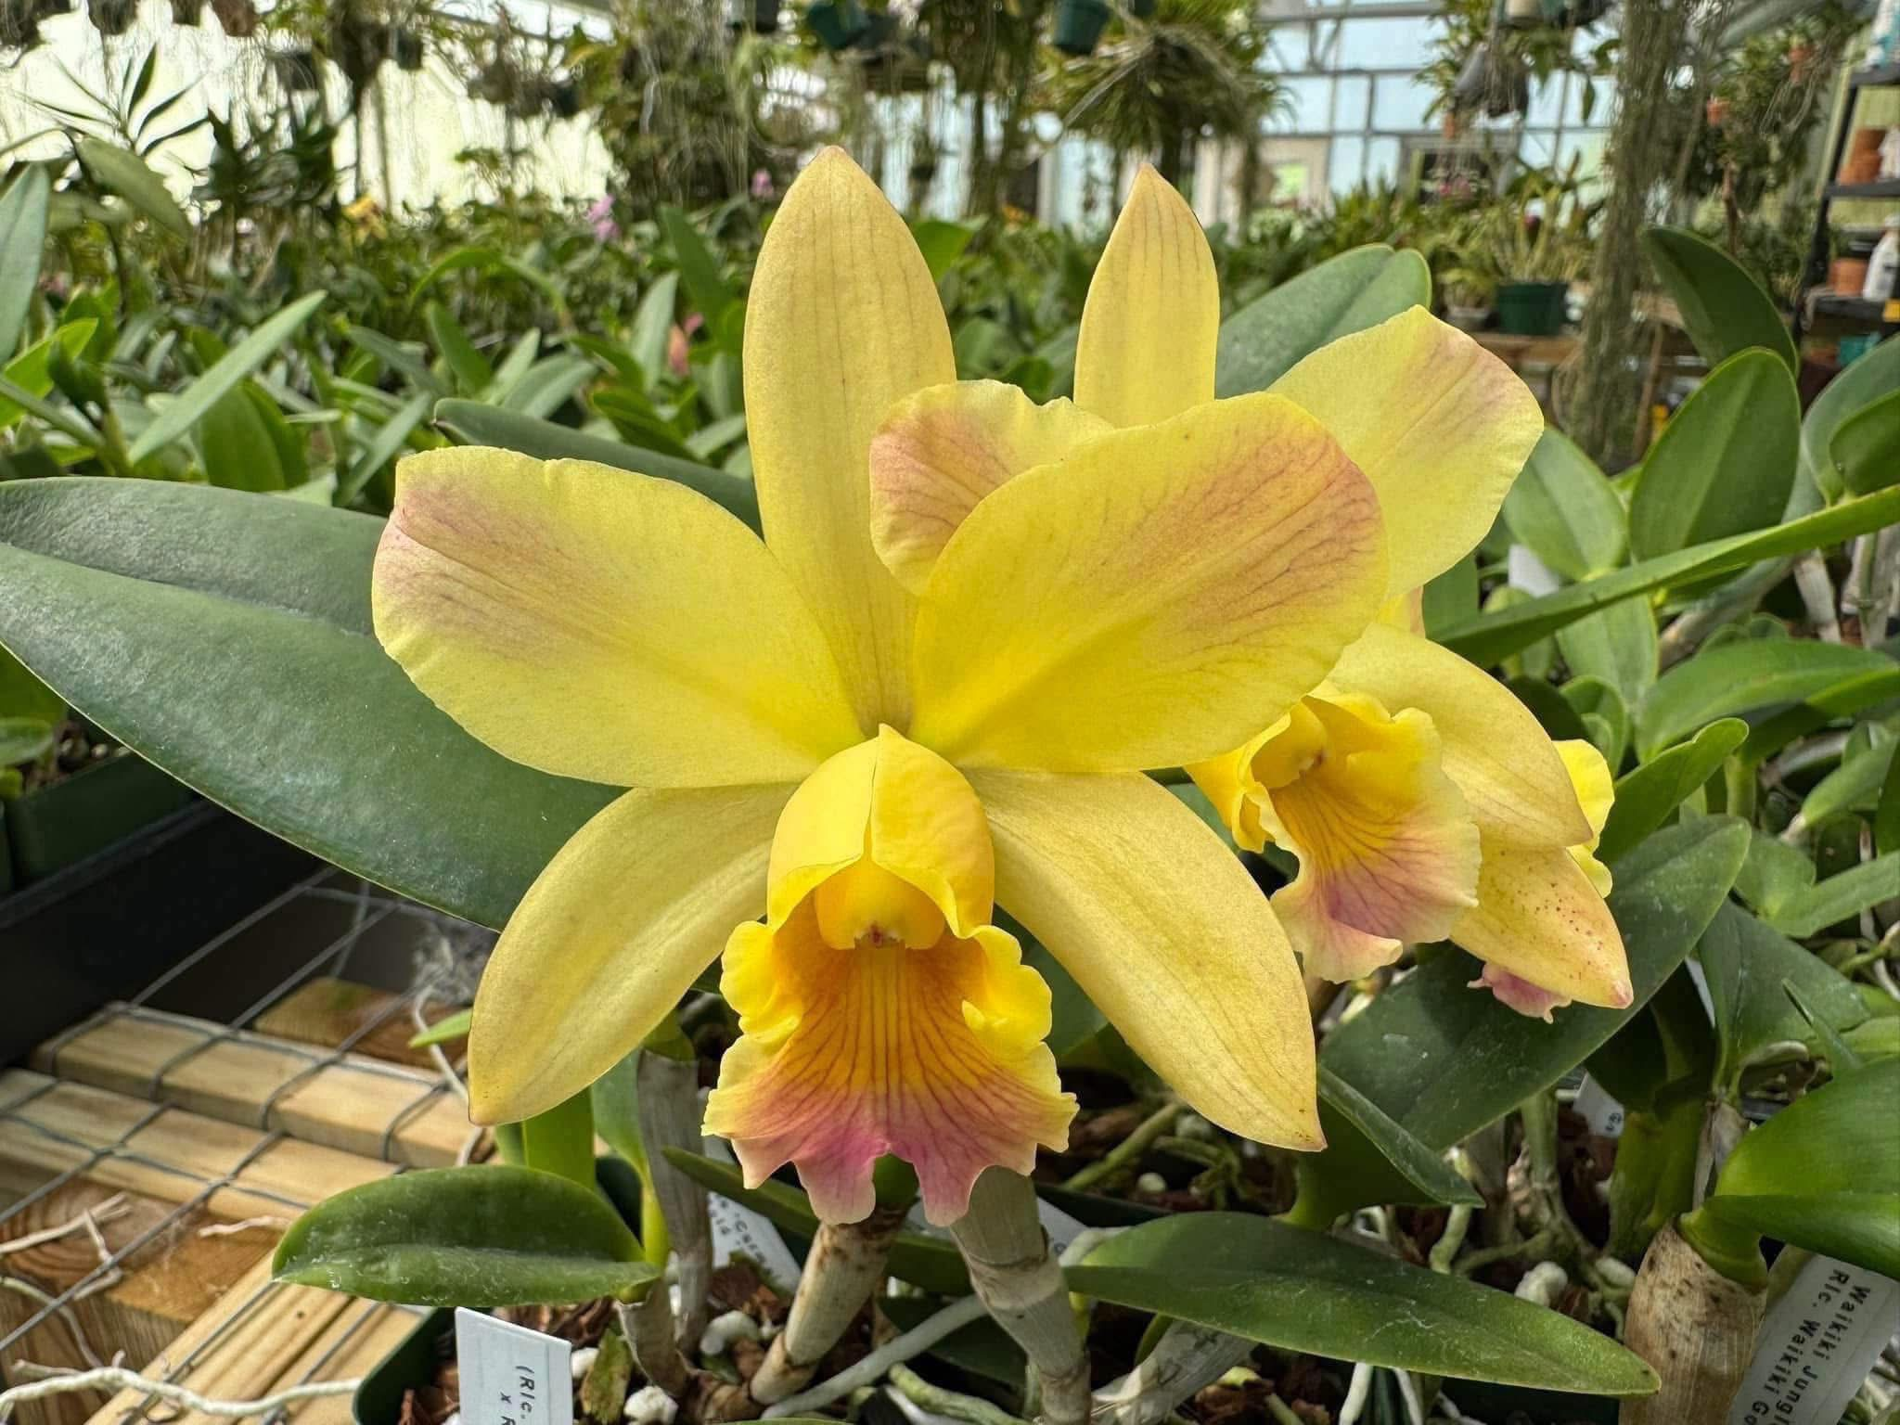  Seedlings that have bloomed
ADD PHOTO | C. Brabantiae x C. Breautiana | 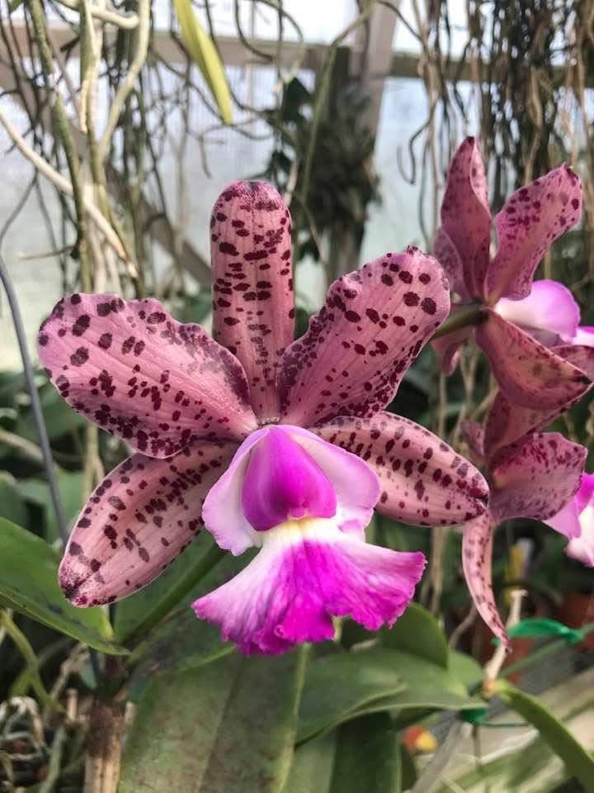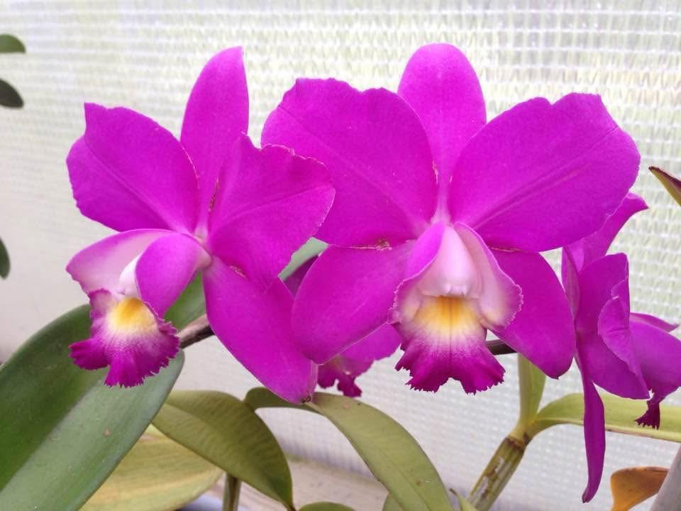 | 2” |  | $15 | $
ADD PHOTO | Phal. bellina coer x self | 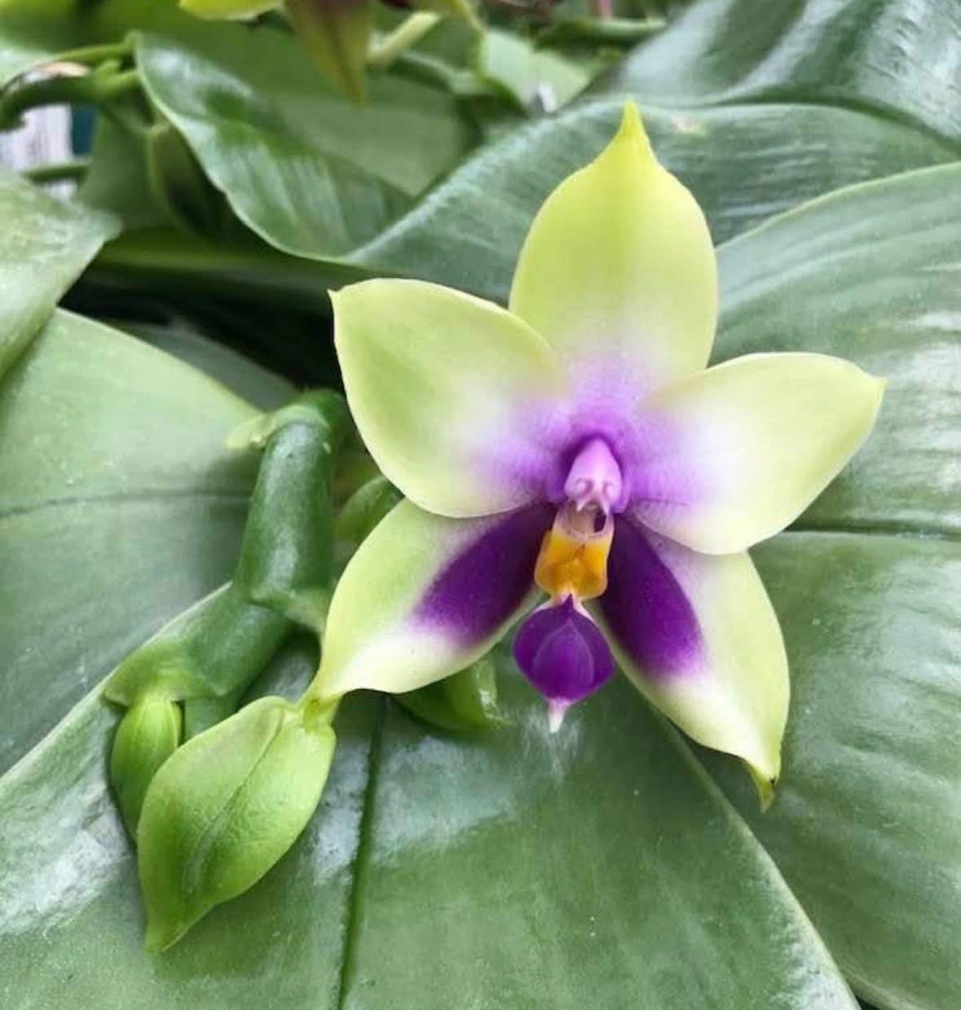 | 2” |  | $15 | $
ADD PHOTO | Schilleriano-harrisoniae x C. Key Largo | 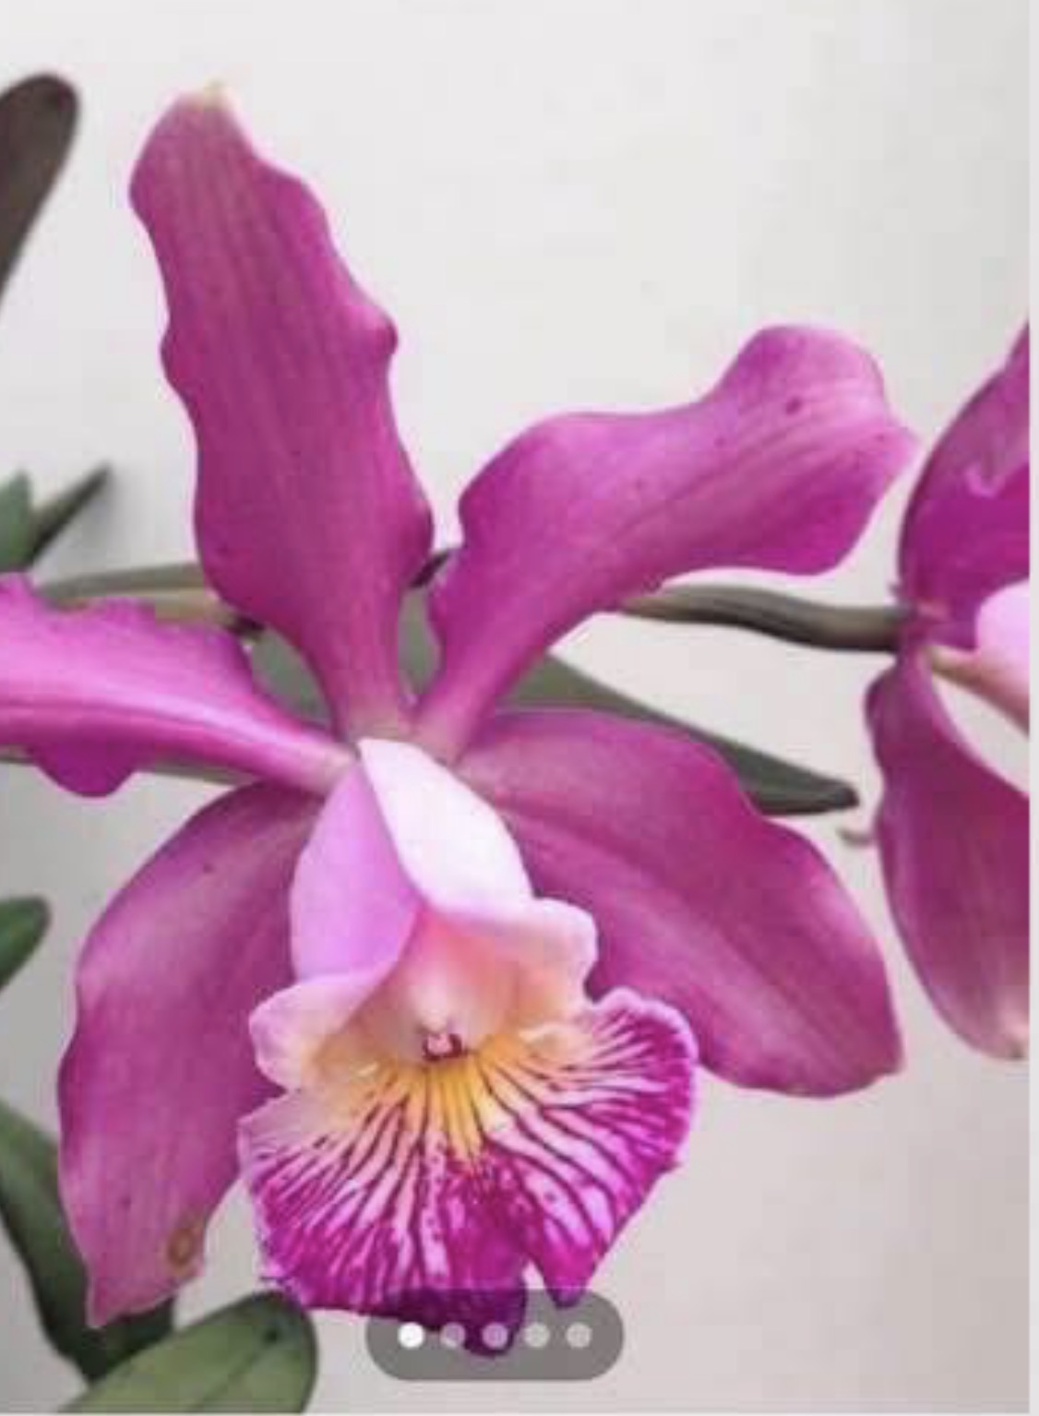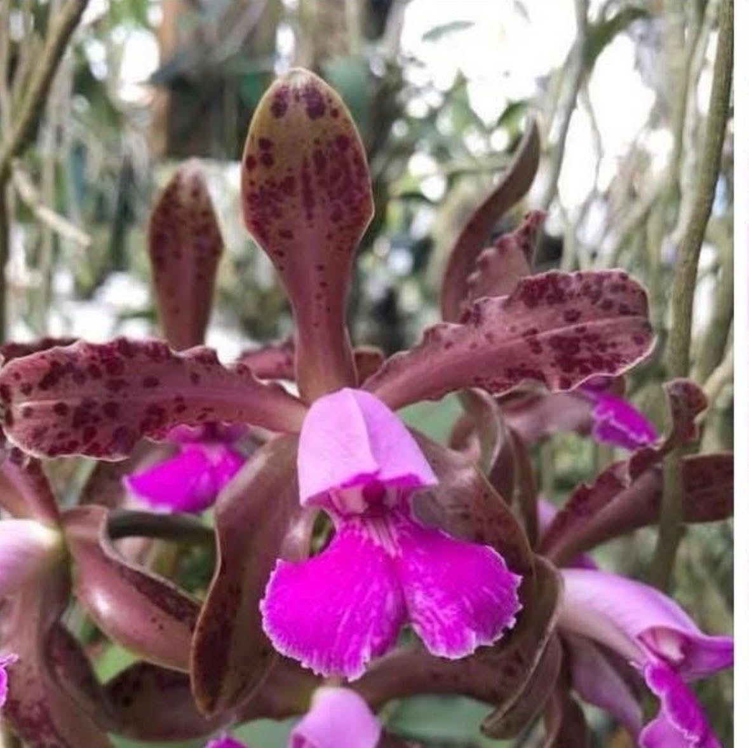 | 4”  Blooming size |  | $35 | $ | 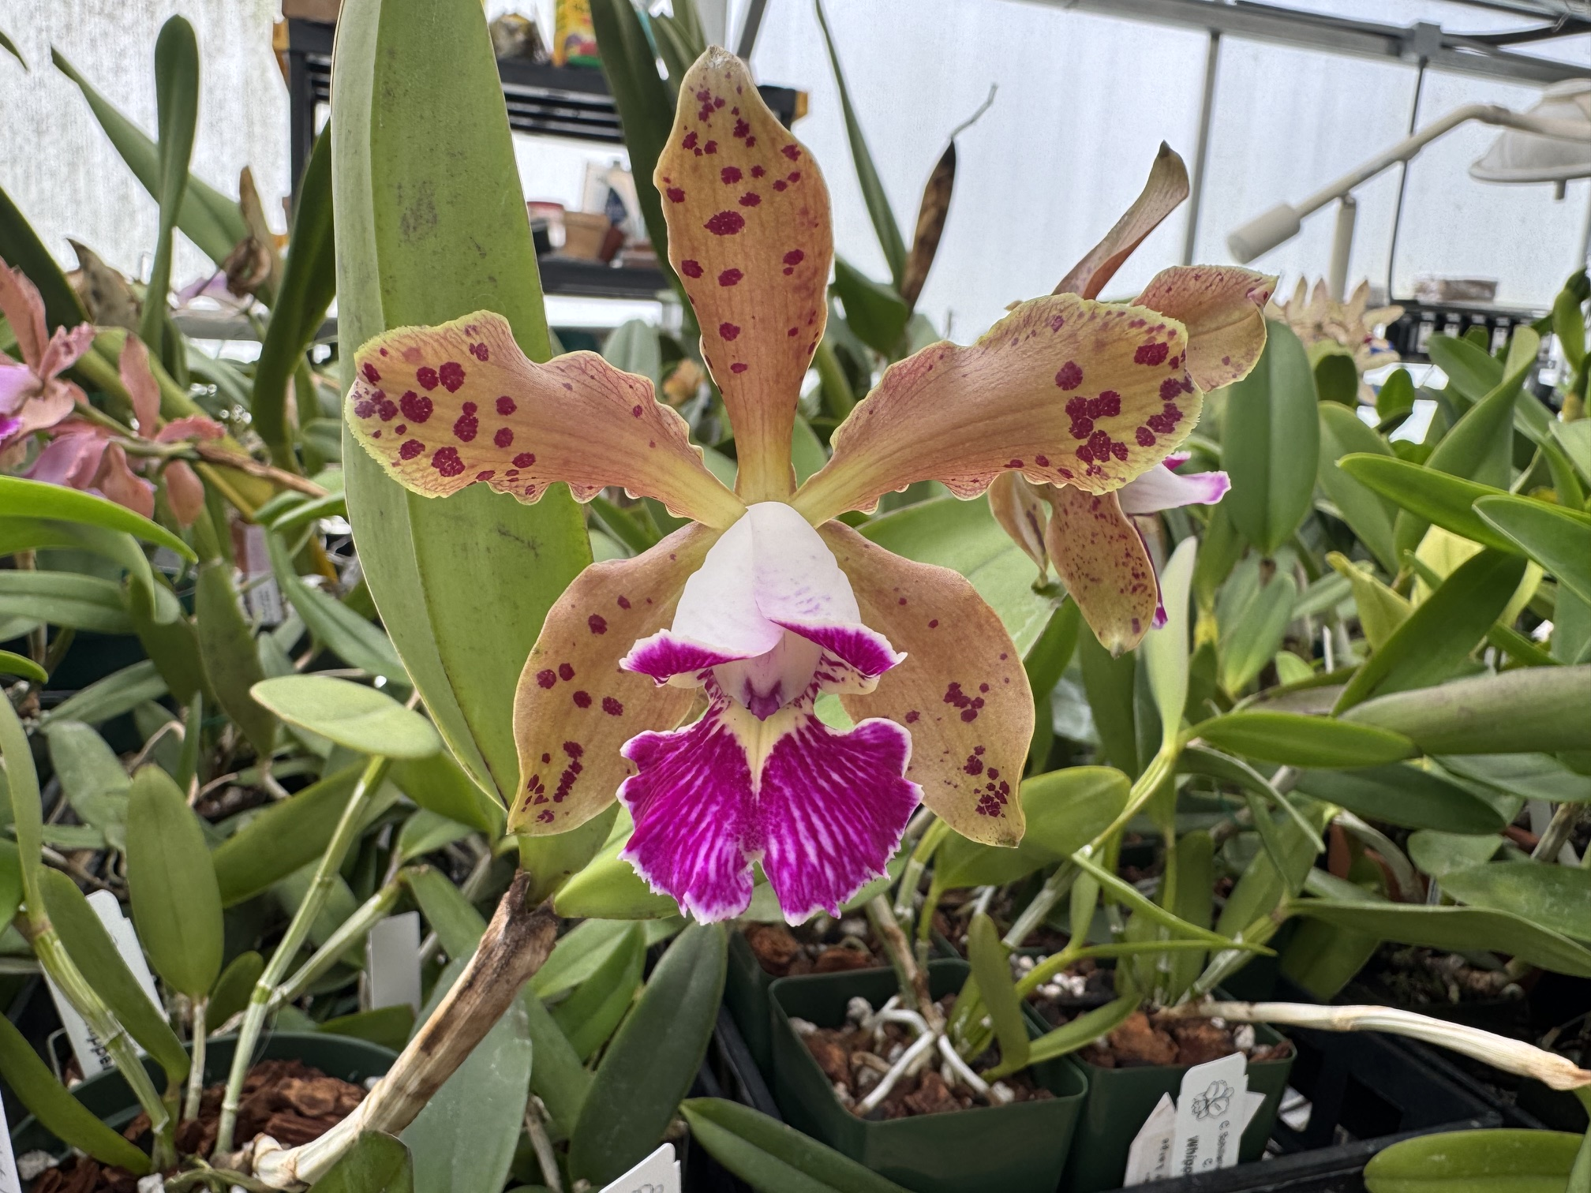 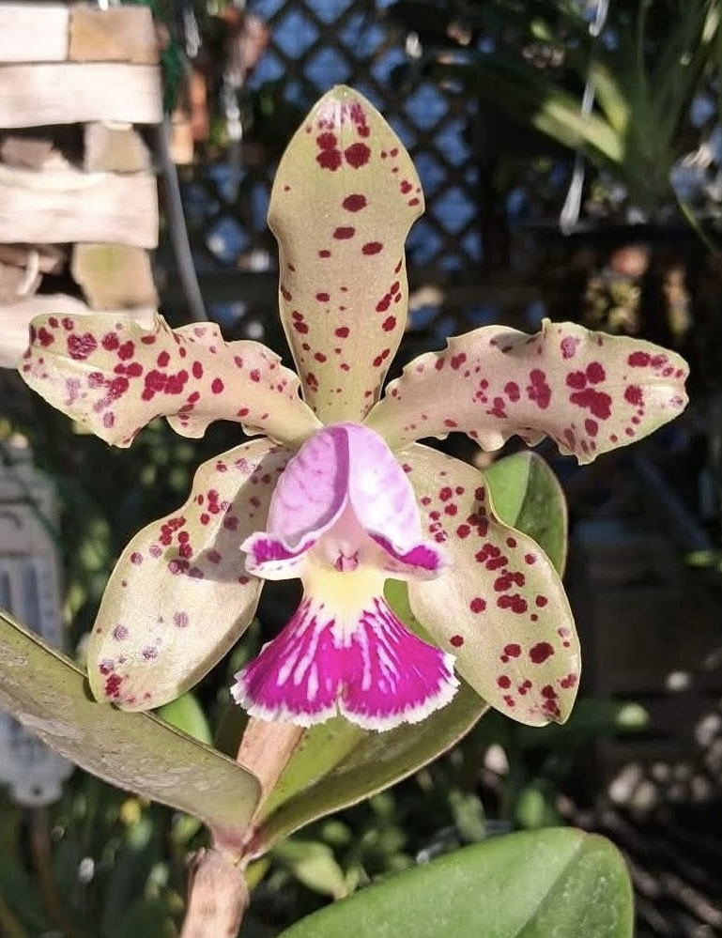 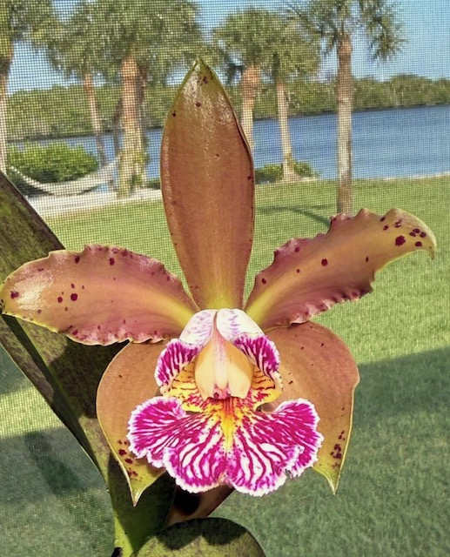  Cool babies that have bloomed
ADD PHOTO | Ctt. Charles Wilson x Aussie Sunset ‘Cosmic Fire’ | 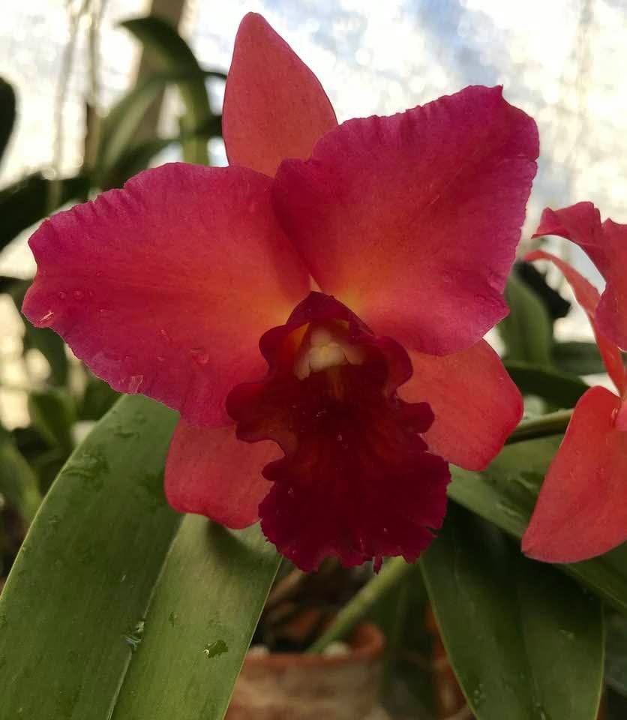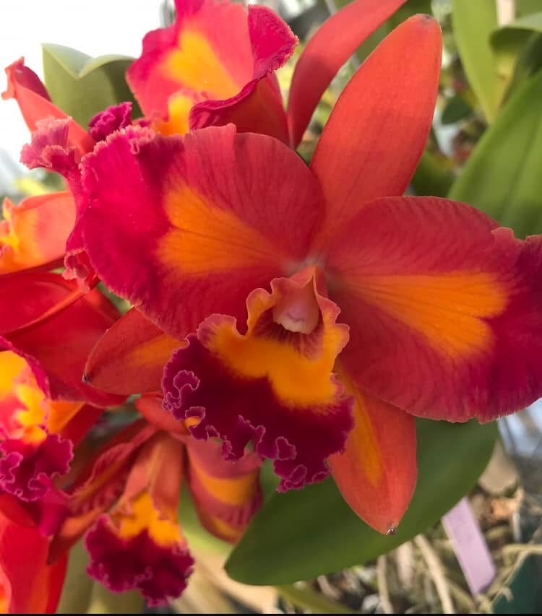 | 2" |  | $15 | $
ADD PHOTO | C. Dale Ott ‘Whipperwill’ x Terry’s Spots | 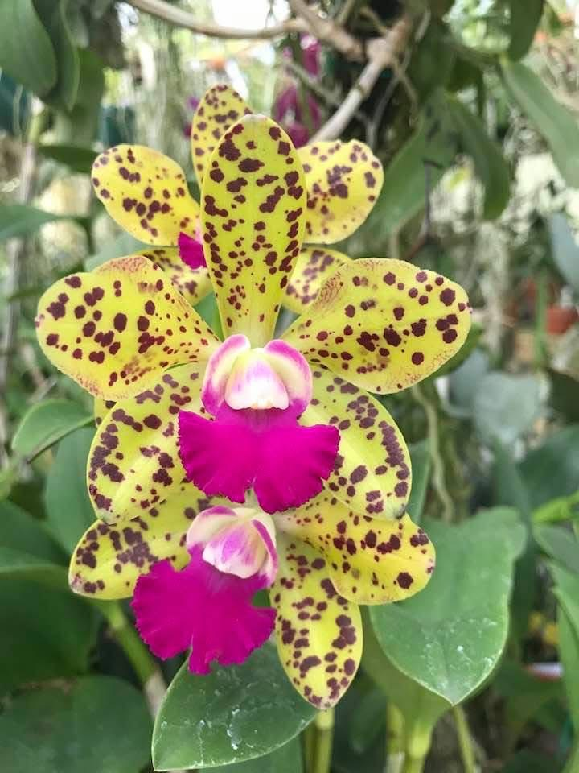 | 2" |  | $15 | $
ADD PHOTO | Rlc. Mount Anderson ‘Dave’ x C. Ruth Gee | 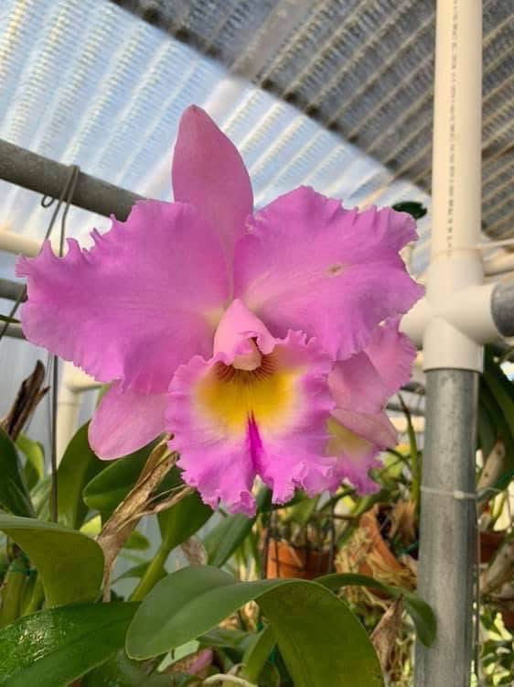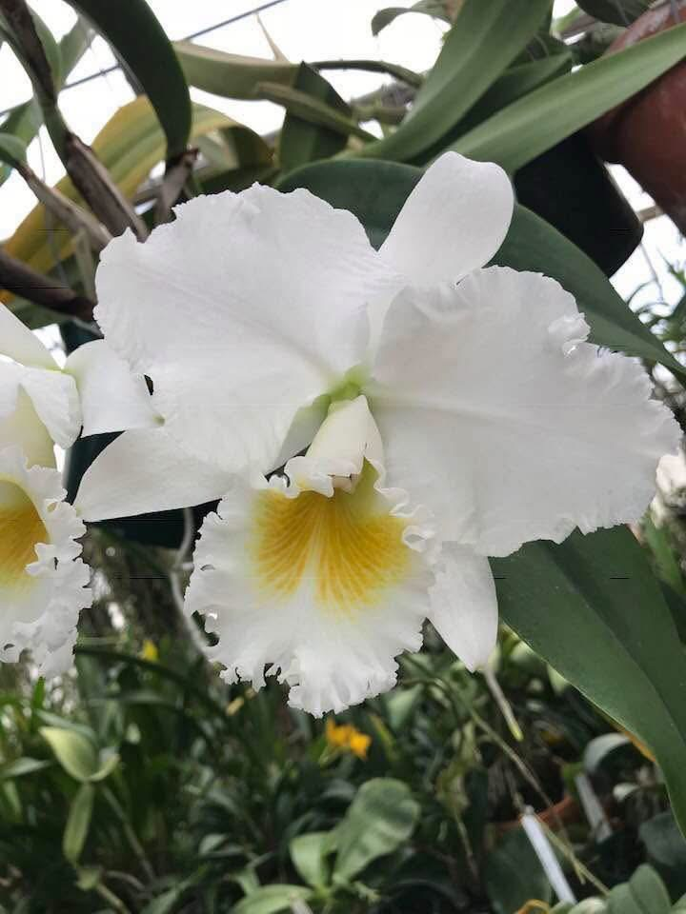 | 2" |  | $15 | $
ADD PHOTO | C. Rock City x C. Ruth Gee | 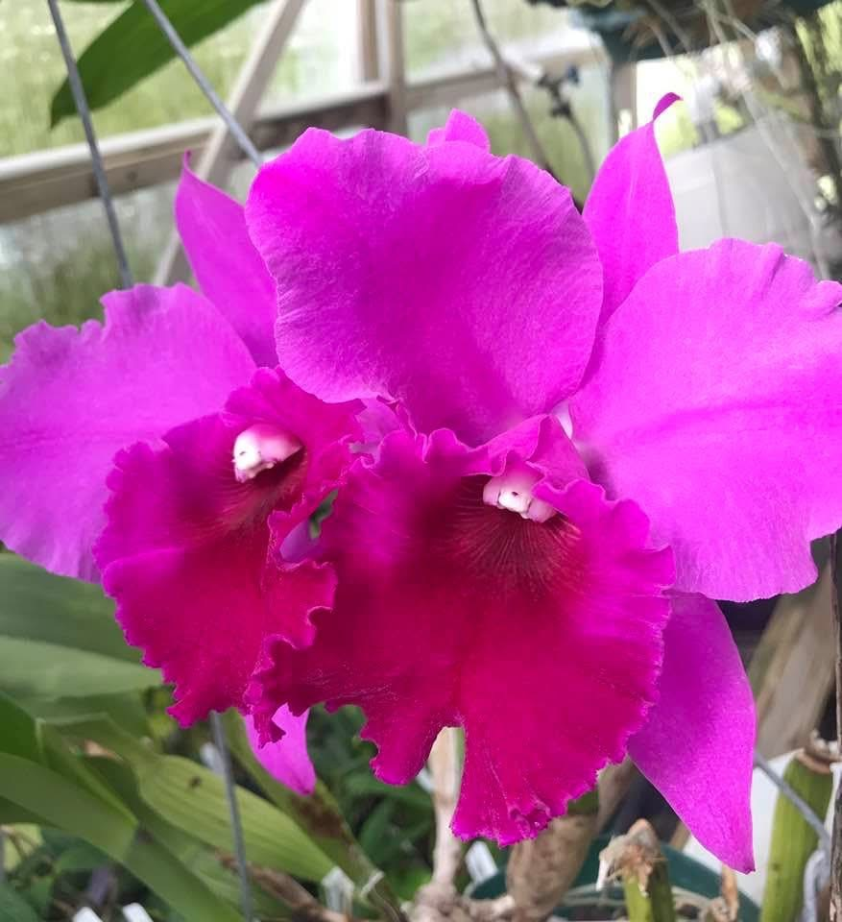 | 2” |  | $15 | $
ADD PHOTO | C. Karen Tobiassen x C. Valentine coerulea | 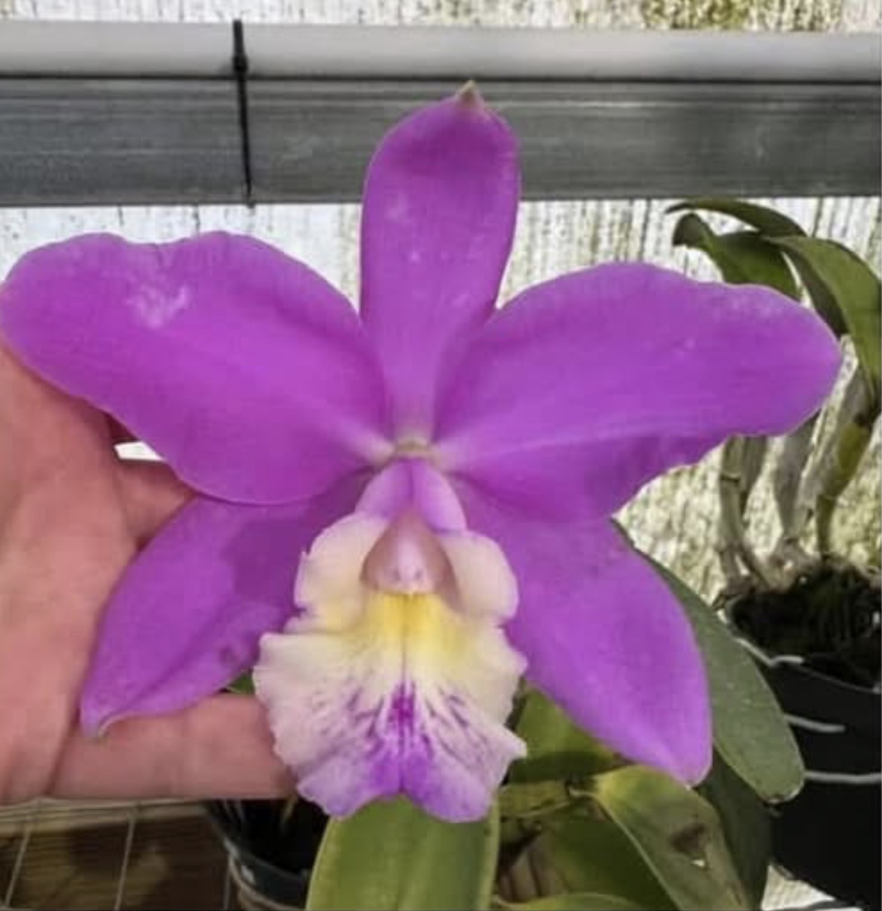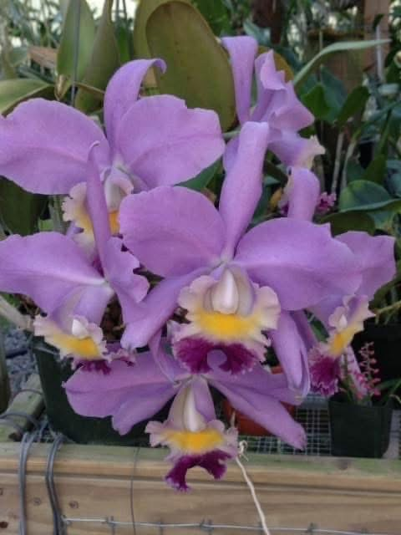 | 3” |  | $25 | $ | NBS to Blooming size  First buds opening next week
ADD PHOTO | Rlc. Tsutung Beauty 'Taiyoung 3 Brothers' HCC/AOS x Irene's Song 'Montclair' HCC/AOS | 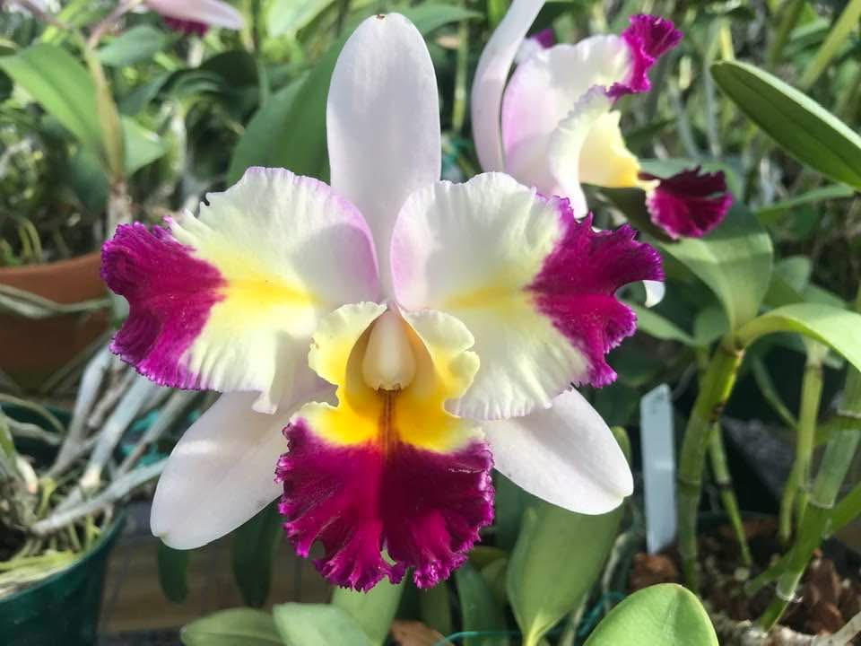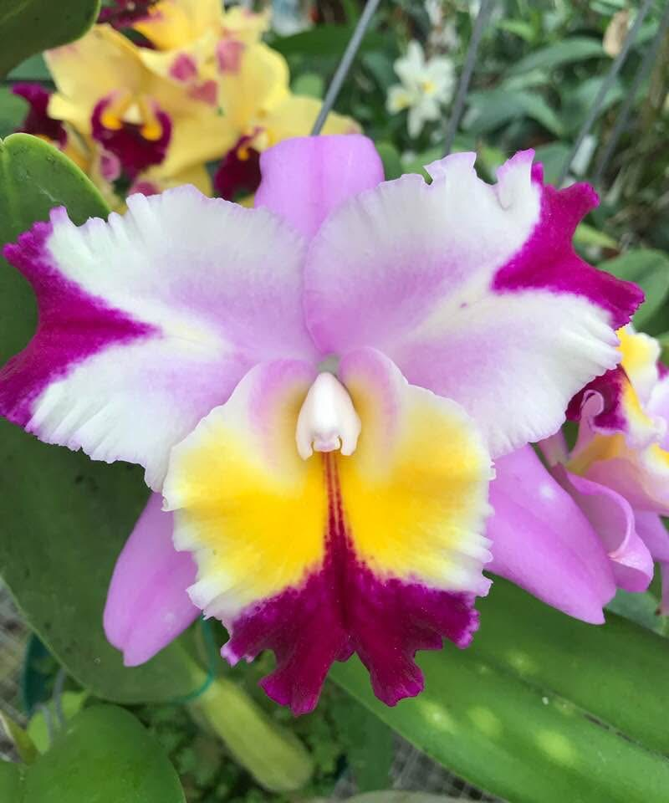 | 2" |  | $15 | $ | Young seedlings but growing fast! First Release.
Schilleriano-harrisoniae | C. Schilleriano-harrisoniae x schilleriana | 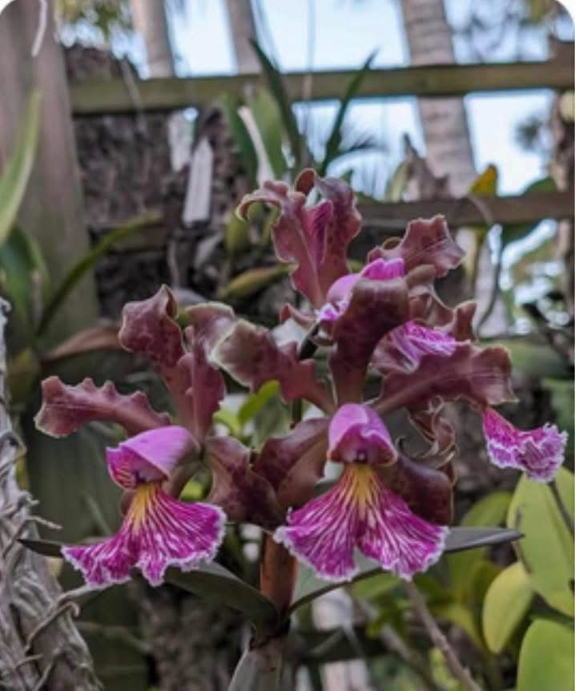 | 2" |  | $15 | $
ADD PHOTO | Rlc. Mem. Bob Crowder ‘Carmela’ x Rlc. Jessie Lee ‘Hawaii’ | 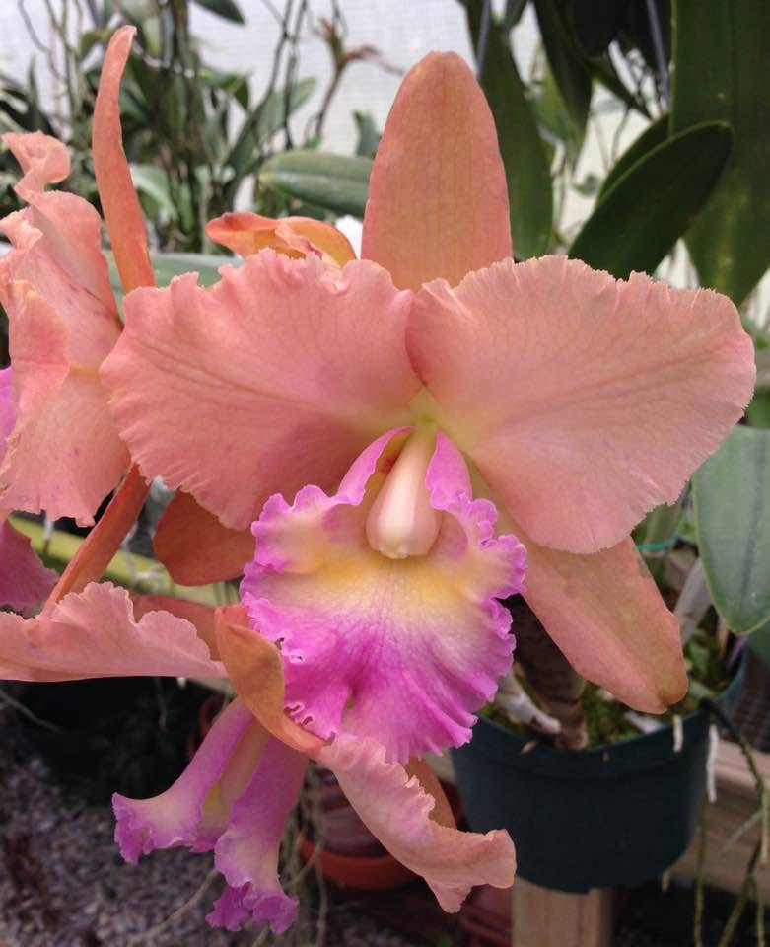 | 2” |  | $15 | $
ADD PHOTO | C. Key Largo x C. schilleriana |  | 3" |  | $22 | $
ADD PHOTO | C. purpurata carnea x self | 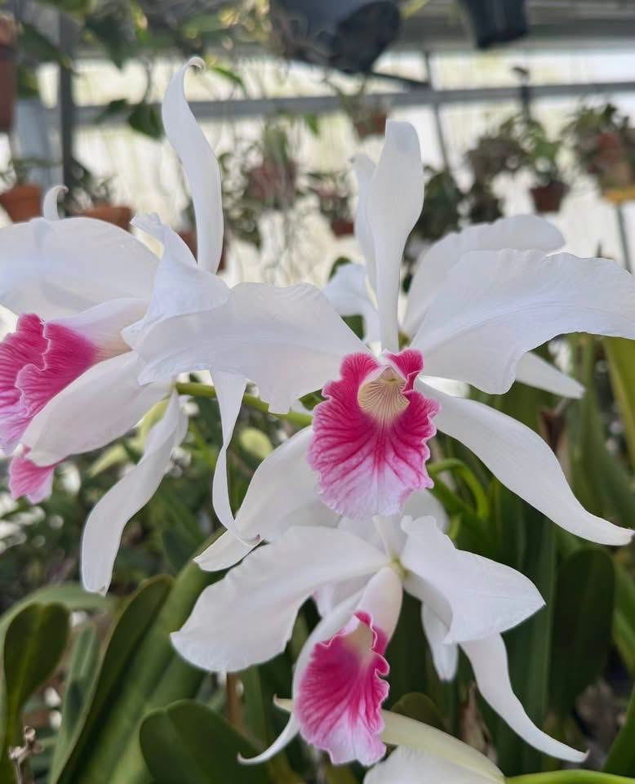 | 3" |  | $22 | $
ADD PHOTO | Rlc. Volcano Plum x C. bicolor | 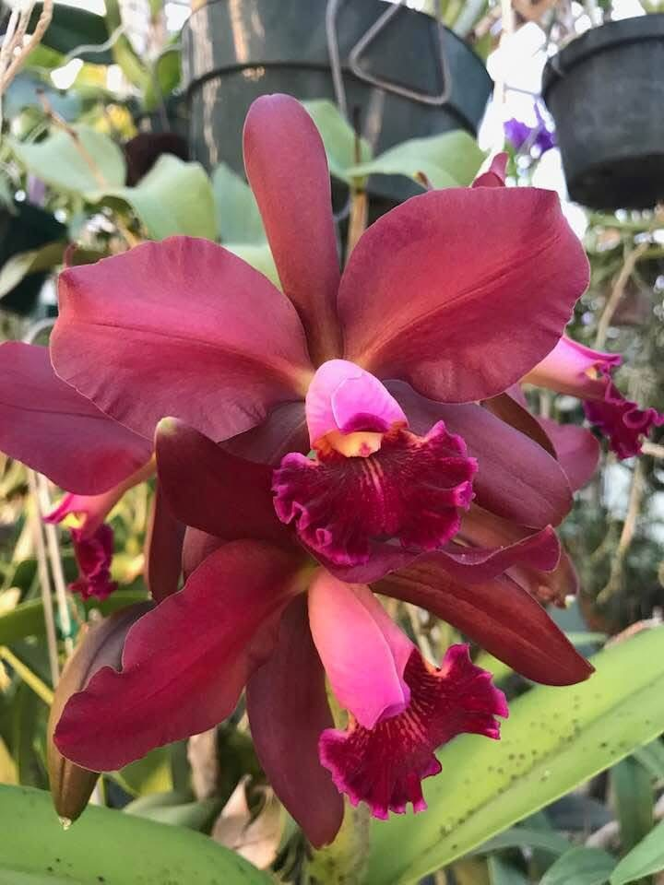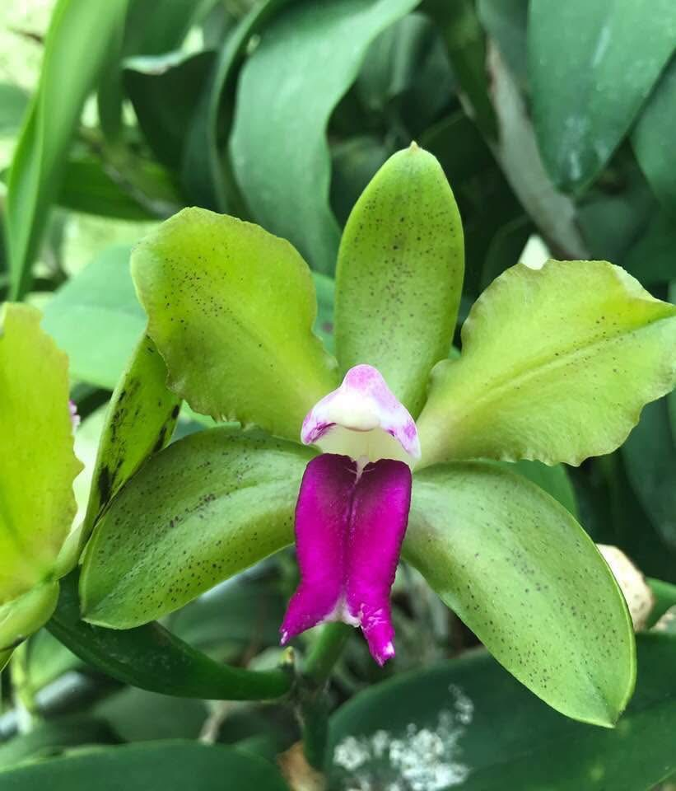 | 4" |  | $35 | $ | Sheaths starting
ADD PHOTO | C. Schilleriana ( The grex, not species. Formerly known as Lc. Schilleriana) | 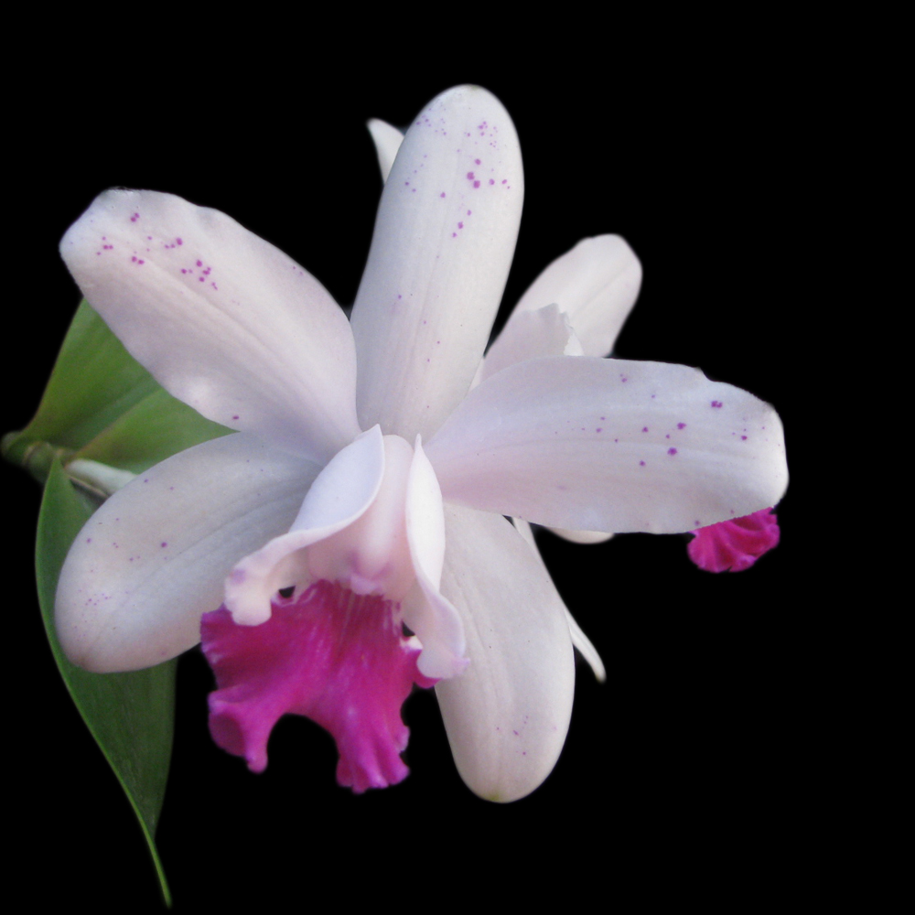 | 4" |  | $25 | $ | 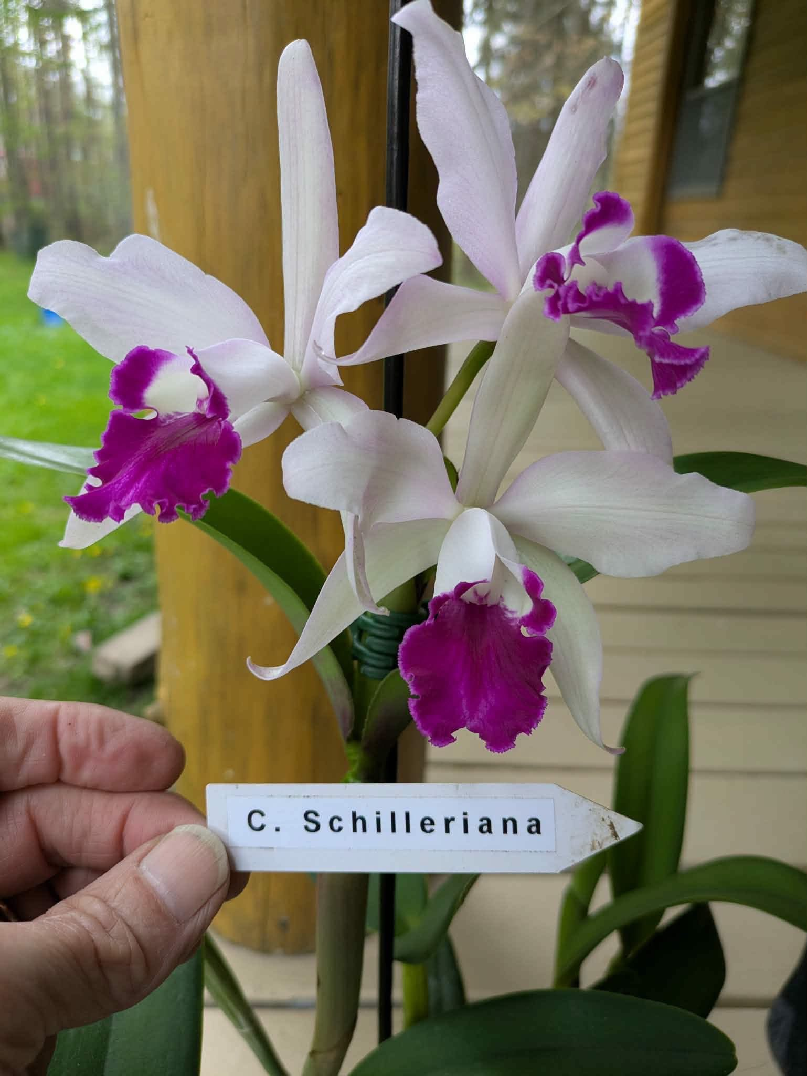
ADD PHOTO | C. Key Largo x C. Landate 'Charm’ BM/JOGA | 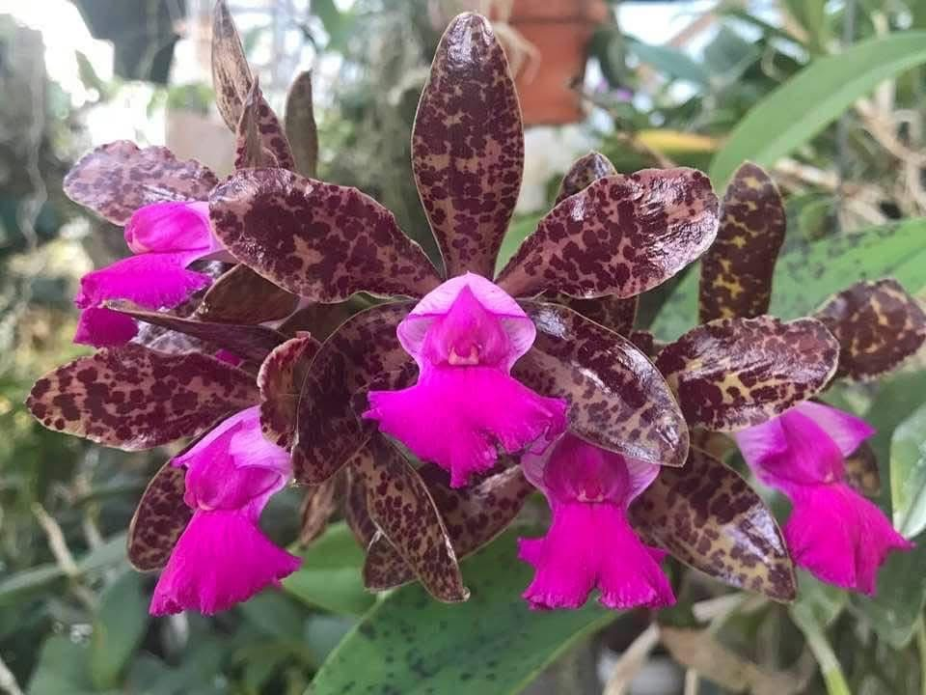 | 3" |  | $22 | $
ADD PHOTO | C. intermedia ‘Whipperwill’ x C. dolosa | 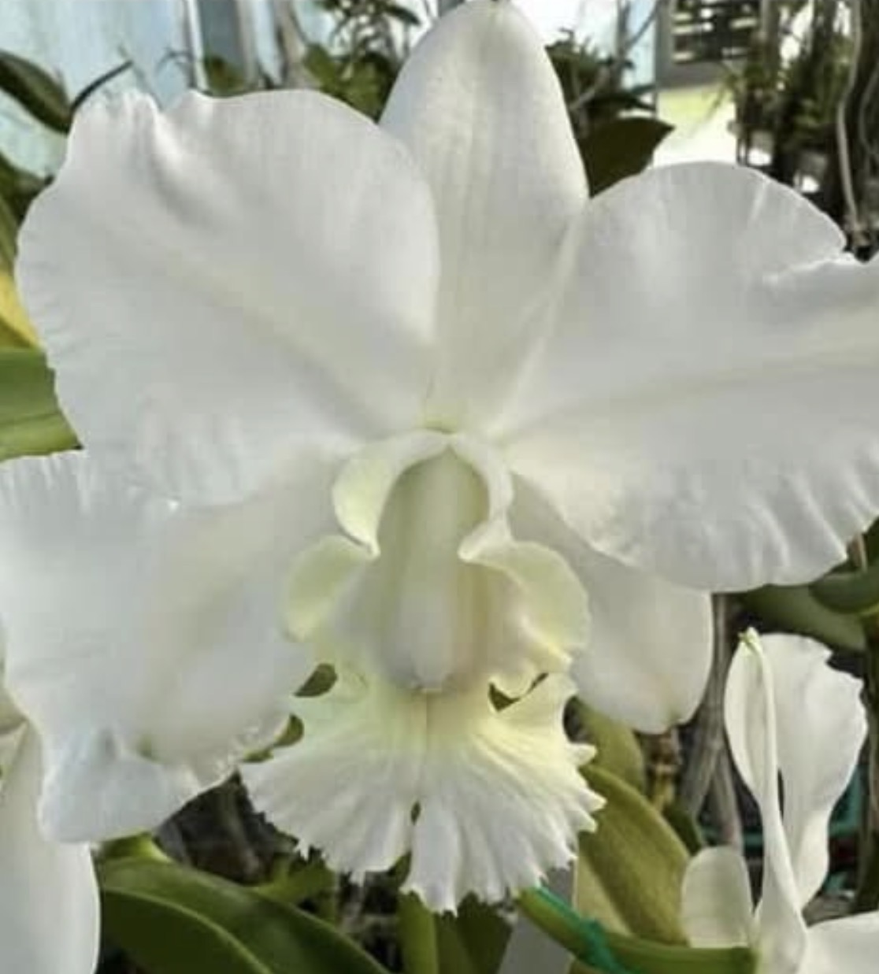 | 3" |  | $22 | $
ADD PHOTO | C. Cariad's Mini-Quinee 'Angel Kiss' x C. Final Blue 'Royal Purple' | 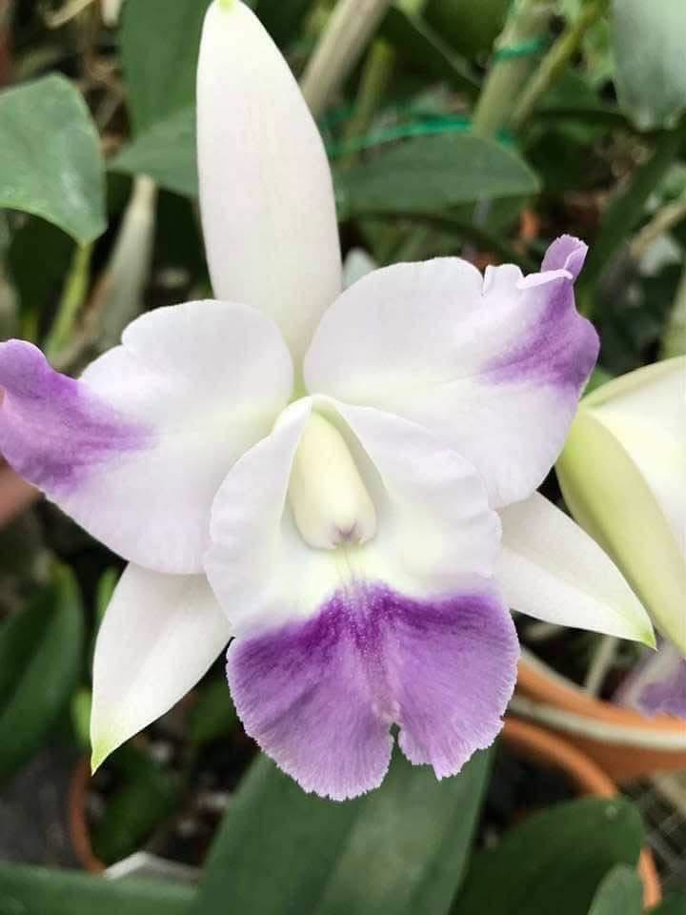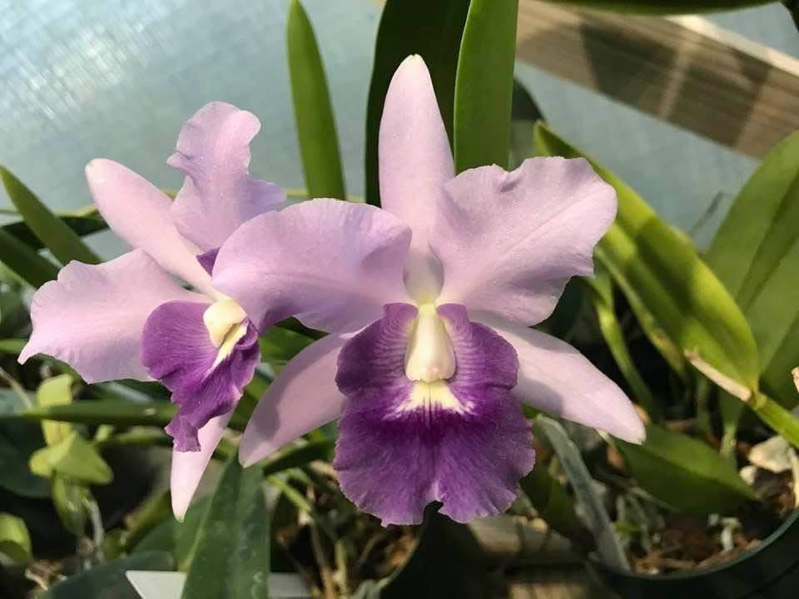 | 3" |  | $22 | $
ADD PHOTO | Ctt.Trick or Treat x Ctt. Trick or Treat | 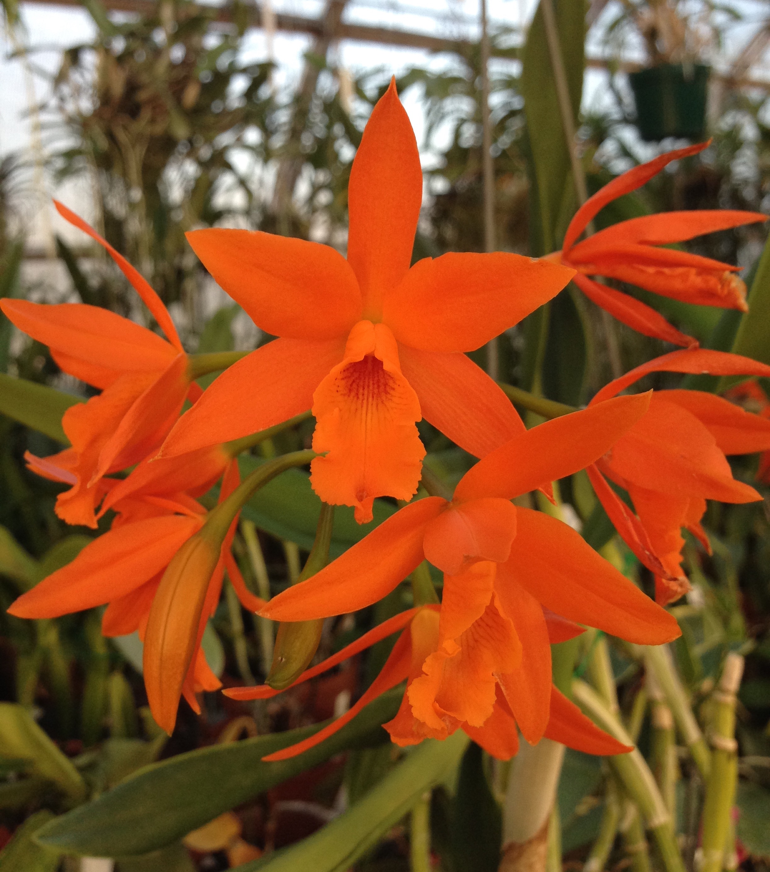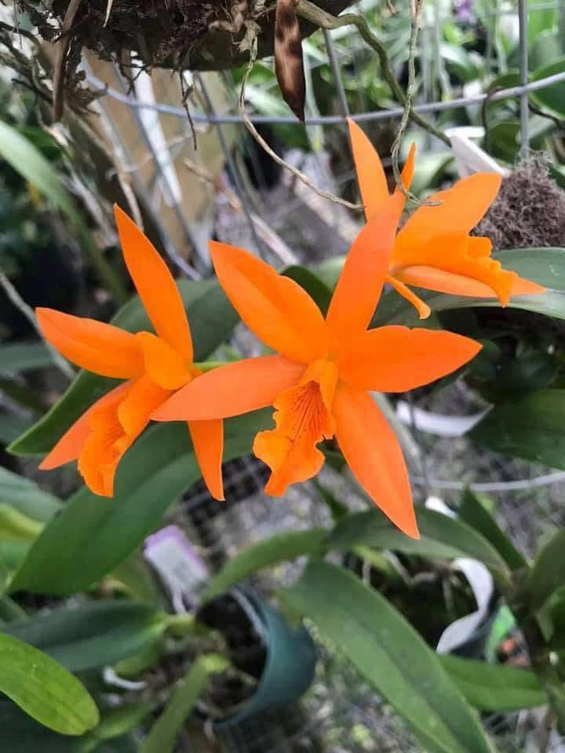 | 3" |  | $22 | $ | Some in sheath
ADD PHOTO | C. Love Knot x C. walkeriana (C. Atticus) | 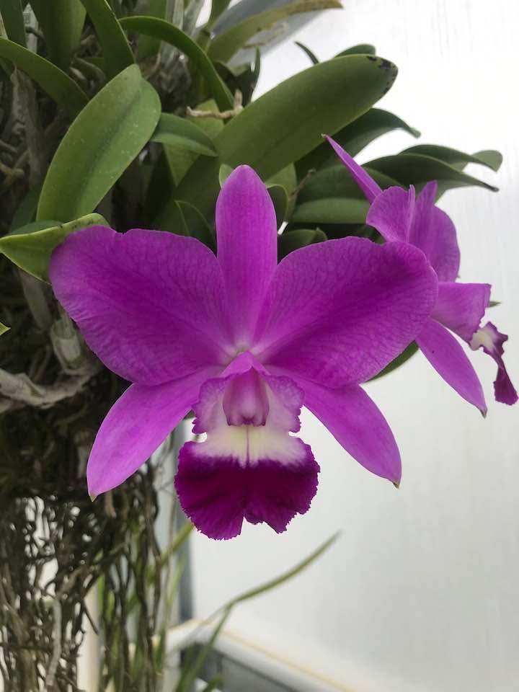 | 3" |  | $22 | $
ADD PHOTO | C. Heathii (‘Maribeth’ AM/AOS x self) x sib | 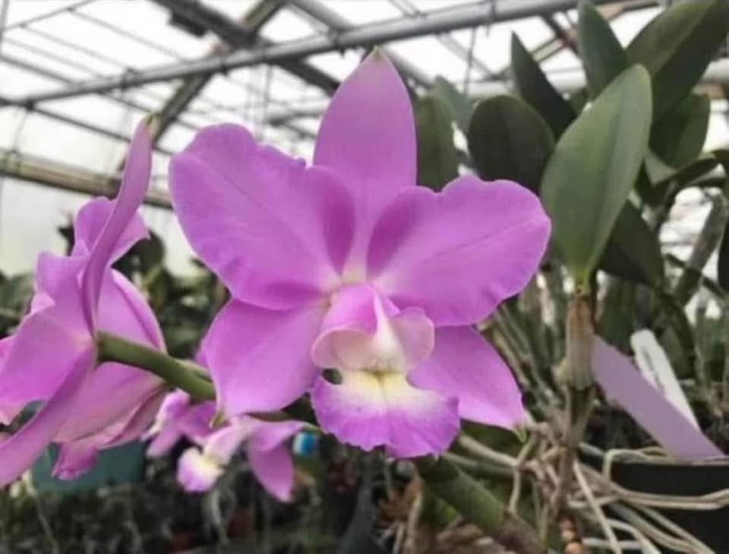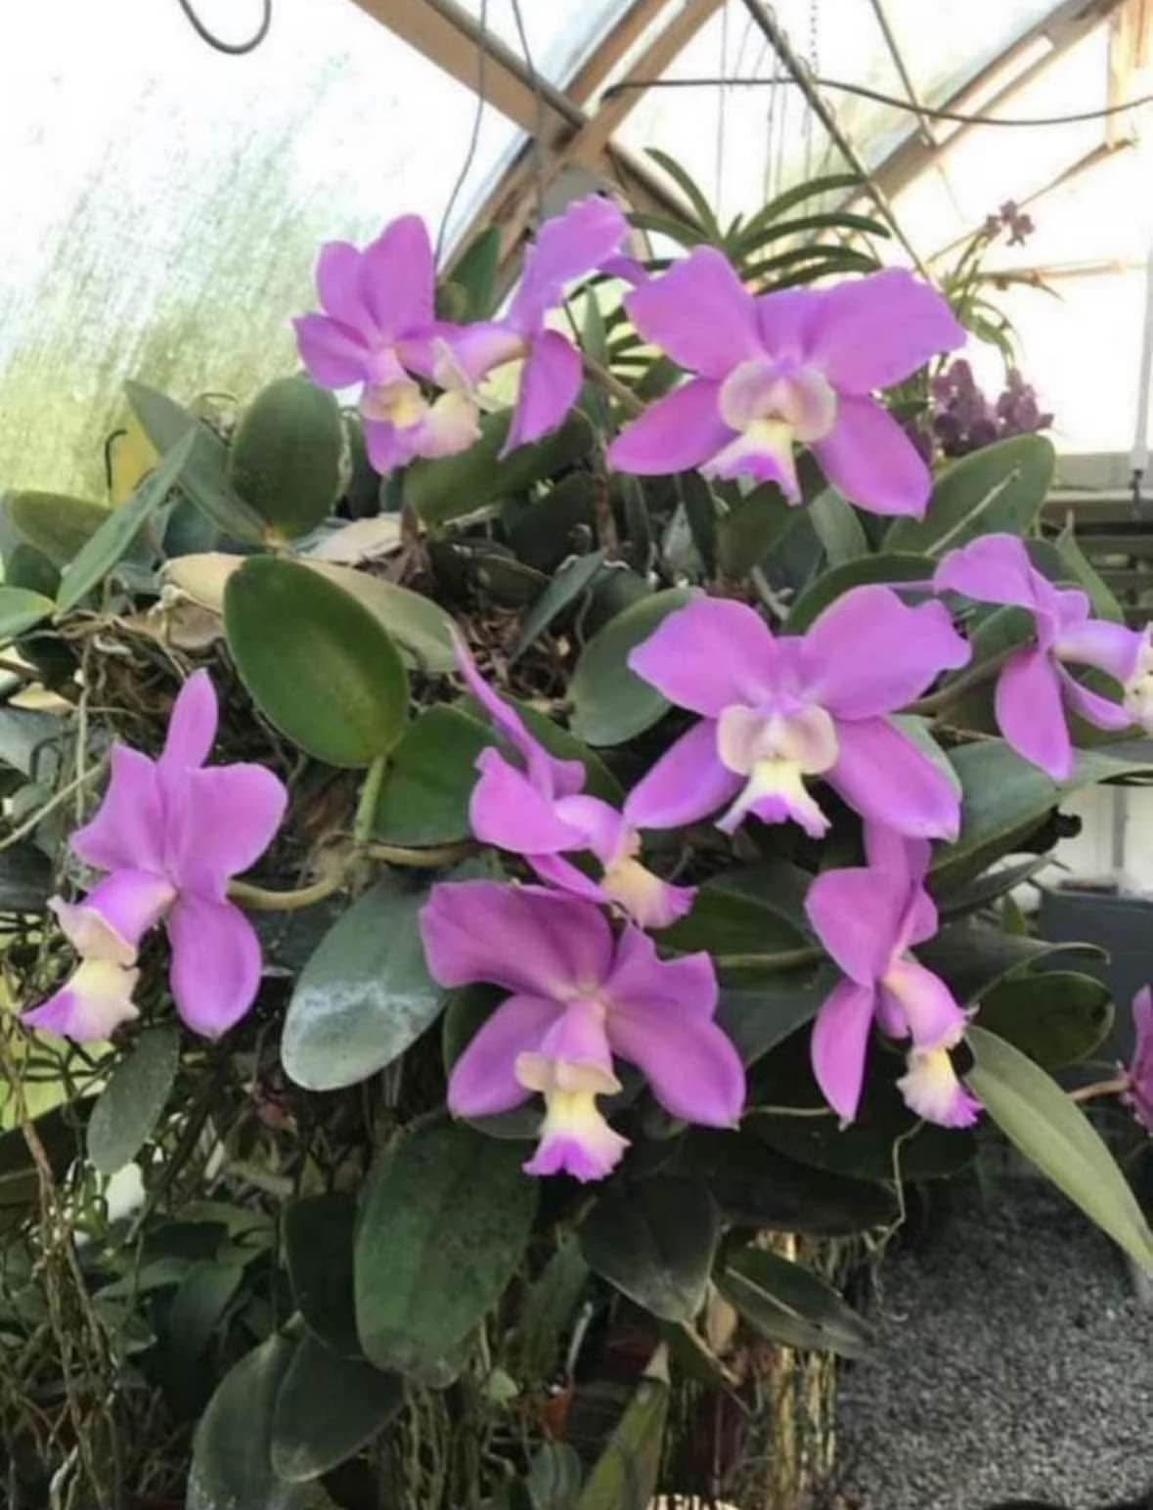 | 4" |  | $25 | $ | Near blooming size
ADD PHOTO | C. Creation 'Summer Choice' x C. Mini Song 'Petite' | 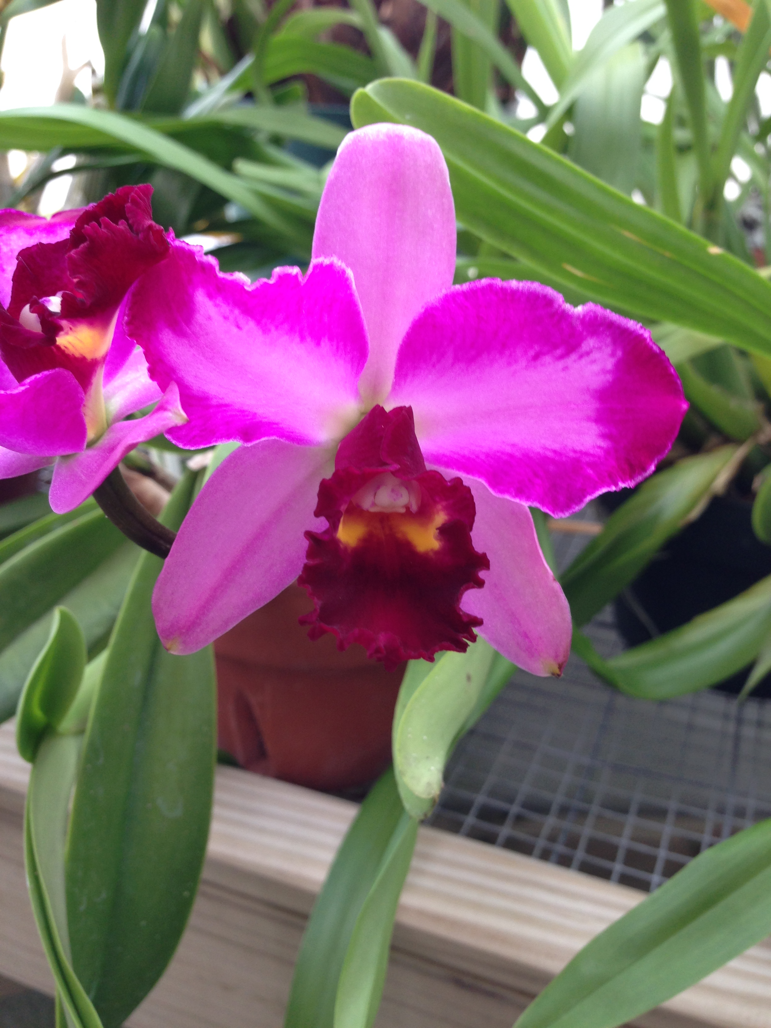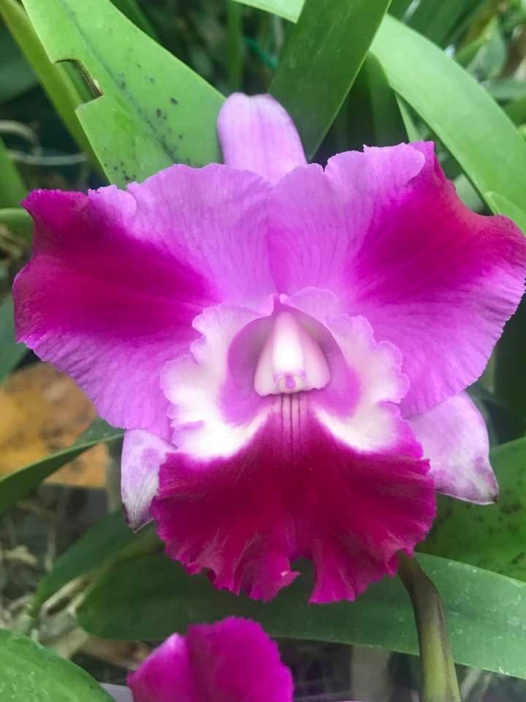 | 3" |  | $15 | $
ADD PHOTO | Lc. Flamingo Dance | 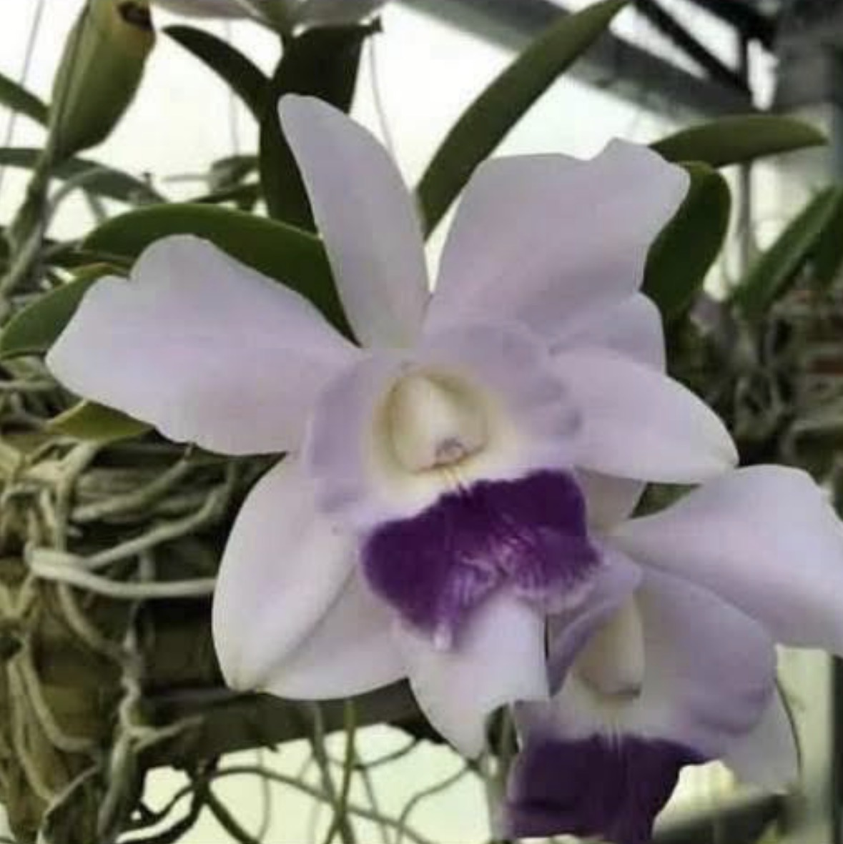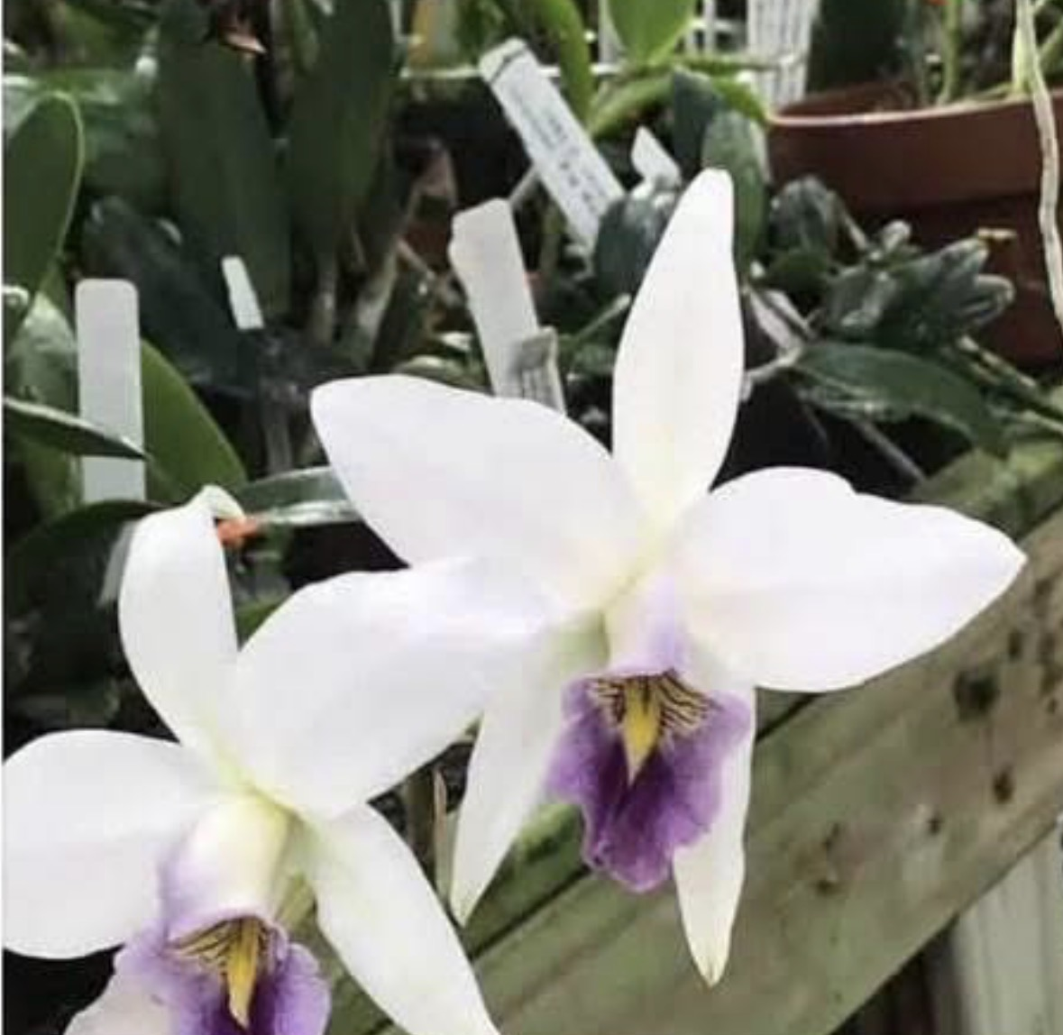 | 3" |  | $22 | $
ADD PHOTO | C. Intercase (C. intermedia ‘Rio’ x C. Aloha Case ‘S &W’ | 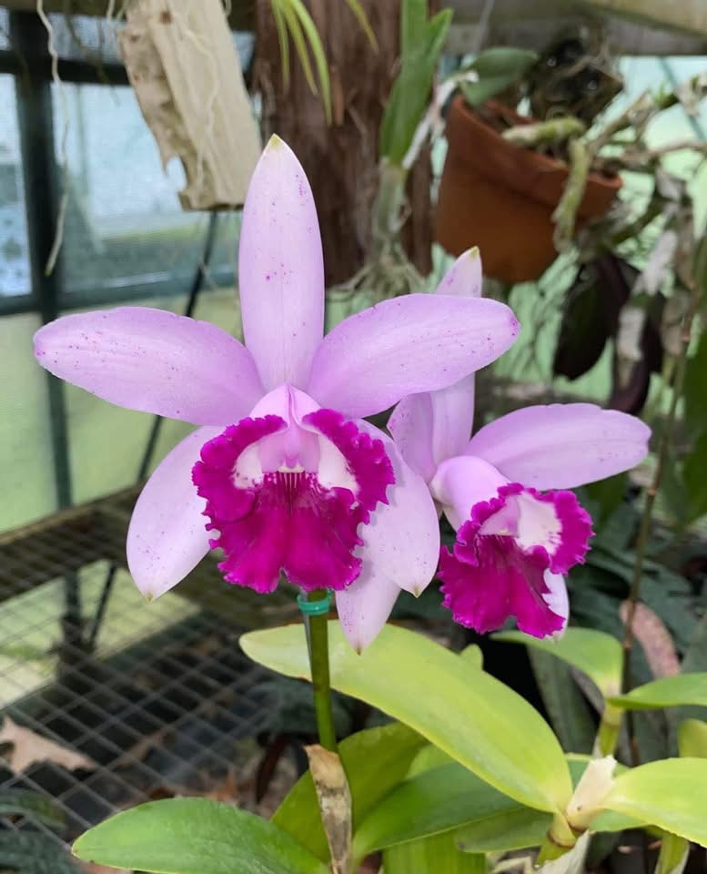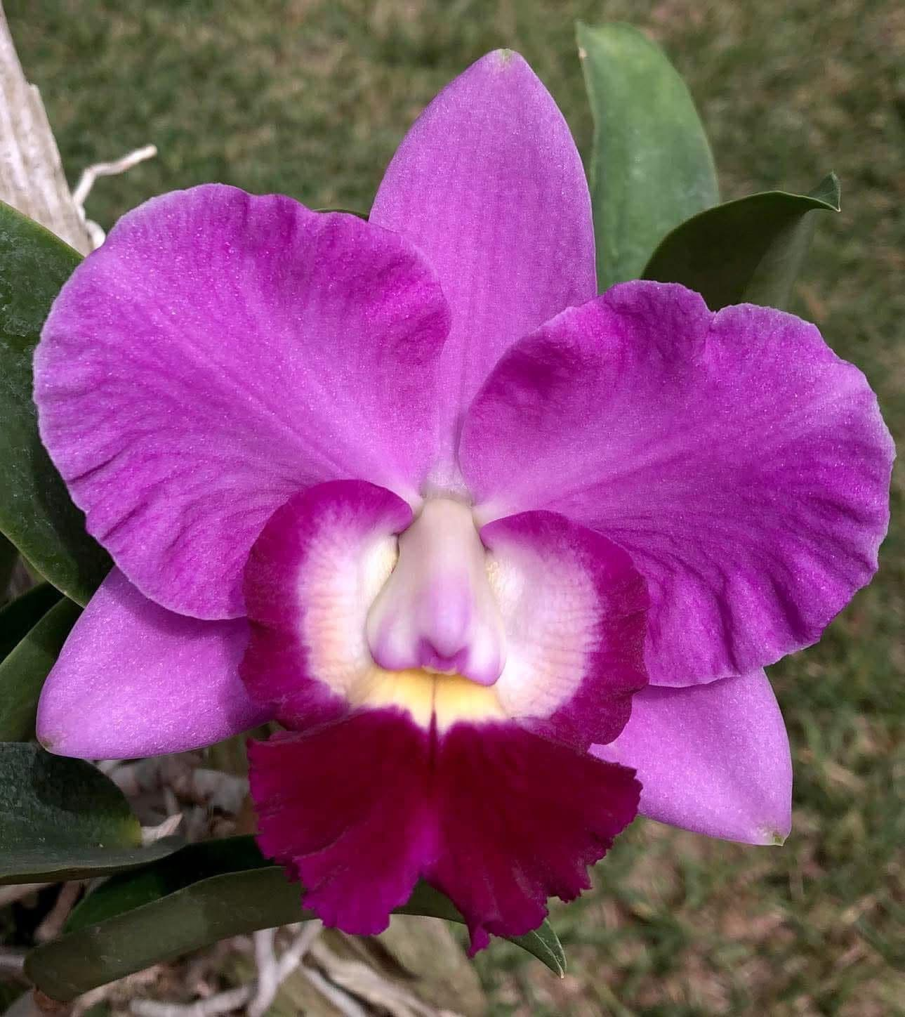 | 4" |  | $25 | $
ADD PHOTO | C. Claesiana (C. loddigesii x C. intermedia) | 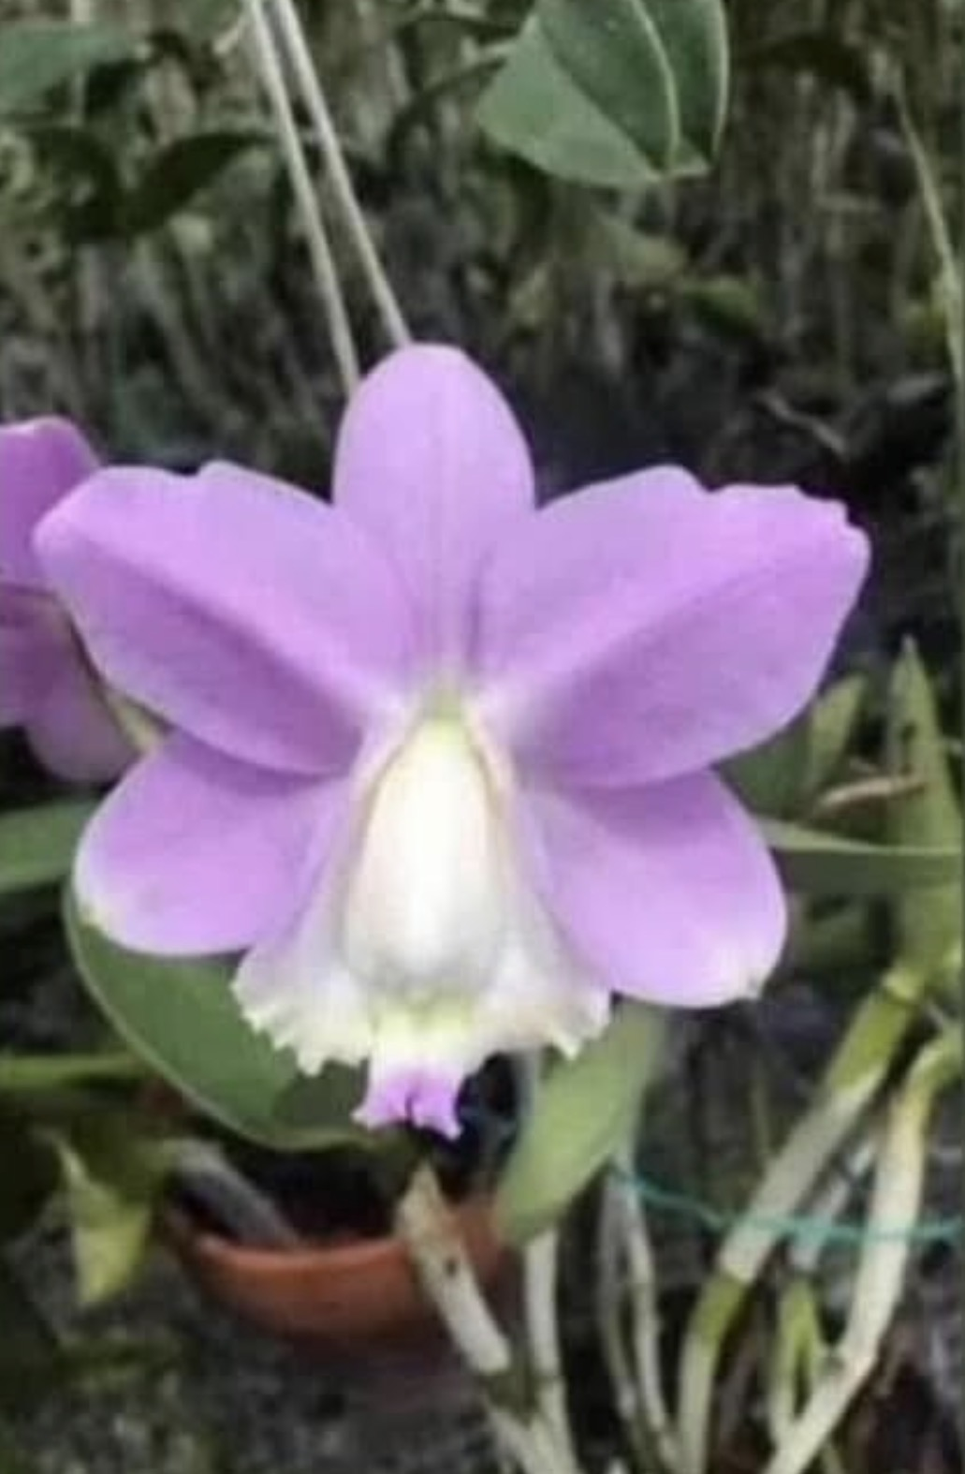 | 4" |  | $25 | $ | Blooming size
ADD PHOTO | C. Valentine x C. Delta Blues | 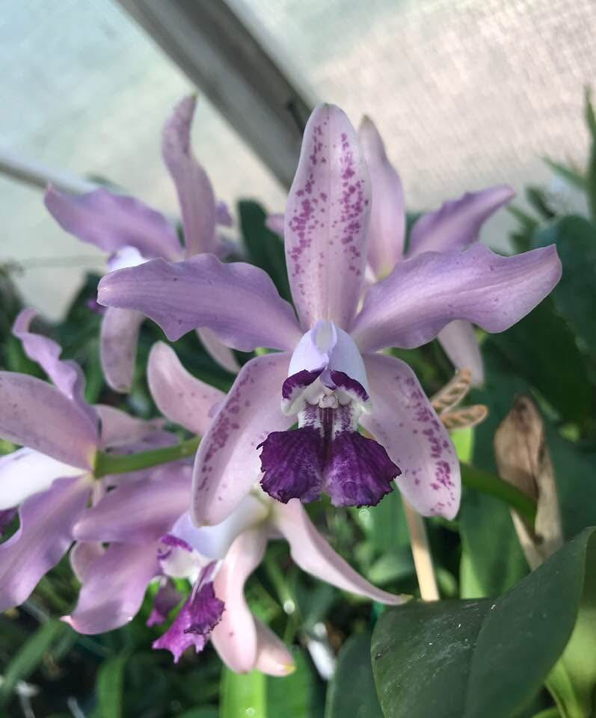 | 4" |  | $30 | $ | 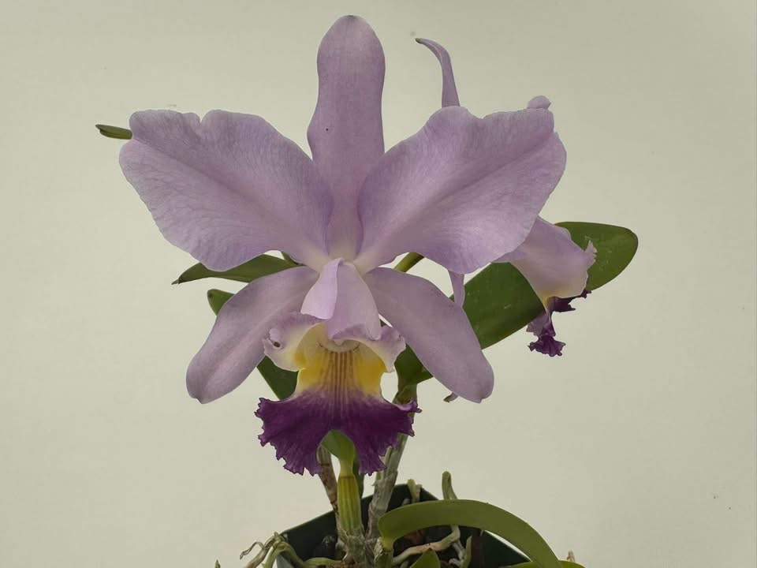  Blooming size  First to bloom
ADD PHOTO | Rlc. Waikiki Jungle 'Carmela' x C. Landate 'Charm’ BM/JOGA |  | 3" |  | $22 | $
ADD PHOTO | C. Valentine x self |  | 4" |  | $30 | $ | 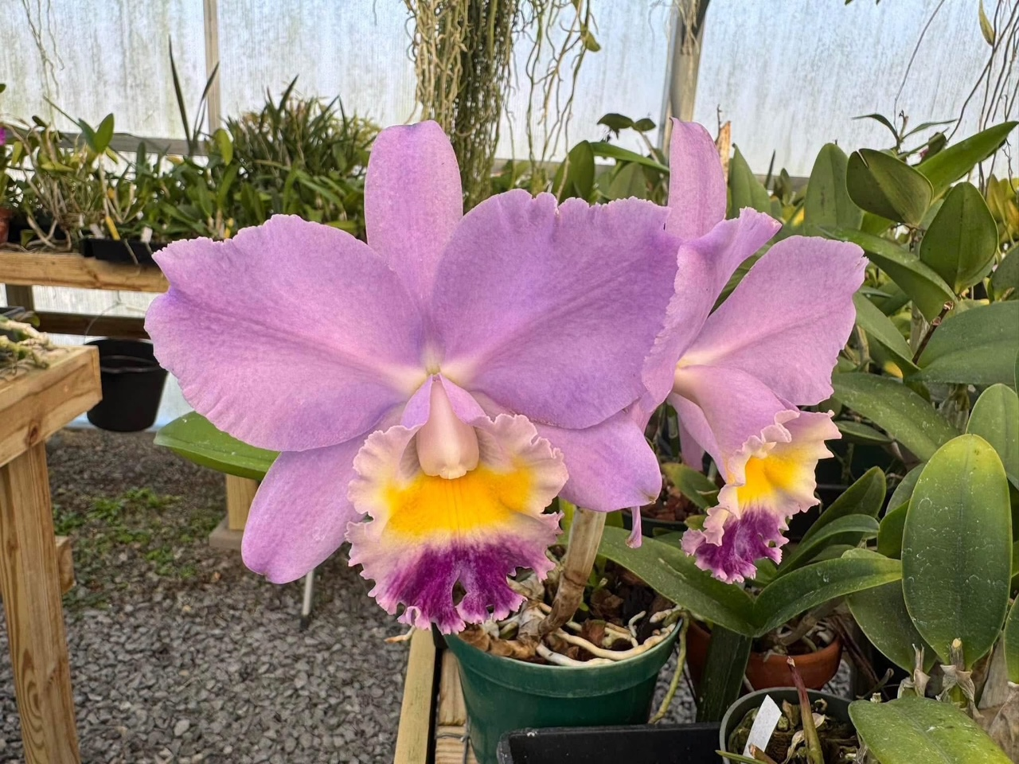  Blooming Size  Babies are better than parent!
ADD PHOTO | Rl. glauca x Rl. Glauca (‘Bob’ x ‘Mabel’ | 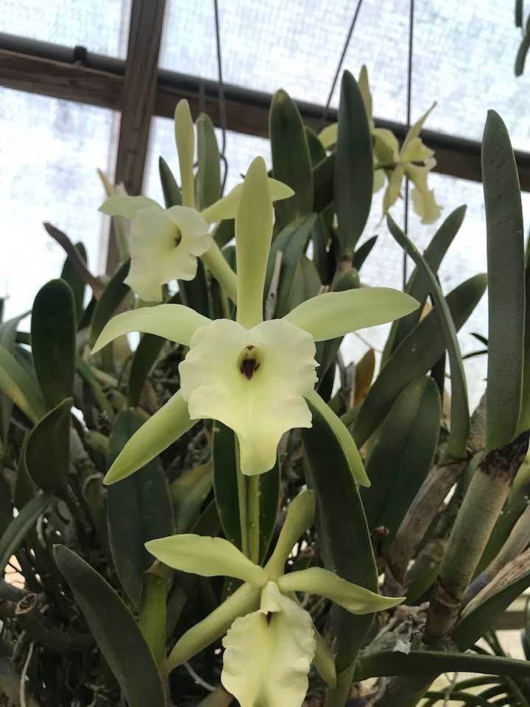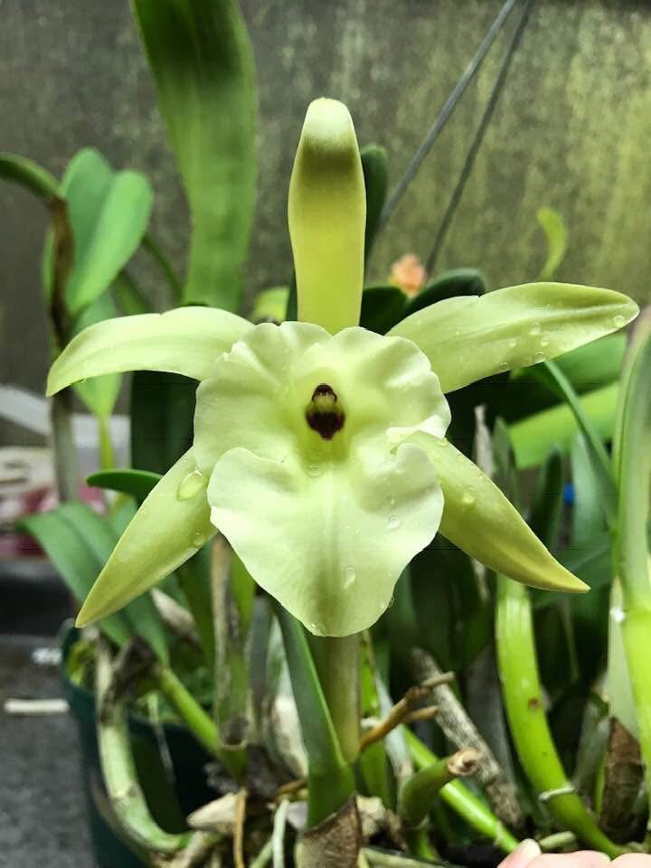 | 4" |  | $25 | $
ADD PHOTO | C. intermedia 'Whipperwill' x 'Celeste' | 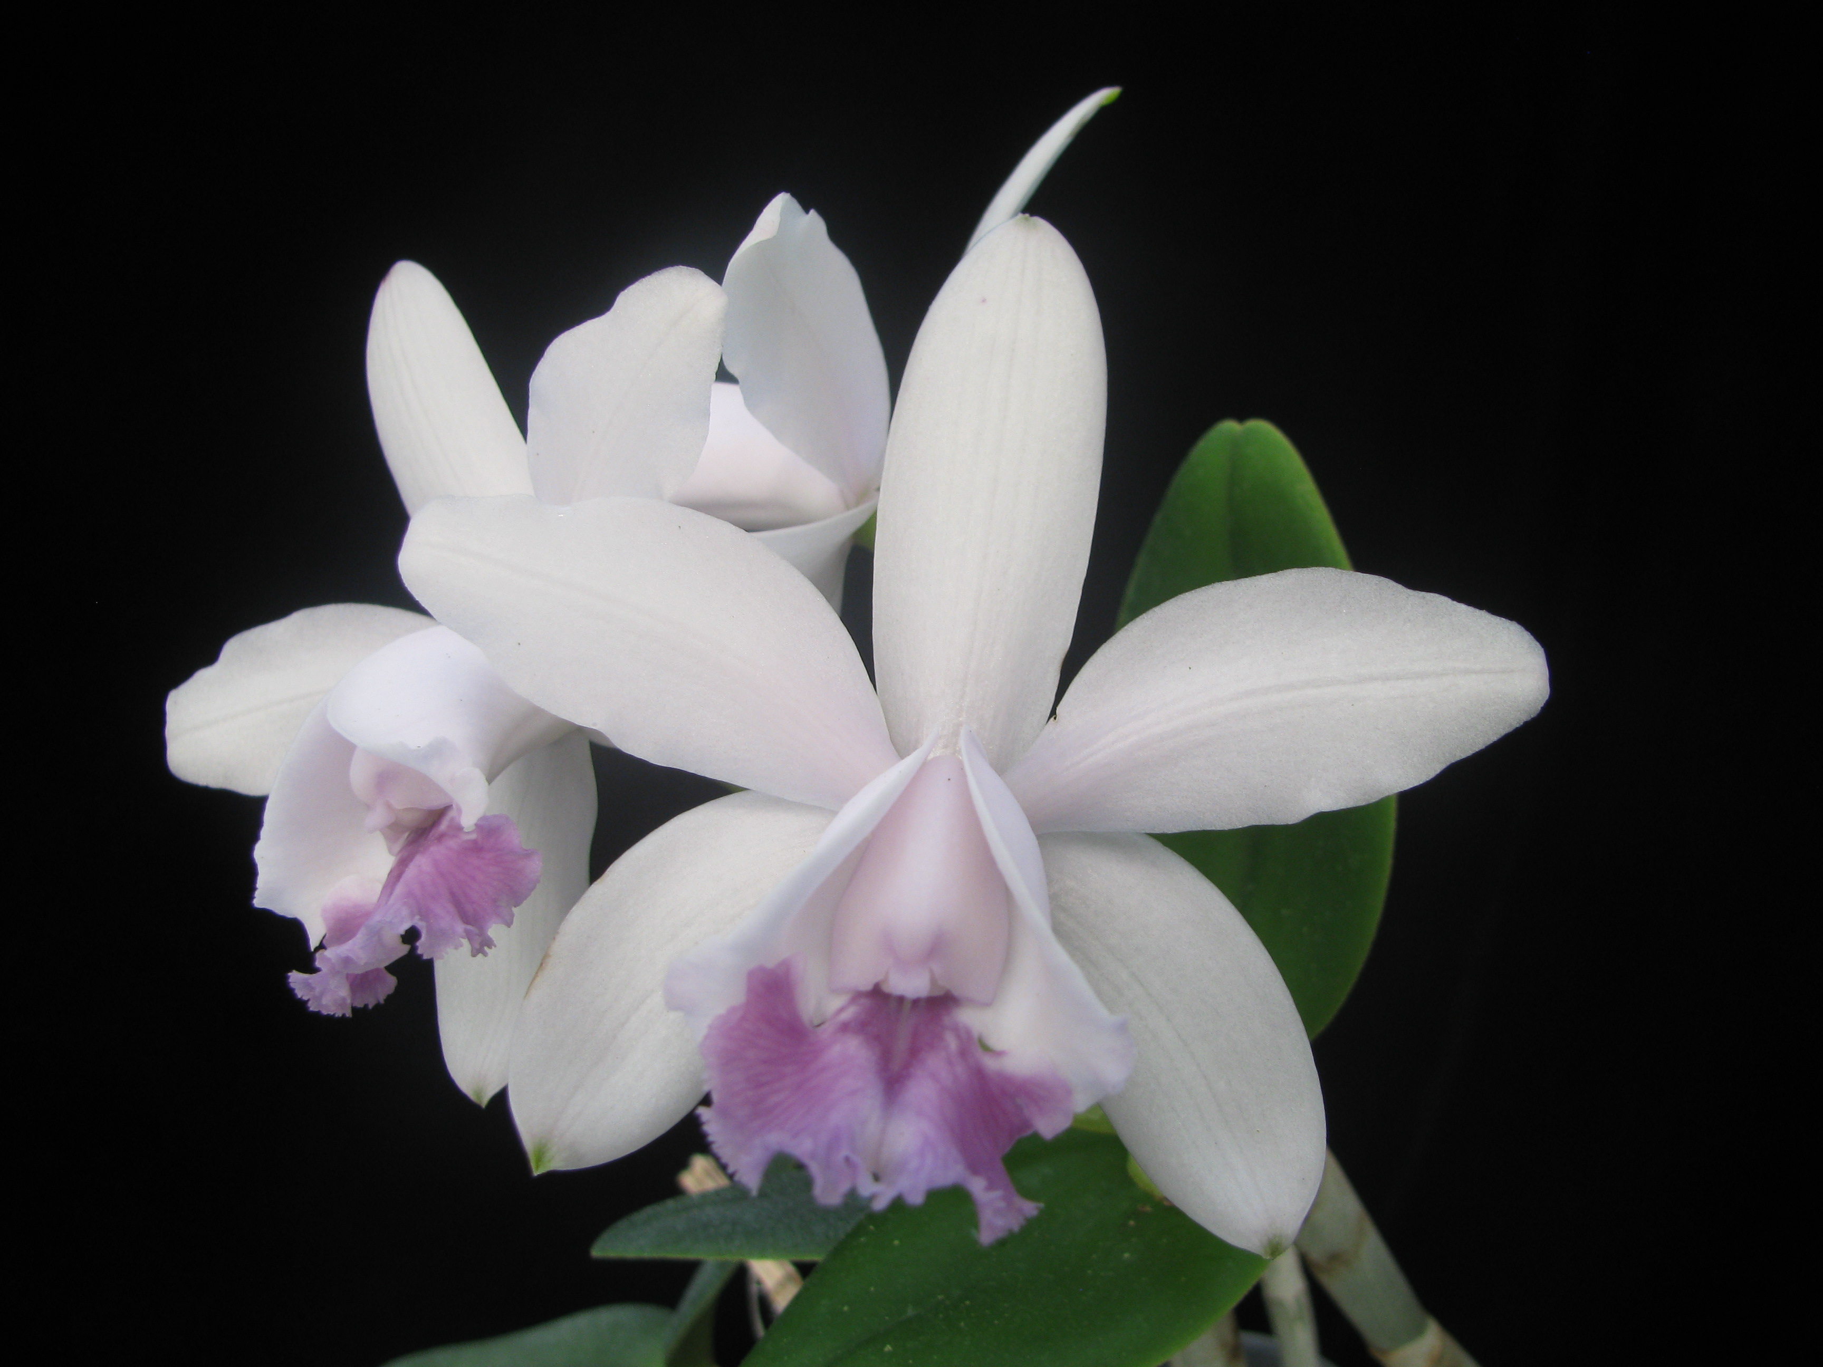 | 4" |  | $25 | $ | Blooming Size
ADD PHOTO | Rl. glauca ‘Bob’ x Fuchs Orange Nugget ‘Lea’ AM/AOS | 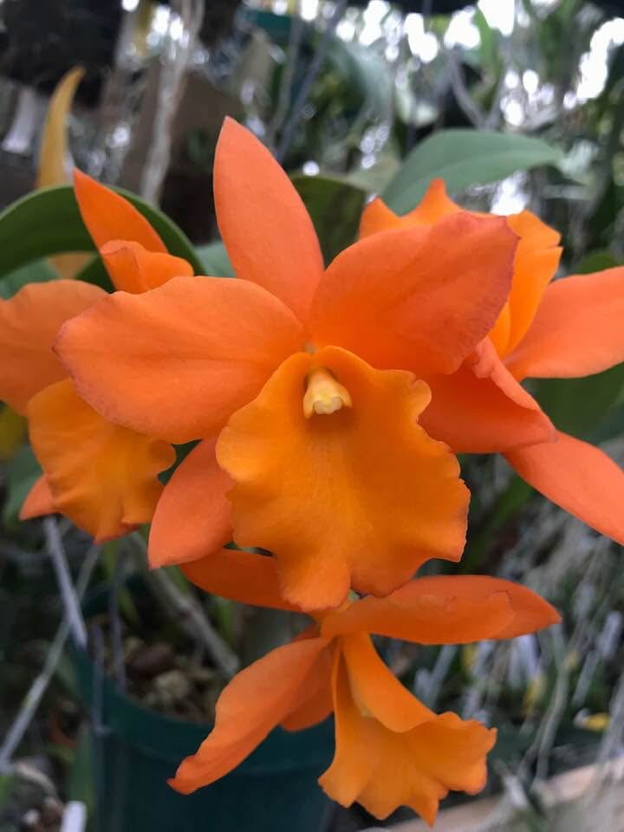 | 4" |  | $25 | $ | Blooming Size
ADD PHOTO | Rlc. Branyan ( C. Mini Purple ‘Tamiami’ AM/AOS x Rlc. Waikiki Jungle  ‘Carmela’) | 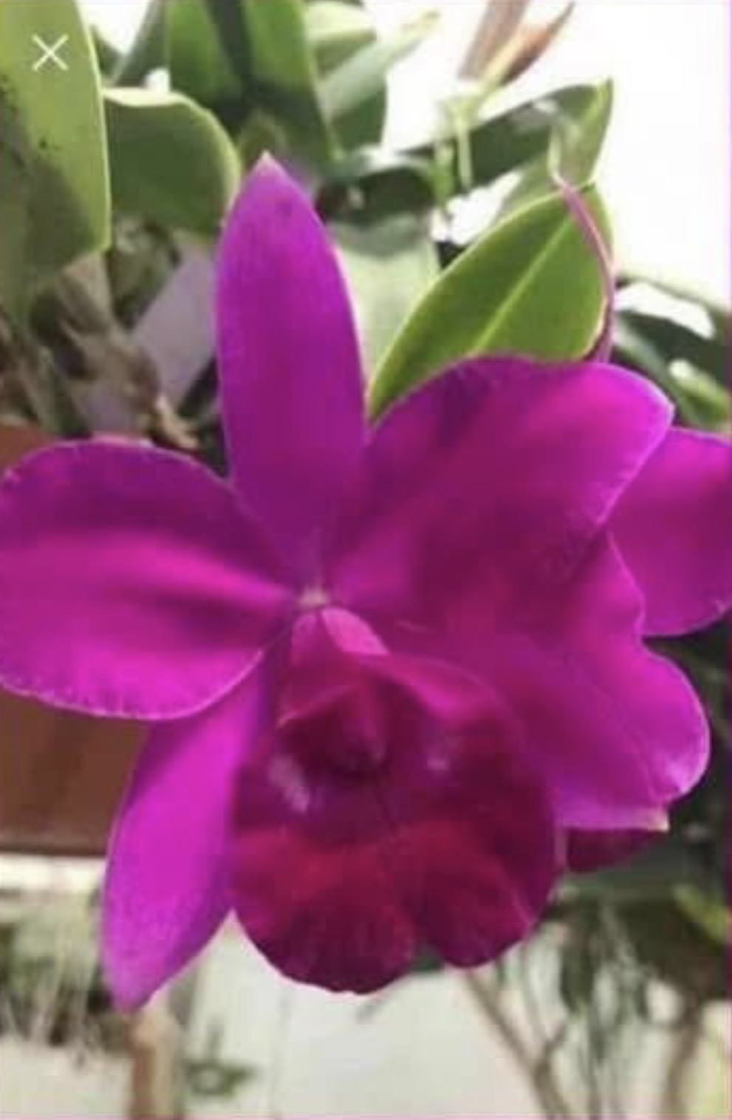 | 4” |  | $30 | $ | 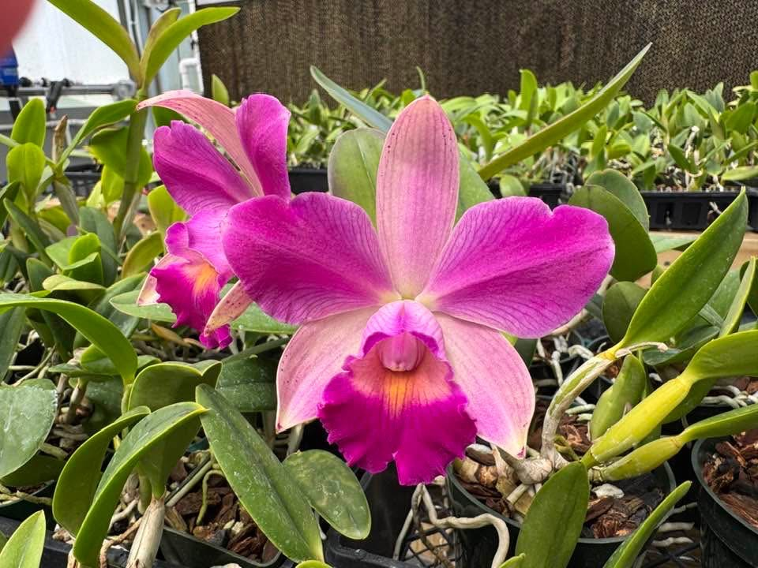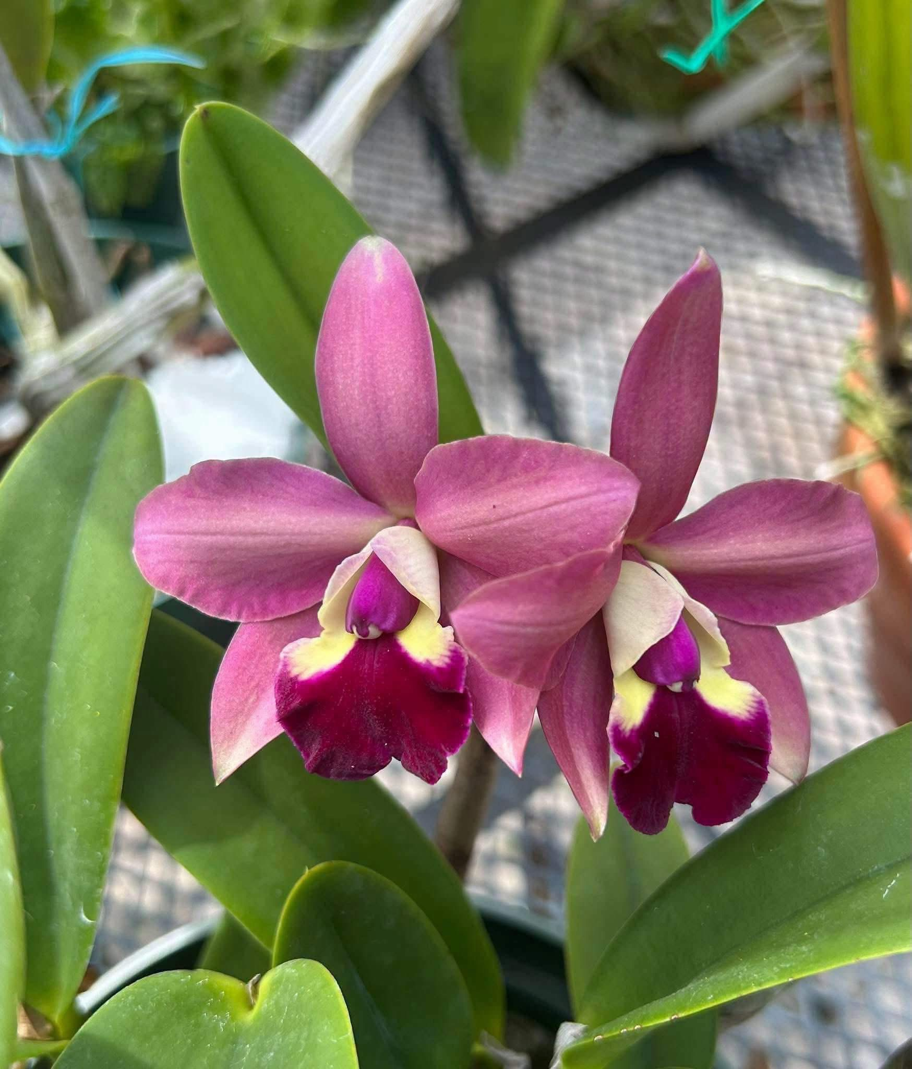  One has been awarded already
ADD PHOTO |  |  |  |  | $ | $
ADD PHOTO | Phal. bellina coer x Phal. violacea indigo | 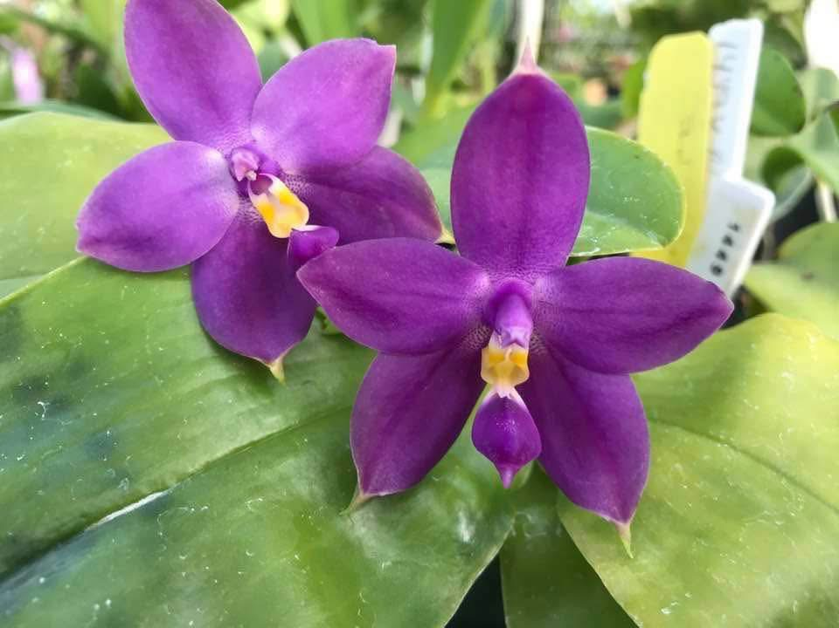 | 2” |  | $15 | $ | Seedlings
ADD PHOTO | Ctt. Petitpetit Candy 'Acane' x Rlc. Hawaiian Prominence ‘America’ | 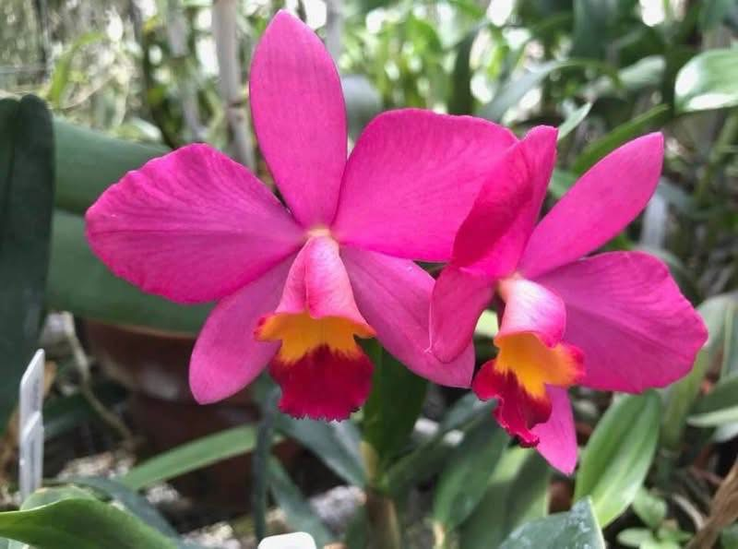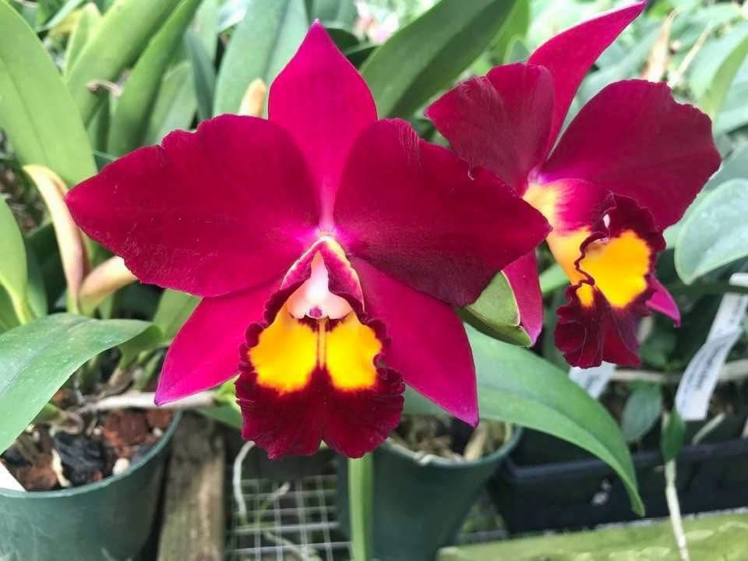 | 2” |  | $15 | $ | 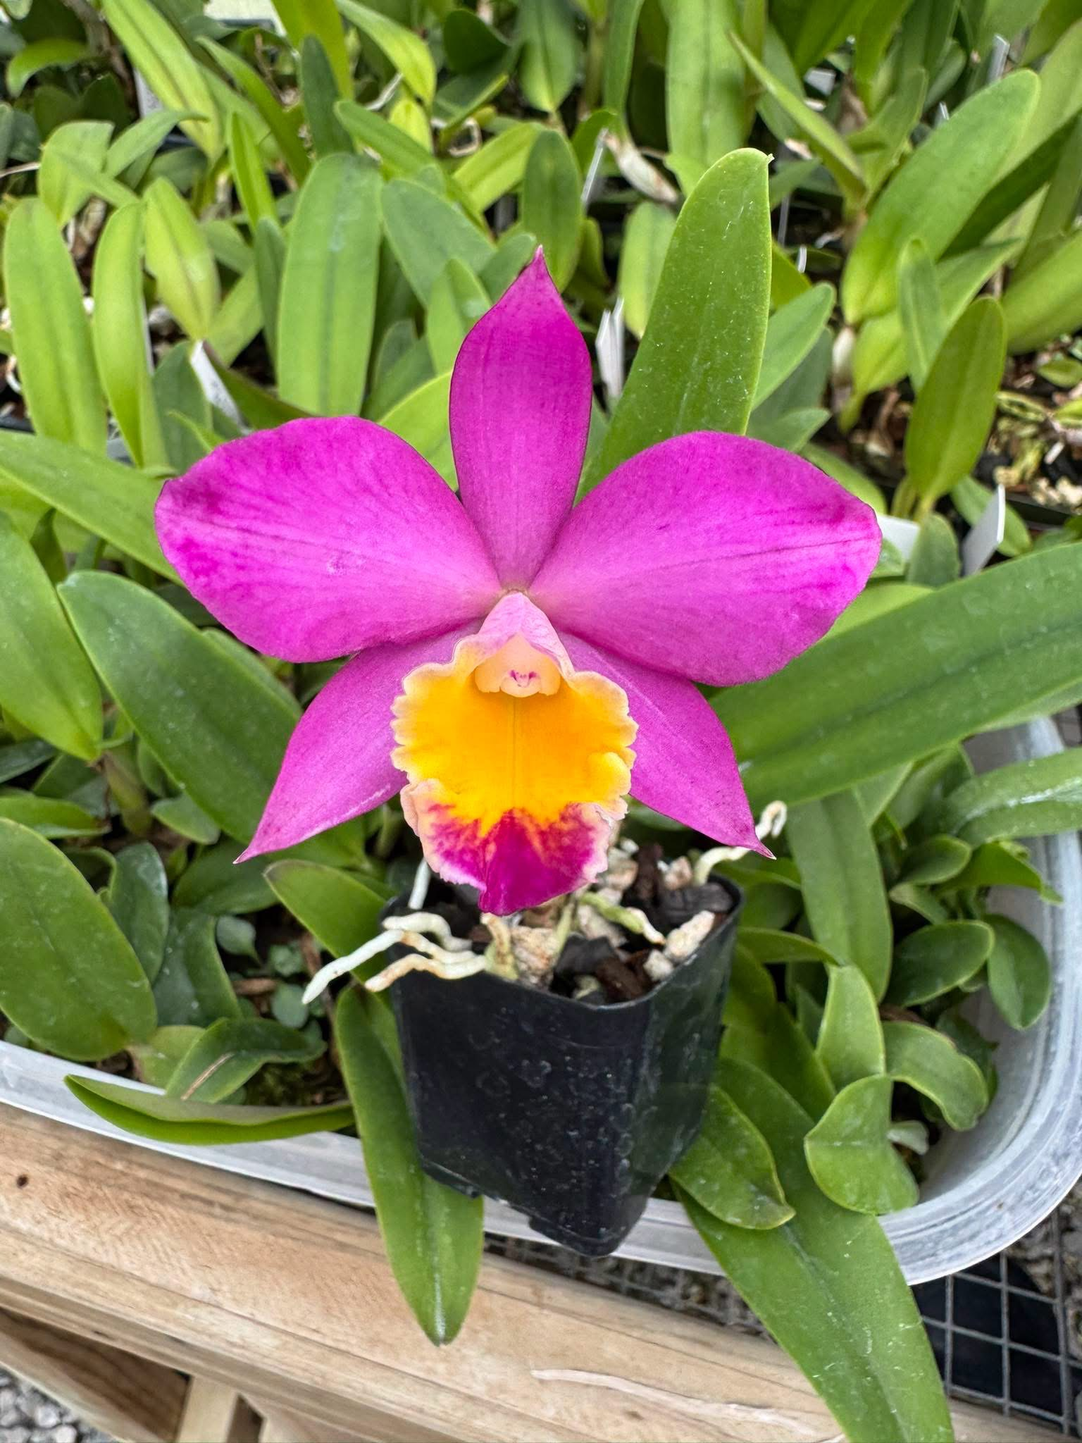  First baby to bloom in 2” pot

Subtotal | $
Tax / Other | $
TOTAL | $
All pre-orders must be received by Sept 1, 2026 and paid prior to the show
You may either print this form and fill in the quantities and snap a photo or simply write down your choices. Either way, email your list to whippetdoc@bellsouth.net. I will then send you a Paypal invoice, Please provide your Paypal email with the list. If Paypal is not an option for you let me know with your order and we can discuss other payment methods. I can’t wait to meet everyone in person and have some fun!
***Spoiler!!! There will be some new crosses debuted at the show***

