
Labor and Service Workforce Audiences Promotion Bundle

Drop-In Articles

To Use: You can post these articles to your organization’s website, publish them in your organization’s newsletter, and/or send them to a local newspaper or magazine. Consider posting these articles to your website or blog and sharing on social media channels such as LinkedIn and Twitter. Fill in the yellow highlighted portions with details specific to your lifestyle change program.

Article #1
Take care of yourself to be there for those you love.
Family and friends are an important part of your life. You love them, care for them, and most importantly you provide for them. But do you know what they need the most? YOU! They need you to be there for them in the long run for warm hugs, shared memories, and family traditions.
Providing for your family financially is only one way you care for them. Staying healthy is crucial to your ability to work and enjoy time with family and friends. Taking care of your health helps you stay strong for those you love.
Type 2 diabetes is a serious condition that affects how the body turns food into energy. It impacts millions of Americans and can affect their health as well as their ability to provide for themselves and others.
Find out if you are at risk for type 2 diabetes by taking the 1-minute Prediabetes Risk Test. If your score shows you may have prediabetes, talk to your doctor about getting a blood sugar test to confirm your result. Without changes to your lifestyle, prediabetes can lead to type 2 diabetes and other serious health conditions.
If you do have prediabetes, the National Diabetes Prevention Program (National DPP) lifestyle change program can help you take control of your health. The lifestyle change program is led by the Centers for Disease Control and Prevention (CDC) and is here to be a part of your community and support system. Learn more about [name of program] part of the National DPP, at [insert link to program website]. We’re here to help you get started today on building a better future for you and those you care about. You’ll be surrounded by a support group of people with similar goals and challenges.

[Highlight testimonials because they are a powerful trust-building tool for first-time visitors and motivation for those already in the program. You can add quotes, video, audio, or link success stories.]
The goal of the lifestyle change program is to support you and provide the tools you need to keep you at the top of your game. In the program, your Lifestyle Coach will help you make little changes in your lifestyle that can have lasting positive effects on your health. [Insert challenges relevant to your audience such as feeling tired, working long shifts, or being busy with work for certain seasons of the year and include testimonials if you have them].
We offer classes [insert details about program times, especially virtual/hybrid options, language, and any information on incentives to help support people’s participation].

Article #2
Stay healthy together for a bright future!
You work hard providing for your family. Long hours can be exhausting, leaving little time and energy for activities to support your health. But you don’t have to do it all alone; together with your family, you can choose a realistic and enjoyable routine for you.
Whether you work outside the home or are the full-time caretaker of other family members, you play an important role in your family’s health. Encourage each other to live healthier together! Motivating your family to live better with healthier food choices and lifestyle habits can help them prevent or delay type 2 diabetes too.
Type 2 diabetes is a serious condition that impacts millions of Americans and their ability to be healthy for the things that matter to them. Type 2 diabetes affects how your body turns the food you eat into energy. This causes your body’s blood sugar levels to be much higher than normal and can lead to other problems like heart disease or vision loss. These problems can severely impact your daily life and work.
The first step in taking charge of your health and your family’s health is taking the Prediabetes Risk Test together with other adults in your family. If your score shows you may have prediabetes, talk to your doctor about getting a blood sugar test to confirm your result.
The National Diabetes Prevention Program (National DPP) lifestyle change program led by the Centers for Disease Control and Prevention (CDC) is here to help make your future as healthy as possible. If you or another adult family member are ready to reduce your risk of type 2 diabetes, learn more about [name of program] at [insert link to program website].
With the National DPP lifestyle change program, you can learn ways to make small changes in your lifestyle that work for you and your family’s needs. Eating more nutritious foods, adding physical activity to your routine, and managing stress are three key areas where the lifestyle change program will support you. We know you do a great job supporting your family, so let the lifestyle change program help you support your family too!
[Highlight testimonials because they are a powerful trust-building tool for first-time visitors and motivation for those already in the program. You can add quotes, video, audio, or link success stories.]
[Name of organization] is here to help you make healthier living a normal part of your day. We offer classes [insert details about program times, especially virtual/hybrid options, language, and any information on incentives to help support people’s participation].

Put the lifestyle change program to work for you and your family and learn more today at [link to program website]!

E-Newsletter Copy

To use: The following e-newsletter copy can be used to promote the program in online e-newsletters and email blasts. Consider placements in a community newsletter, local health care provider or network newsletter, and/or faith-based newsletter.

E-Newsletter #1
Take care of your family for a healthier future.
Your influence can guide the behaviors and attitudes of your family. Having healthy habits in your home can encourage your loved ones to pick up those habits too. [Name of organization] is here for you and your family to support you in building a healthier future.
One of the ways we do this is through CDC’s National Diabetes Prevention Program (National DPP) lifestyle change program. Millions of US adults have prediabetes, a condition where their blood sugar levels are higher than normal and their risk for type 2 diabetes is increased. With the National DPP lifestyle change program, the goal is to help you prevent or delay type 2 diabetes and keep you healthy for what matters most to you.
You are there for your family after long hours and busy work weeks. You can be there too for their health with the National DPP lifestyle change program, which can help you learn ways to apply small changes to your lifestyle that work for you and your family’s needs. Encouraging healthy eating, reducing stress, and getting at least 30 minutes of activity, indoors or outdoors, 5 days a week can improve your health, and the lifestyle change program will help you do just that.
Be that support for your loved ones and start healthy habits to prevent or delay type 2 diabetes. The healthy changes you and your family make don’t have to be drastic. Try one of these tips today:
- Eat smaller portions of foods that have lots of carbs and sugars (such as rice, pasta, bread, and potatoes) and unhealthy fats (such as fried foods).

- Add more fruits and vegetables to your plate. With smaller portions of high-carb foods, you’ll have more room to load up on nonstarchy veggies and fruits. Try having a side salad to round out your meals. Your goal is to have a plate that’s full of color from the fresh foods you’re adding in.

It may seem like a lot at first, but take it one step at a time and allow the National DPP lifestyle change program to support your family too! For more information on the program and how to enroll, visit [insert organization website].

E-Newsletter #2
Healthy you + healthy family = happy and healthy life!
We want you to stay healthy for a better life with those you love. You work hard to support your family. Make sure you also work towards a stronger and healthier version of you.
You want to be able to continue to provide for your family, and taking care of your health will allow you to be more confident of your future. Prediabetes is a health condition that can impact your ability to work and stay energized, as higher-than-normal blood sugar levels may lead to getting type 2 diabetes and serious health problems like vision loss, heart attack, or stroke.
Get ahead of your health to ensure that prediabetes and type 2 diabetes won’t slow you down. The good news is that even if you have prediabetes, now is the perfect time to make healthy changes that can prevent or delay type 2 diabetes. Here are some steps to take care of your health so you can continue to take care of those you love:
- Learn about your risk for prediabetes by taking the Prediabetes Risk Test. It only takes a minute!
- Join CDC’s National Diabetes Prevention Program lifestyle change program. This program can help you make healthy changes to prevent or delay type 2 diabetes, including eating favorite foods in healthier ways, getting more physical activity, and managing stress for better health.
- Make some health goals with your family and friends. This could mean adding more fruits and vegetables to meals or getting outside together for a walk.
- Don’t be afraid to reach out for help. It can be difficult to live healthier with all you have going on! That’s why the lifestyle change program is tailored to your needs and schedule and led by a trained Lifestyle Coach to work with you on your health goals.

Seeking help to get your health on track is the perfect way to support your family. Think of the relief they’ll feel knowing you are finding out your type 2 diabetes risk now and doing something about it. The lifestyle change program can help you get started on a healthier life today. For more information on the [name of program] and how to enroll, visit [insert organization website].

Social Media Images & Post Copy
To use: You can use the following social media post copy and images on Facebook, Instagram, and Twitter. Photos are available for download on the 1815/1817 Box site. Links have been provided below each photo.

Post Copy | Recommended Image
Every day you get it done … providing for your family and caring for your community. Bring that can-do attitude to your health with CDC’s National Diabetes Prevention Program lifestyle change program. Get the tools you need to lower your risk of type 2 diabetes and stay healthy for what matters most. [URL] | 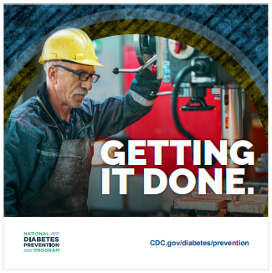  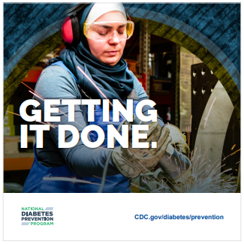  Download Image
You know what it takes to produce a bountiful harvest. While you wait for the harvest, come learn how to cultivate better health for you and those you love. CDC’s National Diabetes Prevention Program lifestyle change program will help you plant the seeds for a healthier future. See how your work can pay off at [URL]. | 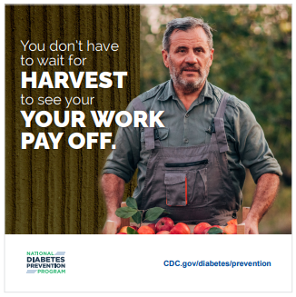  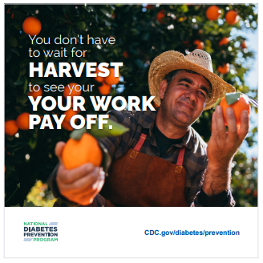  Download Image
You can’t take care of your family if you’re not taking care of yourself while out on the water fishing. Join CDC’s National Diabetes Prevention Program lifestyle change program and get hooked on some simple changes that keep you strong and help you prevent type 2 diabetes. Learn more at [URL]. | 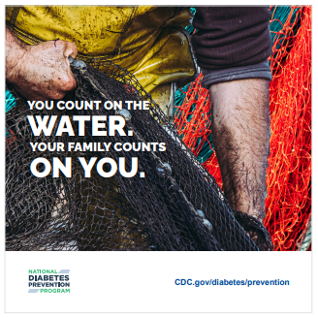  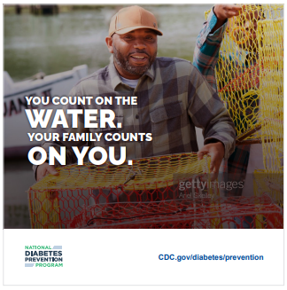
We know you work hard to provide and care for your family. That’s why it’s important to take care of yourself too. Join CDC’s National Diabetes Prevention Program lifestyle change program and see how simple changes can lead to a healthier future for you and those you love. Learn more at [URL]. | 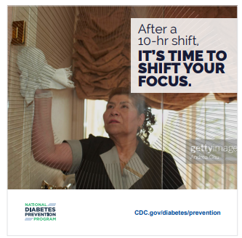  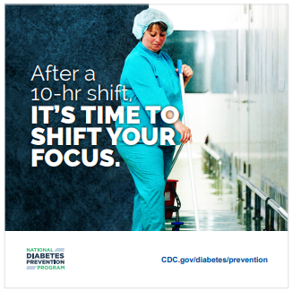  Download Image
Put your health at the top of the menu. Nourish yourself to better health by joining CDC’s National Diabetes Prevention Program lifestyle change program. You’ll learn to make changes with simple tips that could help lower your risk of developing type 2 diabetes. Learn how at [URL]. | 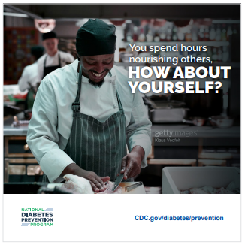    Download Image

Additional Promotional Resources

Beyond the content provided in this bundle, there are many other marketing and training materials available for your use in promoting the lifestyle change program. As you consider the demographics of your audiences, you may find some of the following materials helpful in engaging local labor communities.

Using the audience insights discussed previously, as well as the tips for cultural tailoring, you can adapt these materials to meet the needs of your diverse communities. Remember, you can use the 1815/1817 photo bank for images that may better represent the populations you are engaging.

National Diabetes Month Testimonials. Bundles include participants Glenn and Jack, both of whom are truckers, in recognition of National Diabetes Month in November. Their bundles feature their stories, posters, postcards, and social media with their pictures.

Glenn’s Testimonial. Glenn is a trucker who made positive changes in his life through the lifestyle change program. Now, he encourages other men to learn about their risk for type 2 diabetes and sign up for the lifestyle change program. His story is featured in a bundle with written content, an infographic, social media assets, and animated Instagram and Facebook stories.

Joyce and Jack’s Testimonial. Joyce talks about the “fear of finding out” about having prediabetes and how this fear prevented men like her husband from getting screened. Their story is told through written content in this bundle, which also includes social media assets.

Tom’s Testimonial/Men’s Health Month. Tom is a former military service member who was able to change his health by participating in the lifestyle change program. His bundle includes standard written content and social media post copy that can be customized for your organization.

Animated Testimonial Videos. Glenn and Tom tell their stories in these animated videos for social media. The videos share audio from interviews with these men and their thoughts on how small changes with the program had a big impact on their health. If you’re looking for new and engaging content, be sure to share these videos on your social media channels.

Engaging Men in the National DPP. This bundle contains insights and various types of written and digital creative content to reach out to male audiences to promote the lifestyle change program. If the labor industry audiences you are engaging include mostly men, you may want to adapt and include some of these pieces in your promotions. The bundle also offers tips on tailoring your messages for men and adapting messages based on cultural considerations.

