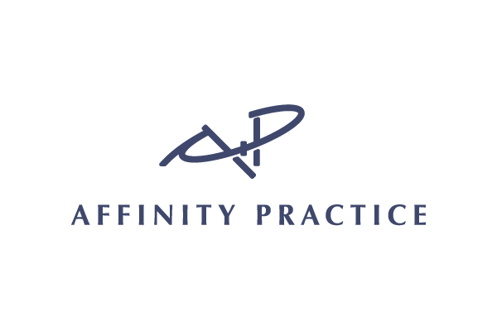

**Introducing Affinity Practice**

Dr. Rhian Morcott is a board-certified psychiatrist in Adult Psychiatry and Child and Adolescent Psychiatry with over twenty years of experience, who recently opened a private practice, Affinity Practice, in Lake Bluff, IL.  She also completed a fellowship in Integrative Medicine from the University of Arizona with Dr. Andrew Weil.

Dr. Morcott has both personal and professional experience with the issues faced by the food allergy community.  As a mother of a now young adult with a life-threatening peanut allergy and asthma, she genuinely appreciates the concerns and challenges that this illness can present to social-emotional development, and this has enhanced her clinical understanding of the tools required to foster growth and resiliency.  She has also been a past keynote speaker for the Food Allergy and Anaphylaxis Network, now a part of FARE.

At Affinity Practice, Dr. Morcott provides personalized care with comprehensive treatment approaches including talk therapy, medications, integrative and lifestyle interventions.  She recognizes that emotional health is complex and is influenced, not only by our genetics and biology, but also by our relationships and the experiences we navigate in life. We are excited to share her information as a resource to our MOCHA community. For further inquiries, please reach out with the contact information below:

Affinity Practice

10 E Scranton Ave, Suite 303

Lake Bluff, IL 60044

312-265-3928

[rmorcott@affinitypractice.com](mailto:rmorcott@affinitypractice.com)

