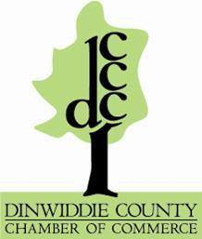
Dinwiddie Chamber of Commerce Membership Meeting
April 22 2020

Welcome
Introductions
- New Board Members
June Pate
Kenneth Byers
Update
-scholarship program
-where to get legislation updates
Discussion
- Any positive stories or impacts to share

- What changes have you made to your business model that are working for you

- What resources have you found beneficial (Share during meeting or afterwards through electronic services)

- What are your biggest concerns moving forward (Share during meeting or afterward through electronic services)

ADJURN we will access feedback on this meeting to evaluate a May meeting

