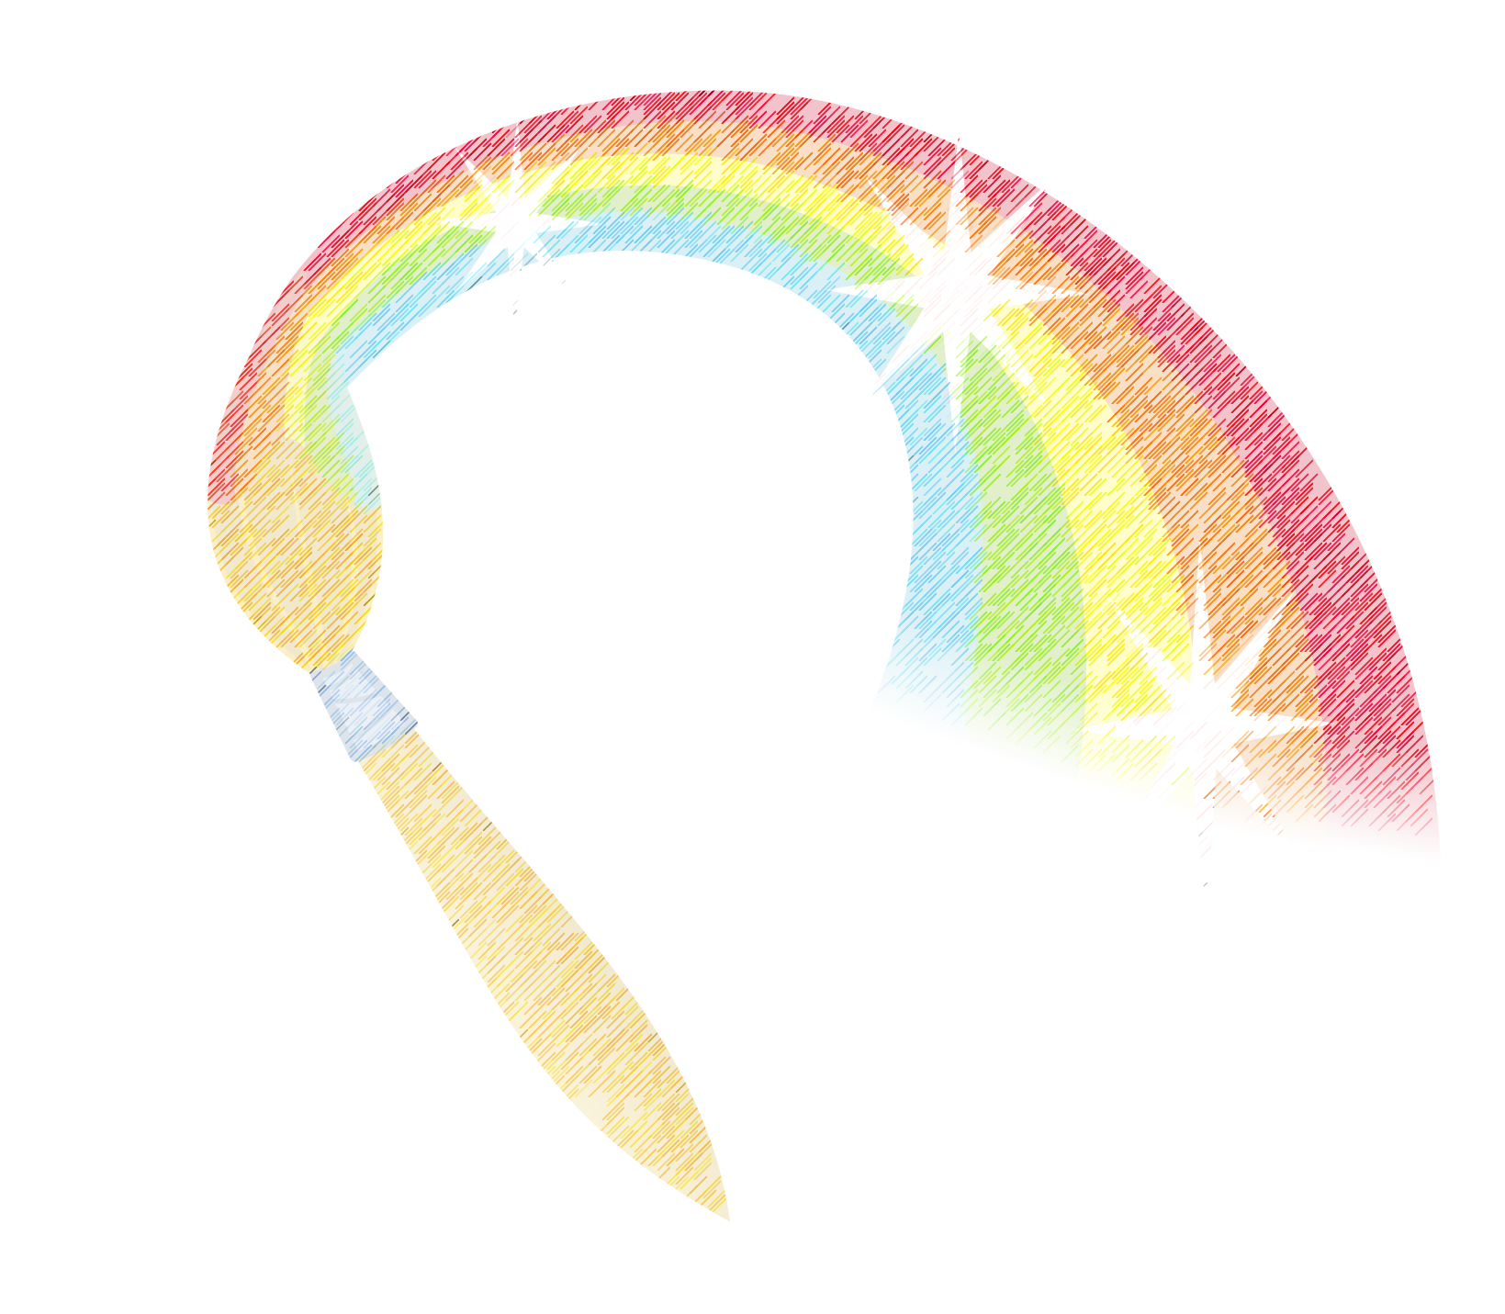
Art News!
WE DID IT! THANK YOU!
Square One is complete and I hope you are enjoying your art keepsakes. Thank you so much for supporting your child’s creativity and our art program. Because of your support, we are looking into being able to purchase a t-shirt screen printer for our art room. What a fantastic art project this will be!
PRIMARY ART
Kindergarten through second grade artists have been learning about Monet. They have been exploring watercolor, tempera and oil pastels to create art in the style of the famous artist’s water lily series. These pictures are so beautiful. I am quite proud of their work.

INTERMEDIATE ART
Third graders are finishing their Monet lessons and beginning to work with collage. They are using textured rubbing plates, marbled papers and textured scissors to make art with cut paper. They are also incorporating grade level art skills from previous lesson into their art. Who knew cutting and gluing could be so much fun? (OK, I did.) Fourth grade students are beginning their ceramics units by creating clay containers. They are learning strategies for joining multiple pieces of clay of together. Of course they are loving this lesson. Fifth grade students are excited to begin clay soon, but in the meantime are working to improve their painting skills by creating silhouette paintings. The results are beautiful.

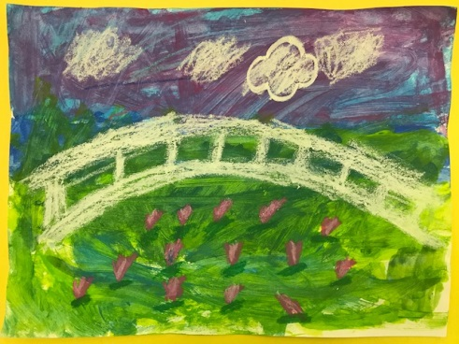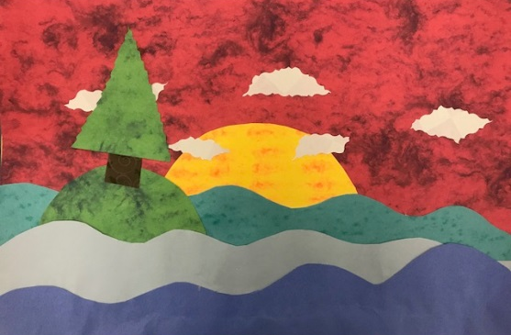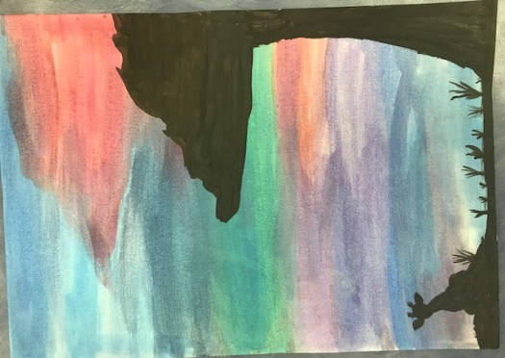
ANNOUNCEMENT:
Be on the lookout for this year’s Family Paint Night for 4th and 5th grade students & guardians. Date to be scheduled soon!

