UW Storefront Studio Helping Enhance Downtown this Spring

The City of Bothell is working with the University of Washington Architecture Department’s “Storefront Studio” this spring to develop designs for façade and other improvements in the historic downtown core. The Storefront Studio is a UW Architecture outreach program focusing on the historic Main Streets of Washington State communities. The students, in the final quarter of their undergraduate programs in architecture and building construction at the main campus in Seattle, will focus on preservation/restoration and economic development.

The project started the last week of March, with City planning and historic preservation staff meeting with the students and providing background on the Downtown Plan and our historic core. On Friday, March 31, the students visited Bothell, toured Main Street and held a Kickoff meeting with a panel of community stakeholders providing additional background and personal perspectives on the history and future of downtown.

On Friday, April 28, a Community Open House was held to present initial student analysis of downtown Assets & Objectives, with preliminary Before & After illustrations of possible enhancements.

Two more community open houses will present the students’ developing proposals:

Friday May 19: Community Open House – Developed Enhancement Proposals

Friday June 2: Community Open House – Final Enhancement Strategies

The City Hall Council Chambers, 18415 101st Ave NE, will be the location for all events and exhibits.
The open houses and presentations will be from 3:30 to 5:30.

A web site will document the work and comments will be encouraged, in person and on-line. www.storefrontstudio.org

The Studio has been recognized by King County Executive and awarded the John D Spellman Historic Preservation Award for a long term record of community assistance.

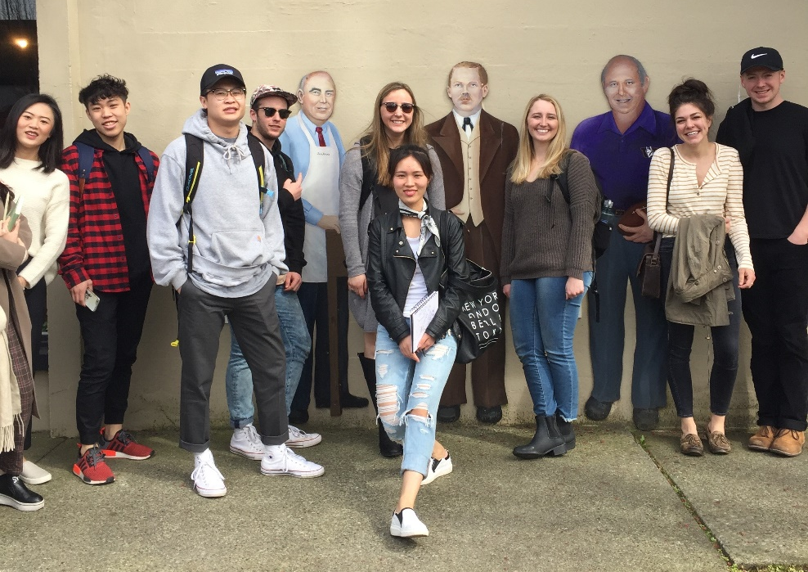
For more information and to comment on the proposals:

Dave Boyd, Senior Planner
City of Bothell, Community Development Department
david.boyd@bothellwa.gov
425-806-6406

Jim Nicholls, Director
UW Storefront Studio
jnicholl@uw.edu
206-779-1461

Right: UW Storefront Studio students posing with historic cut-outs during a tour of downtown Bothell prior to the March 31 Kickoff Meeting & Town Hall

