Arts of Kenmore

FOR IMMEDIATE RELEASE

October 3, 2016

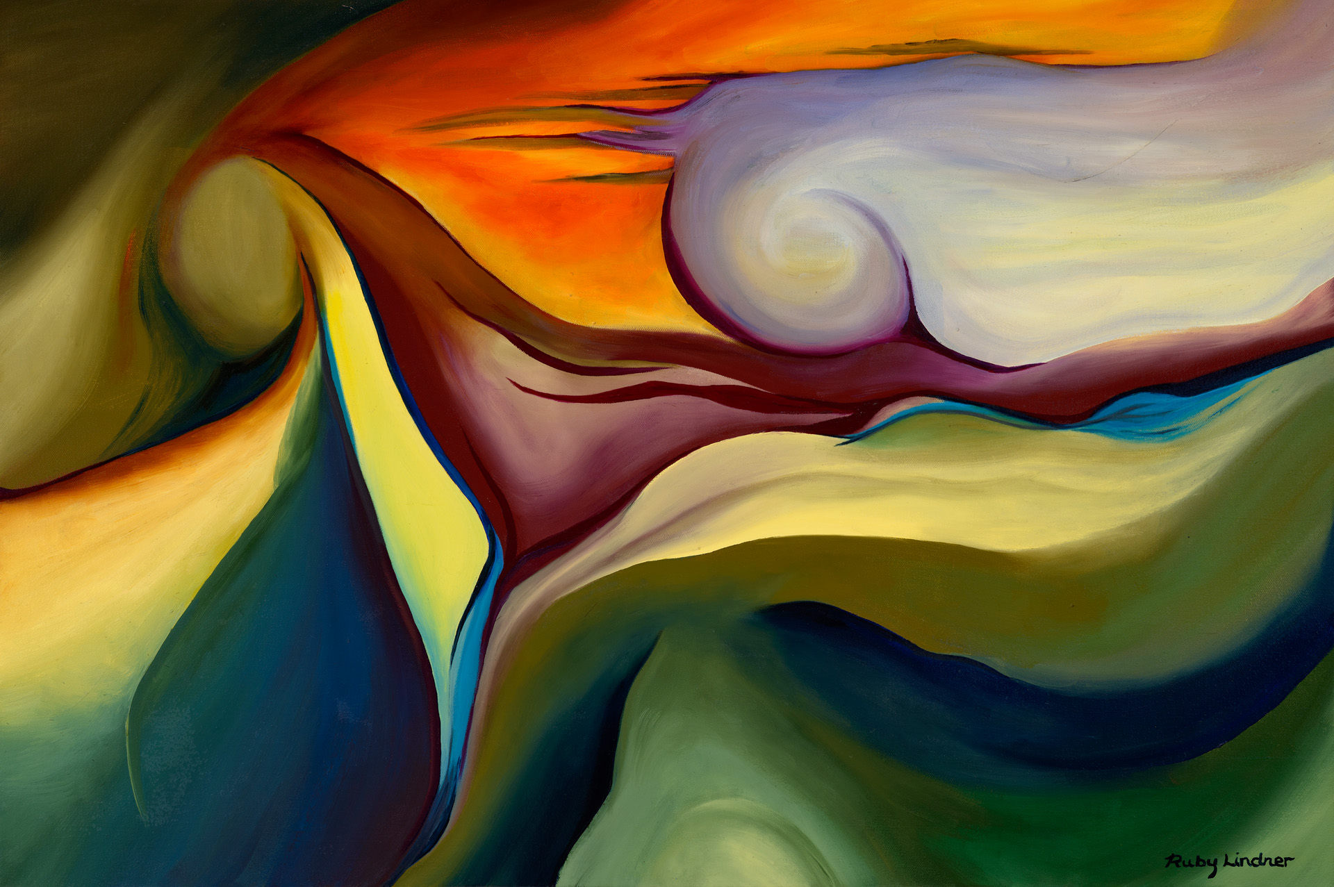
In the Beginning by Ruby Lindner

“The Art of Local Color” is focus of new Kenmore city hall exhibition

KENMORE, Wash.— The public is invited to a new exhibit featuring the works of local arts group, Artists Outside the Box. The event will open Friday evening, October 7, at the Arts of Kenmore Gallery in the Kenmore City Hall, 18120 68th Ave. N.E. The reception begins at 6:30 PM with a presentation by AOTB members at 7:00 PM.
Artists Outside the Box is a collective association of artists who originally came together at the Kirkland Arts Center Store, now demolished, hence the name; and made the decision to exhibit as a group in diverse venues, without the limitation of a brick–and-mortar gallery.
A mutual collaboration was further borne between the Arts of Kenmore Gallery and AOTB, fulfilling the missions of both organizations to diversify outreach and promote all manner of the arts throughout the community. Several of the artists have exhibited in the Kenmore Art Show and previous AOK Gallery shows, and received awards throughout the Pacific Northwest region. The Art of Local Color is the AOTB’s first endeavor of producing an exhibit as a collective group in a gallery.

Nine members of the collective group will be featured in this exhibit with 25 works in painting, photography and mixed media. Artists include Jill Beppu, Diana Grant, Sherrill Hull, Deborah Knetzger, Ruby Lindner, Robert Moreno, Sheila Ralston, Jan Tervonen, and Joann Wadge.

The Art of Local Color is the latest in a series of five exhibits mounted throughout the year by the Arts of Kenmore. These exhibits are made possible with support from the City of Kenmore, 4Culture, and AOK Supporters.

The mission of the Arts of Kenmore, an all-volunteer, non-profit 501(c)3 organization, is to promote the arts in the Kenmore community. Among other initiatives, AOK produces the annual Kenmore Art Show at Bastyr, provides grants for art projects at six public schools in the city and is working to facilitate the creation of public art work in the Kenmore area.

To learn more about the Kenmore Art Show, purchase artwork from AOK Gallery exhibits, support AOK Grants for Schools program and get involved with the Arts of Kenmore, please visit www.artsofkenmore.org or contact info@artsofkenmore.org. or David Maehren, president of the Arts of Kenmore, at dmaehren@artsofkenmore.org.

