**ASFS Outdoor Movie Night: Saturday, October 15th**

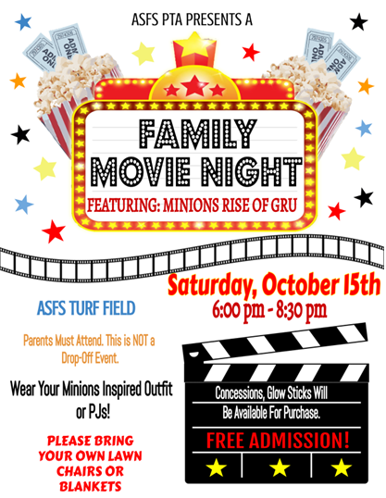



**To support the event, click to** [**volunteer**](https://www.signupgenius.com/go/5080F4BABA82FA4FB6-asfs) **or click to** [**donate**](https://www.signupgenius.com/go/5080F4BABA82FA4FB6-food)**. Please contact** [**Nicole Sioson**](mailto:nsioson1@gmail.com) **for more information.**