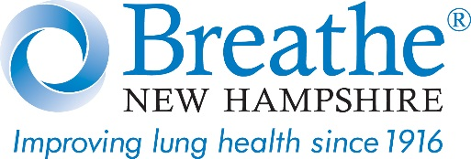

State Legislature Raises Age of Tobacco Product Sales to 19
Breathe New Hampshire Says Law Doesn’t Go Far Enough
MANCHESTER, NH--As a lung-health organization, Breathe New Hampshire is disappointed in the new state law raising the age of sales of tobacco products, which includes e-cigarettes and vapes, to 19 because this is not a proven public-health strategy.
Nineteen is not enough for several reasons:
- 18 to 20 is when smokers and vapers typically become daily users
- 95% of those who use tobacco products start before age 21
- 88% of smokers start before 18
- 17-, 18- and 19-year-olds are in the same peer group, versus 21-year-olds

Our goal is “Tobacco 21,” that is, raising the age to 21; this is critical to protect youth targeted by the vape and tobacco industry.
Breathe New Hampshire agrees with the American Academy of Pediatrics recommending 21 as the minimum age for sales of tobacco products. Teens are particularly susceptible to nicotine addiction through vaping and smoking, leading them to become lifetime users. Plus nicotine “rewires” young brains, triggering susceptibility to other addictive substances.
Nineteen doesn’t go far enough to protect teens and young people from tobacco initiation and nicotine addiction, and to prevent lung disease.
Breathe New Hampshire was instrumental in getting HB1541 passed in 2010, prohibiting the sales of e-cigarettes to minors—one of the first states to do so. We are committed to preventing lung disease and youth nicotine addiction, and offering public education about the youth vaping epidemic through our signature program, Vaping Unveiled™.
Since March 2018, Vaping Unveiled has been presented to 7,500 people in 150 communities, in several age-appropriate programs. This includes middle and high schools, colleges, medical centers, and to parents, educators (school nurses, guidance counselors, health teachers and administrators), law enforcement (corrections and probation officers, school resource officers) youth and community coalitions, at YMCAs, and Boys & Girls Clubs.
See www.BreatheNH.org or call 603-669-2411 to bring Vaping Unveiled to your community or school.
#

