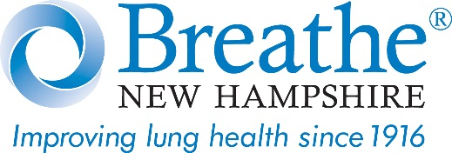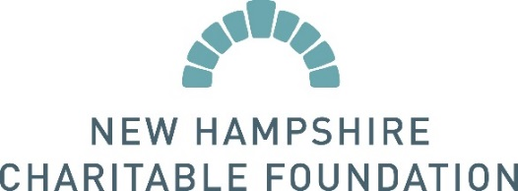

New Hampshire Charitable Foundation Grant
To Help Prevent Youth Vaping, Nicotine Addiction

MANCHESTER, NH—Breathe New Hampshire, the state’s only nonprofit public-health agency dedicated solely to lung health, has received a $22,000 grant from the New Hampshire Charitable Foundation to support its signature program, Vaping Unveiled™, about the dangers of vaping and youth nicotine addiction.

“Breathe New Hampshire is pleased to receive this generous support from the New Hampshire Charitable Foundation, as our organization is working hard to address a public health threat that has quickly become an epidemic among young people,” said Daniel Fortin, President and CEO.

In 2018, about 4.9 million middle and high school students were current users (used in past 30 days) of some type of tobacco product, up from 3.6 million in 2017. This increase erased past progress in reducing youth tobacco product use, according to the Centers for Disease Control and Prevention (CDC). The 2017 Youth Risk Behavioral Survey showed that more than 41% of New Hampshire students have used a vape device.

“Nicotine use at a young age not only disrupts the formation of brain circuits that control attention and learning, but it also puts kids at risk for developing a full-blown nicotine addiction before they’ve graduated high school,” said Traci Fowler, senior program officer at the New Hampshire Charitable Foundation. “We’re fortunate to have an organization like Breathe New Hampshire on the ground working with schools to keep our kids healthy.”

Vapes are also seen as gateways to traditional tobacco products, which often results in combustible cigarette use or dual use (using two or more tobacco products). Many devices resemble common school items such as flash drives, makeup, or pens, which makes them harder to identify and easier for students to use in class.

As new products enter the market, it is more difficult for parents and school officials to stay on top of trends. Breathe NH also learned that the perceived risk of harm was extremely low, and that often parents purchase vapes for their kids--unaware that the vast majority contain addictive nicotine.

Breathe NH partnered with NH-based physicians to develop our Vaping Unveiled program as a solution to this growing public health concern and to educate communities. Audiences have included: middle and high schools, medical professionals, parents, educators, and the public. The program gives an overview of electronic cigarettes and vaping, emphasizing the effects of nicotine on developing brains and lungs, reviews the disturbing trends of newer devices, and looks at the health impact of long-term tobacco use.

As with traditional tobacco products, early intervention is key to preventing youth nicotine use. While anyone can become addicted to nicotine, the younger you are when you start using it, the more likely you are to become addicted.

About Breathe New Hampshire

Breathe New Hampshire, founded in 1916, is improving the quality of life for those with lung disease through educational programs, public health advocacy, and supporting scientific research. See www.breathenh.org or call 603-669-2411 to bring Vaping Unveiled to your community or school.

About the New Hampshire Charitable Foundation

The New Hampshire Charitable Foundation is New Hampshire’s statewide community foundation, founded in 1962 by and for the people of New Hampshire. The Foundation manages a growing collection of nearly 2,000 funds created by generous individuals, families and businesses, and awards nearly $40 million in grants and more than $6 million in scholarships every year. The Foundation works with generous and visionary citizens to maximize the power of their giving; supports critical work happening in our communities, and leads and collaborates on high-impact initiatives. For more information, please visit www.nhcf.org or call 603-225-6641.

#

