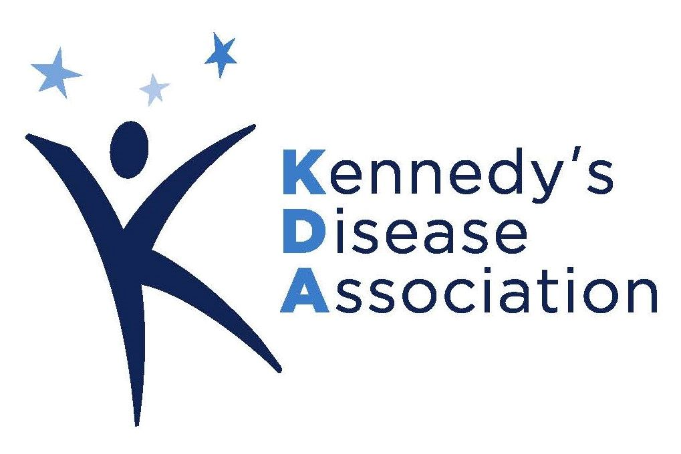
March 1, 2023
2023 SBMA Research Grants
Request for Proposals

Introduction
The Kennedy's Disease Association (KDA) is planning to fund one or more research grants this year to further the understanding of the pathological mechanisms or possible treatments of Kennedy's Disease. The KDA projects that funding for each grant can be up to $100,000 for one year or $50,000 per year for two years. Funding for the second year of a two-year grant is contingent upon a review of progress at the end of the first year. Applications from junior investigators and from senior post-doctoral fellows are encouraged.
Your proposals must be received by Monday, July 3, 2023. The KDA will send a confirmation email within three days of receipt. Please send your proposals as a pdf file to the following address:

Email: info@kennedysdisease.org ; please cc to emeyerth23@gmail.com

Schedule and Review Process:
Request for Proposals published: March 1, 2023
Completed applications due: July 3, 2023
Scientific Review Board review: September 2023
Notification of award: October 2023
Grant start date: January 1, 2024
The general guidelines for the format of the proposal are shown below. If you have additional questions, do not hesitate to contact the KDA’s Ed Meyertholen at the following email address: emeyerth23@gmail.com. We also request that you forward this information to other researchers whom you believe would be interested in applying for one of the grants.
The Kennedy's Disease Association is a non-profit organization dedicated to finding a treatment or cure for Kennedy's Disease. For more information on the KDA, visit our web site at www.kennedysdisease.org.

2023 Grant Proposal Guidelines
A. PROPOSAL LENGTH:
The narrative for Full Proposals should total no more than three (3) pages in length (Arial font, 11pt, and margins at least 0.5 inch), with one additional page allowed for tables and figures as well as an additional page for budget, other support and applicant information. There is no page limit for the list of references.

B. COMPONENTS OF THE PROPOSAL
- Cover Sheet - contact information for the applicant and responsible institutional official and proposal summary

- Narrative: (limited to three pages)
  - Program Aims and Objectives - A description of the aims and objectives of the proposed project, and their relevance to the understanding and treatment of Kennedy's disease.
  - Background - An overview of the status of research relating to the proposed project, including a review of the current literature. This section may also include preliminary data relevant to the proposed aims.
  - Methodology - Rationale and description of the research methods, including statistical data analysis, to be used to carry out the proposed project. This should also include a proposed timeline for the completion of the project.
  - Dissemination of Expected Results - Plans for disseminating the expected results as well as a discussion of potential funding sources for future research.
- References to Cited Publications
- Budget/Funding Requirements - Detailed budget including an explanation of the funding request in relation to the aims of the proposed project.
- Applicant Information - A description of the qualifications of the applicant: this should include academic background, relevant research experience, funding history and a list of relevant publications and presentations.
- Other Support - List other funding support, including effort.
C. ADDITIONAL REQUIREMENTS:
- The recipient of any research grant from KDA must use the awarded funds for the specific purpose they were originally intended. Funds not used in the above specified manner must be returned to KDA within 60 days of the receipt of the annual financial reconciliation report by KDA. Payment of the awards is contingent on receiving any institutional approvals (IRB or IACUC) that are required for the proposed research.
- As a condition for funding any grant, "indirect costs" should not exceed five percent (5%). Several institutions in the past have waived all "indirect costs." Check with your administrators to make certain this is not an issue before submitting your proposal.
- Awardees will be required to submit to the KDA annual project updates (should the project extend beyond one year) and a final project report when the project has been completed. The final report should include a list of all publications, presentations, and other grant proposals that arise from the sponsored research. Funded researchers are also required to submit or have submitted for them to the National Institutes of Health’s PubMed Central database an electronic version of their final, peer-reviewed manuscripts upon acceptance for publication, to be made publicly available no later than 12 months after the official date of publication. Copies of publications would also be appreciated by the KDA.
- Awardees agree to acknowledge the KDA for their support of the research reported in publications, related announcements, and/or presentations.
- Awardees are expected to present their results at the annual KDA Conference upon the completion of the grant period.

