Who We Are
Established in 1897 in Muncie, Indiana, Psi Iota Xi was formed through the collaboration of women committed to making a positive impact on individuals and communities, one at a time. The primary objective was to introduce a broader range of cultural experiences to their communities. Music and art were incorporated into these communities through funds raised by women. As the organization expanded, literature and literacy were subsequently included as areas of emphasis. The scope of focus has now expanded to encompass support for individuals facing speech, hearing, and communication challenges.
Every chapter is unique since every community’s needs are different. Psi Iota Xi strives to build a supportive and committed network of women that can address the varied needs of people, their families, and the communities they belong to.
Reasons to Join
Iota Lambda

Sisterhood
This is a wonderful place to get to know like-minded community focused women. You will connect and grow relationships with Psi Ote sisters from your chapter, state, and national organization.

Make a Difference
Our chapter is 40 years old and supports the Ferdinand, IN community and the Southeast Dubois School district. We donate our time, talents, and monetarily to local endeavors tied to our mission of art, literature, music, and speech & hearing. Each sister truly makes an impact for those in need.

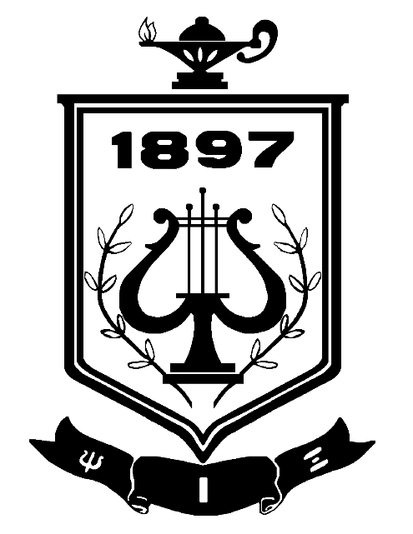
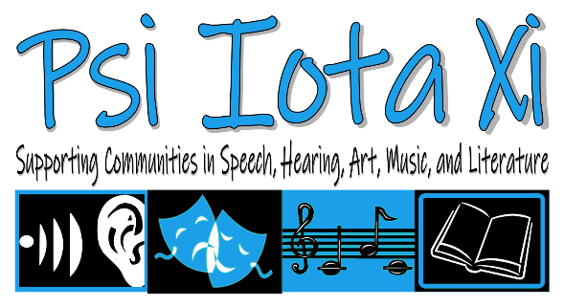
INSTRUCTIONS:
This template is only one example of how you could disperse information about your chapter to your local community. To edit, click inside any text box to remove & add your own wording.

The font color of the text can be changed, but the images are made as watermarks and not as easily adjusted.

When typing in the bulleted list (inside section of the tri-fold brochure), just click enter for another bullet to appear.

You may click on this orange instruction box and press the delete button on your keyboard to remove it at any time. Happy creating!
Psi Iota Xi
Psi Iota Xi is a National Philanthropic organization focusing on art, literature, music, and speech & hearing. We serve to better our communities.

www.psiiotaxi.org
Iota Lambda
Ferdinand, IN
pixferd@gmail.com

Check out our Facebook Page: Psi Iota Xi – Ferdinand Indiana Chapter Iota Lambda

What We Do

Attend Meetings
- There are 10 meetings a year, and the requirement is to attend at least half.
- Meetings are the first Wednesday of every month.
- No business meeting in July or January.
Fundraise & Volunteer
- We ask that you participate as much as possible in fundraisers and volunteer activities – though no requirement.
- There are opportunities to chair a committee or organize a social event.
Participate in Social Events
- January Taster’s Party & Bunco
- July Girls Night Out
- Family Picnic
- Christmas dinner & gift exchange
- Speakers or demonstrations before meetings
- Annual State Meeting and National Convention!

Giving Back to Our Community

Community Outreach
- Plant flowers around Ferdinand community (May)
- Run a Kids Craft Booth @ Ferdinand Folk Festival (Sept)
- Host a Halloween Activity (Oct)
- Volunteer to sell Christkindlmarkt items at their booth (Nov)
- Organize the Ferdinand Community Christmas Program (Dec)

Annual Fundraisers
- Cheeseballs
- Poinsettias/holiday greenery
- Spring flowers and Welp’s Greenhouse gift cards

Giving Back to Our Community

Annual Donations
- FPHS Band, Choir, and Music Departments
- All SE Dubois School Art Departments
- All SE Dubois School Libraries
- Dubois County Libraries - Summer Reading Program Sponsor & Friends of Ferdinand Library
- Junior Achievement
- Ferdinand Heimatfest
- Ferdinand Folk Festival
- FPHS Senior Scholarships

