Christ Memorial Episcopal Church
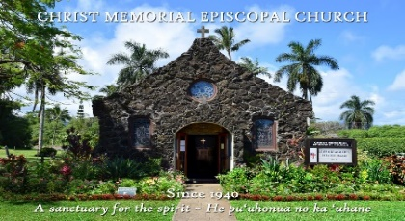
WEEKLY NEWSLETTER
The Very Rev. William O. Daniel, Jr., PhD
The Rt. Rev. Robert Fitzpatrick, Bishop of Hawai`i
March 07, 2021
The Third Sunday in Lent

PROPERS FOR THIS SUNDAY:
The Collect of the Day
Almighty God, you know that we have no power in ourselves to help ourselves: Keep us both outwardly in our bodies and inwardly in our souls, that we may be defended from all adversities which may happen to the body, and from all evil thoughts which may assault and hurt the soul; through Jesus Christ our Lord, who lives and reigns with you and the Holy Spirit, one God, for ever and ever. Amen.

The Reading from Hebrew scriptures Exodus 20:1-17
Then God spoke all these words: I am the Lord your God, who brought you out of the land of Egypt, out of the house of slavery; you shall have no other gods before me. You shall not make for yourself an idol, whether in the form of anything that is in heaven above, or that is on the earth beneath, or that is in the water under the earth. You shall not bow down to them or worship them; for I the Lord your God am a jealous God, punishing children for the iniquity of parents, to the third and the fourth generation of those who reject me, but showing steadfast love to the thousandth generation of those who love me and keep my commandments. You shall not make wrongful use of the name of the Lord your God, for the Lord will not acquit anyone who misuses his name. Remember the sabbath day, and keep it holy. For six days you shall labour and do all your work. But the seventh day is a sabbath to the Lord your God; you shall not do any work—you, your son or your daughter, your male or female slave, your livestock, or the alien resident in your towns. For in six days the Lord made heaven and earth, the sea, and all that is in them, but rested the seventh day; therefore the Lord blessed the sabbath day and consecrated it. Honor your father and your mother, so that your days may be long in the land that the Lord your God is giving you. You shall not murder. You shall not commit adultery. You shall not steal. You shall not bear false witness against your neighbor. You shall not covet your neighbor’s house; you shall not covet your neighbor’s wife, or male or female slave, or ox, or donkey, or anything that belongs to your neighbor.

The Psalm Psalm 19
1 The heavens declare the glory of God, *and the firmament shows his handiwork.
2 One day tells its tale to another, *and one night imparts knowledge to another.
3 Although they have no words or language, *and their voices are not heard,
4 Their sound has gone out into all lands, *and their message to the ends of the world.
5 In the deep has he set a pavilion for the sun; *it comes forth like a bridegroom out of his chamber; it rejoices like a champion to run its course.
6 It goes forth from the uttermost edge of the heavens and runs about to the end of it again; *nothing is hidden from its burning heat.
7 The law of the Lord is perfect and revives the soul; *the testimony of the Lord is sure and gives wisdom to the innocent.
8 The statutes of the Lord are just and rejoice the heart; *the commandment of the Lord is clear and gives light to the eyes.
9 The fear of the Lord is clean and endures for ever; *the judgments of the Lord are true and righteous altogether.
10 More to be desired are they than gold, more than much fine gold, *sweeter far than honey, than honey in the comb.
11 By them also is your servant enlightened, *and in keeping them there is great reward.
12 Who can tell how often he offends? *cleanse me from my secret faults.
13 Above all, keep your servant from presumptuous sins; let them not get dominion over me; *then shall I be whole and sound, and innocent of a great offense.
14 Let the words of my mouth and the meditation of my heart be acceptable in your sight, *O Lord, my strength and my redeemer.
The Epistle 1 Corinthians 1:18-25

The message about the cross is foolishness to those who are perishing, but to us who are being saved it is the power of God. For it is written, “I will destroy the wisdom of the wise, and the discernment of the discerning I will thwart.” Where is the one who is wise? Where is the scribe? Where is the debater of this age? Has not God made foolish the wisdom of the world? For since, in the wisdom of God, the world did not know God through wisdom, God decided, through the foolishness of our proclamation, to save those who believe. For Jews demand signs and Greeks desire wisdom, but we proclaim Christ crucified, a stumbling block to Jews and foolishness to Gentiles, but to those who are the called, both Jews and Greeks, Christ the power of God and the wisdom of God. For God’s foolishness is wiser than human wisdom, and God’s weakness is stronger than human strength.

The Holy Gospel John 2:13-22
The Passover of the Jews was near, and Jesus went up to Jerusalem. In the temple he found people selling cattle, sheep, and doves, and the money changers seated at their tables. Making a whip of cords, he drove all of them out of the temple, both the sheep and the cattle. He also poured out the coins of the money changers and overturned their tables. He told those who were selling the doves, “Take these things out of here! Stop making my Father’s house a marketplace!” His disciples remembered that it was written, “Zeal for your house will consume me.” The Jews then said to him, “What sign can you show us for doing this?” Jesus answered them, “Destroy this temple, and in three days I will raise it up.” The Jews then said, “This temple has been under construction for forty-six years, and will you raise it up in three days?” But he was speaking of the temple of his body. After he was raised from the dead, his disciples remembered that he had said this; and they believed the scripture and the word that Jesus had spoken.

CONNECT
- Becoming Eucharist: The Movement of Love with Fr. Billy Daniel+
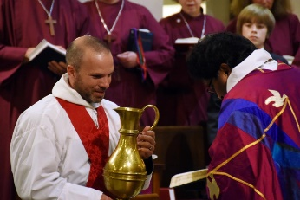
Session Two: Word
March 11, 2021 @ 10:00 am

“You only see the tree by the light of the lamp. I wonder when you would ever see the lamp by the light of the tree.”
~G. K. Chesterton, Manalive

What does it mean to have the mind of Christ? In this session we will explore what it means to think with the mind of Christ. Working with 1 Corinthians 2:2-16, we will explore thinking and knowing in relation to being-known by God in Christ. What does it mean to be known by God? What does Jesus reveal about God’s knowledge of created life? And what are the implications for how we think newly about what it means to be human and how human life is cultivated?
Email the church office or visit the church website for more details.

- Bishop’s Scholarship
Information regarding two Diocesan scholarship funds have been made available to students for the 2020-2021 school year. Information can be found on our online newsletter, or you can email the church office for further details. Application packets are due in the Office of the Bishop by Tuesday, April 6 @ 4:00 pm.
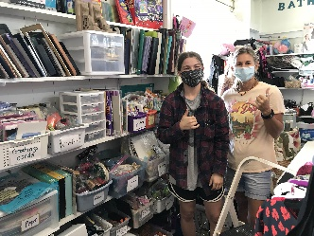
- Helen Mitsui Shared Blessings Thrift Shop is seeking Volunteers for 2021
Volunteers are invaluable to serving our community. Our goal is to reuse, repurpose and recycle goods — keeping as much as possible out of landfill — while providing our community with a welcoming shopping experience and access to reasonably priced, quality merchandise.

PRAYER REQUESTS THIS WEEK
Healing of body, mind, and spirit for
Marilyn (recovery from broken hip); Sarah and Julie (mental peace & to feel God's presence) Hillis and Dorothy (may they rest in peace); Gae; Bill (recovery from a heart attack); Mary (late-stage bone cancer); Roe (healing); Nelli (health); Tony (health); Gregg (continued healing of COVID); Bobby (healing of COVID); Nancy (healing of lung cancer); Scott (coping with dementia); Greg (healing of leukemia); Webb (healing of lymphoma); Peter (continued healing from heart surgery); Susan (strength and courage during cancer treatment); John; Michael; Terri (healing of multiple myeloma); Sue Ellen, Peter, Xavier, Kelly (healing of cancer); Doug (recovering from stroke); Bill (healing of infected shoulder).

