Christ Memorial Episcopal Church

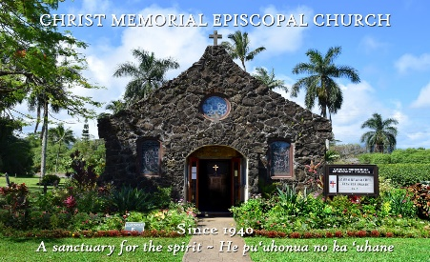
WEEKLY NEWSLETTER
The Rt. Rev. Robert Fitzpatrick, Bishop of Hawai`i
The Very Reverend Zachary Fleetwood
December 06, 2020
The Second Sunday of Advent

PROPERS FOR THIS SUNDAY:

The Collect of the Day
Merciful God, who sent your messengers the prophets to preach repentance and prepare the way for our salvation: Give us grace to heed their warnings and forsake our sins, that we may greet with joy the coming of Jesus Christ our Redeemer; who lives and reigns with you and the Holy Spirit, one God, now and for ever. AMEN.

The Reading from Hebrew scriptures Isaiah 64:1-9
Comfort, O comfort my people, says your God. Speak tenderly to Jerusalem, and cry to her that she has served her term, that her penalty is paid, that she has received from the Lord's hand double for all her sins.

A voice cries out: “In the wilderness prepare the way of the Lord, make straight in the desert a highway for our God. Every valley shall be lifted up, and every mountain and hill be made low; the uneven ground shall become level, and the rough places a plain. Then the glory of the Lord shall be revealed, and all people shall see it together, for the mouth of the Lord has spoken.”

A voice says, “Cry out!” And I said, “What shall I cry?” All people are grass, their constancy is like the flower of the field. The grass withers, the flower fades, when the breath of the Lord blows upon it; surely the people are grass. The grass withers, the flower fades; but the word of our God will stand for ever. Get you up to a high mountain, O Zion, herald of good tidings;
lift up your voice with strength, O Jerusalem, herald of good tidings, lift it up, do not fear; say to the cities of Judah, “Here is your God!” See, the Lord God comes with might, and his arm rules for him; his reward is with him, and his recompense before him. He will feed his flock like a shepherd; he will gather the lambs in his arms, and carry them in his bosom, and gently lead the mother sheep.

The Psalm Psalm 85:1-2, 8-13
1 You have been gracious to your land, O Lord, *you have restored the good fortune of Jacob.
2 You have forgiven the iniquity of your people *and blotted out all their sins.
8 I will listen to what the Lord God is saying, *for he is speaking peace to his faithful people and to those who turn their hearts to him.
9 Truly, his salvation is very near to those who fear him, *that his glory may dwell in our land.
10 Mercy and truth have met together; *righteousness and peace have kissed each other.
11 Truth shall spring up from the earth, *and righteousness shall look down from heaven.
12 The Lord will indeed grant prosperity, *and our land will yield its increase.
13 Righteousness shall go before him, *and peace shall be a pathway for his feet.

The Epistle 2 Peter 3:8-15a
Do not ignore this one fact, beloved, that with the Lord one day is like a thousand years, and a thousand years are like one day. The Lord is not slow about his promise, as some think of slowness, but is patient with you, not wanting any to perish, but all to come to repentance. But the day of the Lord will come like a thief, and then the heavens will pass away with a loud noise, and the elements will be dissolved with fire, and the earth and everything that is done on it will be disclosed. Since all these things are to be dissolved in this way, what sort of persons ought you to be in leading lives of holiness and godliness, waiting for and hastening the coming of the day of God, because of which the heavens will be set ablaze and dissolved, and the elements will melt with fire? But, in accordance with his promise, we wait for new heavens and a new earth, where righteousness is at home. Therefore, beloved, while you are waiting for these things, strive to be found by him at peace, without spot or blemish; and regard the patience of our Lord as salvation.
The Holy Gospel Mark 1:1-8
The beginning of the good news of Jesus Christ, the Son of God. As it is written in the prophet Isaiah,“See, I am sending my messenger ahead of you, who will prepare your way; the voice of one crying out in the wilderness: ‘Prepare the way of the Lord, make his paths straight,’” John the baptizer appeared in the wilderness, proclaiming a baptism of repentance for the forgiveness of sins. And people from the whole Judean countryside and all the people of Jerusalem were going out to him, and were baptized by him in the river Jordan, confessing their sins. Now John was clothed with camel’s hair, with a leather belt around his waist, and he ate locusts and wild honey. He proclaimed, “The one who is more powerful than I is coming after me; I am not worthy to stoop down and untie the thong of his sandals. I have baptized you with water; but he will baptize you with the Holy Spirit.”

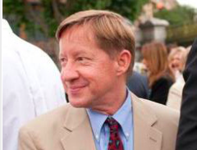
CONNECT
The Way of Love: An Advent Journey with The Very Reverend Zachary Fleetwood
December 10th & 17th at 10 a.m.
Zoom link: https://us02web.zoom.us/j/81848943145

I pray that you, being rooted and established in love, may have power, together with all the Lord’s holy people, to grasp how wide and long and high and deep is the love of Christ, and to know this love that surpasses knowledge— that you may be filled to the measure of all the fullness of God. – Ephesians 3:17-19

Presiding Bishop Michael Curry regularly welcomes us to live not just as the church but as the Episcopal branch of the Jesus Movement: the ongoing community that follows Jesus into loving, liberating, life-giving relationship with God, with one another, and with all creation.

The season of Advent invites us into an attitude of hopeful expectation as we anticipate the celebration of Christ’s birth. Each year in these four short weeks, we have this precious opportunity to wonder and reflect on the meaning of Jesus’ birth for our lives, the life of our community and the life of the world.

Please join Zack+ for this time of reflection, conversation, and prayer. Focusing on readings from the Gospel of Mark and the Book of Isaiah, Zack+ will offer a meditation, followed by discussion and a time for quietness and intercessory prayer.

CALENDAR THIS WEEK
THRIFT SHOP HOURS FOR SHOPPING AND DONATIONS:
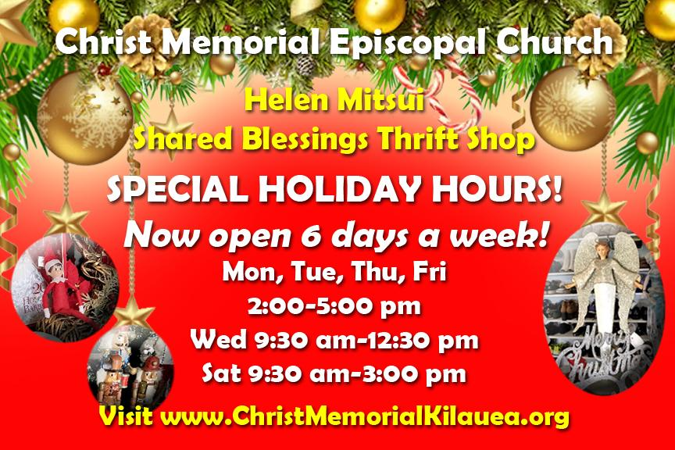
Monday, Tuesday, Thursday, Friday 2:00 – 5:00 pm
Wednesday 9:30 am – 12:30 pm
Saturday 9:30 – 3:00 pm

HEALTHY LIVING RECOVERY GROUPS
AA is back meeting in the Parish Hall.
New Schedule:
Monday 6:15 – 7:15 pm and 7:30 – 8:30 pm
Tuesday 10:00 – 11:00 am and 7:30 – 8:30 pm
Wednesday 7:30 – 8:30 pm

ONLINE STUDY
Our Wednesday bible study group is studying Letters of Paul, Wednesdays 2:00 – 3:15 HST. If you wish to join, let the church office know and we will send you the link and discussion questions.

PRAYER REQUESTS THIS WEEK
Healing of body, mind and spirit for Chelsea; Gregg (struggling to hold on to life, COVID); Peggy (healing from daughter’s suicide); Nancy (healing of colon cancer); Scott (coping with dementia); Greg (healing of leukemia); Webb (healing of lymphoma); Sarah (peace of mind & to feel God's love); Julie (patience and peace of mind); Peter (continued healing from heart surgery); Susan (strength and courage during cancer treatment); John; Ola; Michael; Terri (healing of multiple myeloma); Stevan (Tinnitus); Scott (coping with dementia); Elaine, Sue Ellen, Peter, Xavier, Web & Kelly (healing of cancer); Nancy (during her radiation treatment); Doug (recovering from stroke); Matt’s dad (polio) and Matt's mom (strength); Bill (healing of infected shoulder); those infected by the virus; healing for our world.

OUR GIVING IS IMPORTANT, ESPECIALLY NOW
Our continued gifts really matter, especially in this time of uncertainty. If you like to give by check, send to: Christ Memorial Episcopal Church, P.O. Box 293, Kilauea, HI 96754. Or consider changing to Automated Giving. It makes life easy. Thank you for your love and care for our Christ Memorial community!

