Christ Memorial Episcopal Church
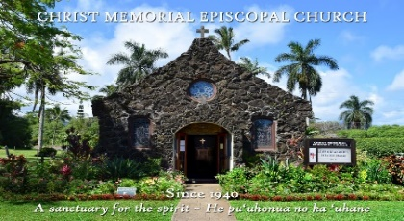
WEEKLY NEWSLETTER
The Rt. Rev. Robert Fitzpatrick, Bishop of Hawai`i
February 21, 2021
The First Sunday in Lent

PROPERS FOR THIS SUNDAY:
The Collect of the Day
Almighty God, whose blessed Son was led by the Spirit to be tempted by Satan: Come quickly to help us who are assaulted by many temptations; and, as you know the weaknesses of each of us, let each one find you mighty to save; through Jesus Christ your Son our Lord, who lives and reigns with you and the Holy Spirit, one God, now and for ever. Amen.

The Reading from Hebrew scriptures Genesis 9:8-17
God said to Noah and to his sons with him, “As for me, I am establishing my covenant with you and your descendants after you, and with every living creature that is with you, the birds, the domestic animals, and every animal of the earth with you, as many as came out of the ark. I establish my covenant with you, that never again shall all flesh be cut off by the waters of a flood, and never again shall there be a flood to destroy the earth.” God said, “This is the sign of the covenant that I make between me and you and every living creature that is with you, for all future generations: I have set my bow in the clouds, and it shall be a sign of the covenant between me and the earth. When I bring clouds over the earth and the bow is seen in the clouds, I will remember my covenant that is between me and you and every living creature of all flesh; and the waters shall never again become a flood to destroy all flesh. When the bow is in the clouds, I will see it and remember the everlasting covenant between God and every living creature of all flesh that is on the earth.” God said to Noah, “This is the sign of the covenant that I have established between me and all flesh that is on the earth.”

The Psalm Psalm 25:1-9
1 To you, O Lord, I lift up my soul; my God, I put my trust in you; * let me not be humiliated, nor let my enemies triumph over me.
2 Let none who look to you be put to shame; *let the treacherous be disappointed in their schemes.
3 Show me your ways, O Lord, *and teach me your paths.
4 Lead me in your truth and teach me, *for you are the God of my salvation; in you have I trusted all the day long.
5 Remember, O Lord, your compassion and love, *for they are from everlasting.
6 Remember not the sins of my youth and my transgressions; *remember me according to your love and for the sake of your goodness, O Lord.
7 Gracious and upright is the Lord; *therefore he teaches sinners in his way.
8 He guides the humble in doing right *and teaches his way to the lowly.
9 All the paths of the Lord are love and faithfulness *to those who keep his covenant and his testimonies.

The Epistle 1 Peter 3:18-22
Christ also suffered for sins once for all, the righteous for the unrighteous, in order to bring you to God. He was put to death in the flesh, but made alive in the spirit, in which also he went and made a proclamation to the spirits in prison, who in former times did not obey, when God waited patiently in the days of Noah, during the building of the ark, in which a few, that is, eight persons, were saved through water. And baptism, which this prefigured, now saves you-- not as a removal of dirt from the body, but as an appeal to God for a good conscience, through the resurrection of Jesus Christ, who has gone into heaven and is at the right hand of God, with angels, authorities, and powers made subject to him.
The Holy Gospel Mark 1:9-15
In those days Jesus came from Nazareth of Galilee and was baptized by John in the Jordan. And just as he was coming up out of the water, he saw the heavens torn apart and the Spirit descending like a dove on him. And a voice came from heaven, “You are my Son, the Beloved; with you I am well pleased.” And the Spirit immediately drove him out into the wilderness. He was in the wilderness forty days, tempted by Satan; and he was with the wild beasts; and the angels waited on him. Now after John was arrested, Jesus came to Galilee, proclaiming the good news of God, and saying, “The time is fulfilled, and the kingdom of God has come near; repent, and believe in the good news.”

CONNECT

- Bishop’s Scholarship
Information regarding two Diocesan scholarship funds have been made available to students for the 2020-2021 school year. Information can be found on our online newsletter, or you can email the church office for further details. Application packets are due in the Office of the Bishop by Tuesday, April 6 @ 4:00pm.

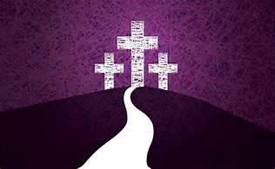
- REFLECTION QUESTIONS TO BEGIN THE SEASON OF LENT:
- Where am I spiritually as I begin Lent? When am I more focused on “me” than God?

- Where is God calling me to change direction?

- When I wake up on Easter Sunday morning, what change would I like to see in me?

- Is there a habit or sin in my life that repeatedly gets in the way of loving God with my whole heart or loving my neighbor as myself? How do I address that habit?

- Is there anyone in my life from whom I need to ask forgiveness or pursue reconciliation?

- What practical steps am I taking to carve out time for daily prayer?

- What spiritual discipline can I continue to improve upon?

- What virtues do I want to focus on this Lent (ie: patience, charity, kindness, gentleness, etc).

If anyone will come after me, let him deny himself, and take up his cross, and follow me.”
-Mark 8:34
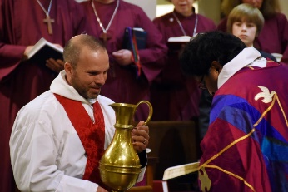

- Incoming Clergy-in-Residence
The Very Rev. William O. Daniel, Jr., PhD will be joining us at Christ Memorial from February 21 to April 25. We look forward to celebrating the Seasons of Lent and Easter with him as well as attending his four-part series Becoming Eucharist: The Movement of Love.

PRAYER REQUESTS THIS WEEK

Healing of body, mind, and spirit for
Hillis and Dorothy (may they rest in peace); Gae; Mary (late-stage bone cancer); Roe (healing); Nelli (health); Tony (health); Gregg (continued healing of COVID); Bobby (healing of COVID); Nancy (healing of lung cancer); Scott (coping with dementia); Greg (healing of leukemia); Webb (healing of lymphoma); Sarah (peace of mind & to feel God's love);Peter (continued healing from heart surgery); Susan (strength and courage during cancer treatment); John; Michael; Terri (healing of multiple myeloma); Scott (coping with dementia); Sue Ellen, Peter, Xavier, Kelly (healing of cancer); Nancy (during her radiation treatment); Doug (recovering from stroke); Bill (healing of infected shoulder).

