Christ Memorial Episcopal Church
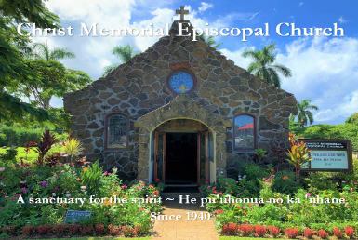
WEEKLY NEWSLETTER
The Rt. Rev. Robert Fitzpatrick, Bishop of Hawai`i
Suzanne Kobayashi, Officiant
November 29, 2020
The First Sunday of Advent

PROPERS FOR THIS SUNDAY:
The Collect of the Day
Almighty God, give us grace to cast away the works of darkness, and put on the armor of light, now in the time of this mortal life in which your Son Jesus Christ came to visit us in great humility; that in the last day, when he shall come again in his glorious majesty to judge both the living and the dead, we may rise to the life immortal; through him who lives and reigns with you and the Holy Spirit, one God, now and for ever. AMEN.

The Reading from Hebrew scriptures Isaiah 64:1-9
O that you would tear open the heavens and come down, so that the mountains would quake at your presence-- as when fire kindles brushwood and the fire causes water to boil-- to make your name known to your adversaries, so that the nations might tremble at your presence! When you did awesome deeds that we did not expect, you came down, the mountains quaked at your presence. From ages past no one has heard, no ear has perceived, no eye has seen any God besides you, who works for those who wait for him. You meet those who gladly do right, those who remember you in your ways. But you were angry, and we sinned; because you hid yourself we transgressed. We have all become like one who is unclean, and all our righteous deeds are like a filthy cloth. We all fade like a leaf, and our iniquities, like the wind, take us away. There is no one who calls on your name, or attempts to take hold of you; for you have hidden your face from us, and have delivered us into the hand of our iniquity. Yet, O Lord, you are our Father; we are the clay, and you are our potter; we are all the work of your hand. Do not be exceedingly angry, O Lord, and do not remember iniquity forever. Now consider, we are all your people.

The Psalm Psalm 80:1-7, 16-18
1 Hear, O Shepherd of Israel, leading Joseph like a flock; *shine forth, you that are enthroned upon the cherubim.
2 In the presence of Ephraim, Benjamin, and Manasseh, *stir up your strength and come to help us.
3 Restore us, O God of hosts; *show the light of your countenance, and we shall be saved.
4 O Lord God of hosts, *how long will you be angered despite the prayers of your people?
5 You have fed them with the bread of tears; *you have given them bowls of tears to drink.
6 You have made us the derision of our neighbors, *and our enemies laugh us to scorn.
7 Restore us, O God of hosts; *show the light of your countenance, and we shall be saved.
16 Let your hand be upon the man of your right hand, *the son of man you have made so strong for yourself.
17 And so will we never turn away from you; *give us life, that we may call upon your Name.
18 Restore us, O Lord God of hosts; *show the light of your countenance, and we shall be saved.

The Epistle 1 Corinthians 1:3-9

Grace to you and peace from God our Father and the Lord Jesus Christ. I give thanks to my God always for you because of the grace of God that has been given you in Christ Jesus, for in every way you have been enriched in him, in speech and knowledge of every kind-- just as the testimony of Christ has been strengthened among you-- so that you are not lacking in any spiritual gift as you wait for the revealing of our Lord Jesus Christ. He will also strengthen you to the end, so that you may be blameless on the day of our Lord Jesus Christ. God is faithful; by him you were called into the fellowship of his Son, Jesus Christ our Lord.

The Holy Gospel Mark 13:24-37

Jesus said, “In those days, after that suffering, the sun will be darkened, and the moon will not give its light, and the stars will be falling from heaven, and the powers in the heavens will be shaken. Then they will see ‘the Son of Man coming in clouds’ with great power and glory. Then he will send out the angels, and gather his elect from the four winds, from the ends of the earth to the ends of heaven. “From the fig tree learn its lesson: as soon as its branch becomes tender and puts forth its leaves, you know that summer is near. So also, when you see these things taking place, you know that he is near, at the very gates. Truly I tell you, this generation will not pass away until all these things have taken place. Heaven and earth will pass away, but my words will not pass away.
“But about that day or hour no one knows, neither the angels in heaven, nor the Son, but only the Father. Beware, keep alert; for you do not know when the time will come. It is like a man going on a journey, when he leaves home and puts his slaves in charge, each with his work, and commands the doorkeeper to be on the watch. Therefore, keep awake—for you do not know when the master of the house will come, in the evening, or at midnight, or at cockcrow, or at dawn, or else he may find you asleep when he comes suddenly. And what I say to you I say to all: Keep awake.”
CONNECT
- The Way of Love: An Advent Journey (New Small Group Opportunity)
The season of Advent invites us into an attitude of hopeful expectation as we anticipate the celebration of Christ’s birth. Each year in these four short weeks, we have this lovely, precious opportunity to wonder and reflect on the meaning of Jesus’ birth for our lives, the life of our community and the life of the world. Through the centuries, Christian communities have adopted disciplines and daily rhythms for living and expressing the teachings of Jesus. Our conversations will focus on several passages from the Gospel of Luke that suggest a pattern for considering practices that might help us to live more fully and meaningfully into the Way of Love as a way of life. Please email the church office for more information.

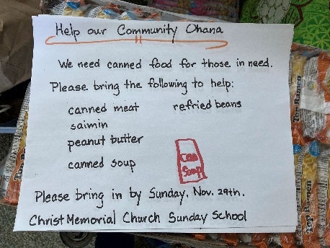
- Christ Memorial Keiki Food Drive
We encourage you to participate and donate canned food items to support our Keiki Ministry, as well as those facing food insecurities in our local community. Please plan to have your food donations in by this Sunday 11/29.

- Stop by Shared Blessings Thrift Store
The thrift store has the best section of Christmas decorations on island! Bring the family and stop by to check out our huge selection of beautiful, second-hand items to spruce up your home this holiday season.

CALENDAR THIS WEEK
THRIFT SHOP HOURS FOR SHOPPING AND DONATIONS:
Tuesday, Thursday, Friday 2:00 – 5:00 pm
Wednesday 9:30 am – 12:30 pm
Saturday 9:30 – 3:00 pm
In need of volunteers, please contact the church office, christmemorialkilauea@gmail.com

HEALTHY LIVING RECOVERY GROUPS
AA is back meeting in the Parish Hall.
New Schedule:
Monday 6:15 – 7:15 pm and 7:30 – 8:30 pm
Tuesday 10:00 – 11:00 am and 7:30 – 8:30 pm
Wednesday 7:30 – 8:30 pm

ONLINE STUDY
Our Wednesday bible study group is studying Letters of Paul, Wednesdays 2:00 – 3:15 HST. If you wish to join, let the church office know and we will send you the link and discussion questions.

PRAYER REQUESTS THIS WEEK
Healing of body, mind and spirit Sarah (peace of mind & to feel God's love); Julie (patience and peace of mind);
Peter (continued healing from heart surgery); Susan (strength and courage during cancer treatment); John; Ola; Michael; Terri (multiple myeloma); Stevan (Tinnitus); Scott (dementia); Elaine, Sue Ellen, Peter, Xavier, Web & Kelly (cancer); Nancy (radiation treatment); Doug (stroke); Matt’s dad (polio) and Matt's mom (strength); Bill, in hospital (infected shoulder); those infected by the virus; healing for our world.

OUR GIVING IS IMPORTANT, ESPECIALLY NOW
Our continued gifts really matter, especially in this time of uncertainty. If you like to give by check, send to: Christ Memorial Episcopal Church, P.O. Box 293, Kilauea, HI 96754. Or consider changing to Automated Giving. It makes life easy. Thank you for your love and care for our Christ Memorial community!

