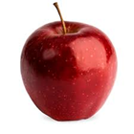

Apple + More Cinnamon Muffins
“More” - your choice.. carrots, zucchini or pumpkin puree
Makes 18 cupcake size servings

Ingredients:
1 cup dry oat bran or Hodgson Mill Quinoa Flax dry cereal
1 cup whole wheat flour
3 1/2 Tbsp. brown sugar
1 Tbsp. baking powder
½ tsp. baking soda
2 tsp. ground cinnamon
1 cup apples, peeled and grated/chopped finely
+choose between 1 cup carrots/zucchini, grated OR 1 cup pureed pumpkin
½ cup plain 0 fat Greek yogurt or fat free milk
2 eggs (or 2 egg whites if preferred)
¼ cup canola oil
1 tsp. vanilla extract

Directions:
- Combine all ingredients in medium mixing bowl.
- Pour batter into 18 individual cupcake size lined muffin cups.
- Bake in preheated oven 350 degrees for 18-20 minutes.
- Cool and refrigerate in covered container. These freeze nicely.

Nutrient Analysis: For one muffin (18/recipe)
Calories: 98, Carbohydrate: 14 gm. Sugars: 5 gm. ( of this added Sugar: 3 gm), Dietary Fiber: 2 gms. Protein: 4 gms. Total Fat: 4 gms. Saturated Fat: 0 gm., Polyunsat. Fat: 1 gm.,
Monounsat. Fat: 2 gms., Omega 3 – DHA: 2 gms., Sodium: 134 mg.

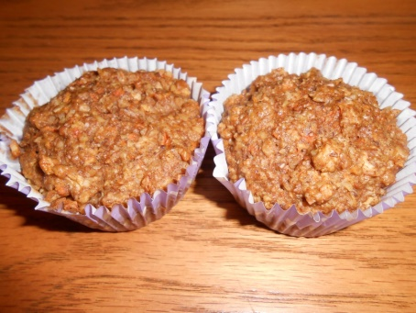

Monica A. Cengia, MS Ed, RDN, LD, CDE,
Registered Dietitian Nutritionist, Licensed Dietitian & Certified Diabetes Educator
1525 E. Stroop Rd. Suite 100, Kettering, OH 45429
Phone: 937-436-1985 FAX 937-436-8085

