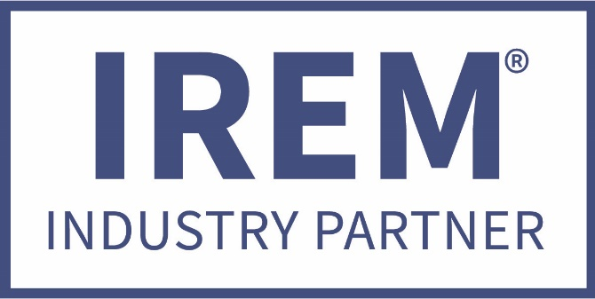
IREM GA 2020
AVAILABLE CATEGORIES FOR 2020

ACCESS CONTROL / ENTRY SYSTEMS
ARCHITECTURAL
ATTORNEYS
BRANDING/MARKETING
CALL CENTER/ANALYTICS
CONSTRUCTION
CORPORATE CATERING
CORPORATE GIFTS
COLLECTIONS
DISASTER RECOVERY
ELECTRICAL
EVICTIONS
FIRE PROTECTION
FLOORING
HVAC
INSURANCE
MUSIC / SOUND SYSTEMS
PLUMBING
RECORDS MANAGEMENT / DESTRUCTION
SIGNAGE / BANNERS

(other categories can be considered)

The Industry Partner program was designed by the Georgia Chapter of IREM to provide a valuable exchange between an elite group of contract service providers and the members of the local IREM Chapter.

Two vendors per category allowed

REFER A REPUTABLE / DEPENDABLE COMPANY TODAY, WE WILL FOLLOW UP ON YOUR BEHALF.
EARN 50,000 IREM GA BUCKS FOR THE REFERRAL WHEN APPROVED.

