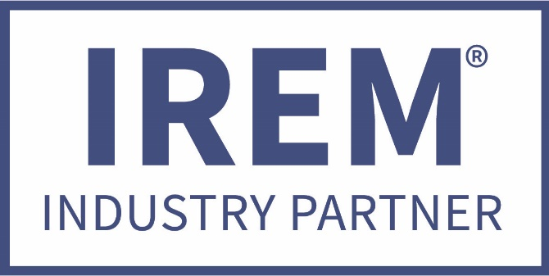
IREM GA 2019
AVAILABLE CATEGORIES FOR 2019

ACCESS CONTROL / ENTRY SYSTEMS
ARCHITECTURAL
ATTORNEYS
CONSTRUCTION
CORPORATE CATERING
CORPORATE GIFTS
COLLECTIONS
ELECTRICAL
EVICTIONS
FLOORING
HVAC
MUSIC / SOUND SYSTEMS
PLUMBING
RECORDS MANAGEMENT / DESTRUCTION
SIGNAGE / BANNERS

( other categories can be considered )

The Industry Partner program was designed by the Georgia Chapter of IREM to provide a valuable exchange between an elite group of contract services providers and the members and affiliates of the local IREM Chapter.

Two vendors per category allowed

REFER A REPUTABLE / DEPENDABLE COMPANY TODAY, WE WILL FOLLOW UP ON YOUR BEHALF. EARN 20,000 IREM GA BUCKS FOR THE REFERRAL.

