Things to do in and Around Orlando that Aren’t Exactly the Major Theme Parks
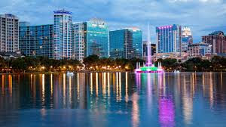
There are so many things to do and so many experiences to have in and around the Orlando area it is difficult to choose what to do in just one week or less. Here is a guide of some local favorites as well as tourist attractions to help you whittle down activities to do when you’re not in CE. Orlando weather in October is beautiful with 84 high / 68 low.

For the Foodie

Close to the convention center:

Everglades Restaurant
https://www.evergladesrestaurant.com/

Maggiano’s
https://locations.maggianos.com/florida/orlando/

Blue Martini Lounge
https://orlando.bluemartini.com/

A little further out:

High Tide Harry’s near the airport
https://hightideharrys.com/

Church Street Station for food, drink, and entertainment
About 20 minutes south of the convention center on I-4.
https://www.churchstreetstation.com/

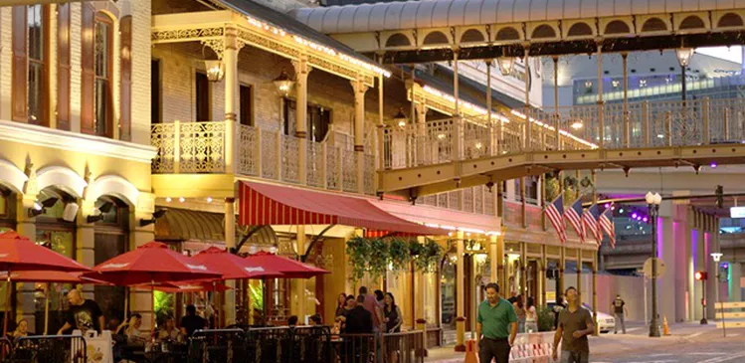

Peruvian - El Inka Grill & Ceviche
http://www.elinkagrill.com/
4 Rivers Smokehouse for delicious burnt ends
11764 University Blvd
https://4rsmokehouse.com/locations/east-orlando/

Le House Vietnamese on Church Street
https://www.scottjosephorlando.com/reviews/75-vietnamese/4703-le-house

For the Sports Enthusiast

Top Golf
https://topgolf.com/us/orlando/

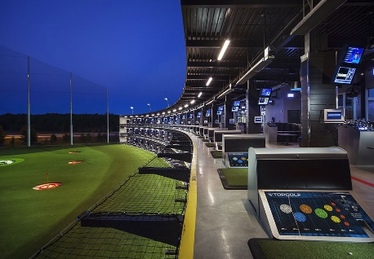

Andretti Indoor Karting & Games
https://andrettikarting.com/

UCF College Football 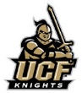
www.ucfknights.com

Orlando Magic NBA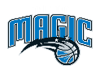
https://www.nba.com/magic/

Golfing
http://www.orlandogolf.com

US Tennis
https://www.usta.com/en/home.html

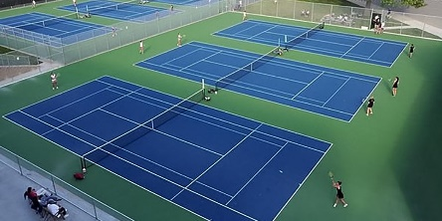

For the Nature Enthusiast

Lake Eola Park
https://www.orlando.gov/Parks-the-Environment/Directory/Lake-Eola-Park

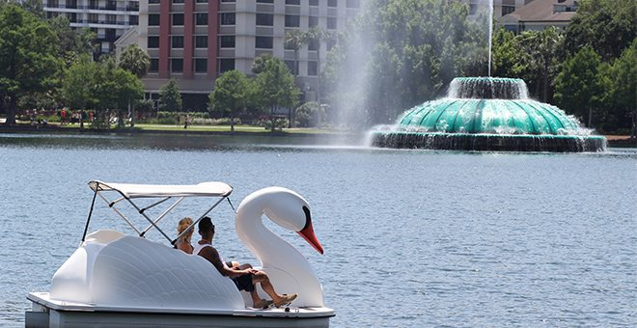

Paddle Board
https://paddleboardorlando.com

Kayak
https://rootsrated.com/stories/the-top-5-places-to-canoe-and-kayak-near-orlando

Gatorland
14501 S Orange Blossom Trail
https://www.gatorland.com

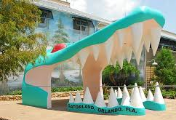

Airboat Rides
https://m.viator.com/Orlando-tours/Airboat-Tours/d663-g3-c26027

For the Shopper

Outlet Mall
https://www.premiumoutlets.com/outlet/orlando-vineland

Mall at Millenia
https://www.mallatmillenia.com/

For Fun & Amusement

WonderWorks
https://www.wonderworksonline.com/orlando/

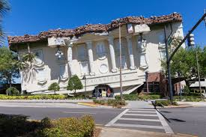

Medieval Times
www.medievaltimes.com

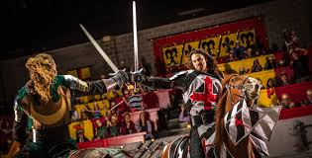

The Wheel at ICON Park
https://iconparkorlando.com/

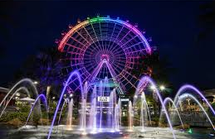

Blue Man Group – imaginative audio and visual experience.
https://www.universalorlando.com/web/en/us/things-to-do/shows/blue-man-group/index.html

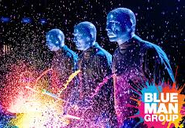

Halloween Horror Nights at Universal Studios – Stranger Things haunted house this year.
www.universalorlando.com

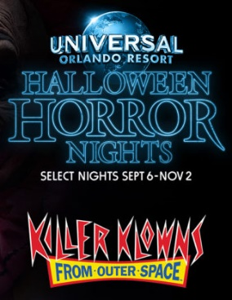

Mickey’s Not-So-Scary Halloween Party at Disney – for those a little less adventurous.
www.disneyworld.disney.go.com

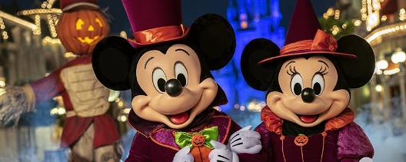

Downtown Disney & Disney Springs – shopping, eating & entertainment without entering parks.
https://disneyparks.disney.go.com/downtown-disney/

For Those Willing to Drive

Less than 1-hour east of Orlando is the beautiful coastline. Kennedy Space Center is an eye-opening experience that can be done in about half a day. The rest of the day can be spent hanging around at the Cocoa Beach pier, Port Canaveral, or anywhere in between.

There are no rocket launches scheduled the week of the meeting but as some launches are scrubbed and rescheduled and there is nothing like seeing one up close. For non-military personnel there are good numerous spots along the Beachline Expressway SR-528 anywhere between Merritt Island to Cape Canaveral or view right from the beach. For military personnel, use NOTU Security for Badging/Access to Cape Canaveral Air Force Station 321-853-1290 to get on base for up close viewing.
Here are some locations and links of interest.
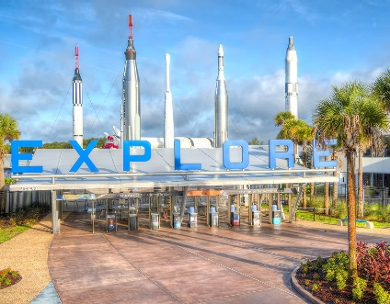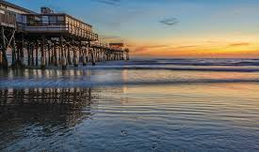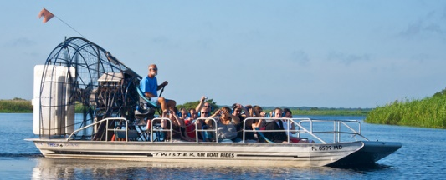

Kennedy Space Center
Florida 32899
https://www.nasa.gov/centers/kennedy/home/index.html

https://www.spacecoastlaunches.com/blog/launch-list/

Navy MWR Cape Canaveral
https://www.navymwrcapecanaveral.com

Patrick AFB MWR
https://www.gopatrickfl.com/outdoor-recreation.html

Exploration Tower at Port Canaveral
http://www.explorationtower.com/

Casino Cruise off Port Canaveral
https://victorycasinocruises.com

Fishing Charter Port Canaveral
https://fishingbooker.com/destinations/location/us/FL/cape-canaveral

Ron Jon Surf Shop Cocoa Beach, open 24 hours
https://www.ronjonsurfshop.com/
Lone Cabbage Fish Camp for airboat rides to see alligators and taste frog legs or gator tail. http://twisterairboatrides.com/index.html
Places to eat or drink in the Cocoa Beach/Cape Canaveral area: Grills, Fishlips, Rusty’s, Florida Seafood, Sandbar, Coconuts, Roberto’s Little Havana.

No matter what you choose to do with your free time in the Orlando area, you’re bound to have an experience to remember. I wish you much fun in the Florida sun with at least a little bit of learning. Be sure to check out photos and info during and after the AFOS meeting on Facebook, Instagram, and Twitter.

