Classic Car Show

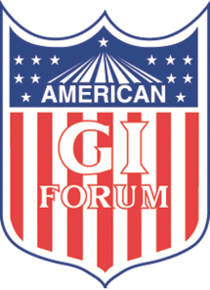

May 15th & 16th, 2021

Saturday, 9am – 5pm & Sunday, 9am – 5pm
Presented by and benefiting:
A portion of the proceeds benefits Modesto American GI Forum. Classic Car Show Applications aren't available at the moment.

