National Park Service News Release

Canaveral National Seashore
212 S. Washington Ave.
Titusville, FL 32796
321-267-1110
321-264-2906 fax
www.nps.gov
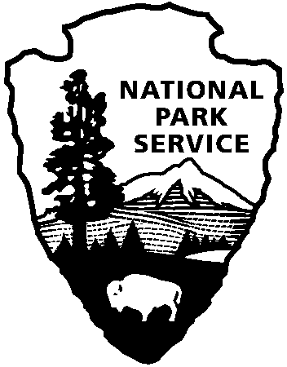
National Park Service
U.S. Department of the Interior

Release Date: Immediately – March 30, 2022
Contacts: Laura Henning – 321-267-1110 Ext. 25

Playalinda District
Interpretive Programs
April 2022

PLEASE NOTE: all programs are subject to cancellation and/or rescheduling due to staff limitations, weather conditions, or other factors. Some programs require reservations, a minimum age, or a cost-recovery fee. Call 386-428-3384 ext. 0 for program information during operating hours (9:00 a.m. to 5:00 p.m.), www.nps.gov/cana. Entrance fees apply to all interpretive program participants. All programs meet the requirements for the Canaveral National Seashore Junior Ranger program.

SUNDAY April 3rd, 17th & 24th – Seminole Rest Home - 12:00 PM - 4:00 PM - Enjoy a brief stroll along the accessible path that leads to the main house located on top of Snyder Mound. Explore the first floor of the late 1800’s gothic revival style home located along Mosquito Lagoon in Oak Hill, Florida. (4 hours)

Saturday April 9th – Trash Bash at Playalinda– 8:00 AM – 12:00 PM – In partnership with Keep Brevard Beautiful help keep our seas trash free. Meet at lot #1 to pick up supplies. Bring sunscreen and water. Other items to consider bringing are gloves, a picker and mosquito repellent. (4 hours)

Friday April 22nd – Playalinda Beach Cleanup – 9:00 AM – 12:00 PM – Celebrate National Park Week with us by participating in a beach cleanup. Meet at parking lot #1 to pick up supplies. Bring sunscreen and water. Other items to consider bringing are gloves, a picker and mosquito repellent. (3 hours)

Instagram & FB @canaveralnatlseashore

