National Park Service News Release

Canaveral National Seashore
212 S. Washington Ave.
Titusville, FL 32796
321-267-1110 office
321-264-2906 fax
www.nps.gov/cana
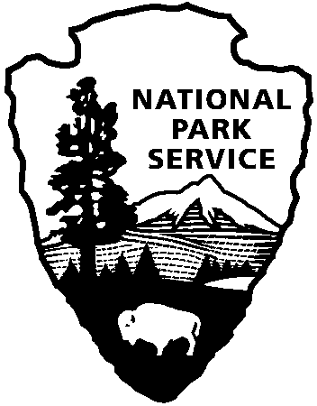
National Park Service
U.S. Department of the Interior

Release Date: Immediately
Contacts: Laura Henning
383-428-3384

PLAYALINDA DISTRICT INTERPRETIVE PROGRAMS - November 2018

PLEASE NOTE: all programs are subject to cancellation and/or rescheduling due to staff limitations, weather conditions, or other factors. Some programs require reservations, a minimum age, or a cost recovery fee. Call 321-403-9334 or 386-428-3384 ext. 0 for program information during operating hours (9:00a.m. to 5:00 p.m.). Visit our website at www.nps.gov/cana. Entrance fees apply to all interpretive program participants. All programs meet the requirements for the Canaveral National Seashore Junior Ranger Program.

THURSDAY, 8TH & WEDNESDAY 14TH – 10:00 AM “BARTRAM NATURE WALK” – Explore the seashore through the view finder. Discover the diversity and beauty of the various plants and animals within the seashore. Bring your camera, water, sunscreen and repellent. Meet at the Eddy Creek parking area. (1 hour)

THURSDAY, 1ST & 15TH – 10:00 AM “BIOLAB NATURE WALK” – Explore the seashore through the view finder. Discover the diversity and beauty of the various plants and animals
within the seashore. Bring your camera, water, sunscreen and repellent. Meet at vista 3. (1 hour)

SATURDAY, 17TH – 10:00 AM “SEASHELL HUNT & BEACH CLEANUP” – Search for that seashell or sea bean with a ranger. Explore the beach wrack line for treasure OR trash depending on what the tide brings in that day. Bring water and sunscreen. Meet at parking area #3. (1 hour)

SATURDAY, 24TH – 10:00 AM “PADDLE THE LAGOON”- Some experience is required and be at least 10 years old and able to paddle and swim. Bring water, sunscreen, & sturdy water shoes. Dress to get wet. Reservations begin: one week in advance. There is no charge for program, please bring your own kayak. If you need to rent a kayak there is a limited number to reserve at $25. Call (321) 403-9334, to reserve a spot and kayak if needed (LIMITED KAYAK AVAILABILITY). Reserve a spot and meet at the Eddy Creek boat ramp. (2 hours)

FRIDAY, 9TH – 10:00 AM “CAST NETTING” – Try your hand at cast netting. Enjoy the lagoon and see what you can catch. Meet at Seminole Rest parking area (210 River Road Oak Hill, FL 32759

