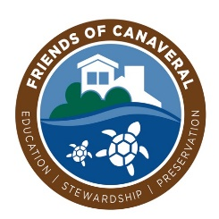

Friends of Canaveral, Inc.

501 (c)(3) Fundraising Partner

[www.friendsofcanaveral.com](http://www.friendsofcanaveral.com)

*Adopt a Sea Turtle Nest at Canaveral National Seashore*

Date _____________________________________

Name ____________________________________

Address __________________________________ Street & Number

__________________________________ City, State & Zip

Phone Number ____________________________

Email ____________________________________

Name to be placed on the ID Nest Stake:

____________________________________

Please enclose a check in the amount of $40.00

Payable to Friends of Canaveral, Inc., and mail to:

Friends of Canaveral, Inc.

P.O. Box 1526

New Smyrna Beach, FL 32170

*Thank you for your donation!*