National Park Service News Release

Canaveral National Seashore
7611 S. Atlantic Ave.
New Smyrna Beach, FL 32169
386-428-3384 phone
386-426-7973 fax www.nps.gov

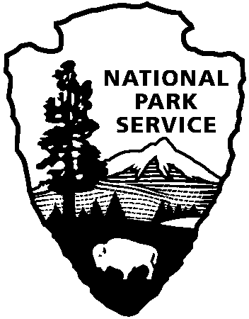
National Park Service
U.S. Department of the Interior

Release Date: Immediately, January 31, 2022
Contacts: Laura Henning – 321-267-1110 Ext. 25

APOLLO DISTRICT
INTERPRETIVE PROGRAMS
February 2022

PLEASE NOTE: all programs are subject to cancellation and/or rescheduling due to staff limitations, weather conditions, or other factors. Some programs require reservations, a minimum age, or a cost-recovery fee. Call 386-428-3384 ext. 0 for program information during operating hours (9:00AM to 6:00PM). Visit our website at www.nps.gov/cana. Entrance fees apply to all interpretive program participants. All programs meet the requirements for the Canaveral National Seashore Junior Ranger program.

TUESDAY 1st and 15th at 10:00AM - “Canoe Mosquito Lagoon”. Reservations will be accepted a week before the canoe date. Join a guide as you explore this rich and diverse estuary up close. Some experience is preferred. You must be at least 8 years old and able to paddle. You must wear completely enclosed shoes (no sandals or flip-flops). Bring water, sunscreen, and a hat. Dress to get wet. There is a $25 canoe rental fee. Call (386) 428-3384 ext. 0 to reserve your spot. Meet at the Pavilion behind the Visitor Center. (2 hours)

WEDNESDAY 2nd, 9th, 16th, and 23rd - “PLANT WALK” 10:00AM. Join us every Wednesday for a walk to identify the plants of Canaveral National Seashore and find out how they have been utilized over the years. Each walk is led by an experienced volunteer and covers a different part of the park. Please bring water for hydration and wear shoes for trail walking. (2 hours) The walks in January will be as follows:

1. Feb. 2nd - Turtle Mound. Meet at 9:45am. Use the Turtle Mound parking area or boat ramp parking lot and walk down.
2. Feb. 9th - Eldora. Meet at 9:45am at parking lot number 8.
3. Feb. 16th - The loop trail on Eldora Rd. Meet at 9:45am at parking lot number 9.
4. Feb. 23rd - Castle Windy. Meet at 9:45am at parking lot number 3 (ocean side).

Saturday 5th at 11am - Canaveral National Seashore and The Moore Cultural Center invite you to celebrate Black History Month. With special guest speaker, Dr. Tyreese R McAllister doing a lecture on mental health wellness. There will be vendors, food trucks and a DJ. Meet at the gazebo at Harry T. Harriette V. Moore Memorial Park. (2 hours)

SATURDAY 12th at 10 AM - "TURTLE MOUND WALK AND TALK". Join a
volunteer for a walk and talk on Turtle Mound where Florida's first people, the
Timucuans, lived. Learn a little about their fascinating story. We’ll walk on the
boardwalk to the top of Turtle Mound, the largest shell midden in the mainland
U.S. Because its location straddles both the temperate and subtropical climate zones, there is also a great variety of plant life to be discovered. Meet in Parking
Lot 1 for the short walk to the mound. (1 hour)"Visitor Center. (2 hours)

SUNDAY 13th at 2PM - Mary McLeod Bethune was a world-renowned educator, civil rights leader, women's rights activist, presidential advisor and public servant. In celebration of Black History Month, come and learn about this extraordinary woman, her life and legacy and contributions to Volusia County. Meet at the pavilion behind the Visitor Center. (1 hour)

Monday 21st 11:00AM - “BROWN BAG LUNCH”. Join us for a monthly discussion of interest to the community. Bring a lunch to share after the presentation. This month’s program will be presented by Tess Sailor-Tynes – the Conservation Science Coordinator at Marine Discovery Center, a non-profit organization that focuses on exploration, education, and conservation of the Indian River Lagoon. Shoreline restoration is a significant part of our conservation work, as the habitat shifts amongst natural events, urbanization, and general human activity. We rely on the implementation of natural elements like grasses, mangroves, and oysters to stabilize shorelines of the Indian River Lagoon. Learn about these practices and the positive changes they make for our local wildlife. Meet at the pavilion behind the Visitor Center. (1 hour)

