National Park Service News Release

Canaveral National Seashore
212 S. Washington Ave.
Titusville, FL 32796
321-267-1110 office
321-264-2906 fax
www.nps.gov/cana
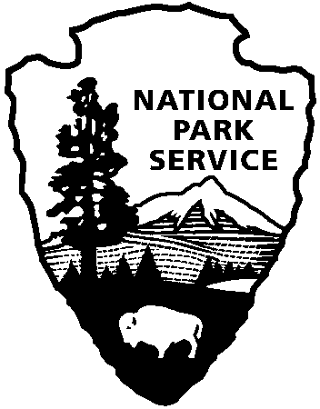
National Park Service
U.S. Department of the Interior

Release Date: Immediately
Contacts: Laura Henning
383-428-3384

PLAYALINDA DISTRICT INTERPRETIVE
PROGRAMS
April 2018

PLEASE NOTE: all programs are subject to cancellation and/or rescheduling due to staff limitations, weather conditions, or other factors. Some programs require reservations, a minimum age, or a cost recovery fee. Call 321-403-9334 or 386-428-3384 ext. 0 for program information during operating hours (9:00a.m. to 5:00 p.m.). Visit our website at www.nps.gov/cana. Entrance fees apply to all interpretive program participants. All programs meet the requirements for the Canaveral National Seashore Junior Ranger Program.

APRIL 21st FEE FREE
CELEBRATE YOUR NATIONAL SEASHORE

WEDNESDAY, 4TH – 1:00 PM “PADDLE THE LAGOON”- Join a ranger as you explore this rich and diverse estuary of national significance. Some experience is required. You must be at least 10 years old and able to paddle/swim. Bring water, sunscreen, & sturdy water shoes. Dress to get wet. Individuals with their own kayaks or canoes are welcome. Reservations begin: one week in advance. Call (321) 403-9334, to reserve a spot and kayak if needed (LIMITED KAYAK AVAILABILITY). Reserve a spot and meet at the Eddy Creek boat ramp. (2.5 hours)
FRIDAY, 6TH – 9:00 AM “WILDLIFE PHOTO WALK” – Explore the seashore through the view finder. Discover the diversity and beauty of the various plants and animals within the seashore. Bring your camera, water, sunscreen and repellent. Meet at vista 3. (1 hour)
SATURDAY, 7TH – 8:00 AM – 12:00 PM “TRASH BASH” - It’s that time of year again! Keep Brevard Beautiful is partnering with Canaveral National Seashore on their 37th annual Trash Bash, and we need your help to make it a huge success. To volunteer at Playalinda Beach email Ashley_Steele@nps.gov. Meet at parking area #1. For more information go to, http://keepbrevardbeautiful.org/event/trash-bash-2018. #cleanYOURblock
FRIDAY, 13TH & 20TH– 10:00 AM “SHORELINE SEASHELL HUNT” – Search for that seashell or sea bean with a ranger. Explore the beach wrack line for treasure. Bring water and sunscreen. Meet at parking area #3 ON THE 13TH AND #7 ON THE 20TH. (1 hour)
THURSDAY, 19TH & WEDNESDAY, 25TH- 10:00 AM “CAST NETTING” – Join a ranger at the edge of the lagoon. Practice casting and see what may be caught in this area of Mosquito Lagoon. Bring your own cast net or borrow one of ours (limited supply). Meet at Eddy Creek boat ramp. (1 hour)

