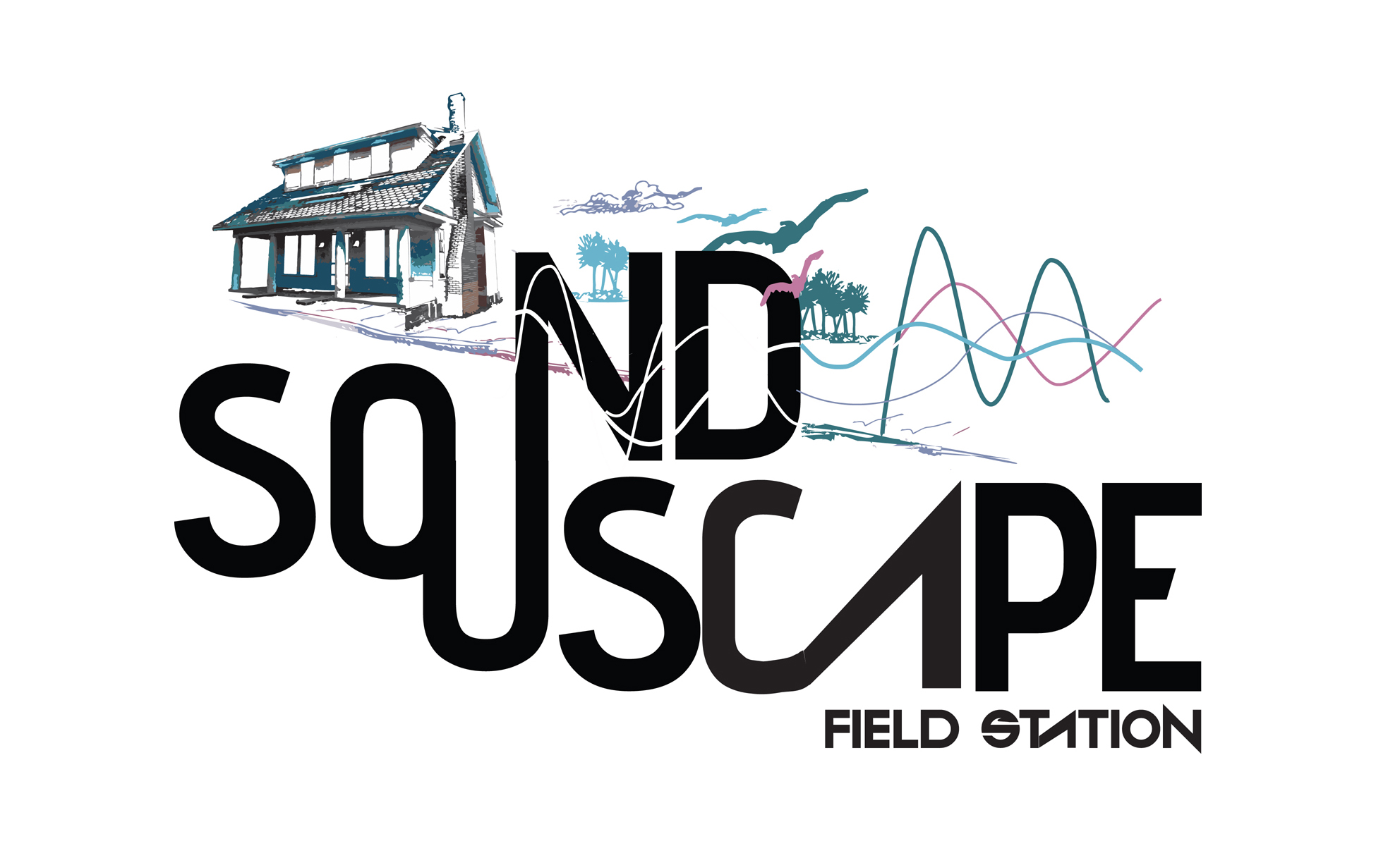

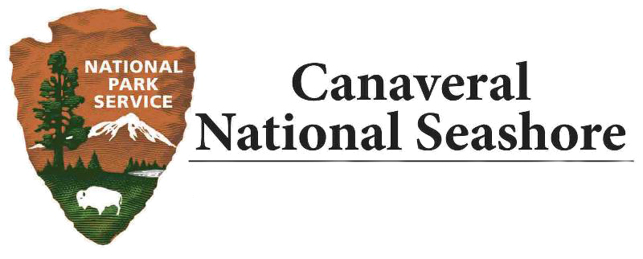

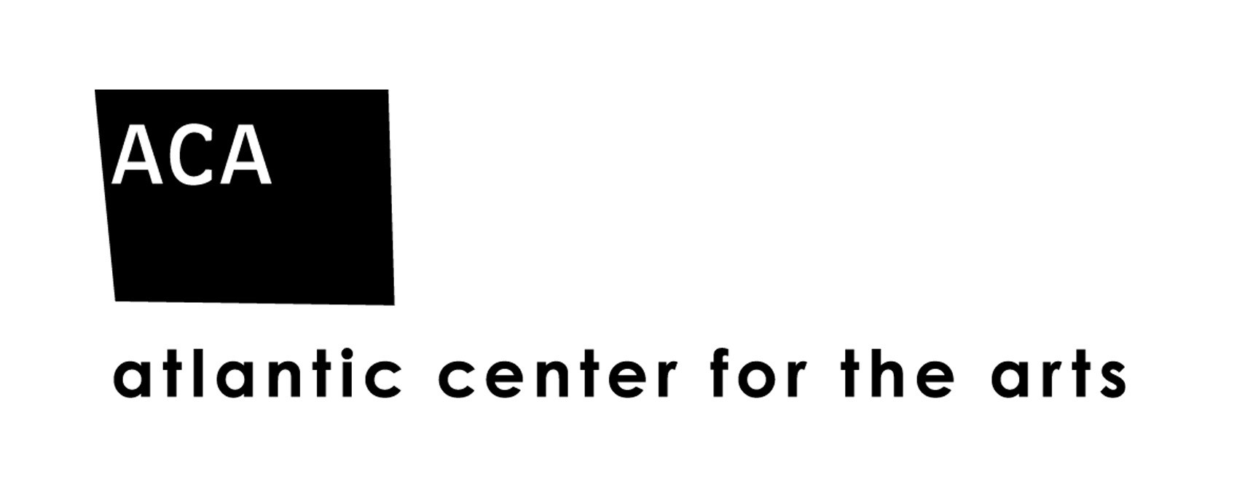

Local environmental arts program announces 2020 artist-in-residence
NEW SMYRNA BEACH, Fla, March 1, 2020 – The ACA Soundscape Field Station, a partnership between Atlantic Center for the Arts and Canaveral National Seashore, announces Dr. Nathan Wolek of Stetson University as its 2020 artist-in-residence. This residency program invites musicians, composers, and ecologists to find innovative approaches that help preserve a healthy and balanced soundscape for current and future generations. The sounds of our environment tell a story of wildlife biodiversity and the health of people living in that community. “It is important to provide innovative opportunities for sound artists to engage the community with the natural world in a new way that will inspire us to protect this resource,” says Eve Payor, ACA Director of Community Programs. Atlantic Center for the Arts has over 40 years of experience in producing artist-in-residency programs that attract distinguished artists from all over the world.

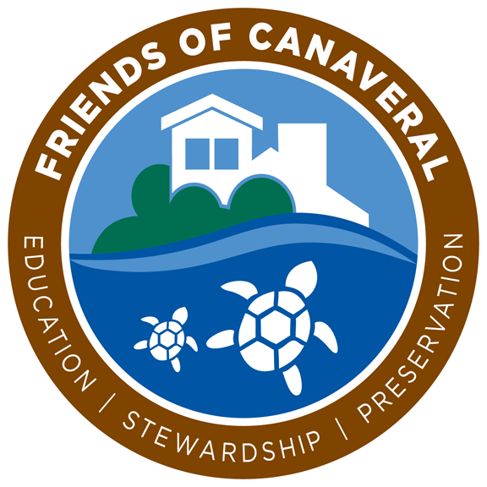
Dr. Nathan Wolek is a professor at Stetson University, and will use this residency as the starting point for a project as a Fulbright Scholar. He explains, “As a sound artist, I have been using audio field recording since 2005. At first, I was interested in it purely to obtain unique sound material for my music making activities. But since 2013, my creative agenda has shifted away from live music performance and more toward soundscape ecology. My interests are now focused on locations where people intentionally go to be in closer contact with nature like our state and national parks. These places have such interesting overlaps between human, wildlife, and Earth generated sounds. I tend to exhaustively explore certain locations by recording them over and over, then edit that material into a sound collage that represents that location. I am very excited for the opportunity to apply these methods while working at the Canaveral National Seashore in the months ahead. I was born and raised in Central Florida, so I have many fond memories of traveling to the beaches in Volusia and Brevard counties. I know it will be a fertile location to document and explore via sound.” Dr. Wolek will begin audio recording at Canaveral National Seashore in the spring of this year and continue through the fall.
More information: www.atlanticcenterforthearts.org/home/soundscapefieldstation
This program is supported by Friends of Canaveral and Atlantic Center for the Arts.
For media inquiries, please contact Eve Payor, ACA Director of Community Programs at 386-423-1753 or Laura Henning, Chief of Interpretation & Visitor Services, Canaveral National Seashore at 321-267-1110 ext. 25.
####

