THE BOLICK REPORT
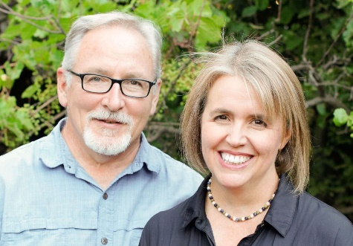

December 2025
Dwight and our partners across Latin America are exploring what it means “to invite people to become disciples of Jesus Christ and to proclaim, through both word and deed, God’s reign of justice, peace, and abundant life for all creation.”
One of the networks Dwight serves is RECONPAZ—the Continental Christian Network for Peace. RECONPAZ supports and equips pastors and communities who protest ecological devastation while also modeling practical, hopeful alternatives for protecting God’s creation.
In Honduras, Dwight focuses on training rural communities in rainwater harvesting, a practice that provides an independent water supply for households and gardens, and reduces time spent searching for water during the dry season. We have trained groups and installed model systems in nine locations in Honduras, - schools, community centers, and even a penitentiary.
One group he works with in Tegucigalpa serves as volunteer caretakers of a 2,500-acre nature reserve. Dwight trained them in developing rainwater collection systems to supply a reservoir used for fighting frequent forest fires and watering a native tree nursery. They are also establishing a botanical garden with walking paths where visitors can learn about ecological stewardship, bearing witness to the hope that all creation will one day be restored and set free from corruption.
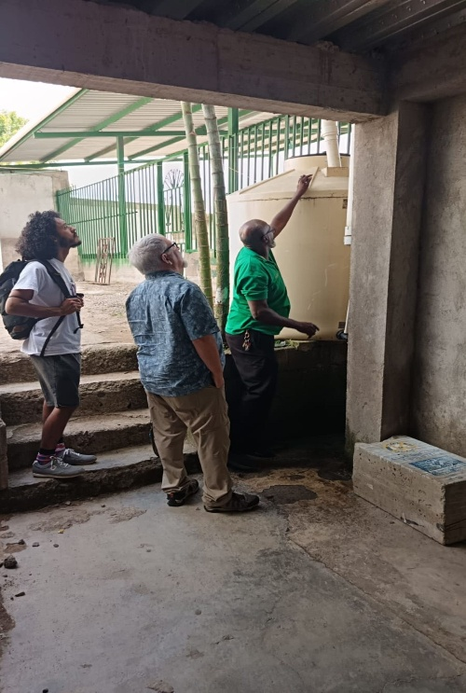
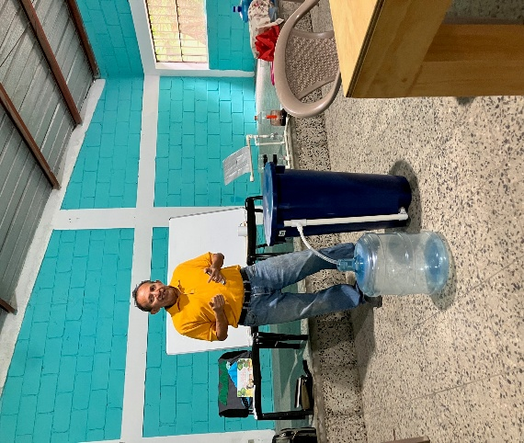
Now in a recent trip, Dwight is introducing bio-sand filters, for use in kitchens and for drinking. Bio-sand filters use gravel and sand, creating a biological layer capable of removing 99.9% of pathogens. With Edgard and Helen, RECONPAZ coordinators in Honduras, we will be training groups and monitoring the uses and maintenance of these natural wonders.
On the outskirts of Tegucigalpa, we are partnering with a missionary pastor, Alvin Anderson, who has planted five churches in isolated, underserved neighborhoods. In these communities, water must be purchased from trucks, which can only reach limited points in the steep terrain.
Access to clean water is a human right. It is also an expression of the abundant life that God dreams for all of us, for all creation, in the power of the gospel of Jesus Christ. Rainwater systems like these are one way of equipping churches for mission.
You can make more rainwater projects possible by donating to the Bolick’s Specifics, designating it for Rainwater. Call 610-768-2323 or write to: imdonorservices@internationalministries.org
https://www.internationalministries.org/author/bd-bolick/

