FITASC REFEREE CLASS
FITASC Referee Training & Certification
Saturday, February 21 2026
AT
OLD HUDSON PLANTATION
Sparta, Georgia
Class Description:
- 1 day class for training and certification as Regional FITASC Referee.
- Class includes class time and range time.
- Successful completition of written exam required.
- Estimated Cost = $180.00 (Check or Cash)
- Cost includes: Instructor fees, target fees, facility fees, lunch and application fee.
- Pre-Registration required by 2-13-2026.
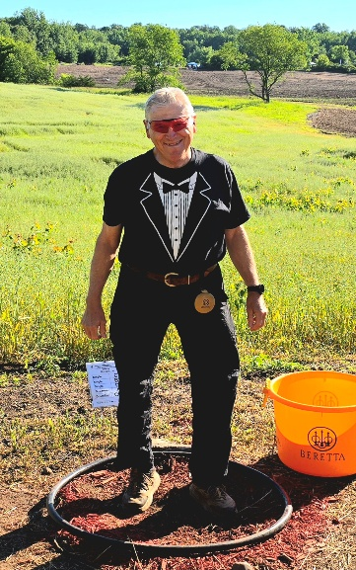
Instructor: SAMMY MCFADDIN
Send Message or call for more information and reserve place.
Sammydoc321@gmail.com
706-474-4808

