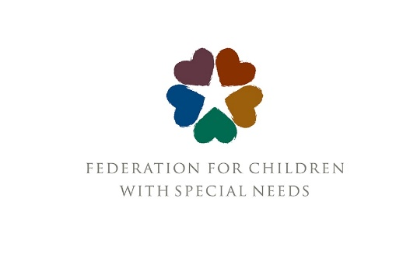

Pathways for Parents
Pathways for Parents is a program at the Federation for Children with Special Needs (FCSN) that supports several programs funded by the Department of Children and Families (DCF) around special education issues. Pathways offers technical assistance and guidance to these programs, and trainings for a wide range of audiences. In all of these roles, the Pathways program is supported by the RTSC group, making a connection at the Federation between all programs that support children involved with DCF (in congregate care for RTSC) and other DCF-supported community programs.
The largest group that Pathways serves is the Family Resource Centers (FRCs). There are now 27 FRCs around the state, with at least one in every county. FRCs are an amazing resource for their communities and offer services for free to any family regardless of income. Each FRC has a partner agency in the community. All FRCs offer parent trainings and support groups, early childhood services and information and referrals for help with issues including housing, benefits and finding psychological supports like counseling. Each offers different programs tailored to their unique communities, such as food and diaper banks, cultural and holiday celebrations and back-to-school supplies for families. All FRCs also have access to the services of the Mental Health Advocacy Program for Kids (MHAP), where attorneys from Health Law Advocates provide legal services for access to mental health care and special education. These services are available to low-income families, and you can learn more at https://www.healthlawadvocates.org/initiatives/mhapforkids.
Staff at the FRCs includes clinicians, family support workers and school liaisons, and the Pathways program supports these staff members with trainings and with answering parent questions around special education. For example, this summer we will provide a training for family support workers on when it may be appropriate to refer a child for an evaluation for special education, as well as a training for school liaisons on issues around the return to school in September, including regression and compensatory services.
The Pathways Coordinator, Eileen Sandberg, does many trainings for FRC families and staff, including Basic Rights in Special Education, Discipline and Suspension, Transition Age Youth, and Understanding the Developmental and Educational Impacts of Childhood Trauma. This summer, we are very excited about the potential to return to in-person IEP clinics, where families can discuss their IEPS with Federation staff, around the state.
Families whose children have special needs come in many forms, and Pathways also supports grandparents and other kinship families through trainings and direct information and support to the Grandparents Raising Grandchildren and the Kinship Navigator programs. These programs help families who may or may not have DCF involvement to find information and resources. Many families who assume guardianship of young relatives may not have had experience in navigating special education, and they need support to learn to advocate for their child’s school needs. Pathways can answer questions for these families, and the coordinator also provides trainings and attends support groups to discuss special education.
The third group served by the Pathways program is the Family Advisory Committee to DCF (FAC). The FAC is composed of volunteers from around the state who all have some experience with DCF, whether as parents with DCF cases, adults who were in DCF custody as children, or as foster or adoptive families. The FAC has several committees, including education, mental health and trauma, substance use, and juvenile justice. The Pathways coordinator is a member of the FAC and provides support around special education issues, and supports the committee work as well.
One example is a series of six trainings developed for foster and adoptive parents, which was sponsored by the FAC Education Committee and was held online this winter and spring. These trainings are designed to help foster parents, who may not be familiar with special education law and regulations, to understand the rights of their foster children and how to best advocate to meet their educational needs. Foster and adoptive families have always been able to access special education trainings from the Federation designed for the community, but we know that children who are in DCF custody typically have a history of developmental trauma which can complicate their needs and make additional training helpful. Understanding how early trauma impacts both their behavior and their educational needs is critical for foster and adoptive parents and other educational decision makers if they are to help their child heal and succeed academically. The series of trainings will be expanded and repeated in the fall of 2021, with a choice of day and evening sessions available for each training. For more information, please contact Eileen Sandberg at esandberg@fcsn.org.

Eileen Sandberg, PhD.
Program Coordinator, Pathways for Parents
Federation for Children with Special Needs
esandberg@fcsn.org

