Urban Soil Health Program

Let’s grow this!

In early May, the Urban Program team met up for our first in-person gathering for a tour of urban and small farm sites in Marion County.

We got an in-depth look into soil health management systems and conservation practices at Marion County SWCD’s Eagle Creek demonstration soil health garden, The Farm at Butler, and Indy Urban Acres.

Thanks to the farm managers at each site, it was a great opportunity to see diverse vegetable systems and cover crop mixes and management strategies in action.

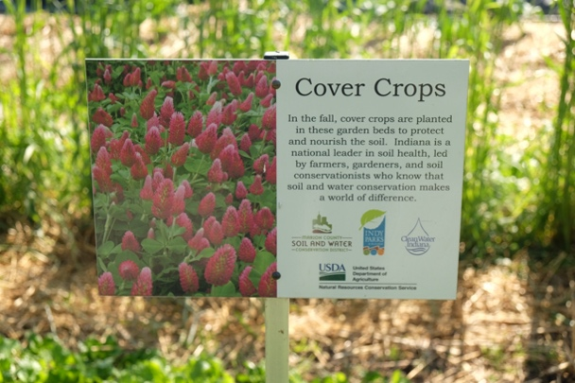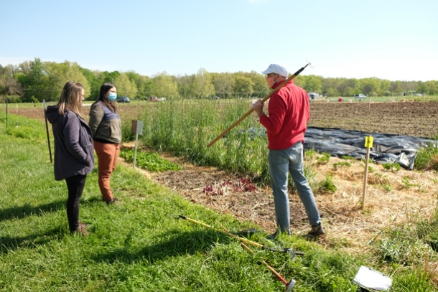

Other highlights include a tour of Hendricks County’s Porter Farm – a working demonstration farm that provides veterans an opportunity to connect with agriculture and learn and teach valuable farming skills.

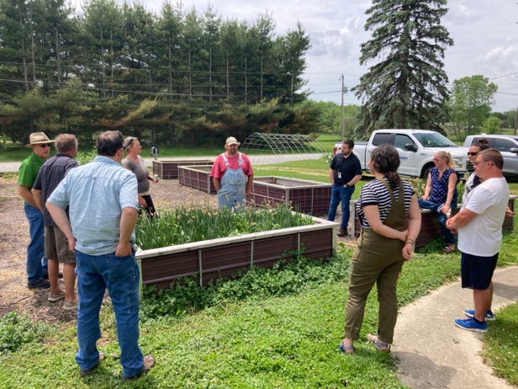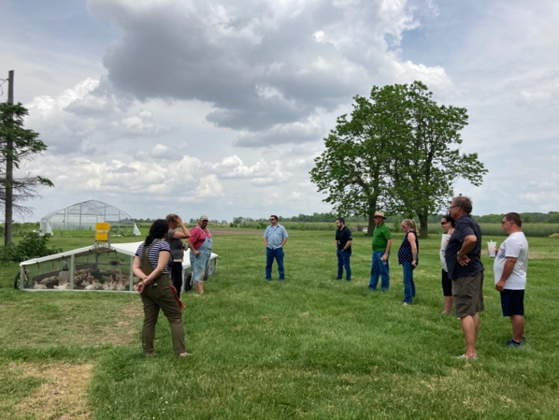

Our team recently connected with conservation partners in Lafayette and heard more about the Purdue Student Farm and GrowLocal – a network of nonprofit sharing gardens across the city.

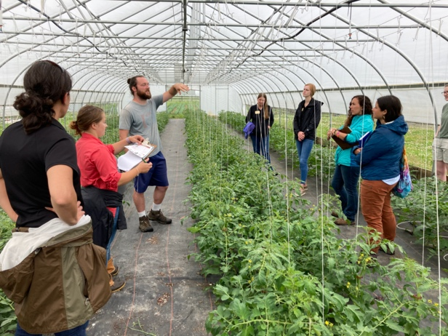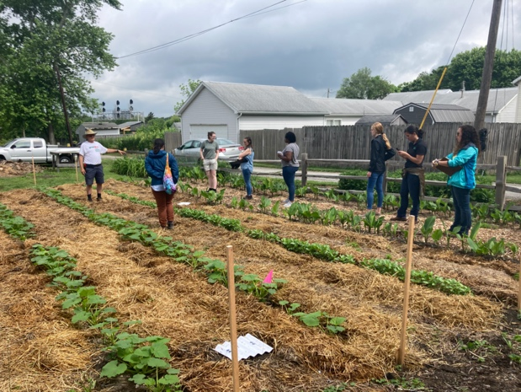

Be in Touch
Please let us know if you’d like us to join an upcoming board meeting to introduce the program and talk about how it could help serve your area.

Have an upcoming soil health focused small farm event? Creating new educational materials? We’d like to know! We may be able to support you.

Program Director
Elli Blaine
360-317-6752
eliana-blaine@iaswcd.org

Regional Urban Soil Health Specialists
Marian Rodriguez-Soto (NW Area)
marian-rodriguez-soto@iaswcd.org

Stephanie Wulpenry (NE Area)
stephanie-wulpenry@iaswcd.org

Casey Kennett (SE Area)
casey-kennett@iaswcd.org

Holly McCutchan (SW Area)
812-897-2840 ex. 3
holly.mccutchan@in.nacdnet.net

