
Spring 2020 Weed Wrangle Indiana® Contest

Goals: To boost Weed Wrangle® participation across the state; Increase CISMA outreach and public awareness in your county; Increase CISMA capacity and CISMA validity in your county

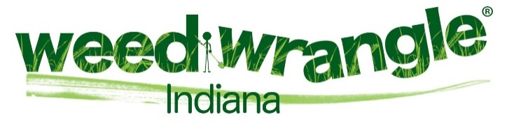
Please join us and host a Weed Wrangle Indiana® in your county. It’s a national event that highlights the necessity to manage invasive species, celebrates our native species and ecosystems, and provides action through hands-on invasive species management in our precious green spaces.
This year we want to explore methods to increase participation and partnerships as well as praise your efforts to make Weed Wrangle® in Indiana successful and long-lasting. Therefore, we have created a contest to increase your creativity and partnerships and reward such efforts.
You may begin earning points immediately. The more points you earn, the more times you will be entered into the contest for a chance to win a monetary prize to be used for your CISMA and invasive species management. We will announce and award the winner(s) at the SICIM Annual Meeting which is held annually in early summer.
So please join us and plan a Weed Wrangle Indiana ®for Spring 2020.

Contest Rules:
You must follow the pre and post submittal process (incorporated below) and use the attached spreadsheet to capture your activities for this year’s contest. Once you submit your pre event info to your Regional Specialists (RS), we will send the Weed Wrangle Indiana® logo to you so you can begin developing advertising media, etc.
Weed Wrangle Indiana timeframe: 15 March – 15 May 2020 (activities outside this timeframe will not be counted in this contest)
Prize:
$500 to the winning CISMA and four hours of hands-on assistance from the Indiana Invasives Initiative Regional Specialists in your area (map is included in Appendix).

Earning points:
Examples in the table below are not all-inclusive. You may find other ways to increase partnership and attendance at your event. We will add points as new criteria are suggested and adopted. We will share via email changes to the point system if and as they occur. We want your event to be fun and worthwhile. We want people to return the following year and bring new people. What we plant matters, so let’s cheer and reward the management of invasive plants, the use of our native plants and the avoidance of invasive plants!
We encourage collaboration with community partners and therefore we will award points if you hold multiple events in your county within the 2020 spring timeframe (see table below for an explanation). We will not award points for simply holding a Weed Wrangle Indiana®. Planning and partnering are key to success, therefore we will reward those “plan for success” efforts.
To even the playing field and prevent bias, each time you earn 7 points your CISMA will be placed in a drawing, which increases your chances of winning the prize. For example; If you hold two events on the same day (five points for the additional location), advertise on FB (one point), advertise at a local library and at a county-wide event [earn 2 points (one point for each venue used)], have a sponsor who will loan equipment (five points), you earn 13 points and have one ticket in the drawing.
You must document efforts, partners, sponsors, number of attendees, media used, etc. We need time stamped photographs, sign-in sheets, a copy of flyers/ posters/videos/ media coverage/ participant reviews, etc.
Provide your event details to your Regional Specialists (RS). I encourage you to communicate regularly with your RS and ask for help and feedback. Our RSs are there to assist, but they are not allowed to lead, or plan your Weed Wrangle Indiana®. To help you, we have attached a planning spreadsheet. Feel to use it or your own version to track your event logistics.

Please let us know if you have questions and let’s have a fantastic year sharing the positive message about using natives and managing invasive plants.

R.
Dawn Slack
Dawn.slack@tnc.org

Table 1: 2020 Weed Wrangle Indiana Contest Points
Activity | Points | Description & Date Accomplished | Description & Date Accomplished | Description & Date Accomplished | Description & Date Accomplished | Points Earned
Event planning meetings | 1 point for each meeting (you must document the meeting)
Save-the-Date | 1
Create a flyer for the event | 1
Display posters around town(s) – must be approved by venue to post | 3
Post on Facebook | 1
Post on Instagram | 1
Newspaper ad | 3
Create a video to advertise your event and use it | 5
Advertise on a local billboard | 5
Neighborhood bulletin board | 3
Contact Town Council or local city board and enlist their support (have them advertise event) | 3
Contact Tree Board and enlist their support (have them advertise event) | 3
Contact Park and Rec Dept or City Park and have them support event by advertising event | 3
Contact Gardening Club and enlist their support | 3
Contact University and garner students for the event | 3
Stage Performance or live advertisement (e.g. provide an announcement at a local theater prior to the movie starting) | 3
Earn a point when a partner / sponsor attends and participates in your Weed Wrangle Indiana®. (must constructively help or participant in invasive species treatment) | 3
Enlist partner / supporter to supply a relevant give-a-way (coupon for native plant at a nursery, etc.) or loan tool/supply for event | 5
Contact Girl/Boy Scouts and enlist their support for your event | 3
Have a fun meter at your event, (you must determine how to measure, and you must photograph it at your event w/ participants behind it) | 4
Hold more than one Weed Wrangle® in your county on the same day to increase participation and partnerships | 5 points for each additional location outside of the “first” location on the same day
Hold more than one Weed Wrangle® throughout the spring timeframe (15 March – 15 May 2020) | 5 points for each. In theory, you are planning these at once so we will award 5 pts for each location/date.
Send us your own idea for earning points, if we adopt it, we will give you points and update spreadsheet and share with others | 1
Submit date-stamped photographs and pre & post planning to RS or Dawn Slack | 5

Weed Wrangle Indiana® Rules (Pre and Post Submittal Process)

Conditions of Trademark Logo Use and Required Event Information

Dear Participant:
Please use the trademark name (attached) as appropriate for your event (beside your group logo, etc.).
Use of the logo must include the trademark symbol.
I will forward your information to the Weed Wrangle folks and they will add it to the National Weed Wrangle event page. They ask that we photograph our Weed Wrangles and share some of those photographs with them. Please take one photograph of your group with the logo.
We may only use the Weed Wrangle Indiana® logo if we 1.) use the trademark symbol with it, 2.) provide invasive species education and treatment, and 3.) provide a brief report about the event. Please ensure you follow these rules. Do not alter the logo. If you are holding a Weed Wrangle Indiana® the logo should be prominently displayed so people know you are holding a Weed Wrangle Indiana®.
I track our Indiana events and will submit all of them to the Weed Wrangle Point of Contact, so you don’t have to worry about submitting anything to them. Send your final report to me. I compile all Weed Wrangle® info and send as one state report.
Submit the following to me: an initial submission of the event and an after-action report.

Initial Submission of Event:
Exact title of your event:
Date of event:
Location:
Event Objective (target species to manage and/or education goals, etc.):
Link to your website (page where you will advertise the Weed Wrangle):
After Action Report:
Total Hours spent on the event:
Event Hours:
Number of participants:
Target Species Removed:
Did you supplement with native plants?
Please submit photos.

Please let me know if you have any questions.
Thank you,
Dawn
Dawn.slack@tnc.org

Appendix

Event Planning Documents and Resources

ACTIVITY SCHEDULE
Activity Name: ______________________ Date: _______________Time: _______________Location: ______________________________________________
Task Description | Timeline |  | Who’s Responsible | Status | Open
Task Description | Start Date | Due | Who’s Responsible | Status | Issues | Revisions
Gather Event Committee & develop timeline
List Partners
Venue Location and Time
Save the Date Created and Shared
Liability Release Forms
Safety Concerns:
List Types of Media Venues
Create Flyer or another media form
Media Blast 1
Media Blast 2
Registration (if needed)
Restrooms
Water
Snacks
Tools

List of Partners/Sponsors
Entity | Status (Partner/Sponsor) | How Supporting Event | Comments/Needs

Event Schedule Planner 2019-2020
 | Goal:
  Event name | Weed Wrangle Indiana spring 2020
  Organizer | ? CISMA

  Project Phase | Starting | Ending
  Phase 1 | Date | Date
  Phase 2 | Date | Date
  Phase 3 | Date | Date
  Phase 4 | Date | Date
  Phase 5 | Date | Date
  Phase 6 | Date | Date
  Project Phase | Starting | Ending
   | Date | Date
   | Date | Date
   | Date | Date
   | Date | Date
   | Date | Date
   | Date | Date

November | December | January | February | March | April
  S | M | T | W | T | F | S
   |  |  |  |  | 1 | 2
  3 | 4 | 5 | 6 | 7 | 8 | 9
  10 | 11 | 12 | 13 | 14 | 15 | 16
  17 | 18 | 19 | 20 | 21 | 22 | 23
  24 | 25 | 26 | 27 | 28 | 29 | 30
  S | M | T | W | T | F | S
  1 | 2 | 3 | 4 | 5 | 6 | 7
  8 | 9 | 10 | 11 | 12 | 13 | 14
  15 | 16 | 17 | 18 | 19 | 20 | 21
  22 | 23 | 24 | 25 | 26 | 27 | 28
  29 | 30 | 31
  S | M | T | W | T | F | S
   |  |  | 1 | 2 | 3 | 4
  5 | 6 | 7 | 8 | 9 | 10 | 11
  12 | 13 | 14 | 15 | 16 | 17 | 18
  19 | 20 | 21 | 22 | 23 | 24 | 25
  26 | 27 | 28 | 29 | 30 | 31
  S | M | T | W | T | F | S
   |  |  |  |  |  | 1
  2 | 3 | 4 | 5 | 6 | 7 | 8
  9 | 10 | 11 | 12 | 13 | 14 | 15
  16 | 17 | 18 | 19 | 20 | 21 | 22
  23 | 24 | 25 | 26 | 27 | 28 | 29
  S | M | T | W | T | F | S
  1 | 2 | 3 | 4 | 5 | 6 | 7
  8 | 9 | 10 | 11 | 12 | 13 | 14
  15 | 16 | 17 | 18 | 19 | 20 | 21
  22 | 23 | 24 | 25 | 26 | 27 | 28
  29 | 30 | 31
  S | M | T | W | T | F | S
   |  |  | 1 | 2 | 3 | 4
  5 | 6 | 7 | 8 | 9 | 10 | 11
  12 | 13 | 14 | 15 | 16 | 17 | 18
  19 | 20 | 21 | 22 | 23 | 24 | 25
  26 | 27 | 28 | 29 | 30


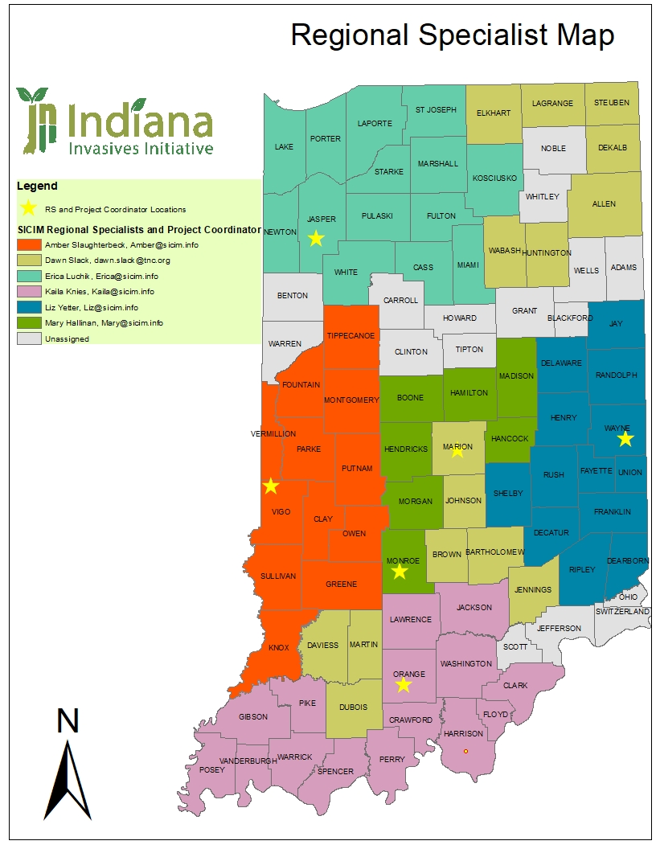

Checklist for Day of Event
1919 Steven Avenue, Bedford, Indiana, 47421
Phone: (812) 653-5563 Website: www.sicim.info

 | Invasive Species Training Event Checklist for Day of Event | ADDITIONAL INFO
 | Printed Materials for the Participants | Per event
☐ | Pretty Awful brochures | Callery Pear tree blooms on the cover
☐ | Terrestrial Plant Rule FAQ sheet here: https://static1.squarespace.com/static/559d59d6e4b03b77d9cd5e00/t/5d2ccb0ca5798500013f1c5a/1563216658885/Terrestrial+Plant+Rule+Fact+Sheet_final.pdf | Indiana’s Terrestrial Plant Rule FAQ sheet on banned plants beginning 2020
☐ | Landowner Toolkit handouts here: http://www.sicim.info/landowner-toolkit
☐ | CISMA demographics survey and Event Evaluation survey | Contact your Regional Specialist for files
☐ | Additional resources here: http://www.sicim.info/links-resources
☐ | Keep a Lookout handout | MIPN handout
☐ | Volunteer Waivers
☐ | General Herbicide Mixing Recommendations Handout
☐ | Landscaping with Natives brochures | Indiana Native Plant Society
☐ | Upcoming meeting and/or event flyers
☐ | SICIM Calendar of Control | Color coded handout with herbicide recommendations
☐ | Business Cards | Include Partnership’s Business Cards
 | Supplies for Outdoor Control Portion
☐ | Trash bags | Make sure to identify how to dispose of full bags before event
☐ | Nitrile gloves
☐ | Work gloves
☐ | First aid kit
☐ | Safety glasses
☐ | Loppers
☐ | Hand saws
☐ | Herbicide applicators | Dobbers, bottles, sprayers, etc.
☐ | Ear plugs | For use with chainsaws, brushcutters, etc.
☐ | Cat litter and/or spill kit | In case of an herbicide spill
 | AV Equipment
☐ | Laptop
☐ | HDMI and/or VGA Cords | Suggested to bring both
☐ | 10’ minimum Extension cord with 3 (three prong) outlets | One for laptop, one for projector, and one additional
☐ | Projector | Suggested to bring something to prop it up or sit it on top of to accommodate each site
☐ | Table | If not provided by the venue
 | Extra items to consider | Per event
☐ | Paper clips, scissors, tape, post-it notes, plant labels, etc. | Create a “kit” for events
☐ | Event sign-in and/or email sign-up | If you have a mailing list make sure to bring a signup form
☐ | Door prize | Native seeds or plants, giveaways, dobbers, etc.
☐ | Raffle tickets for door prize | Give one to each individual as they enter your event
☐ | Invasive Plant cuttings and/or live potted samples | Make sure to notify Dawn Slack about transporting live Invasive Plants
☐ | Pull up banners with displayed images
☐ | Reference Materials | Your recommended field guides
☐ | Boot brushes to remove invasive seeds from participants shoes before they leave your event | Hoof picks work great
☐ | Flags to mark invasives and/or natives. Use two different colors of marking tape if marking both. | Marked for removal or saving
☐ | Directional Signage | Very much appreciated by participants
☐ | Snacks and drinks

