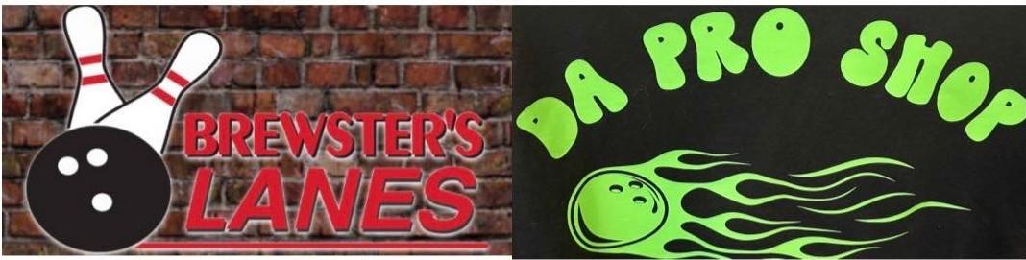

- 2026 Summer Drop-In League -
Bowling starts at 6pmon Tuesday May 19th. Cost is $10 per week.
Bowl as many weeks as you want. No long-term commitment is required. This is a non-sanctioned league.

Each week, you bowl a 3-game series including handicap. (Handicaps will beestablished the first night of bowling and adjusted every week.) The top 4 bowlers advance to compete in a one game, bracket-style competition.
The 2 bracket winners will then compete to determine our weekly winner. Prize money for the top four will bedetermined by the total number of entries each week. A minimum of $50 will bedivided.

The league will be10weeks total. (Nine weeks of qualifying and 1 week for the year end tournament.) Each week that youbowl, you earn 1 point. If you win the weekly roll-off, you will earn an additional 1 point.

To qualify for the year-end tournament, you must accumulate 7 points total. Pre-bowling is allowed but must be done at the conclusion of each weeks qualifying event. Post-bowling will notbeallowed.

This is a handicap league of 90°/o of 225 per series with no maximum.
Sand bagging will notbeallowed. Wereserve the right to disqualify anyone we feel is doing this.

Theyear-end tournament participants will receive additional cash awards courtesy of Brewster's Lanes & Da Pro Shop.

If you are interested in participating, please contact Robat (608) 434-4370 or Mo at (608)228-8694

