9 Pin Tap Tournament Enrollment Sheet
Singles Tournament
July 18, 2021 Benefit Featuring SWING CREW
TEAM ENTRY FORM
Team Name: ______________________________________
1._____________________________________________AVG__________
2._____________________________________________AVG__________
3._____________________________________________AVG__________
4._____________________________________________AVG__________
5._____________________________________________AVG__________
Bowling Starts at Noon. Cost is $25 per person.
All bowlers get free admittance into Swing Crew event.
AND BE A LANE SPONSOR
____ We will donate $50.00 to Sponsor a lane (Bronze Sponsor)
____ We will donate $100.00 to Sponsor a lane (Sliver Sponsor)
____ We will donate $150.00 to Sponsor a lane (Gold Sponsor)

PLEASE MAKE CHECKS PAYABLE TO:
BREWSTER’S LANES
Mail To:
Brewster’s Lanes
121 Viking Drive
Reedsburg, WI 53959
CONTACT: Bruce or Julie Bill
PHONE: 608-524-2276

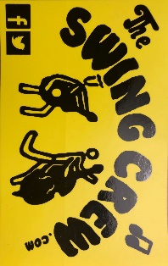

Portion of proceeds will benefit Boys & Girls Club

