Ijams Nature Center
Local Phenology Program
A Participatory Science Project

Report Covering Activities in 2025



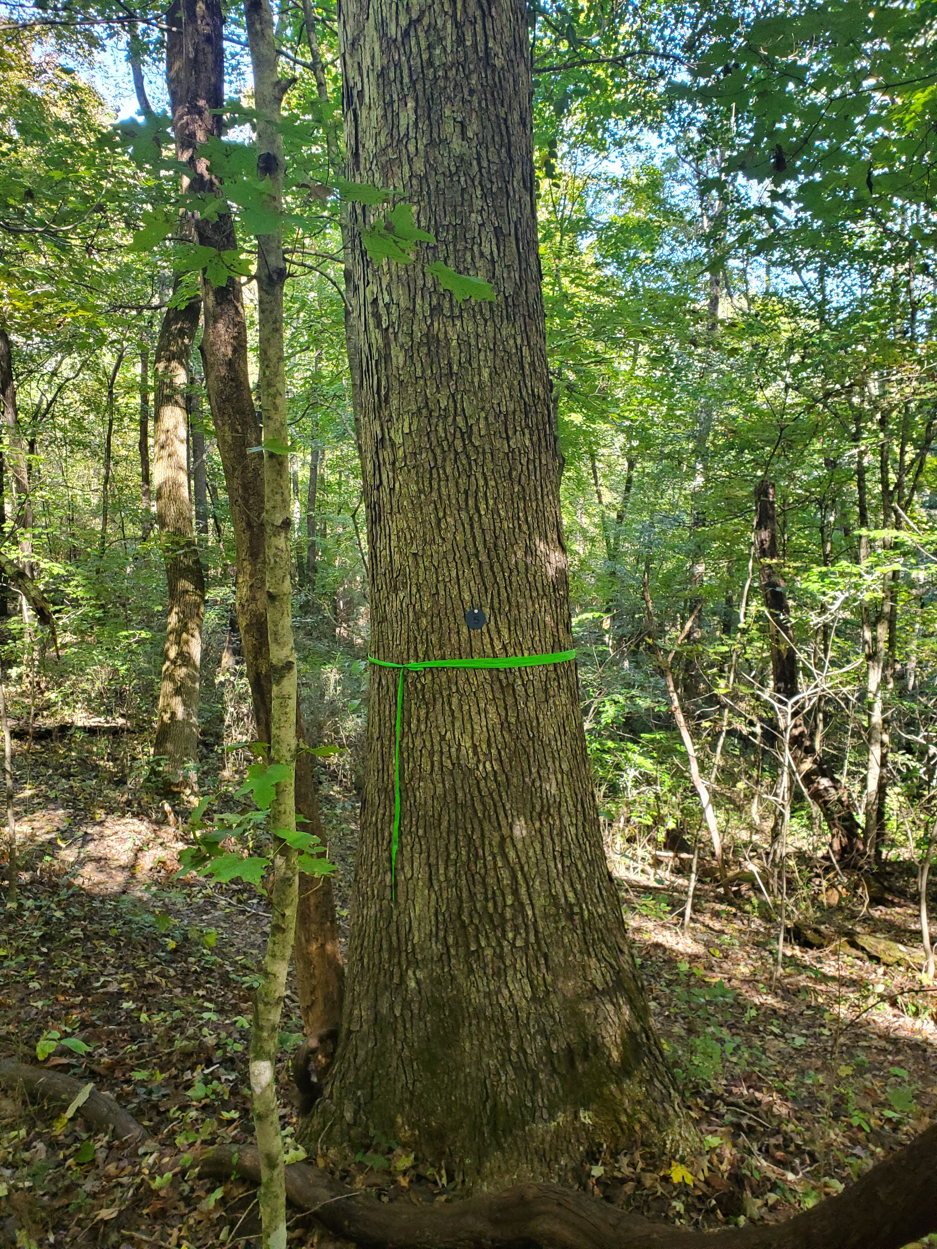
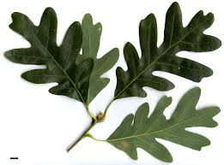
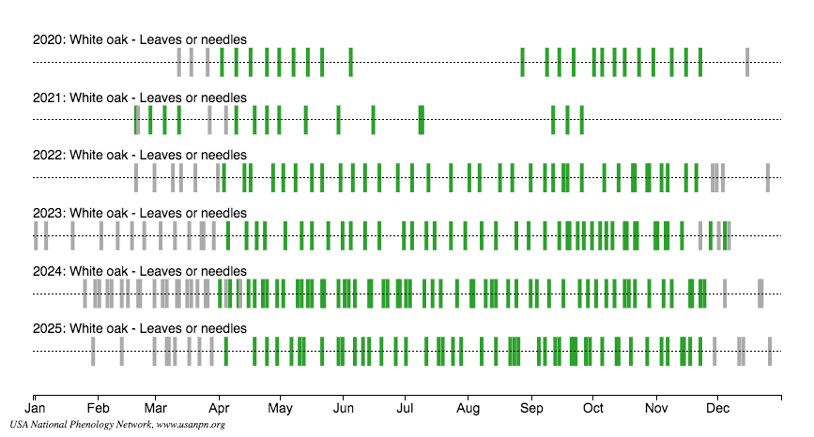

Ijams Nature Center Local Phenology Program:
A Participatory Science Project

Introduction

Phenology refers to the study of recurring plant and animal life cycle stages, such as leafing out and flowering, the maturation of agricultural plants, the emergence of insects, and the migration of birds. It also involves understanding the relationship of these life cycle stages to weather and, in the long term, climate.

The USA National Phenology Network (USA_NPN, https://www.usanpn.org/home) was established in 2007 to collect, store, and share phenology data and information. Phenology observations using the USA_NPN protocols were started at Ijams Nature Center in the fall of 2016. The USA_NPN provides standardized observation protocols and on-line training. The Ijams phenology observations are made by a team of volunteers that are in-person trained to collect accurate data using the specified protocols at established plots at Ijams Nature Center. Data collected by these volunteers are uploaded to the USA_NPN database where they are immediately available to scientists and the public.

Our phenology information also provides information on the response of Ijams Nature Center ecosystems to changes in environmental and biological conditions. Specifically, these regular observations provide new information on the biology of many tree species at Ijams. This includes impact of invasive species, response to management for enhancing the recovery of disturbed ecosystems, and monitoring the impact of changing climate on growth and reproduction of the forests at Ijams. Participation in phenology monitoring engages a wide variety of volunteers and provides useful information on sustainability of Ijams forests, and help guide management decisions. This participatory science program also provides a wealth of information that can be used in hands-on placed-based learning opportunities (e.g. school field trips, service projects) and training (e.g. Tennessee Naturalists) programs.

Scientists use observational data in the National Phenology Database along with models to understand how responsive species and phenological phases are to changes in climate across time and space and used in over a hundred scientific publications every year. Ijams phenology observations have already made important contributions to this larger scientific enterprise (see page 11).

Ijams Nature Center Phenology Program

In early fall of 2016 we established the first 2 tree plots that included 15 trees with 11 different tree species. In January 2018, 2 additional plots, called Shady Invader plots, were added to better understand the phenology and ecology of 3 species of invasive shrubs compared to 2 species of native understory woody plants. The Shady Invader Plot 1 was discontinued in 2022 after the invasive plants in that plot were inadvertently removed. In 2025 Shady Invader Plot 2 was discontinued due to numerous tree falls disrupting the plot. In October 2019 three additional plots were established on the Meads Quarry side of Island Home Ave. Two were established in the Subaru Preserve – one in the riparian zone of Toll Creek, the second in an upland location. The third plot is located in a mature oak-hickory stand along the Hickory trail. In 2025, 2 additional tree plots were established in areas where an Ijams bird-banding project is conducted - Aralia Trail, and Quarry Plot. The Quarry plot has 2 sections. One section is off trail in a narrow section of woods between the meadow next to Imerys trail and Flow trail. The other section is on the Tharps Trace trail just south of Meads Quarry. See Figures A1and A2 in Appendix A.

The current 7 phenology plots cover a wide variety of Ijams forest ecosystems including various types and stages of disturbance. Data from these plots provide important primary information on Ijams ecosystems that can be used to more deeply understand the present status and provide information for understanding future response of trees and shrubs to management, recovery processes, and changing environmental conditions at Ijams. The 3 relatively mature forest tree plots (Secret Pond Trail, River Trail, and Hickory Trail) provide information on 23 tree species. The two Subaru Preserve plots provide monitoring information that may be useful for assessing the impact of restoration of these damaged ecosystems. The 2 new plots in 2025 (Aralia Trail, and Quarry) were established in areas around Meads Quarry where Bird Banding was recently started.

Results from 2025

Observation Quantity Summaries

Observation quantity information was prepared using the Local Phenology Project Dashboards page (www.usanpn.org/nn/groups/dashboard). There have been a total of 116,901 observations added to the USA_NPN database to date from Ijams Nature Center phenology plots. Table 1 provides details.

Site Name | 2016-19 | 2020 | 2021 | 2022 | 2023 | 2024 | 2025 | Totals
River Trail Plot | 6,468 | 1,955 | 2,412 | 2,475 | 2,197 | 1,050 | 2,936 | 19,493
Secret Pond Trail Plot | 7,851 | 2,786 | 2,871 | 3,686 | 2,765 | 2,640 | 2,010 | 24,609
Shady Invader 1 Plot | 3,795 | 2,422 | 2,444 | -- | -- | -- | -- | 8,661
Shady Invader 2 Plot | 3,773 | 2,422 | 2,436 | 1,734 | 1,248 | 717 | 613 | 12,943
Subaru Preserve Creek Plot | 385 | 2,002 | 1,309 | 3,278 | 3,696 | 3,080 | 2,453 | 16,203
Subaru Preserve Upper Plot | 370 | 1,850 | 1,313 | 3,119 | 3,700 | 2,738 | 1,924 | 15,014
Hickory Trail Plot | 228 | 1,900 | 1,389 | 3,140 | 3,605 | 3,716 | 3,170 | 17,148
Aralia Trail Plot |  |  |  |  |  |  | 1,640 | 1,640
Quarry Plot |  |  |  |  |  |  | 1,190 | 1,190
Totals by Year | 22,870 | 15,337 | 14,174 | 17,432 | 17,211 | 13,941 | 15,936 | 116,901

Table 1. Quantity of phenology records by plot and year.

The following pie chart gives a snapshot of the number of phenology records per phenophase for 2025. Approximately one-half of the observations are related to the presence and status of leaves. Another one-third of the observations are related to the presence and status of fruits. The remainder of the observations are concerned with flowers. This proportion is largely the same for every year.
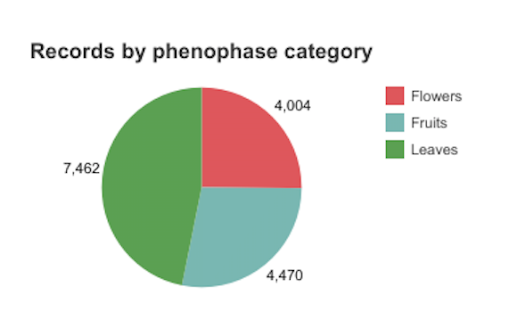

Figure 1. Summary for 2025 of the quantity of phenology observation for all of the Ijams plots by phenophase category. Phenophase categories are composites of a larger number of phenophases actually recorded. Leaves includes Breaking leaf buds, Leaves, Increasing leaf size, Colored leaves, and Falling leaves. Flowers include Flowers or flower buds, Open flowers, and Pollen release. Fruit includes Fruits, Ripe fruits, and Recent fruit or seed drop.

Site Name | 2016-19 | 2020 | 2021 | 2022 | 2023 | 2024 | 2025 | Totals
River Trail Plot | 77 | 23 | 30 | 30 | 29 | 14 | 40 | 243
Secret Pond Trail Plot | 96 | 38 | 38 | 47 | 37 | 34 | 30 | 320
Shady Invader 1 Plot | 74 | 47 | 47 | -- | -- | -- | -- | 168
Shady Invader 2 Plot | 73 | 46 | 47 | 31 | 24 | 14 | 12 | 247
Subaru Preserve Creek Plot | 5 | 25 | 17 | 43 | 48 | 40 | 30 | 208
Subaru Preserve Upper Plot | 5 | 25 | 18 | 41 | 48 | 37 | 25 | 199
Hickory Trail Plot | 5 | 25 | 19 | 42 | 47 | 49 | 42 | 229
Aralia Trail Plot | -- | -- | -- | -- | -- | -- | 20 | 20
Quarry Plot | -- | -- | -- | -- | -- | -- | 14 | 14
Totals by Year | 335 | 229 | 216 | 234 | 233 | 188 | 213 | 1,648
Observer Activity

Volunteers are the key to the success of the phenology program. Their activity is easily monitored using the Nature Notebook Observer Activity dashboard. Table 2 indicates the number of volunteer visits to each of the phenology plots.

Table 2. Number of visits by volunteers by plot and year.

Figure 2 shows the number of active observers by month and the total records for each observer during 2025.

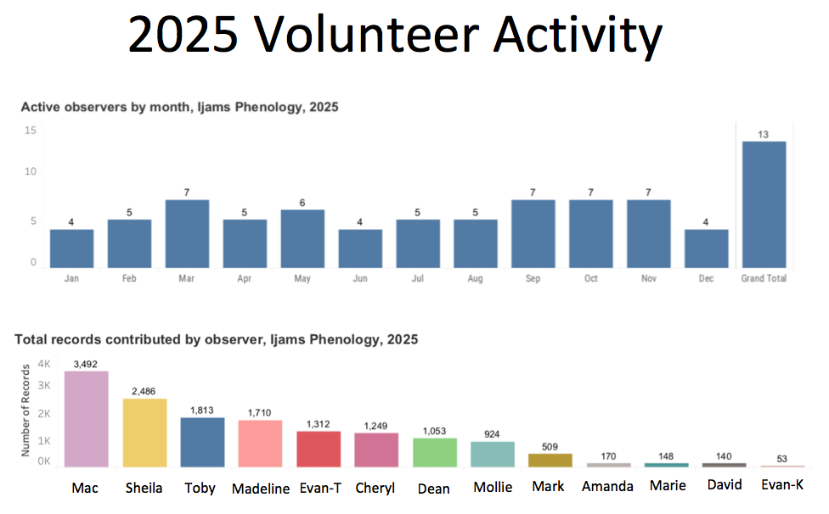
Figure 2. Volunteer activity by month and observer for 2024.

There are many reasons people volunteer to make phenology observations. These include having fun outdoors, deepening connections with nature, learning about phenology, and contributing to scientific discovery. We currently have 9 active volunteers.

Data Collected at Ijams

The data based on observations made by Ijams volunteers are collected using a smart phone application called Natures Notebook. The data are automatically uploaded to the NPN where it is stored and made publicly available. This circumvents the need for Ijams to maintain the data the volunteers collect. The NPN has created a phenology visualization tool, located at https://www.usanpn.org/data/visualizations, to explore the phenology data including all data collected at Ijams. Here, for illustration of the types of data inquiries that can be obtained, we provide examples of output from the visualization tool using Ijams data.

White Oak Leaf Observations. With 9 years of data we can look for some tentative trends. Below are two plots with data from the past 6 years. These are calendar visualizations. The grey bars indicate days observations were made and “No” was recorded. Colored bars indicate “Yes” was recorded. Figure 3 is bud burst information for all the white oak individuals that are monitored. These have initial shoot and leaf growth fairly early in spring compared to other species.

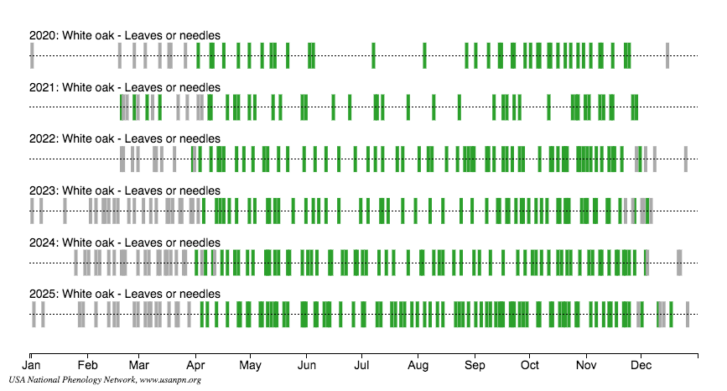

Figure 3. Leaves Present observations for white oak in Ijams phenology plots. See Table A1 to see which plots contain white oak. Note: The grey bars represent observations when leaves were not observed.

It appears that white oak leaved appeared about2 weeks earlier in 2021 than in earlier years. Leaf-out is largely a function of accumulated growing degree-days (GDD). Growing degrees days are defined as the number of degrees the average daily temperature exceeds a base temperature. GDDs are fairly easy to calculate: We use GDD base 32. Add the maximum temperature to the minimum temperature for a day, divide by two, and subtract 32 (the base temperature). If the number resulting from this calculation is above zero, then that is the number of degree days for that day. If the result is zero or below, the number of GDD is zero for that day. These growing degree-days are cumulative.

Warmer springs generally result in earlier leaf-out. Figure 4 is a plot of the GDD for Ijams for the years 2020, 2021 and the 30-year average (1991-2020). The year 2021 started and stayed cooler than average for the entire year. However, the previous year, 2020, was much warmer than average – especially during fall and early winter. Unusual, but perhaps this may explain the early break in dormancy in 2021.

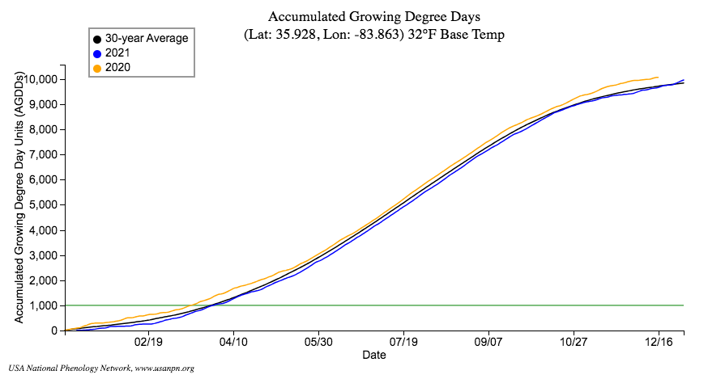

Figure 4. Accumulated growing degree days (GDD) using a base temperature of 32 degrees for the area including Ijams Nature Center. The 30-year average is for 1991 to 2020.

Lessons Learned

Our lessons learned mainly revolve around how best to recruit and schedule volunteers, how to split them up amongst our plots. While we currently have a dedicated team of phenology volunteers, keeping the interest of volunteers and retaining them requires continual attention. Our solutions to these issues are continuing to evolve. Last year we had 4 of our most dedicated and longest serving volunteers leave the project due to limited time for this volunteer effort. With much appreciated assistance from the Ijams Volunteer Manager, Brandy Cox, we were able to identify and train 4 new volunteers, all Tennessee Naturalist Program participants. The Tennessee Naturalist Program does provide volunteers that are very interested in phenology observing and wanting to participate in collecting scientific data.

We are currently working with Ijams staff to increase the number and visibility of ongoing scientific projects at Ijams. Part of this effort is to identify pathways to report our phenology data to the Ijams Nature Center staff and Ijams Board of Directors, and to the public.

Education and Outreach Activities

There are several opportunities to use phenology participatory science to provide educational activities for youth and adults. Engaging people in phenology observations offers placed-based, hands-on learning opportunities about the process of science and the use of science observations in understanding natural processes. Current phenology volunteers could be a resource in the development of these education and outreach opportunities.

Programs with adults could provide information about the importance of phenology and how the Ijams phenology program is contributing to scientific data and information. In particular, information on how phenology is contributing to understanding how Ijams ecosystems respond to disturbances from invasive species, past and current land management, and climate change could be the focus of short field trips.

We have already had several field trips with middle school age students that focused on Participatory Science. One of the activities in the rotation of activities for these field trips is phenology. The students get a brief orientation about phenology and how phenological events can be divided into phenophases and quantified. The students are then given individual sheets from the plot packet to locate the tree and make the observations using a simplified data sheet with the protocol questions. This has been well received by the students and teachers. However, a curriculum needs to be developed in order to meet the quality standards of an Ijams field trip opportunity. A lesson plan for the Ijams Junior Naturalist Program seems like a natural fit. See the short-term objective 2 in the following section on Next Steps.

Summary and Next Steps

The Ijams phenology program has completed over 8+ years of data from the original 2 plots and since has established an additional 7 plots, 2 of which have been discontinued. Observations have engaged adults, many graduates of the Tennessee Naturalist Program, and college students. Data collected so far when combined with observations from the larger USA_NPN network have informed several science investigations.

This project would benefit from development of long-term and short-term objectives. The following objectives should be considered for continued development of this project.

Objectives

Long-term Objectives:
1: Inform the public about the scientific significance of Ijams Nature Center resources for contributing to scientific research and understanding;
2: Provide science based educational opportunities for school field trip programs, adult programs, and service projects; and
3: Provide data from phenology studies for resource understanding and management by Ijams staff.

Short-term Objectives:
1 : Develop a phenology annual report.
- Responsible Person(s): Mac Post, volunteer observers, Kat Livar (Ijams Public Programs Manager)
- Barriers and Challenges: Use NN visualization tool to create graphics using Ijams Phenology data. Compose message about goals and objectives achieved and plans for future for inclusion in Nature Center’s annual report.
- Required Resources: NN Visualization Tool
- Completion Date: February 2027

2 : Develop materials for use with middle school field trips or as a component of the Ijams Junior Naturalist Program targeting middle and high school students.
- Responsible Person(s): Mac Post, appropriate Ijams Staff
- Offer placed-based, hands-on learning opportunities.
- Barriers and Challenges: Become familiar with science standards for 6, 7, and 8 grade students, design a 2 hour program that provides hands-on learning incorporating pertinent standards, get feedback from local teachers
- Required Resources: Documentation of state science standards
- Completion Date: August 2026
- Interim Updates: Draft materials for review July 2026

3 : Provide an opportunity for Tennessee Naturalist Program graduates with service opportunities.
- Responsible Person(s): Mac Post, Kat Livar, Brandy Cox
- Barrier and Challenges: Develop a learning module compatible with the TN Naturalist Curriculum and train the teaching staff to use the module.
- Required Resources: Considerable information for module development exists on the USA_NPN website and can be modified appropriate to introduce phenology and participatory science to TNP participants.
- Completion Date: Already started and ongoing. This is incorporated into the TNP Forest module and involves active data recording at the Hickory Trail plot.

Location of Project Components

All data is entered online via Nature’s Notebook usually using their smartphone application, and sometimes by their web portal, and is stored in the USA‐NPN National Phenology Database, available for download at www.usanpn.org/data.

Using the administrator login and going to the “My Observation Deck” link, many management activities can be performed including managing users (assigning administrators, data technicians, users), adding sites, adding or editing plants, downloading site data.

Information packets for use by volunteers are available in the Hub Room.

For additional information about the location and composition of the phenology plots see Appendix A.

Appendix A: Observation Locations, Methods, and Materials of the Ijams Phenology Program

Monitoring Locations

Ijams Phenology currently has 7 active plots for long term observation and contribute to NPN’s goals of understanding climate change impacts. This information is also relevant for Ijams science and education programs, and for informing management decisions. Three plots are in relatively mature, not recently disturbed, stands. One is located on the Secret Pond Trail (SP), another is at the junction of the North Cove and River Trails (R), and the third is on the Hickory Trail (H) south of Island Home Ave.

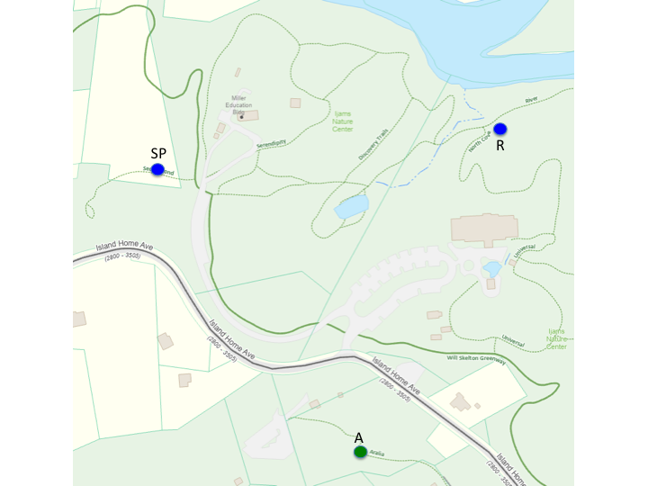

Figure A1. Location of the Ijams Phenology plots north of Island Home Ave. Dark blue dots indicate the 2 tree plots – Secret Pond Trail and River Trail. The green dot is for a tree plot that was added in 2025 – Aralia Trail.

Two additional plots are located in the Subaru Preserve (SC, SU) and are intended for monitoring potential changes in phenology resulting from restoration management. In 2025, 2 additional tree plots were established in areas where an Ijams bird-banding project is conducted - Aralia Trail (A), and Quarry Plot. The Quarry plot has 2 sections. One section is off trail in a narrow section of woods between the meadow next to Imerys trail and Flow trail (Q-a). The other section is on the Tharp’s Trace trail just south of Meads Quarry (Q-b).

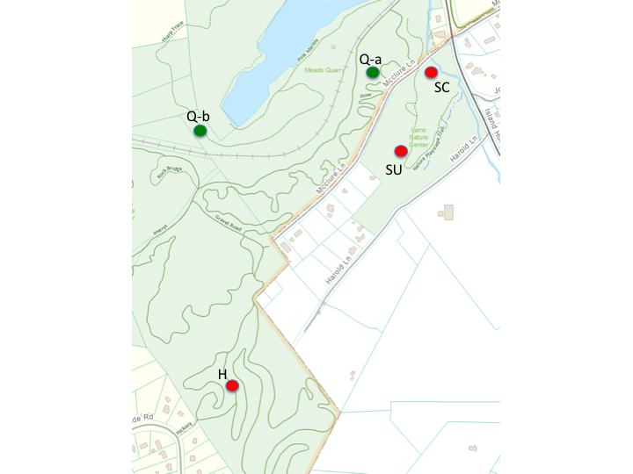

Figure A2. Location of Ijams Phenology plots south of Island Home Ave. The plots marked with red dots were established in September of 2019. Those marked with green dots were established in 2025.

Discontinued Plots

There were 2 plots for the understanding of the current and future impacts of invasive shrubs. One of these plots, SI-1, was discontinued in 2022. The other, SI-2 was discontinued in 2025. These Shady Invader Plots monitored 5 understory plants – 3 invasive (Amur honeysuckle, privet, multiflora rose) and 2 native (northern spicebush, flowering dogwood). Both of these plots were located on the River Trail. These were purposely set-up for the NPN’s Shady Invaders project - https://www.usanpn.org/nn/campaigns/ShadyInvaders. The data from these plots contributed to the findings in the following publication:

Maynard-Bean, E., Kaye, M., Wagner, T., Burkhart, E.P. 2020. Citizen scientists record novel leaf phenology of invasive shrubs in eastern U.S. forests. Biological Invasions. https://doi.org/10.1007/s10530-020-02326-1

The raw data from these plots is accessible from the National Phenology Network at https://www.usanpn.org/data

Data Collection Procedure and Maintenance

Information packets (one for each plot) describing the location of the plots and positions and photographs of the trees and shrubs in each plot are located in the Hub Room just outside the Lead Naturalist’s office. These packets contain information on each tree/shrub that aid the volunteers in making observations using the USA_NPN protocols. The data is entered using the Natures Notebook application on smartphones or tablets carried to the locations. Data is automatically uploaded to the USA_NPN database when the observer syncs their Natures Notebook phone app data with the USA_NPN database.

The phenology lead volunteer keeps volunteers engaged by communicating with volunteers on a monthly basis with observing tips, data results of interest, scientific results that involve currently collected data. The lead volunteer, or finds a willing volunteer, to fill in for others that cannot make timely observations. Recruiting and training volunteers is currently done on an ad hoc basis when needed, usually by the lead volunteer.

The lead volunteer does on-going maintenance and up-keep. Tree and shrub tags can become weathered or vandalized (usually by squirrels), and need periodic checking on their condition. Occasionally observed trees die and are replace by new individuals within the plot. The information packets for each plot are maintained and are especially for orientation of new volunteers.

Species Composition of Phenology Plots

A total of 51 woody plants are included in the 7 phenology plots. There are 31 different tree species and 1 shrub contained in all the plots.

River Trail  Lat: 35.95719, Lon: -83.86659, Elev: 898 ft  RT-1 basswood  RT-2 mockernut hickory  RT-3 hackberry  RT-4 northern spicebush  RT-5 white oak  RT-6 silverbell  RT-7 redbud (dead – no longer observing)  RT-8 sugar maple | Subaru Preserve Creek  Lat: 35.95032, Lon: -83.86534, Elev: 839 ft  SPC-1 sugar maple  SPC-2 hackberry  SPC-3 silver maple  SPC-4 box elder  SPC-5 box elder  SPC-6 American elm  SPC-7 sycamore
Secret Pond Trail  Lat: 35.95714, Lon: -83.87024, Elev: 925 ft  SPT-2 mockernut hickory  SPT-3 northern red oak  SPT-4 sugar maple  SPT-5 beech  SPT-7 tuliptree  SP-10 sugar maple  SP-11 shagbark hickory | Subaru Preserve Upper  Lat: 35:94849, Lon:-83.86607, Elev: 885 ft  SPU-1 black walnut  SPU-2 black locust  SPU-3 black gum  SPU-4 spicebush  SPU-5 sugar maple  SPU-6 winged elm  SPU-7 white oak
Hickory Trail  Lat: 35.94458, Lon: -83.87048, Elev: 935 ft  HT-1 sugar maple  HT-2 black cherry  HT-3 chestnut oak  HT-4 mockernut hickory  HT-5 white oak  HT-6 northern red oak  HT-7 shagbark hickory | Aralia Trail  Lat: 35.9543, Lon: -83.8678, Elev: 875  A-1 American beech  A-2 pawpaw  A-3 devils walking stick  A-4 tuliptree  A-5 common buckthorn  A-6 persimmon  A-7 hackberry  A-8 white oak
Quarry Plot
Lat: 35.9506, Lon: -83.8664, Elev: 846

Q-1 black cherry
Q-2 American elm
Q-3 hackberry
Q-4 black locust
Q-5 callery pear
Q-6 boxelder
Q-7 sugarberry
Q-8 northern red oak

Table A1. Geo-location and Tree and Shrub Species Components of Ijams Phenology Plots

